This desk aid was developed to give guidance on some activities in ETO and is not intended to be a replacement for the user guide. Individual offices or areas may have different procedures. Please contact your local trainer or designated staff to determine if these guidelines are appropriate for your area.
Entities, Sub-entities and recruiters
In the customer management system, Efforts to Outcomes (ETO), employer records are called Entities and have three levels:
- Company Entity is the primary record. Think of this as the headquarters building.
- Sub-Entity is the next level of record related to the Company Entity. Think of this as the worksite. If there is more than one worksite, there can be more than one Sub-Entity record under a Company Entity.
- Recruiter represents a person within the company.
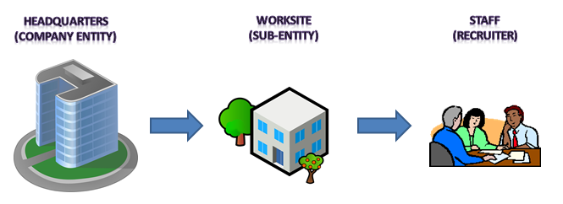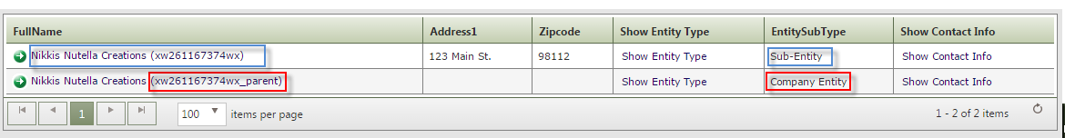
Employer Services can be documented under the Sub-Entity or Recruiter record. A best practice is to document Employer Services and Employer Notes under the Sub-Entity, not the recruiter. The benefits of documenting Employer Services in the Sub-Entity record are:
- Services are under a common record.
- Job postings display under the Sub-Entity record.

Finding a Sub-Entity
You can find a Sub-Entity two ways. Either by record Type or by Name.
Finding a Sub-Entity by type
To find a Sub-Entity by type, use the navigation bar on the right side of the screen. Use the following steps:
- Click the navigation bar arrow on the right side of the screen to display the menu.
- Click Entities>Find Employer by Type
  - Entity Type: Employer
  - Entity Subtype: Sub-Entity
- Click Show Entities
- Type the company name in the Entity Name field.
- Click the link of the correct company.
- Click Go to Dashboard on the right hand side of the screen.
Finding a Sub-Entity by name
To find a Sub-Entity by name, use the navigation bar located at the right side of the screen.
- Click the navigation bar arrow on the right side of the screen to display the menu.
- Click Entities and View Employer by Name.
- Type Entity name or Employer ID number in the search field.
- Click Search.
- Click the arrow by Entity Name to display the search results.
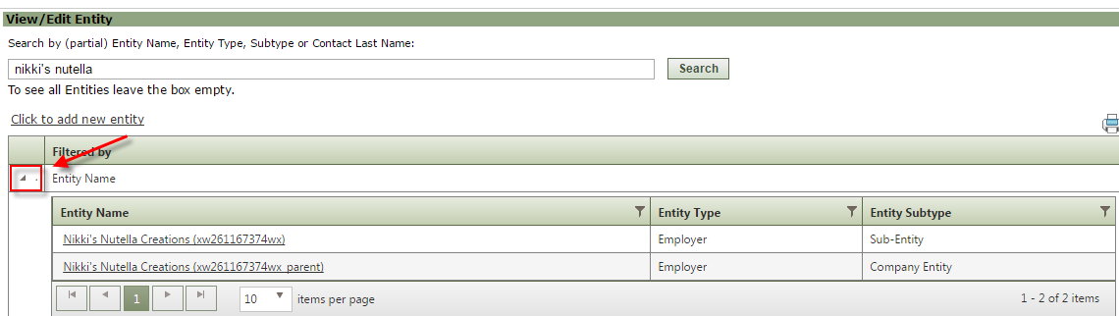
Finding a Sub-Entity by Recruiter name:
- The company (Sub-Entity) name displays in the Entity Information section of the Recruiter Dashboard in the Company Affiliation field.
- You can search by the name of the company (Sub-Entity) or the Employer ID number, displayed in parenthesis next to the company name.
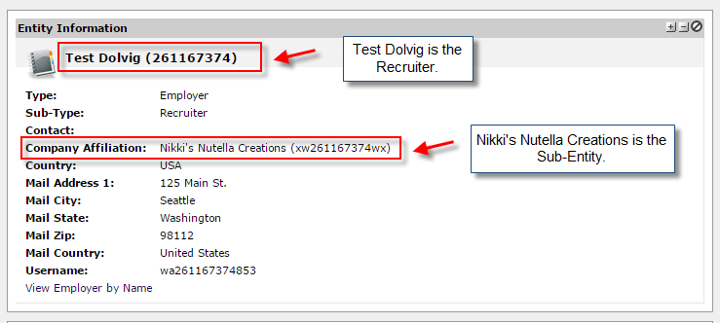
Recording Employer Services
Once you’ve selected the correct Sub-Entity record, you can access Employer Services TouchPoints from the View Employer Recruiter TouchPoints widget on the Dashboard or from the Most Recent Employer Services on the Dashboard.
Recording a service from View Employer/Recruiter TouchPoints widget
- Click the View Employer/Recruiter TouchPoints widget at the top of the dashboard.
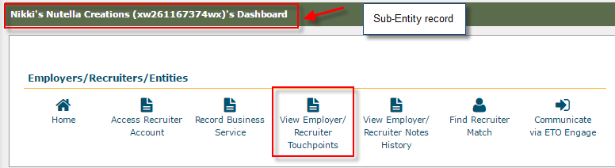
- Click “Take New TouchPoint.”
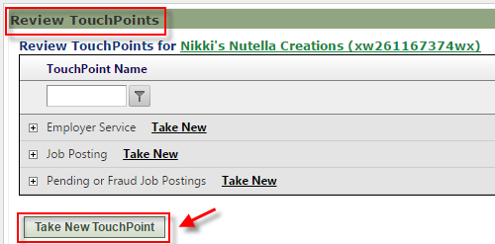

- Select the “Employer Service” TouchPoint.
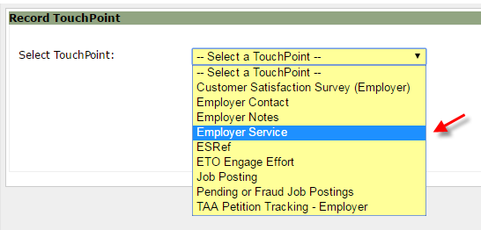

Note: If an Employer Service TouchPoint has already been recorded, you can click Take New next to the Employer Service TouchPoint.
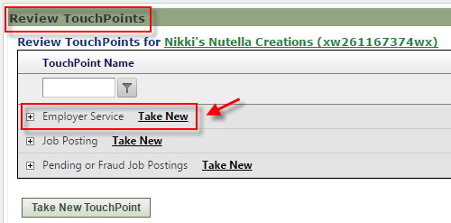

Recording a service from Most Recent Employer Services section on Dashboard
- Click + New in the Most Recent (20) Employer Services section on the dashboard.
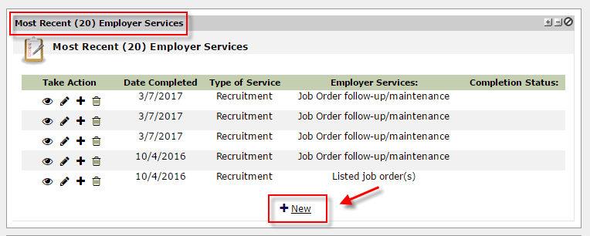

Recording Employer Notes
You can access Employer Notes TouchPoint from the View Employer/Recruiter TouchPoint widget or the Most Recent Employer Services section on the dashboard.
Recording notes from View Employer/Recruiter TouchPoint widget
- Click the View Employer/Recruiter TouchPoints widget at the top of the dashboard.
- Click Take New TouchPoint.
  - If an Employer Note has already been recorded, you can click Take New next to the Employer Notes.
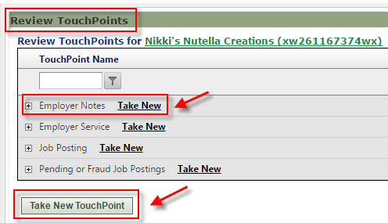

Recording notes from Most Recent Employer Services section
- Click +New in the Most Recent Employer Services section on the dashboard.

Finding Recruiters
You can search for a list of all recruiter records associated with that Sub-Entity’s record. This is important if you need to access a recruiter’s Job Match account via impersonation.
- Once you’ve selected the Sub-Entity record, click the Find Recruiter Match widget on the dashboard.
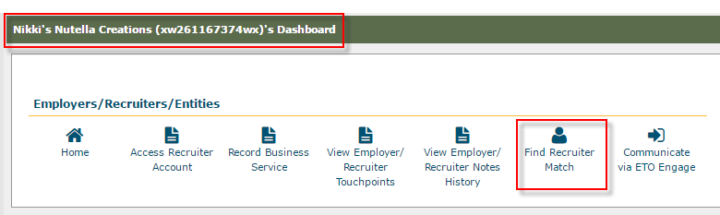
You can also search for the Recruiter record via the navigation bar using two methods: Find Entity by Type or View Employer by Name.
Find Entity by Type
- Click on the Navigation bar on the right side of the screen.
- Click Entities.
- Click “Find Entity by Type.”
  - Entity Type: Employer
  - Entity Subtype: Recruiter
- Click Show Entities
- Type recruiter’s name in the Entity Name field.
View Employer by Name
- Click on the Navigation bar on the right side of the screen.
- Click Entities.
- Click View Employer by Name.
- Type the recruiter’s name in the search field
- Click Search.
- Click the arrow to display search results.
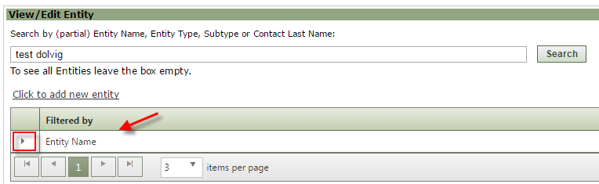
- Click on the recruiter’s name.
- Click Go to Dashboard.
Additional Information
- The ETO User Guide outlines additional ETO functionality and features regarding employer records in Lesson 4: Working with Employers, pages 38-42.
  - Recording TouchPoints (Take New TouchPoint) is outlined in Lesson 5: Using TouchPoints, pages 46-49.
- All employer demographics should be updated in the employer’s Job Match account.
- In order to access the employer’s Job Match (WorkSource WA) account, you must select a recruiter record in ETO.
- The Quick Search bar, located at the top of the screen, can be used to search for Sub-Entities and Recruiters. It is a “best practice” to use the search functionality via the navigation bar on the right side of the screen. The search parameters in the Quick Search bar are different. If you choose to use Quick Search, you can only search by:
  - “Sub-Entity Name”;
  - “Recruiter Name”; or
  - “Employer ID”
Please note: You cannot search by “Entity Type.”

