Job Match for Employers
Contents
Lesson 1: Account Creation and Registration 3
Sign In Page 3
Self-Service Password Reset 3
Employer Account Request 4
Lesson 2: Employer Dashboard & Your Account 7
Account Settings 8
Company Settings 9
Users 11
Lesson 3: Job Posting 14
Job Details Page 14
Posting Options Page 21
Screening Questionnaire 23
Hands-on Activity – Post a Job 25
Manage Job Postings 26
Lesson 4: Resume Search 28
Basic Search 28
Advanced Search 30
Resume Search Results 33
View Candidate 34
Add Candidate to Folder 35
Save Resume Search 36
Manage Saved Searches 37
Hands-On Activity – Search Resumes 37
Lesson 5: Manage Candidates 38
Manage Candidate Folders 39
Display Candidates in Folders 40
Manage Candidates 41
More Actions 44
Hands-On Activity – Manage Candidates 45
Lesson 6: Hiring Library 46
Job Information 46
Create a Jobs Template 46
Apply a Jobs Template 47
Letters 47
Create a Letter 48
Questionnaires 49
Create a Questionnaire 50
Auto-Reply Letter 53
Hands-On Activity – Create Templates 54

Section Objectives
After completing this section, you will be able to:
- Request an employer account and log in to approved accounts
- Manage account and company settings
- Perform basic and advanced resume searches to find qualified candidates
- Save and manage candidates in folders
- Create and manage templates to use for posting jobs, including letter templates and applicant questionnaires

Section Duration
Instruction for this section will last approximately 2 hours.

Lesson 1: Account Creation and Registration

Sign In Page
The Sign In page allows users to request accounts and log in to existing accounts. Once logged in, employers can post jobs, search resumes, and manage candidates.
Requesting an employer account will initiate the account review and approval process. In order to verify/validate employer account requests, a system administrator will review employer information for authorization. If approval criteria are met, approval will occur within 1-3 business days from the request and the system will issue an email confirming the account has been authorized. From that time on the supplied credentials will satisfy login requirements, and provide access to the employer dashboard.
To request an account, click “Continue” in the “New to WorkSource?” box and the system will guide the user through the registration process. After the account has been authorized, log in by entering the username or email address and password into the boxes provided and clicking “Sign In.” Upon first-time login, users will be asked to complete security questions and a company profile (if the user is the account administrator) before reaching the employer dashboard. For all subsequent logins, users will be taken directly to the employer dashboard. For more information about the employer dashboard, see lesson 2.
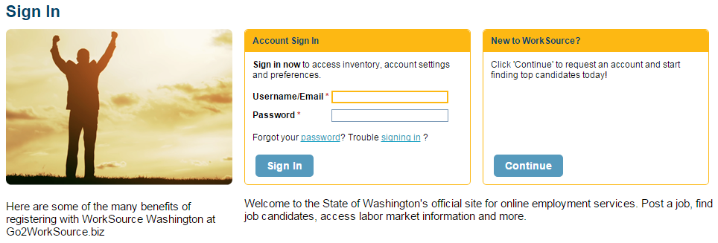

Self-Service Password Reset
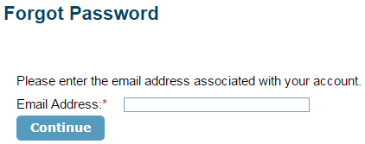
If users forget their account password after creating an account, the password reset feature provides functionality to access the account without helpdesk support. By clicking on the “Forgot Password” link, users are given the opportunity to enter the email address associated with an account.
After entering the email address and clicking “Continue,” users will receive a system-generated email that includes a link and instructions to change the account password.

Employer Account Request
To complete the employer account request process, users must provide information in three sections: Account Information, User Information, and Additional Company Information. Throughout the account setup form, required fields are identified by a red asterisk.
The first section on the Account Setup page asks users to enter Account Information, such as name and address.
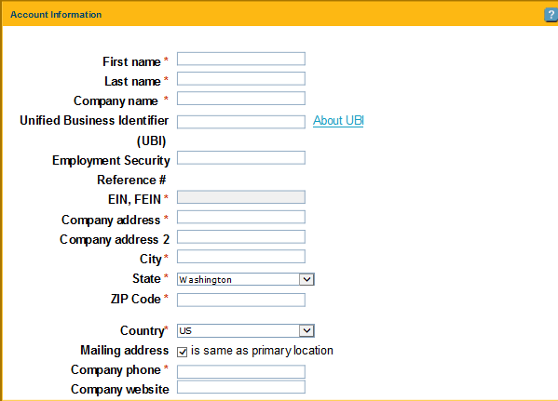
The second section is for User Information. The username must be unique. If the username entered is already associated with an existing account, the system will recommend a unique username that can be used to complete the account setup process.

When a password is created, it must meet certain criteria. Specifically, passwords must be between 8-20 characters and contain one letter and one number or symbol. Passwords must exclude username, first name, last name, email address, and “Monster.” Also, email addresses must follow the standard format (e.g., include the “@”symbol).
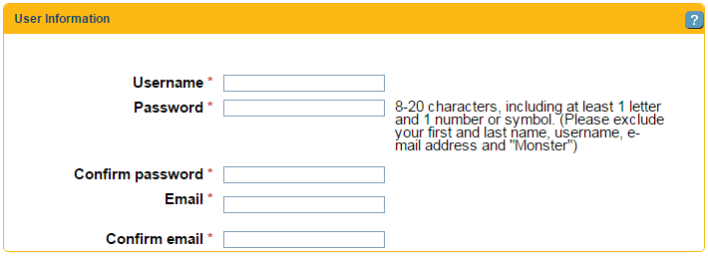
In the Additional Company Information section, users must enter a 6-digit NAICS code to describe the company. A link to the US Census Bureau website is provided below the text box to identify an NAICS code for the company. Users must also select the Number of Employees for the company from the available drop down list. Options for type of organization include:
- Private Sector
- Local Government
- State Government
- Federal Government
- International/Foreign Government
- Non-profit
- Higher Education
- K-12 Education

Finally, select federal contractor status.
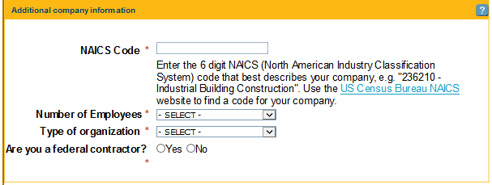

After completing all required fields, click the checkbox to accept the terms of use and privacy policy at the bottom of the page.
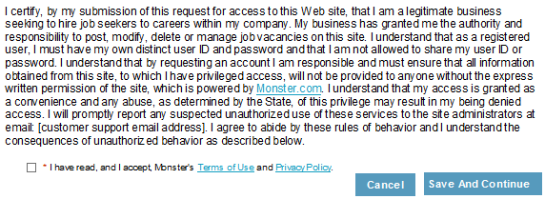

Click “Save And Continue” to submit the account setup information. The system will display a message to confirm successful submission of the information. Users will be notified within the specified time period when the account is approved via email. Approved accounts are accessible using the credentials provided in the registration form.

Lesson 2: Employer Dashboard & Your Account
All employer activities are accessible from the dashboard. Users search resumes, post jobs, manage candidates (including creating folders of categorized candidates), and utilize metrics to analyze the job market. Using the navigation bar across the top of the screen allows users to engage in employer activities.
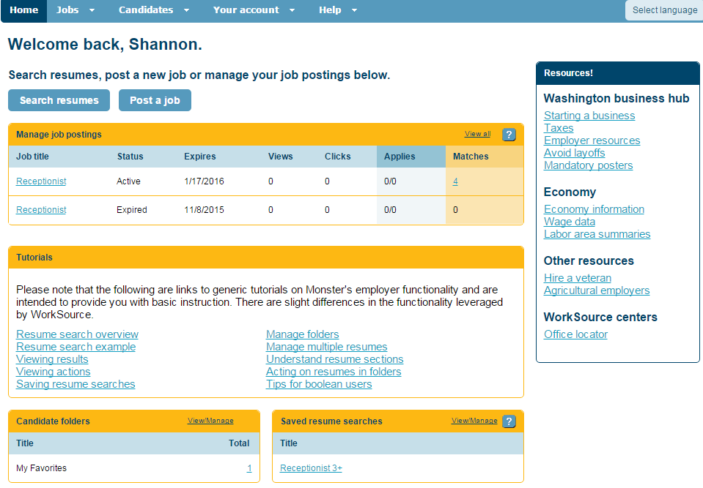
From the Jobs menu, users post jobs and manage postings. For more information on these activities, see lesson 3. From the Candidates menu, users search for candidate resumes, manage saved candidates, and manage saved searches. For more information on these activities, see lessons 4 and 5. From the Your Account menu, users can manage account settings, company settings, account users, and templates in the hiring library. For more information on these activities, see later topics in this lesson and lesson 6. From the Help menu, users may contact the support desk.
Below the navigation bar is the “Search Resumes” and “Post a Job” buttons. These buttons provide a shortcut alternative to the navigation bar for accessing common employer activities.
The dashboard also includes summary sections for major employer activities. If an employer has created job postings, they are listed in the “Manage Job Postings” section. Click on individual postings or the “View All” link to view details and take actions (see Lesson 3). At the bottom of the employer dashboard are summary sections for “Candidate Folders” and “Saved Searches.” If users have created folders in which candidates are grouped and managed, they can be accessed by the link displaying the number of saved candidates. Similarly, saved resume searches will be displayed in the summary section and can be managed using the links provided.
The Tutorials section on the dashboard provides helpful links to assist the user with every aspect of the employer site. Tutorials cover topics such as performing resume searches, saving resume searches, and tips for Boolean searches.

Account Settings
The Account Settings page displays profile and preferences information provided during registration. Access the Account Profile and Account Preferences by selecting the Account Settings option from the My Account menu on the navigation bar.
The Account Profile tab includes: Account Profile, Username & Password, Employer ID Number, Job Posting Contact, and Additional Company Information. To edit profile information, click “Edit” in the desired section. The system will display profile information in an editable format. To save changes, click “Save.”
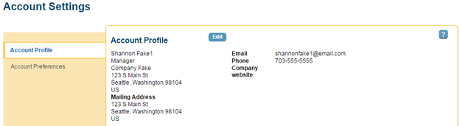
The Account Preferences tab allows the user to set preferences that apply to the user’s individual account. The Standard Apply Response Preferences section determines how applicant responses are received. Users choose to receive responses through their WorkSource account only (Job folder), or through the WorkSource account and email (Job folder & email). Users may also choose to only receive responses from candidates who meet provided filter criteria (Job folder & email (restricted)). If email is included, the user can specify additional preferences regarding email format (HTML or text), subject line information and content.
The Page Display section determines defaults for viewing information on the screen, such as pre-populating information on job posts and the number of items displayed on the Manage Candidates screen. The Resume Search section determines which search options are available when performing a resume search. A Security Clearance requirement can be also selected or deselected. The Resume Search Results section allows the user to specify if the keyword search is flexible or restricted. Finally, users specify notification preferences regarding job posting activity and recommended resumes.
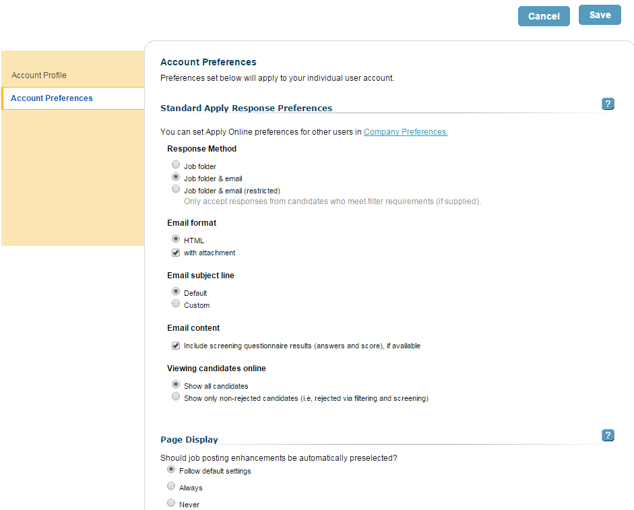

Company Settings
If the user is the account administrator, the user will be prompted to provide company profile information upon initial login to the account. If the user chooses not to enter information at that time, or needs to edit information, the Company Profile can be accessed using the Company Settings option from the Your Account menu on the navigation bar. In addition, users can update Company Preferences on this page.
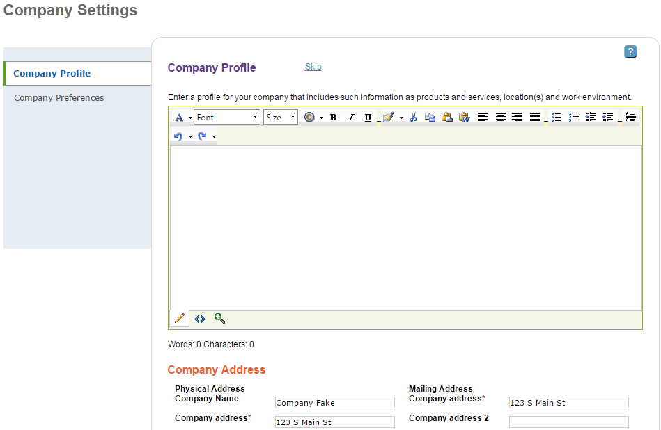
Company profile information includes a textbox to enter a company description, a section for benefits offered, and special hiring features. All of these fields are optional. The Company Description is limited to 7,000 characters, and the system provides editing tools and a spell check feature.
Selections made on the Company Preferences tab will set the preferences applied to all new user accounts. Individual account holders can change their preferences on the Account Preferences page, unless the checkbox to restrict user preferences is selected. Company Preferences include Standard Apply Response Preferences options discussed in the Account Settings section of this lesson. Company Preferences also include a Recommended Resume Delivery section allowing users to automatically send job postings to qualified job seekers and opt for resumes to be accessible in the Manage Candidates Job Folders.

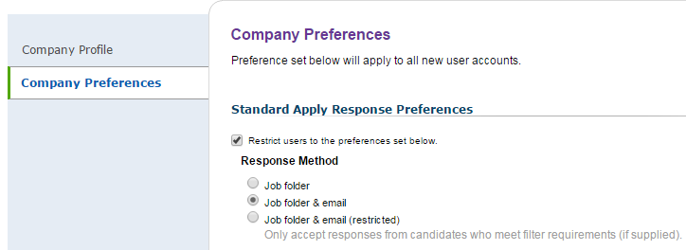

Users
The Users page displays a summary of existing accounts and allows for multiple actions to be taken. To access the Users page, click on the Users option from the Your Account menu on the navigation bar.
Using the Actions drop down list next to each account displayed, the user can:
- View/edit account information
- Copy the account
- Disable the account
- Reset the account password
- Reset the account security question
If the user selects the Copy action, the system will open a screen to edit the copied account information and provide a unique username. Note, not all of these actions may be available to users based on their assigned role. 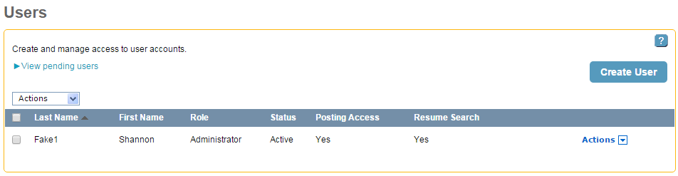
Account holders may add additional users to their account without requesting approval from account system administrators. There is no limit to the number of user accounts an employer can have. Click “Create User” to create a new user and open the Create User page shown below.
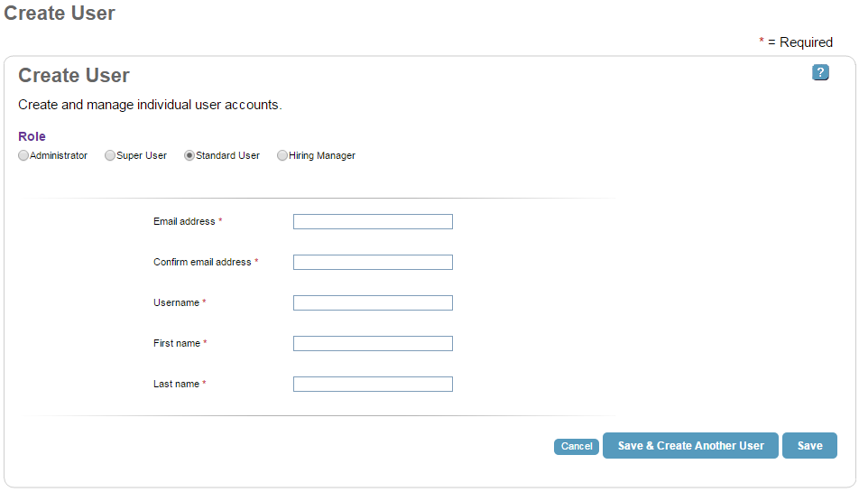
All create user fields are required:
- Email Address
- Confirm Email Address
- Username
- First Name
- Last Name
Please note that the username provided must be unique. If a username is already associated with an existing account, the system will suggest an alternative, unique username.
The role of the new user account defaults to Standard User but can be edited. Each role is granted different permission levels for performing activities in the account depending on rules established by the enterprise manager.
Users assigned the ‘Administrator’ role can:
- Create, modify, and delete users
- Administer company preferences
- Require use of Hiring Library items
- View, modify, and delete user items
- View individual and company level reports

Users assigned the ‘Super User’ role can:
- View, modify and delete user items
- View individual and company level reports
Users assigned the ‘Standard User’ role can:
- View personal and public items
- View personal reports
Users assigned the ‘Hiring Manager’ role can:
- View, rate, and add notes to assigned candidate folders

Click “Save & Create Another User” to submit the new user account information and enter additional users, or click “Save” if finished entering new users. Once the new user account information is submitted, the user is navigated back to the Users screen where the new account information is displayed in the Pending Account section until the new user logs into the account for the first time. Upon first login, the new user will create a password and security question.

Lesson 3: Job Posting
The system provides a two-step wizard to help employers post jobs. The first page of the wizard collects job details, such as job information, the job description, and company information. The second page of the wizard allows the user to select posting options, such as job post criteria and additional hiring tools.

Job Details Page
The first section on the Job Details page is Job Information. Required fields include
- Job Title
- Job Location
- Job Type
- Job Duration
The Job Title field includes a type-ahead feature that suggests job titles as text is entered. The user may select a job title from the dynamic drop down list. Job Location defaults to the U.S. and will automatically populate the City and State fields when a valid ZIP Code is entered. A link is provided to look up ZIP codes, or the user may enter the City and State directly by selecting State from the drop down list. Job Type defaults to Employee and Full Time, but other options are available from the drop down lists, including:
- Temporary/Contract
- Intern
- Seasonal
- Full Time
- Part Time
- Per Diem
Job Duration is an optional field, including:
- 1-3 days
- 4-150 days
- Over 150 days
Salary/Wage information optional and includes a minimum and maximum amount with the currency in US dollars. There is a drop down list to specify the pay interval:
- Per Year
- Per Hour
- Per Week
- Per Month
- Biweekly
- Per Day
The Other Salary Information field is optional; the user may choose to enter commissions, bonuses, etc.
The Years of Experience field is optional, and includes:
- Less than 1 year
- 1+ to 2 years
- 2+ to 5 years
- 5+ to 7 years
- 7+ to 10 years
- 10+ to 15 years
- More than 15 Years
Career Level and Education Level are also optional, with the following choices:
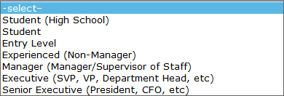
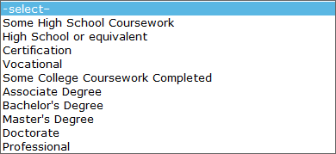
Reference Code and Number of Positions to be filled are also optional fields. The Reference Code allows users to enter a value according to organizational procedures for internal tracking purposes.

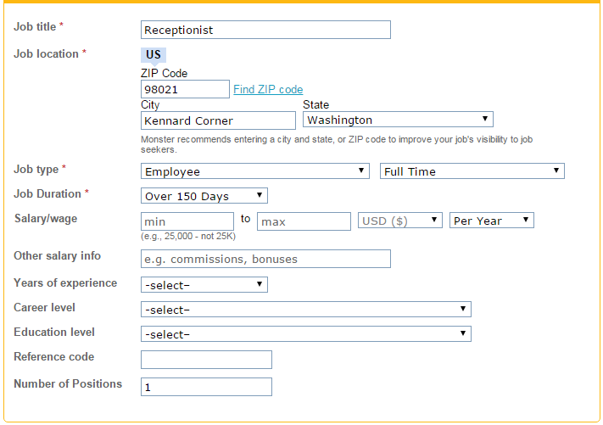
The second section of the Job Details page is the job description. Select from one of three methods to provide a job description. Two options are shortcut methods and the third option allows for text to be entered directly. A minimum of 200 characters is required for the job description.
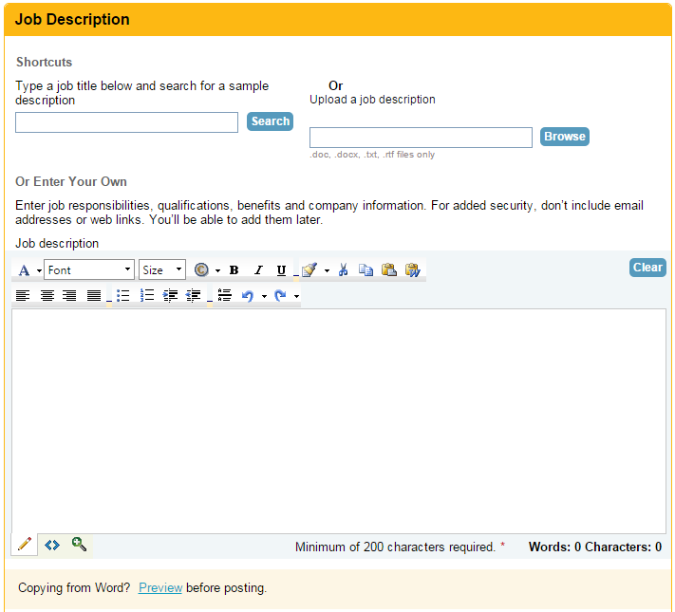
Job Description - Shortcuts
The first shortcut option is to search for an existing job description sample and enter it into the job posting wizard. Type a job title in the provided textbox and click “Search.” A list of sample descriptions will appear below the search textbox. Click on a job description link to view it in a new window and click “Use This Description” to insert the text into the field. Users can edit the sample description as needed.
The second shortcut option is to upload an existing job description from your computer/network. Click “Browse” and navigate to the file they wish to upload. The file must be in one of the following formats: .doc, .docx, .txt, or .rtf. There is no file size limitation.

Job Description - Or Enter Your Own
The third option is to use the rich text editor to type a job description manually. Text editing and formatting functions are available to customize the job description information.
Below the job description field is a “Preview” link that allows the user to preview the job description as it would appear in the job posting. If this link is clicked, a new window opens with the preview. The preview window is a snapshot in time and does not refresh if additional changes are made to the job posting. To ensure users are previewing the most recent version of the posting, close the preview window, make any necessary changes, and then click the “Preview” link again.
The next section on the Job Details page is Company Information. The Company Name field is required; however, the user has the option to check the “Keep Company Name Confidential” checkbox to hide that information from candidates. Company Industry is a required field that is pre-populated with the company’s industry from your account information, but can be modified. The Industry field offers the type-ahead feature and the user must select one of the NAICS codes from the drop down list that appears.
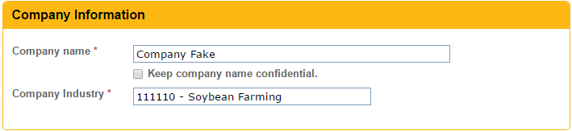
In the Apply Method section, Email Address and Contact Method are required fields. The email address will not appear in the job posting; the system will use this email address to notify the user of job seeker interest. The user is required to select at least one Contact Method, but may select more than one. The system defaults to the first option indicating applicants will apply to the job posting using the online system apply feature and will be managed through the users account. Unclicking this box will disable the online apply feature and prevent the user from adding a questionnaire to the job posting.
If applicants apply online, the “Flag Resumes When Candidates Do Not Meet Specific Criteria” checkbox is available. Use this feature to specify job application criteria (e.g., career level, minimum education, ZIP code) and the system will flag candidates who apply for the job but who do not meet the criteria. This feature is optional.
Alternatively, the user may specify a URL of their choice to direct seekers to when they apply to the job. When entering the URL, users must include “http://” at the beginning.
Finally, users have the option of having applicants apply by contacting them directly. If this is selected, options will appear for email, phone, fax, and mail. The user will be required to provide contact information for the options selected.
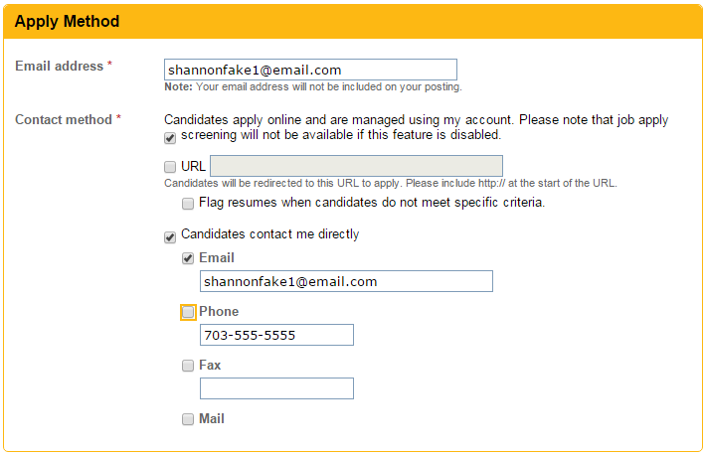
The Additional Information section allows the user to enter further descriptions of the job posting. This section is optional.
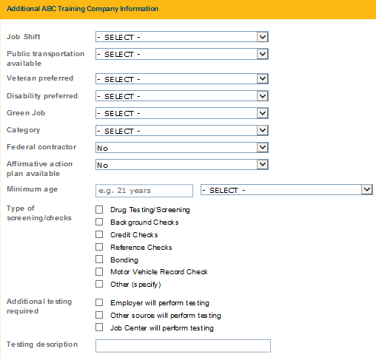
At the bottom of the Jobs Details page, click the icon of the magnifying glass over the document, or on the “Job Posting” link, to open a new window with a preview of how the job posting will appear in its current state. The browser window is a snapshot in time and does not refresh if additional changes are made to the job posting. To ensure users are previewing the most recent version, close any open preview window, make the necessary changes, and then click the “Job Posting” link again.
Users have the option of saving a job posting as a template that can be used in future postings. This action saves time if posting a similar position in the future. To save a posting as a template, click the “Save Job to Hiring Library” checkbox. If selected, an option appears to mark the job template as private (i.e., the template is not accessible to non-administrative users). Users can access and manage saved templates, including job postings, cover letters, and questionnaires, from the Hiring Library. For more information about the Hiring Library, see lesson 6.
When finished, click “Continue” or the “Save for Later” link. Clicking “Continue” will save information on the Job Details page and take the user to the Posting Options page to complete the job posting. The “Save for Later” link preserves the work on the current job posting and will take the user to the Manage Job Postings page. The user may then return at a late time to complete the job posting.
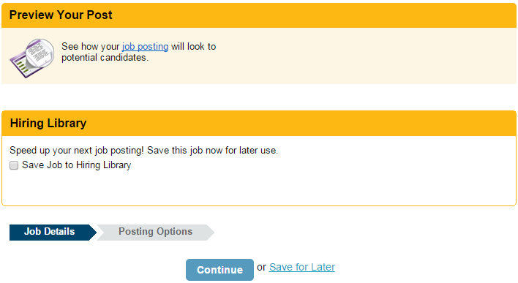

Posting Options Page
All fields in the Job Search Criteria section are required. Search Location and Search Occupation directly impact results when seekers search for jobs. Search Location will auto-populate based on information entered on the Job Details page, but can be edited if necessary. Search Occupation may also auto-populate based on information entered on the Job Details page, but can be edited if necessary.
Posting Date defaults to the current date but can be edited by clicking on the calendar icon and selecting a future date. Expiration Date defaults to 60 days after the posting date but can be edited similarly.
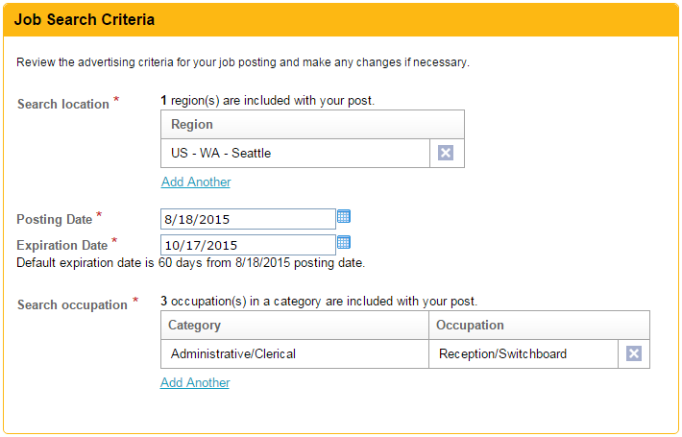
There are multiple methods to add Search Occupations that will match job postings with job candidate searches. The Search Occupation field contains a type-ahead feature that suggests occupations as text is typed in the box. Select an occupation from the dynamic drop down list and click “Add.” Alternatively, click the “Browse List” link to select search occupations from a categorized list that appears in a pop up window.
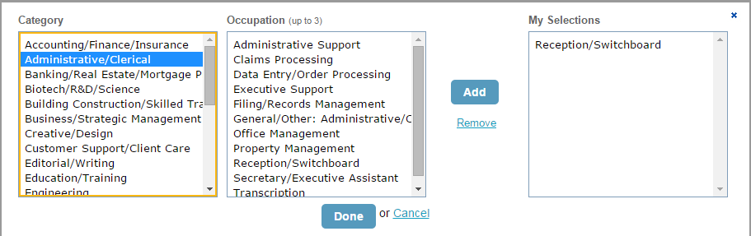
After Search Location and Search Occupation information is added, they will appear on the Posting Options page and can be deleted by clicking “X.”
The Additional Hiring Tools section will only appear if candidates are allowed to apply online, which can be managed in the Contact Information section on the Job Details page. The “Screening” checkbox provides the user with an opportunity to add a questionnaire to the job posting. Applicants will respond to the questionnaire as part of the application to supplement qualification evaluations. Screening questionnaires are discussed further on the next page and in lesson 6.
The “Auto-Reply Letter” checkbox automatically sends a reply letter to any seeker who applies to the posting.
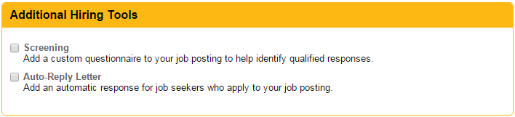
Note, if additional hiring tools are selected, the user is navigated to the Screening Questionnaires page or Letters page after clicking “Post Job Now” to select the specific tool desired. If additional hiring tools were not selected, clicking “Post Job Now” will post the job and display a confirmation page.

Screening Questionnaire
If the user selects the “Screening” checkbox to add a questionnaire to the job posting, the user will have the option to create a new questionnaire or choose an existing questionnaire. For more information on how to create a new questionnaire, see lesson 6.
Select Use a Saved Questionnaire to choose from questionnaires stored in the Hiring Library (via the Questionnaires tab). Alternatively, select a sample questionnaire from the Washington ESD Questionnaires tab. The Use a Saved Questionnaire view defaults to Washington ESD Questionnaires that are recommended based on the information in the job posting. To view all existing questionnaires or questionnaires for a specific industry, make the selection of your choice from the View drop down list.
Click “Go Back” to modify previous sections of the job posting process. Click “Save for Later” to save the job posting and selected questionnaire for future completion. Click “Skip” to continue with the job posting without using a questionnaire. Click “Continue” to view and edit the selected questionnaire, if desired. Click “Continue” again to save the questionnaire information and post the job; the job posting is immediately available to job seekers.
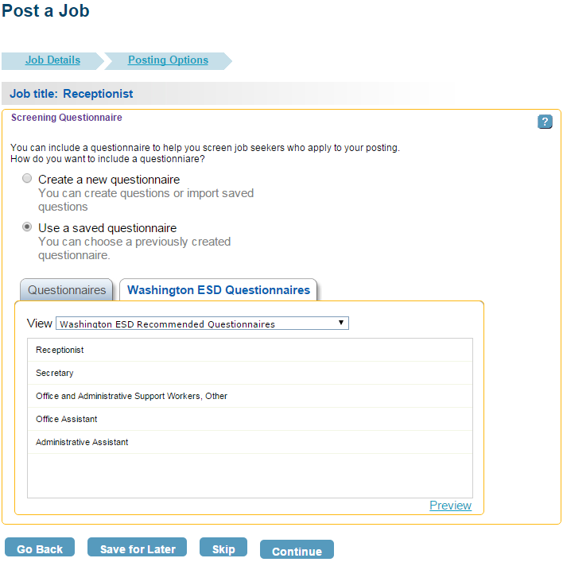
Once the job is posted, the system will display a confirmation page which includes a unique ID number, the search area, and the search category for the job posting, in addition to links for other job tools (e.g., manage jobs, post another job). The system-assigned ID number helps to identify the posting and keep track of all activity related to that posting. Also, the system will recommend resumes that match the job posting, if available, and will save them in the job’s candidate folder accessible from the Manage Candidates page.
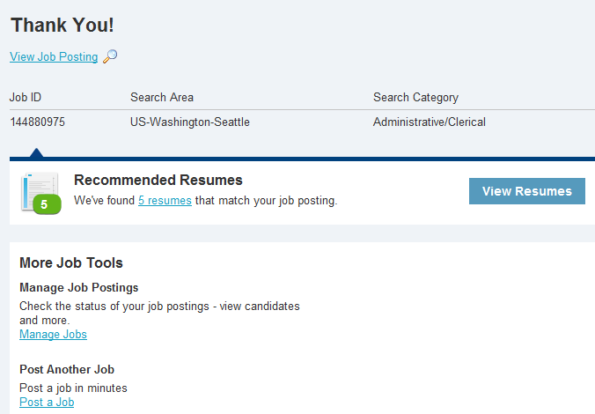

Hands-on Activity – Post a Job

Use the Job Post wizard to post a job for a position of your choice:
- Enter information into all required fields.
- In the Job Description section, either type your own short narrative in the box provided or insert a sample job description using the Search shortcut.
- Save the job to the Hiring Library.
- Add an existing Questionnaire to the job posting.
- Preview your post.

Manage Job Postings
Access the Manage Job Postings page by selecting the Manage Job Postings option from the Jobs menu on the navigation bar. Alternatively, click the “View All” link on the job postings summary section of the dashboard.
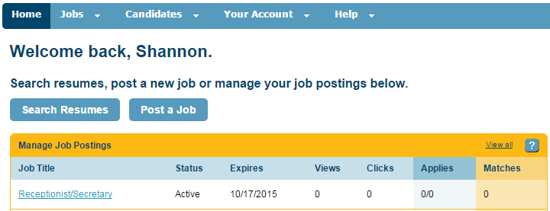
The Manage Job Postings page defaults to displaying a summary of all active jobs. The summary includes highlights of the type of job posting as well as tracked information (e.g., number of views, clicks, online applications). Views refers to the number of times seekers have viewed the job posting and Clicks refers to the number of times seekers have clicked on any of the action links within the job view, such as save, share, etc.
The side-bar on the left side of the screen allows the user to modify which postings are displayed on the screen. Under View, users select which types of job postings they want to see:
- Incomplete
- Pending
- Active
- Expired
- Archived
They can also choose to see postings from different users on the account with the User drop down menu. In the Edit Filters section of the side-bar, users can filter postings by date modified, Reference Code, or Job ID number.
Users can take multiple actions to manage job postings in their account. For active postings, select an option from the Actions drop down menu next to each posting, including:
- Edit
- Renew
- Copy
- Expire
- Archive
- Preview
For incomplete postings, edit or delete the posting. For archived postings, edit, renew or copy the posting. Users can also click the job posting name or ID link to view the job and click “Edit” to make edits.
Click the checkbox next to each job posting for multiple postings and use the “Select” drop down menu to execute bulk actions.
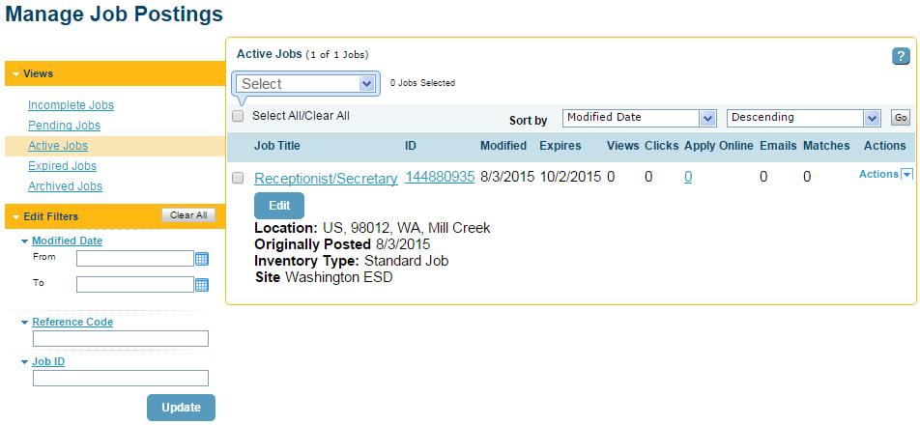

Lesson 4: Resume Search
There are a number of options to launch the Search Resumes function. On the employer dashboard, users may choose the Search Resumes option from the Candidates menu on the navigation bar or click “Search resumes” from the dashboard.
It is recommended that initial resume searches be broad to include a wide audience. Enter information into a limited number of search fields (described below). Then refine the search criteria to narrow the candidate pool, as needed. One method to refine the search criteria is to review the Candidate Details from the preliminary search to generate ideas for additional search criteria, such as skills.
At the top of the Search Criteria screen, users have the option to search resumes from one of two sources. The first source pulls candidates from the web (i.e., Monster.com); the second source is a database maintained by Washington in support of WorkSourceWA.com.
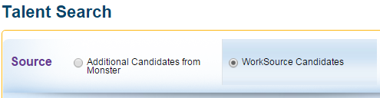
Basic Search
The Basic Search provides a simple set of search criteria for searching resumes. Enter basic information to quickly initiate a search.
Job Title
As the user enters characters for a job title, a type-ahead feature produces a drop down list of existing job titles from which to choose. Selecting a job title from the dynamic drop down list is recommended, but not required. Alternatively, complete typing a job title of their choice.
Years of Experience
The user has multiple options for typing in the desired years of experience. Entering a discrete number of years will attempt to match resumes with that number exactly. Entering numbers separated by a hyphen will search for years within the range (including the bounds). An upper bound can be specified by using a “<” prefix (e.g., “<8”), and a lower bound can be specified by entering “+” after the number (e.g., “2+).

Nice to Have versus Required
This feature appears on a subset of search criteria fields. If the “Nice to Have” icon is shown, resumes that comply with the associated criteria are sorted to appear first in the search results list. Click this icon to toggle to the “Required” option and show only resumes meeting the associated criteria in the search results. For a basic search, the Years of Experience and the Skills/Keywords fields utilize this toggle icon feature.
Location
This field allows the user to order or limit results to candidates near a specified location. Location may be specified as a State, City or ZIP code, and this field includes a type-ahead feature. The drop down list to the right of location allows the user to specify a range (e.g., within 50 miles), and a checkbox is provided to limit search results to candidates who are authorized to work in the specified location.
Skills/Keywords
These fields allow the user to order or limit the search results to specific criteria. The type-ahead feature provides the user with common keywords linked to resumes in the database. The “Add Another Skill or Keyword” link creates additional fields if more than three Skills/Keywords are necessary.
Language Proficiency
This field stipulates a language and associated proficiency level. Proficiencies of Beginner, Intermediate, Advanced, and Fluent can be specified.
Resumes Updates
This field allows users to limit the search criteria to resumes that have been updated after the specified date. Options in the drop down list include multiple choices for ranges in days, weeks, and months. If you do not want to limit the search criteria for this field, select All Resumes.
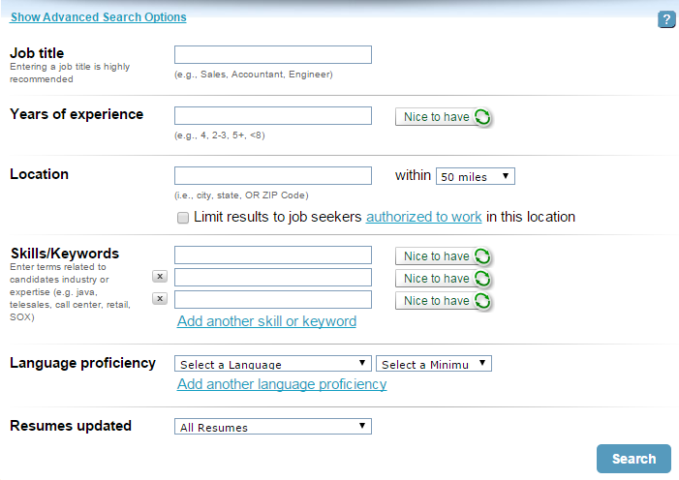

Advanced Search
If additional search criteria are needed beyond the Basic Search, click on the “Show Advanced Search Options” link. The resume search page will expand to include the fields described below.
Education
This field allows the user to specify a Minimum Education Level from a drop down list as well as a Degree/Major. The Degree/Major field allows the user to select “Nice to Have” or “Required.”

School
The field allows the user to limit or order the results by adding specific schools in the resume search criteria.

Company
This field allows the user to limit or order the results by adding specific company names in the resume search criteria.
Candidate Name
This field allows the user to search for a specific candidate when their name is known.
Job Type
This option allows users to filter search results by applicant’s job type preference. Options include Per Diem, Temporary/Contract, Seasonal, Permanent, Full Time, Intern, Part Time, and Casual.

Job Duration
This field provides a drop down list of job durations in increments of years. Use this to select a desired average tenure.

Willing to Travel
This field provides a drop down list of percentages in 25% increments representing the amount of time candidates are willing to travel for work. Users can also select “No travel required.”
Relocation
This field is a checkbox that limits search results to candidates who are willing to relocate.

Security Clearance
This option allows users to filter search results by applicant’s security clearance status. Options include Active Confidential, Active Secret, Active Top Secret, Active Top Secret/TCI, Active TS/SCI-CI Polygraph, Active TS/SCI-FS Polygraph, Inactive Clearance, and Other Active Clearance.

Veterans Preference
This field is a checkbox that allows users to restrict results to only candidates that have priority of service status (veterans).
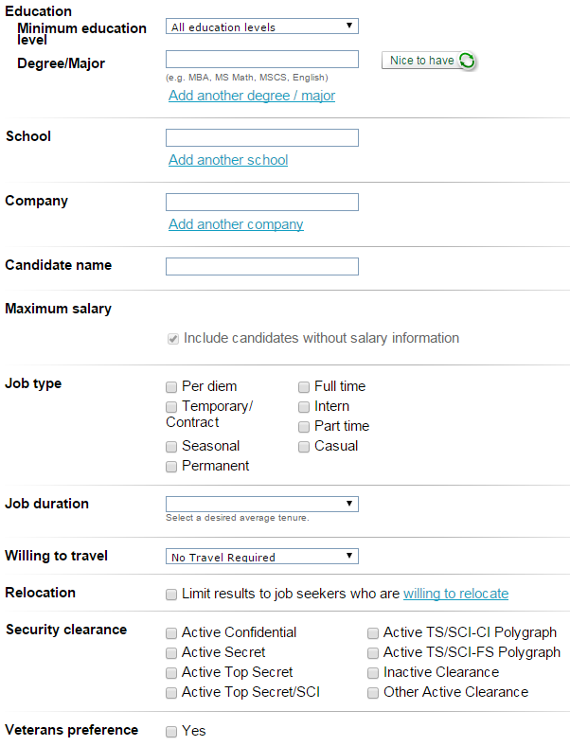
Search Criteria Example
The search example shown below is based on the following criteria:
- At least three years of experience as a receptionist is required
- Any Location
- Telephone Skills are required
- Experience with Microsoft Excel and Travel Planning is preferred
- Any Language proficiency
- All resumes will be searched regardless of last date revised
Enter the criteria into the basic search fields as shown and click “Search.”
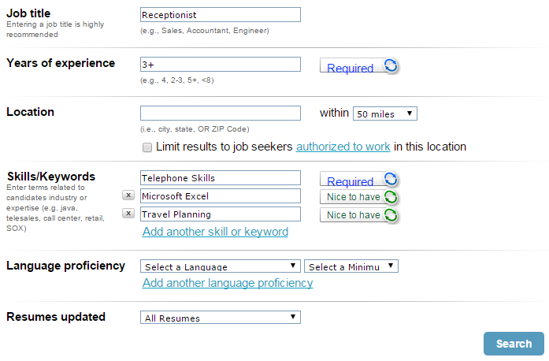

Resume Search Results
The resume search functionality will return a list of candidates that match the search criteria. The system will indicate at the top of the page the number of candidates on the list. The active Search Criteria is shown on the left portion of the screen, which can be revised and resubmitted to broaden or narrow the results list.
Each candidate receives a match score. The match score is calculated by a proprietary algorithm that matches the specified criteria with resume content. Match scores range from 0-10, where higher scores indicate a better match.
When Veterans from the Monster resume database appear in the search results, a red and blue icon () is shown to the right of each candidate’s name. For candidates in the WorkSource database, a yellow icon () appears to the left of the candidate’s name to identify Veteran status.
The Search Results page shows a summary of each candidate’s information. Links are provided on the right side of each candidate summary for the user to perform candidate actions:
- Add to Folder
- Block Candidate
- View Candidate
These options allow users to save and organize collections of candidates, remove candidates from future search results, and view detailed candidate information.
Users can also select the check box next to a candidate’s name and perform the same actions using the drop down box at the top of the search results page. Bulk actions for multiple candidates can also be performed this way.
The “View Candidate” and “Add to Folder” links are described in the next section.
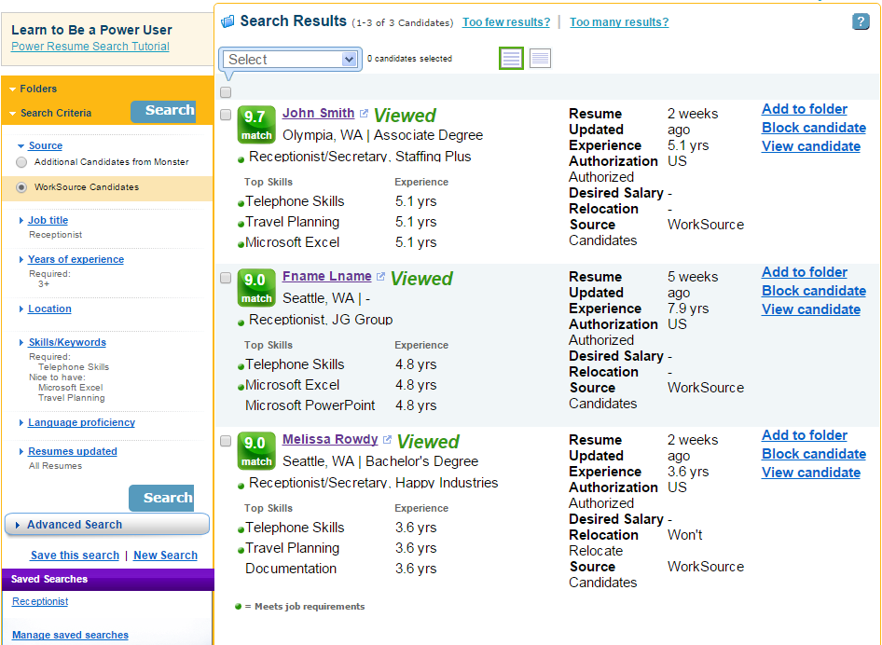

View Candidate
By clicking on a candidate’s name, or the “View Candidate” link, users can view additional details about the candidate.
On the Resume tab, review the complete resume posted by the candidate. Please note that the screenshot below shows a partial view of the candidate’s resume. Words in the resume that match the search criteria are highlighted in yellow. The Candidate Detail tab shows a summary of the candidate’s Experience/Work History, Education, and Skills, when available. The Additional Info tab shows additional information provided by the candidate, such as career information and target job. The Activities tab shows actions that have been performed on the candidate, such as saving the candidate’s resume in a folder. The Activities tab will only appear when actions have been performed on the candidate.
Return to the list of search results by clicking the “Back to Search Results” link at the bottom of the Candidate Detail page.
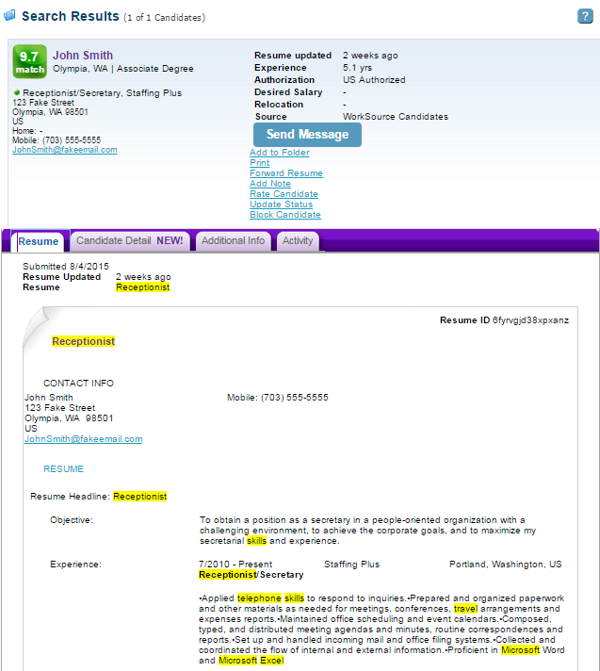

Add Candidate to Folder
The “Add to folder” link on the Resume Search Results page will save the selected candidate in the folder of your choice.
In the Add to Folder window, navigate to an existing folder or create a new folder to organize saved candidates. Folders can be managed from the Manage Candidates page. For more information about the folders, see lesson 5.
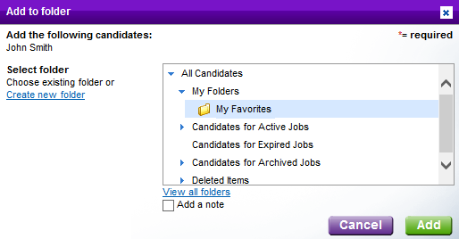

Save Resume Search
Initiate a new search or save the current search by using the links at the bottom of the search criteria side-bar. When the “Save This Search” link is clicked, the Saved Search window opens.
The Name field is required and uniquely identifies this set of search criteria from others. The Send Email Results options are viewable using a drop down list:
- Daily
- Weekly
- Bi-Weekly
- Monthly
- Never
The system will automatically run the saved search and notify users of the results via email based on the frequency selected in this field. Results are sent to the address entered in the Email Address field. Click “Save” to save the search. Saved searches appear under the Saved Searches section at the bottom of the Search Criteria side-bar on the Resume Results page as well as on the Dashboard.
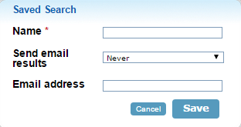

Manage Saved Searches
By clicking Saved Searches from the Candidates menu in the navigation bar, users are able to view and manage saved searches. Click the name of the search, which is an active link, to run the search and view the search criteria. Alternatively, select the Run Search option from the Actions drop down list. The Actions drop down list also allows the user to edit or delete the saved search. Click “Create Saved Search” to set the search resume criteria and save-search options in the same step.
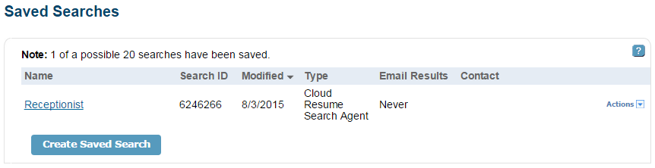

Hands-On Activity – Search Resumes

Use the resume search feature to find potential candidates for an Accounting Clerk position:
- Perform a Basic Search to find candidate resumes, using job title and years of experience.
- Update your search criteria to narrow or expand your search results, by changing the source, adding/removing search criteria, and/or changing the “nice-to-have/required” toggle.
- Save your final job search.
- Save candidates to a folder.

Lesson 5: Manage Candidates
Manage folders and saved candidates by selecting the Manage Candidates option from the Candidates menu on the navigation bar. When selected, users will be directed to the Manage Folders page.
Alternatively, links are provided in the Candidate Folders summary section on the dashboard. The “View/Manage” link will navigate to the Manage Folders page, or click the number link under Total to navigate to a specific folder and view candidates.
With this feature, users manage candidate folders, customize the screen display for viewing folders and candidates, and manage candidates within folders. Each of these activities is described in this lesson.
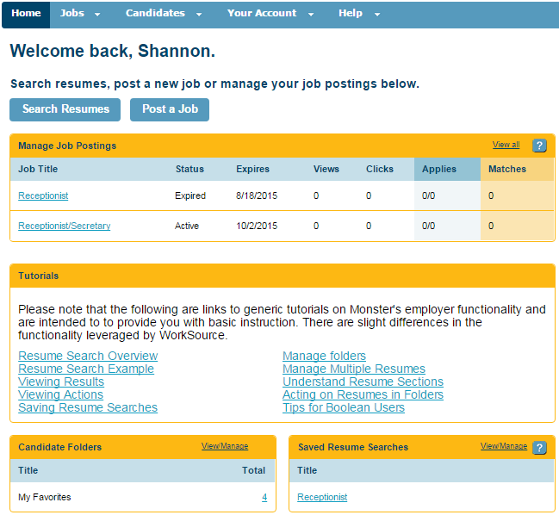

Manage Candidate Folders
There are a number of actions users can take to manage candidate folders. Grayed options on the navigation bar (i.e., View Candidates, Create New Folder, Rename, Share/Edit, and More Actions) indicate they are inactive. When a folder is selected (by clicking the radio button next to the folder title) additional options become active and change from grey to blue.
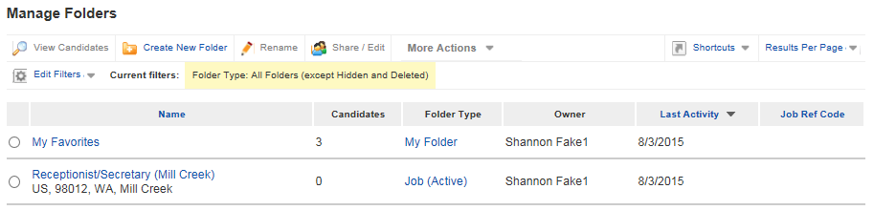
The “View Candidates” link displays all the candidates in the selected folders. Alternatively, click the name of the folder to only view candidates in that folder.
The “More Actions” menu on the navigation bar provides the user with the opportunity to reassign members of a folder to another user account, delete a folder, or undo a previous action.
The “Shortcuts” link provides users with an opportunity to view collections of candidates grouped by system defined properties (e.g., View Candidates in the Last 60 Days, In Active Jobs, In Pending Jobs, In Expired Jobs, In Archived Jobs).
The “Edit Filters” link provides options to filter the display of folders based on Folder Type, Folder Name, User Account, Job Reference Code, and a date range of activities.
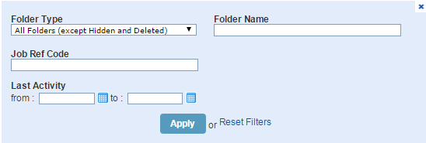
The “Create New Folder” link opens a dialog box to enter the name of a new folder. The “Rename” link opens a dialog box to alter the name of an existing folder.

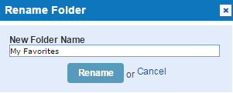
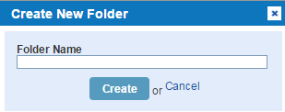

Display Candidates in Folders
When viewing the list of candidates within a folder, users can edit the screen display by using the Results View, Sort by, and Edit filter options.
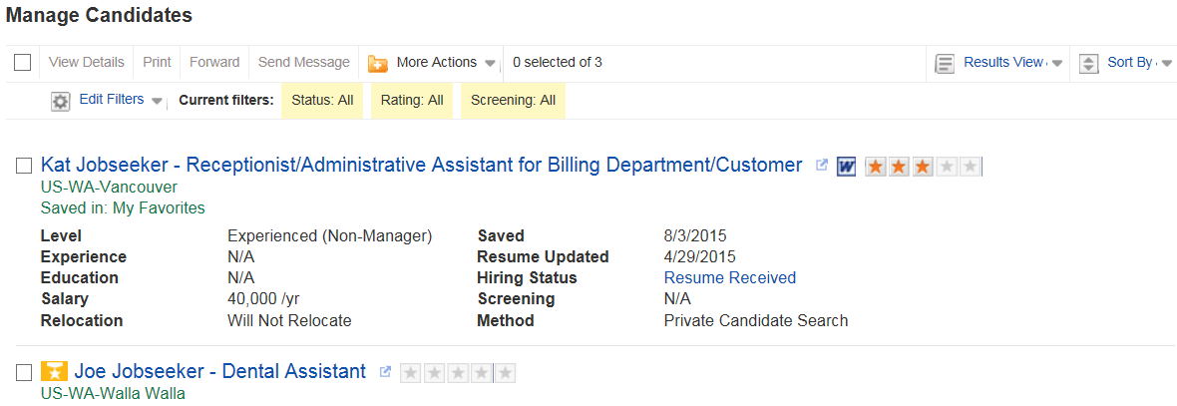
The “Results View” link allows the user to select either “single-line” or “multi-line” (default) to display candidate information. Single-line display allows the user to view more candidates at one time, but less detailed information.
Multi-line Display Example:
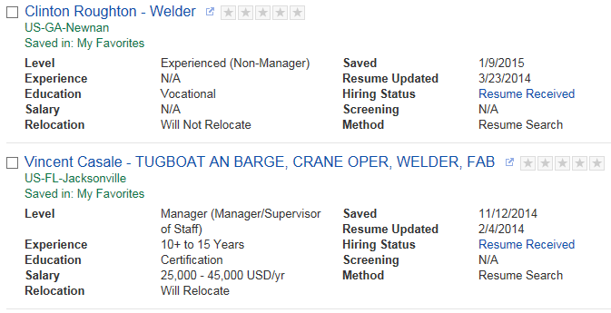

Single-line Display Example:
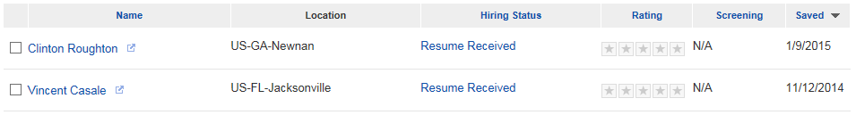
The “Sort By” link allows users to sort the contents of a folder in ascending or descending order based on the following criteria: Date Saved, Name, Method, Screening Score, Rating, and Hiring Status.
The “Edit Filters” link allows users to filter candidates in a folder by Rating, Screening Score, Hiring Status, or date (range) the candidate was saved.

Manage Candidates
There are a number of actions users can take to manage saved candidates in a folder. The first four actions on the Manage Candidates navigation bar (i.e., View Details, Print, Forward, and Send Message) are inactive until a candidate is selected using the checkbox next to the candidate’s name. When the links are active, the color will change from gray to blue.
The “View Details” link will navigate to the candidate’s details (e.g., resume) view. Alternatively, click on the candidate’s name.
The “Print” link opens a separate window to connect to a printer of your choice and specify printing preferences.
The “Forward” link opens a separate window which allows the user to send candidate information to a coworker. The Forward Resumes page shows the name of the selected candidates and provides two options for privacy settings:
- Viewable Company-Wide
- Private
If the user selects Viewable Company-Wide, the forward activity is viewable to all users on the company account, whereas the Private option will only display the action on the user’s individual account when looking at the candidate information.
To forward a candidate, provide the receiver’s email address, a subject, and a message (limited to 7,000 characters). Email addresses can be entered manually or selected from the user’s address book. The system conveniently provides a “Save to Address Book” checkbox if the email address is not already saved. In addition, click on the “Address Book” link to access and manage contact information.
The “Save Message as a Note” checkbox allows users to save the contents of the typed message as a note, which is accessible when viewing the saved candidate information. Once the fields on the page are complete, click “Send” to forward the resume.
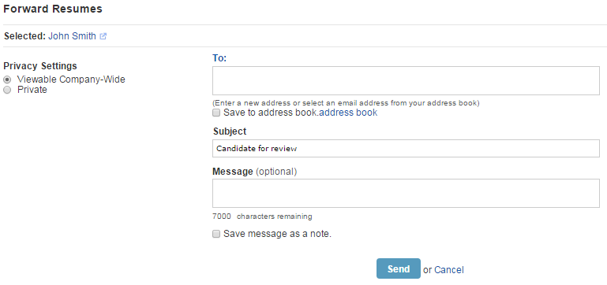
The “Send Message” link opens a new window from which the user may send the candidate an email message. The window prompts users to enter a subject for the email and a message.
Users have the option of typing directly into the Subject and Message fields or using a template. To use a template, select the template name from the Letter Template drop down list. This will populate the text fields with template information, which is then available for editing. A spell check feature is provided. Also, the user may print the message using the Printer icon.
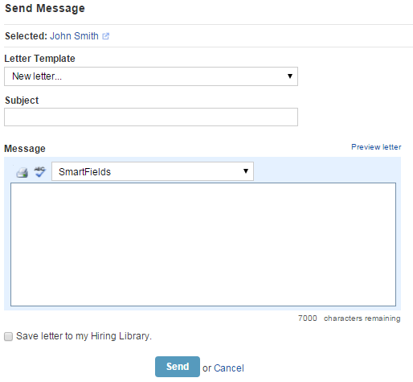
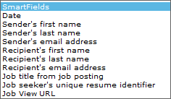
The smart field feature automatically inserts unique information in the message, such as the recipient’s name, so users are not required to edit these details for each email sent. To insert a smart field into the email message, navigate to the desired section of the message and select the option from the drop down list (shown left).
To preview the final letter with the smart fields activated, click the “Preview Letter” link.
The Save the Letter to My Hiring Library option saves the message in letter format so it can be used for future communications. Saved letters are managed through the Hiring Library described in lesson 6.

More Actions
From the More Actions drop menu, users can perform a number of activities to manage candidates.
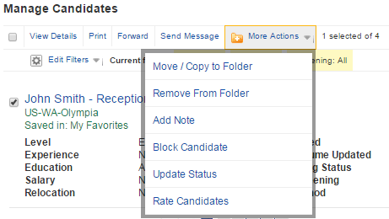
The Move/Copy to Folder action allows users to add the candidate to additional folders, or move the candidate to a new folder.
The Remove From Folder action allows users to delete the saved candidate from the folder. The candidate will no longer be saved; however, the candidate may appear in future resume searches.
The Add Note action allows users to enter a comment in a text field that will be viewable in the candidate’s details.
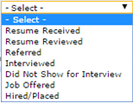
The Block Candidate action will prevent the candidate from appearing in future searches. The candidate’s name will be displayed in a strike-through font without the candidate summary when viewing candidates in the folder.
The Update Status action allows users to track status activities for the candidate. The following options are available from the drop down list (shown right).

The Rate Candidate action allows uses to enter a rating on a 5-point scale to indicate the user’s opinion of the candidate’s qualifications. Ratings are displayed as stars next to the candidate’s name.

Hands-On Activity – Manage Candidates

Navigate to the Manage Folders page to view and manage folders and candidates:
- Create a new folder and move candidates into the new folder.
- Adjust the folder/candidate display by using the “Sort by” and/or “Edit Filters” menus.
- Take actions to manage candidates, such as updating their status, adding a note, or rating the candidate.

Lesson 6: Hiring Library
In the Hiring Library, users create and manage:
- Job posting templates,
- Letters to job seekers, and
- Screening questionnaires to evaluate applicant qualifications during the application process.
To access the Hiring Library, from employee dashboard select Hiring Library from the Your Account menu on the navigation bar.

Job Information
The Hiring Library defaults to the Jobs page. This page displays a summary listing of all current job templates. Any jobs saved to the Hiring Library through the job posting wizard will be included in this list. Click on the “Name” link for a job template to view details of the template or use the Actions drop down list to edit, copy, or delete the template.
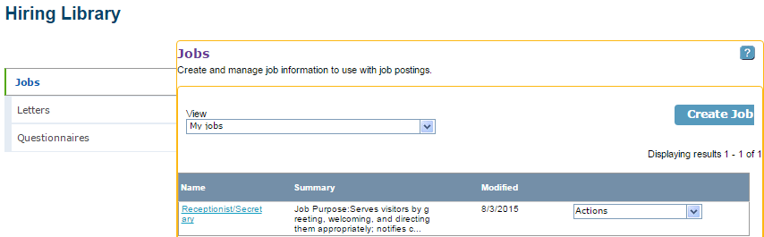

Create a Jobs Template
To create a new jobs template, click “Create Job” from the Jobs page of the Hiring Library. This will open the Create Job screen and allow users to enter a template name and a summary, for reference purposes. If the template is used to post a job, the candidates will not see the name and summary information.

The create job screen also includes fields to enter all the job detail information included in the first step of the job posting wizard (lesson 3). Once all required fields are completed, the template can be saved for future use.
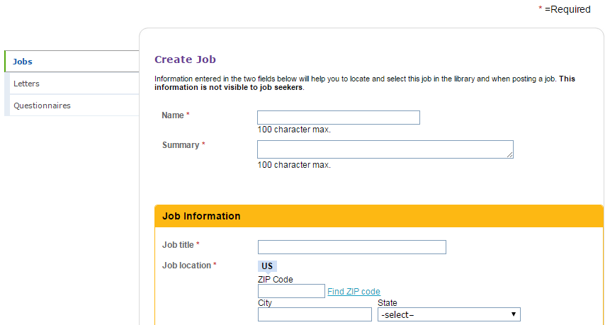

Apply a Jobs Template
To use a job template to create a new job posting, follow the steps described in lesson 3 to open the job posting wizard. At the top of the page, above the Job Information section, the system will provide an option for selecting a template and users may select the template by name from the drop down list (see screenshot below). This will automatically complete the Job Details page with template information that can be edited to fit the position.

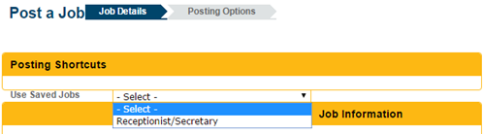

Letters
The Letters page in the Hiring Library allows users to create and manage letters to send to job seekers. This page displays a summary listing of all current saved letters. Any letters created and saved to the Hiring Library through the job posting wizard will be included in this list. Similarly, email messages using the Send Message feature saved to the Hiring Library will be included in this list. Hover the cursor over the “View” link next to the name of the letter to show a preview or use the Actions drop down list to edit, copy, or delete letters.

Select from letters created in the user’s account or public letters created by other users, if available, by using the View drop down list and selecting My Letters or All Letters.
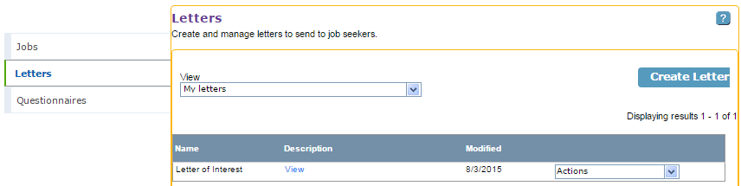

Create a Letter
To create a new letter in the Hiring Library, click “Create Letter” on the Letters page. Users must enter a name for the letter, a subject for the letter, and a body. The description field is optional. Note that only the Subject and Body fields will be viewable by the letter recipient. The Name and Description fields will assist the user in locating the appropriate letter in the future.

When creating the body of the letter, a spell check feature is provided. Also, the user may print the letter using the Print icon.
The smart field feature automatically inserts unique information in the letter, such as the recipient’s name, so users are not required to edit these details for each letter sent. To insert a smart field into the text of the letter, navigate to the desired section of the letter and select the option from the drop down list:

To preview the letter with the smart fields activated, click the “Preview Letter” link.
Once all required information is entered, click “Save” to save the letter in the Hiring Library. It will then be available for future use. Click “Cancel” to terminate the letter creation process.
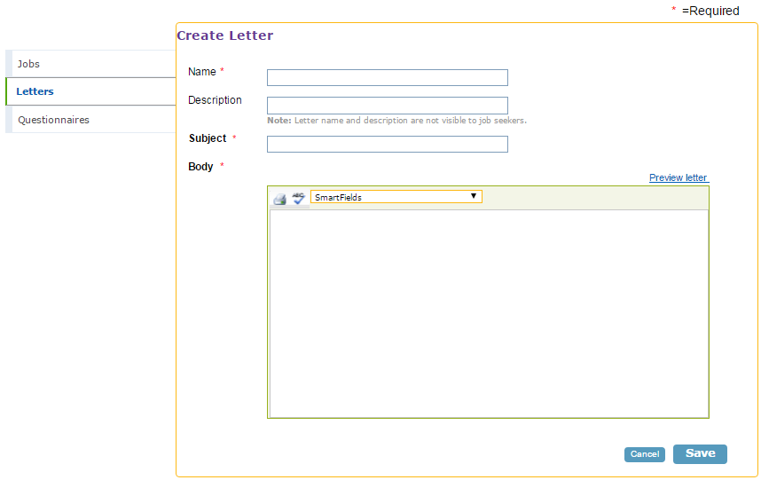

Questionnaires
The Questionnaires page in the Hiring Library allows users to create and manage questionnaires that job seekers will complete when applying to jobs. Questionnaires are used to gather additional information about candidates’ job qualifications. The Questionnaires page displays a summary listing of all current saved questionnaires. Any questionnaires created and saved to the Hiring Library through the job posting wizard will be viewable here.

The Questionnaires tab shows questionnaires created by users on the account. The Washington ESD Questionnaires tab shows existing questionnaires for different types of jobs the user can select and edit. Click on the name of the questionnaire in the list to view it or select “view” from the Actions drop down list. Additional user actions from the drop down list include edit, copy, and delete for user created Questionnaires. For Washington ESD Questionnaires, user actions only include view and copy.
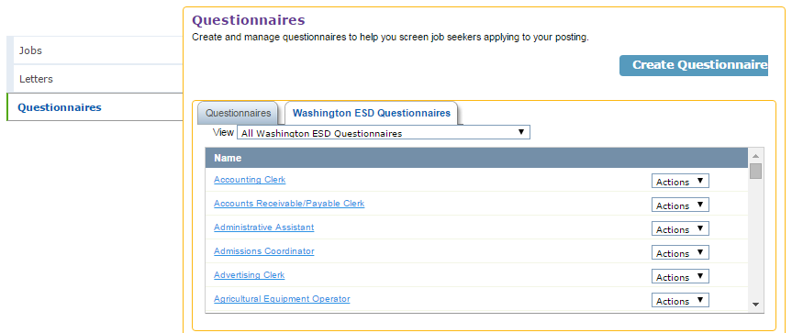

Create a Questionnaire
To create a new questionnaire, click “Create Questionnaire.” Users are required to enter a questionnaire name and have the option to add an introduction to summarize the content and purpose of the questionnaire. There are two options for building questions: create new questions or select from existing questions to import into the questionnaire.
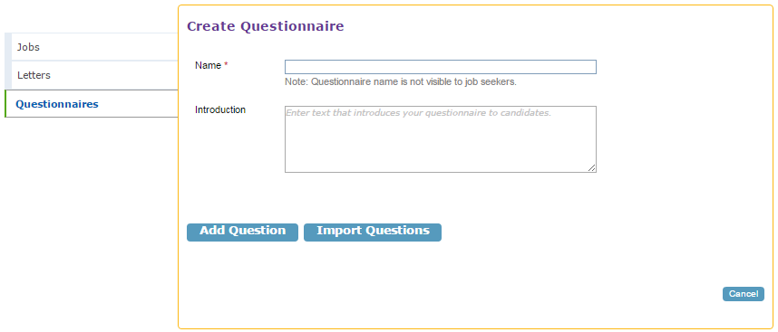
To select an existing question, click “Import Questions.” The system will open the Import Question(s) window and display a list of questionnaires to choose from. Click the link for the desired questionnaire and scroll down to the bottom of the window to select the questions to import. Click the “Select All” checkbox to select all questions for import or click the checkbox next to individual questions. Click “Import” to insert existing questions in the new questionnaire.

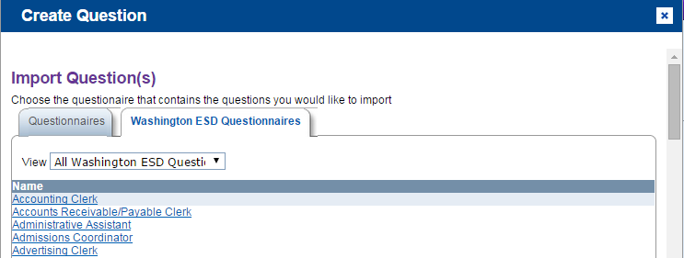
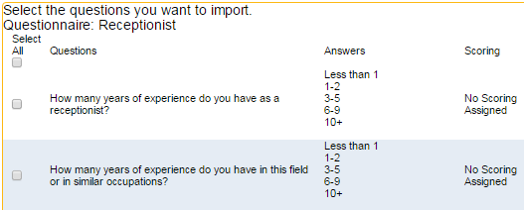
To create a new question, click “Add Question.” Enter the text of the question in the Question field. To require an applicant to respond to the question during the application process, click the “Required Question” checkbox.
The Type of Question field defaults to Multiple Choice. For Multiple Choice questions, applicants select their response from a list of choices. For Yes/No questions, applicants select either “yes” or “no” when responding to the question. For Text questions, the applicant is provided with a textbox to type a narrative response to the question.
The Answer Choice section allows users to enter customized choices for multiple choice questions. The system default displays fields for four (4) choices; however, additional choices can be added by clicking the “Add More Answer Choices” link. Click the “Allow Candidates to Select More Than One Response” checkbox to allow applicants to select all choices that apply to them when answering the question, as opposed to being limited to selecting the single, best choice. If Yes/No is selected for the type of question, the Answer Choices section will dynamically update to show a “yes” and “no” option. If Text is selected, the Answer Choices section will be replaced by a sample textbox in which candidates will type their answers. Scoring is not available for Text responses.
The Answer Choice section also allows users to assign a score to each choice by clicking the “Assign a Score to Each Answer” checkbox. Uncheck this box if system-generated scores will not be used. To assign scores to choices, select a score option from the drop down list next to each choice, including:
- Auto-Reject
- Neutral
- Better
- Best
Click “Save” to save the question. When saved, the question appears in the Start of Questionnaire section. To add additional questions, repeat the steps above by clicking “Add Question” or “Import Questions.”
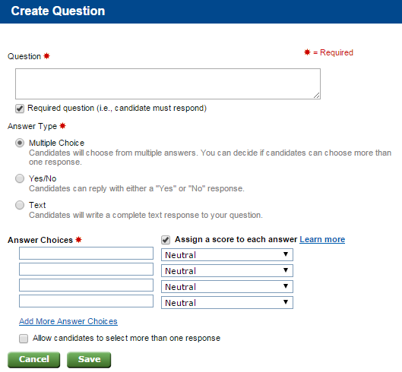
As questions are added to the questionnaire, the system will display a summary of each question in the questionnaire and allow users to take multiple actions.
From the drop down list to the right of each question, select Edit, Copy, or Delete to perform those actions. Users can also move the question up or down in the display order of the questionnaire. Alternatively, click on the question’s link (blue text in the Question column on the screen) to view and edit question fields.
A “Preview” link is provided to view the questionnaire in the format the applicants will see. The system will open a new viewing window to preview the questionnaire when this link is clicked. Also, the “Spell Check” link is provided to spell check question text.
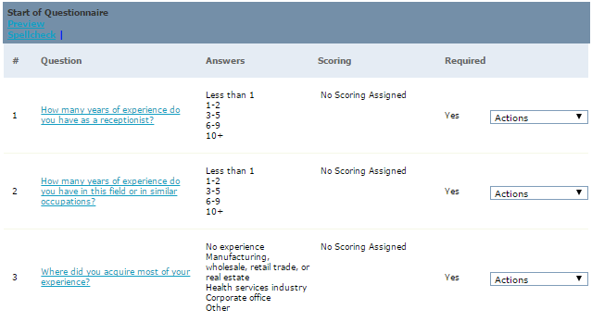

Auto-Reply Letter
At the bottom of the Create Questionnaire screen, the system allows users to specify a letter to send to all job applicants after they complete the questionnaire. Users can send the same letter to all candidates, choose different letters to send candidates based on their responses to the questionnaire, or choose not to send reply letters. Saved letters can be used or users may choose to develop a new letter. Use the drop down lists to select from saved letters and the Preview and Edit links to perform selected actions. Click the “Create New” link to write a new letter.
After all questionnaire information and options have been completed, click “Save Questionnaire” to save the questionnaire to the Hiring Library.
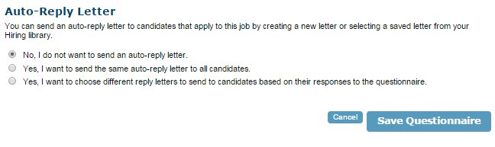

Hands-On Activity – Create Templates

Navigate to the Hiring Library page and complete the following activities.
- View and edit the Job Template you created in Lesson 3.
- Create a Letter that could be sent to applicants. Use the SmartFields functionality and preview the finished letter.
- Create a Questionnaire for a position of your choice by importing existing questions and creating new questions.

