Topaz Pens – How to use in IE Mode
History: Topaz pens have not been working since the sunset of IE and are not compatible with Chrome or Microsoft (MS) Edge browsers. As a result, staff have not been able to collect signatures in ETO.
What’s New: by running MS Edge in “IE Mode" staff can successfully use their Topaz pens to collect signatures.
Follow the instructions below to change your settings.
Note: Per Microsoft guidelines, changing these settings will only work for 30 days at a time. You will have to redo this process every 30 days. It may be helpful to add a reminder to your calendar to prevent it from expiring.
Note: This will NOT work in Chrome
How to change your settings:
- logout of ETO before starting this process
- From your MS Edge browser, click the three dots to display the menu, and select Settings
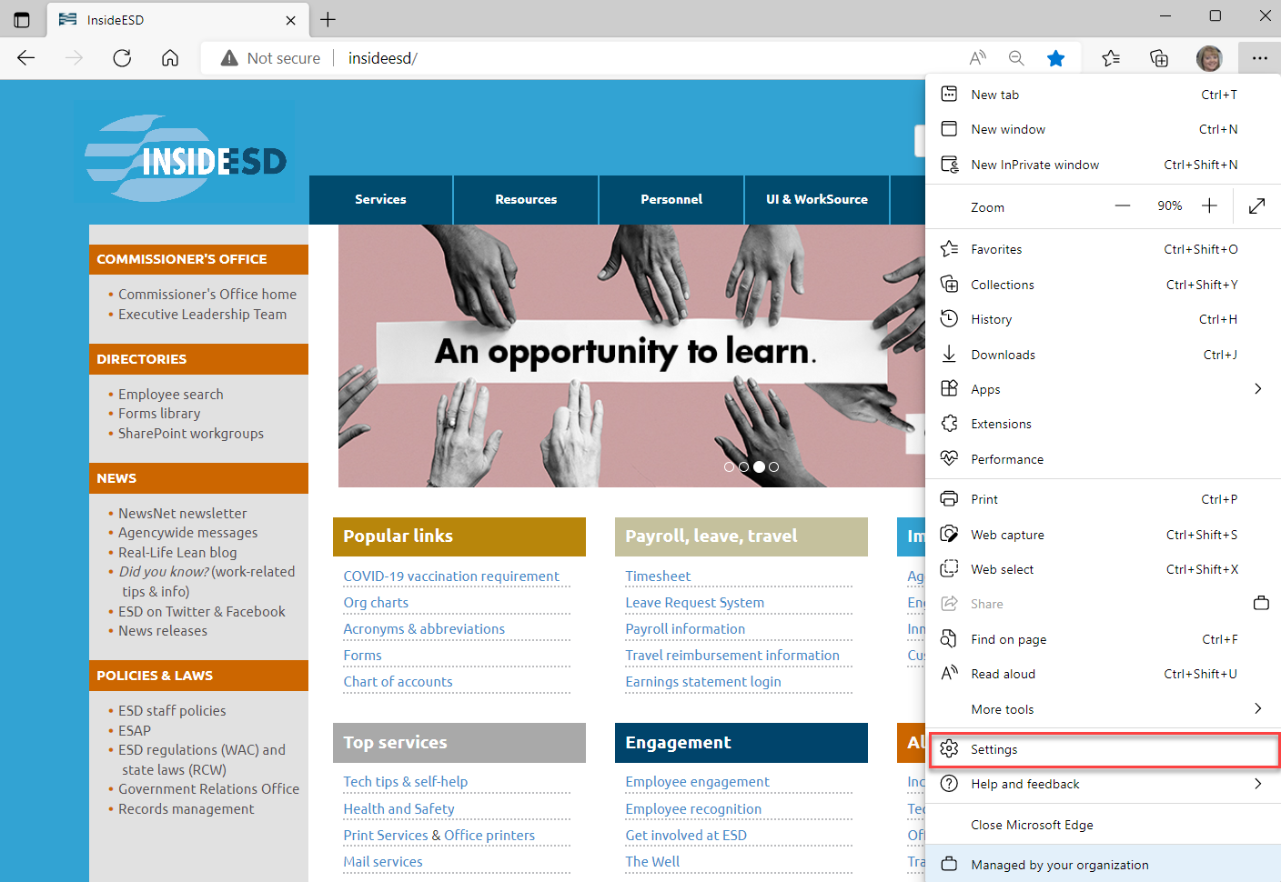

- From the settings menu, click on Default browser on the left side
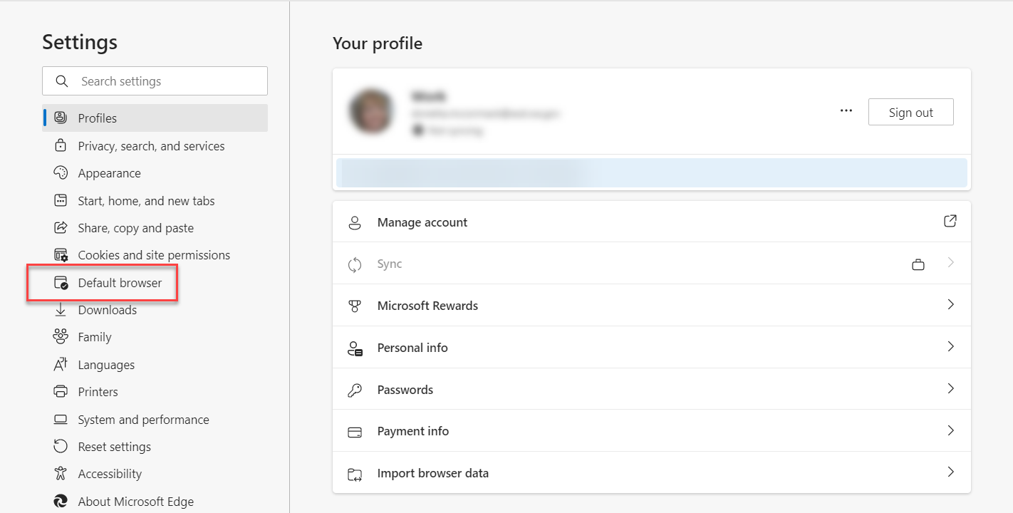

Make the following changes:
- Allow sites to be reloaded in Internet Explorer mode (IE mode) – Set this to Allow
- Internet Explorer mode pages – click Add
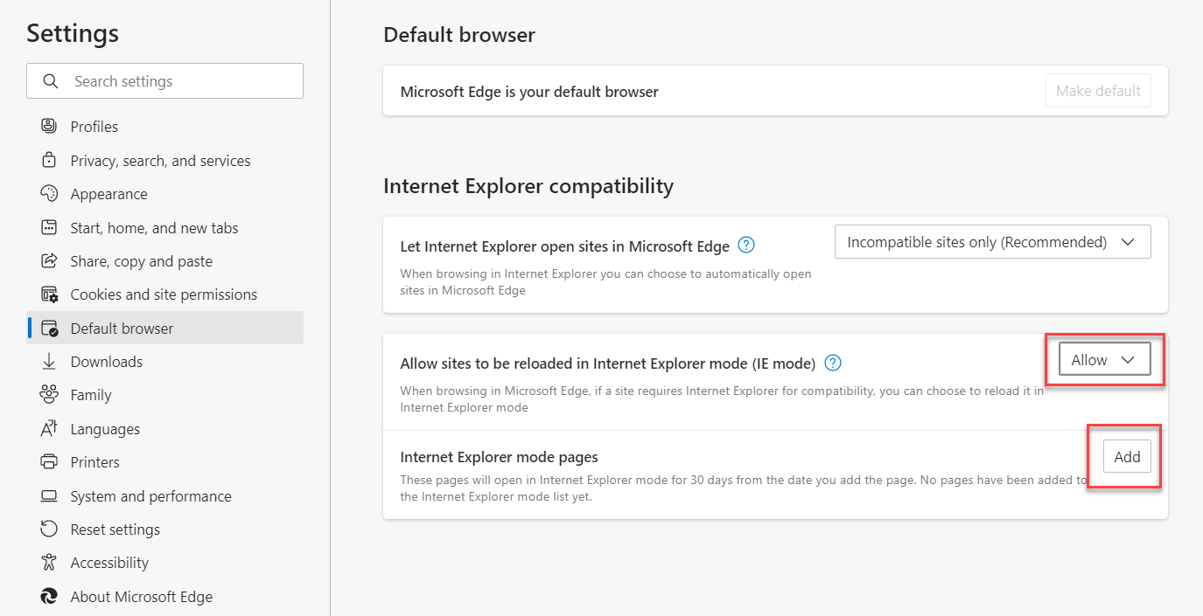

After clicking add, a pop-up box displays:
- Enter the URL/address for ETO https://wa.etosoftware.us/ in the space provided
- Click Add to save your information and to close the pop-up box
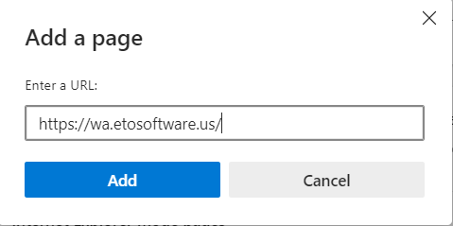
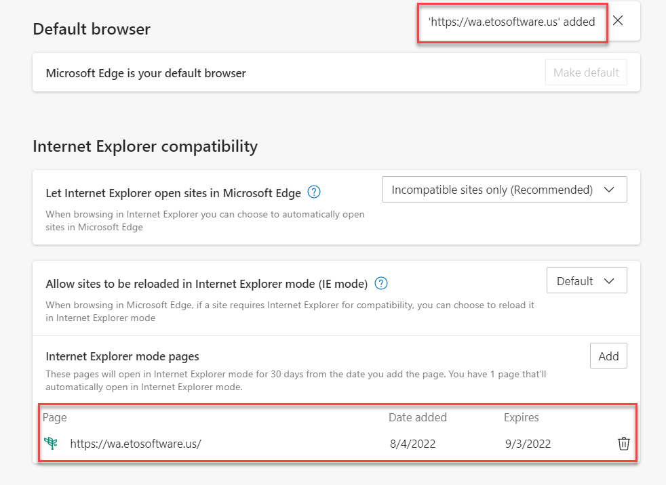
Figure 1: When you return to the settings screen, you may notice that the ETO URL has been added.
Next Steps:
- Log into ETO – You may see a message alerting you that you are in Internet Explorer mode.
- If you are still unable to get the Topaz pen to work, restart your computer.
Note: Clicking on “Open in Microsoft Edge” will take you out of IE Mode. You can ignore this message if you wish to keep these settings.
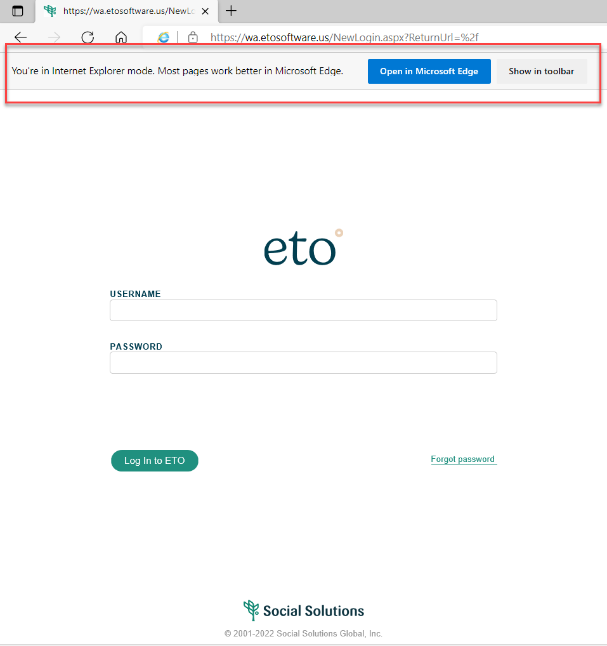

Note: IE mode will last 30 days before it reverts back to your Edge or Chrome settings requiring you to change your settings as instructed above.
If you tried running MS Edge in “IE Mode" and still cannot use your Topaz pens to collect signatures, submit a remedy ticket and ask to have your old version of Sig-Plus software reinstalled.

