T12 Meeting Minutes 1-13-2021
Remember: After starting a Webex meeting to mute your audio and disable the video feature. Too many attendee’s with active video can interfere with everyone’s audio quality. Hover over the lower edge of your monitor screen to find the icons.

Thanks to all who contribute to this weekly call!

This meeting was cancelled due to a statewide power outage

New Business

- ETO Enhancements updates – Check out the report changes here https://wpc.wa.gov/intro_enhancements
- Tickets into production – Nothing to report this week
- ETO maintenance –
  - Jan 14, 2021 release is not expected to affect Washington. Submit a remedy ticket if you experience issues after this date
  - Extended maintenance window 7AM 1/23/ to 2PM 1/24/21. SSG says this upgrade will drastically increase ETO performance for 2021. Submit a remedy ticket if you experience issues after this date
- WSWA maintenance – n/a
- Velaro maintenance – The Velaro Product Team will be performing maintenance activity on Friday, January 15, at 3:30 AM PT, the estimated duration is 1 hour. We do not expect any impact to your service, yet in some cases, there may be a brief interruption. Submit a remedy ticket if you experience issues after this date
- ETO Engage – We continue work on the enhancement of this tool, creating training material and delivery of training.
- ETO Basic and Refresher Training 1/19/21 2-4PM class is full. Next training is 2/1/2021 10-12
  - ETO Basic training is the 1st Monday 10-12 and 3rd Tuesday 2-4 of every month (except holidays). Send email to Lynn Aue to receive more information, training account if needed and be added to the training Webex call. All ETO/WSWA system users are welcome to attend the training but please do not forward invites as I need to review all attendees and assign training accounts if needed.
  - Training recordings and user guides are posted on the WPC website here https://wpc.wa.gov/tech/ETO-refresher-training
  - Submit a remedy ticket requesting additional training opportunities and resources
- What’s new on WPC –
  - Checklist of things to do before submitting a remedy ticket
  - Virtual training tools; Google tools, Microsoft tools, Public use computer https://wpc.wa.gov/tech/techrefresh
  - Report’s enhancements; check it out here https://wpc.wa.gov/intro_enhancements
    - Changes added this week to; Employer & Job Posting Reports, Job seekers, Outreach, Re-Entry Reports, TAA Reports
  - ETO user role; check it out here https://wpc.wa.gov/tech/security
- Open discussion and training issue(s)–
  - Reminder: Submit remedy tickets for all work requests. The WSS team cannot begin work without a service request. Reaching out to us directly can affect the time it takes to resolve your issue. Thanks! https://wpc.wa.gov/tech/issues
  - Open discussion topic;
- UI announcements –
  - RESEA will relaunch on January 11, 2021. Be prepared for claimants seeking reemployment prep even though job search is waived through at least January 19, 2021
  - CARES act and decisions made around that – what does that mean for us and the customers?
  - Congress passed 5500-page extension of the CARES act, has a focus on extending UI benefits
    - Extends Pandemic Unemployment Assistance Act by 11 weeks – from 39 weeks to 50 weeks
    - Extends PEUC by 11 weeks – from 13 to 24 weeks
    - Additional “cash” in extension – was previously $600 but will be $300
    - Extends Shared Work program
    - Maintains waiver of wait week for unemployment claims
    - Higher screening/verification for qualifying for this assistance
  - Extension will go to at least March 12: clients can receive benefits through March 12, but if on that date the maximum weeks payable not reached, could go as far as April 10 (previous deadline was 12/26)
  - Will be waiting from DOL federal guidance policy letter (UIPL) for requirements to implement these extensions and all the documentation part of that
  - Job search information found here https://esd.wa.gov/unemployment/job-search-requirements /

  - Here is the information to provide feedback on Work Search Requirements
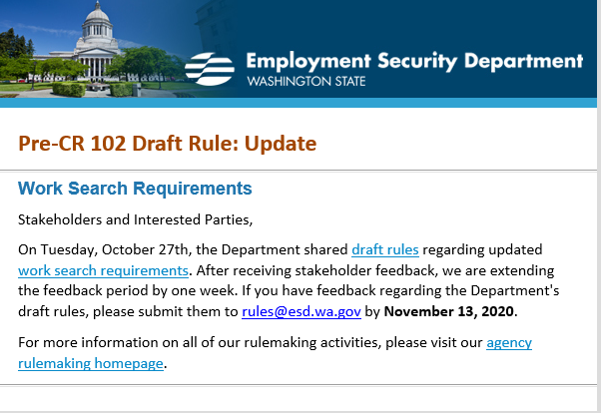

All initial unemployment claims and continued claims decreased during the week of January 3 – January 9
During the week of January 3-9, there were 27,147 initial regular unemployment claims (down 8.4 percent from the prior week) and 515,561 total claims for all unemployment benefit categories (down 7.5 percent from the prior week) filed by Washingtonians, according to the Employment Security Department (ESD).
- Initial regular claims applications remain at elevated levels and are at 203 percent above last year’s weekly new claims applications.
- Initial claims for regular unemployment, Pandemic Unemployment Assistance (PUA), Pandemic Emergency Unemployment Compensation (PEUC), and continued/ongoing claims for regular benefits all decreased over the week.
- Reductions in seasonal layoffs in construction and agriculture drove a decrease in new regular jobless claims last week. Regular initial claims in the construction sector decreased by 1,742 over the week to 3,199 total regular initial claims, while initial claims in the Agriculture, forestry, fishing and hunting sector decreased by 422 over the week to 739 initial claims.
In the week ending January 9, ESD paid out over $146.8 million for 310,021 individual claims. Since the crisis began in March, ESD has paid more than $13.5 billion in benefits to over a million Washingtonians.
- For current COVID-19 and UI information ESD.wa.gov or ESD Facebook page
- Before submitting a service ticket, review this desk aid “Check list: things to try before submitting a service/remedy ticket”
- Visit this page on the WPC site to submit a service request: https://wpc.wa.gov/tech/issues If you are an ESD partner, there is a downloadable form that you must fill out and send to the Technical Solutions service desk – their e-mail is ESDDLITBITechnicalSolutions@ESD.WA.GOV
Review of ETO/WSWA and other resources (AKA old business)
- Encourage all staff who use ETO and WSWA to sign up for the T12 calls. These calls are not just for trainers but for all system users and a great way to stay up to date on changes or improvements to ETO and WSWA. Send requests to esdgpWSSteam@esd.wa.gov to be added to the ITSD Training Team’s distribution list
- WorkSource Systems resources found on the WPC Technology site https://wpc.wa.gov/tech
  - We try our best to make sure all the links are operational but depend on you to submit a remedy ticket if you find broken links!
- WSWA Virtual services to assist job seekers/employers to sharpen skills. There are many tools on WSWA but here are a couple of my favorites!
Check out these virtual classes under Resources>Training and other programs.

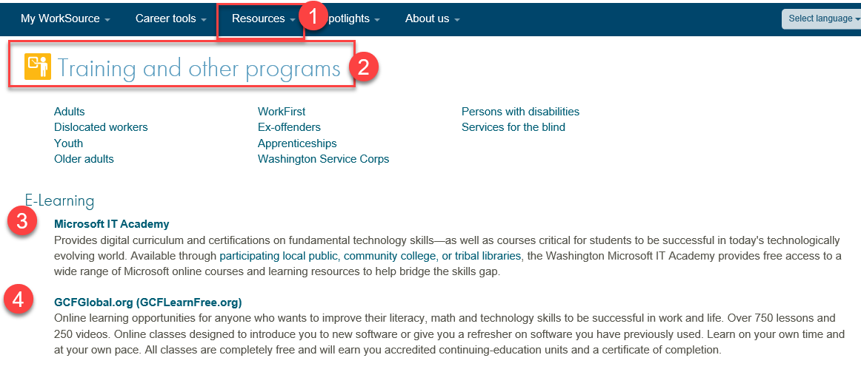

- Stay up to date on COVID19, teleworking and WorkSource Virtual services. Check out the information the WPC website to help all WorkSource staff telework.
  - IT service delivery
  - WebEx
    - Browse the Webex handbook and watch 5 videos on how to make the most out of this tool for conducting meetings with staff and customers.
  - Other resources include:
    - Now that you are teleworking reference guide
    - How to use SKYPE for online meetings
    - How to sign into ESD email from outside the network
    - How to sign into an off-site Wi-Fi from your computer
    - Can I access Internet Explorer from a MAC computer?
    - ESD service Desk information.
- UI Fraud help
  - www.esd.wa.gov/fraud
  - Fax information to claims centers 833-572-8423 –calling is not recommended due to the high volume of calls
  - Reviewing our web resources with them. Some helpful pages include:
- Employee FAQs
- Employee instructional videos
- How to file weekly claims
But you CAN’T help by:
  - Contacting an intake agent at the claims center and asking them to review your friend or family member’s claim or solve their issue.
  - Using your influence to move your friend or family member’s claim up the queue to be processed faster.
  - Using your influence to give any kind of advantage to your friend or family member.
  - Using your access to UTAB, if you have it, to give someone information about their claim.
  - Using your friend or family member’s SAW account and applying for benefits or submitting their weekly claims for them.
- Cisco Softphones training material Link http://insideesd.wa.gov/services/it-services
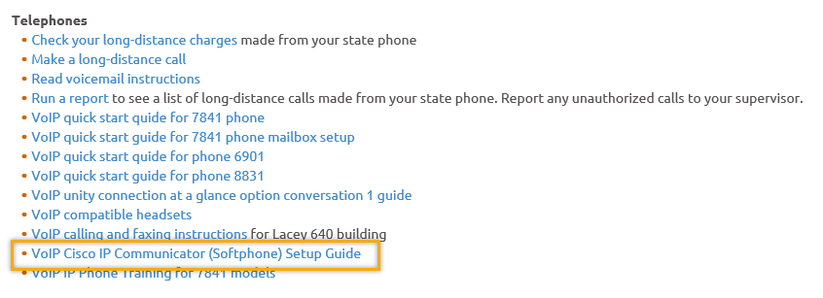

CHAT

ATTENDEES This meeting was cancelled due to power outage

Attended second half

