Review Staff Efforts
To access and use the ‘Review Staff Efforts’ functionality, you must have a Program Manager role or above. Your role displays under your name once you log into ETO.
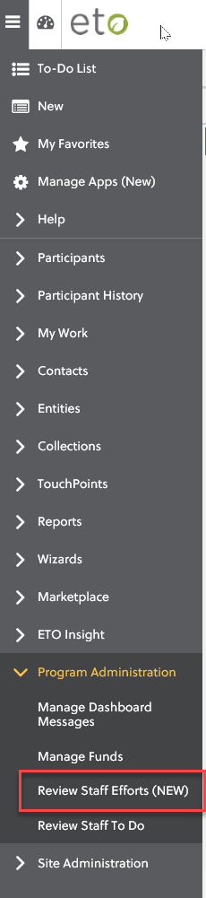
Step 1: To access from the menu, click on the and expand ‘Program Administration’ and select ‘Review Staff Efforts (NEW)’.

Step 2: After selecting ‘Review Staff Efforts’, the following displays:
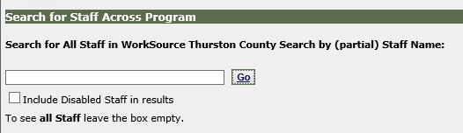

Step 3: Type in the name of the staff you want to review.
Helpful Hints: The search functionality works best if you either use a partial search by typing in the staff’s last name, or a full search by typing in last name and first name.
We discourage using the ‘all staff’ search.

Step 4: Once you type in the staff name, the search results display. You may receive different results based on how you did your search. Locate the staff and click on ‘Go’ or the name.
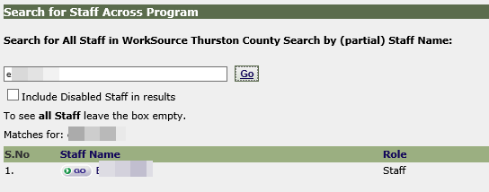
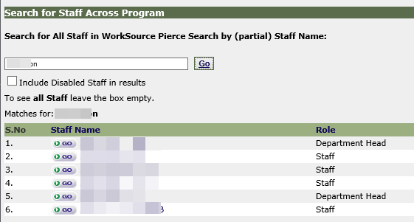

Helpful Hints: If you manage staff in multiple offices, results may return quicker if you can log into the office for that particular staff; however, if results do not return, there are steps below (7a/b) you can take to display the staff efforts without having to change your office.

Step 5: The dates automatically populate for the past week. Change the selection by either: 1) typing in specific start/end dates; 2) clicking on the calendar icon and selecting different start/end dates; 3) clicking on ‘This’ or ‘Previous’ for either the Month or Quarter, which automatically selects the entire month or quarter; or 4) selecting ‘Year To Date’.
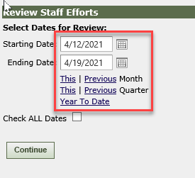
Once selection is complete, click on the ‘Continue’ button, and be patient, as it may take time for the results to display.

Step 6: The search results display.
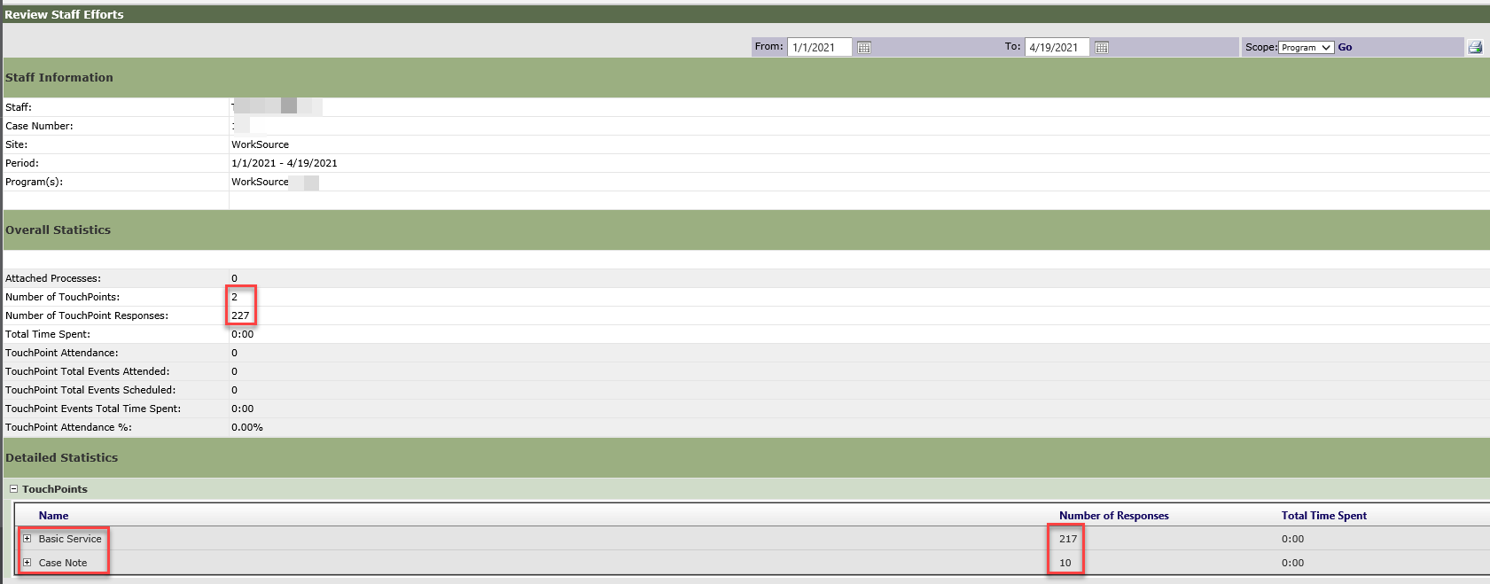
The ‘Number of TouchPoints’ and ‘Number of TouchPoint Responses’ displays the overall statistics for the selected staff.
To view the data, expand on TouchPoints by clicking on the plus (+) symbol, and then expand on each individual TouchPoint by selecting the plus (+) symbol for each.

Step 7a: If the search does not return any results:
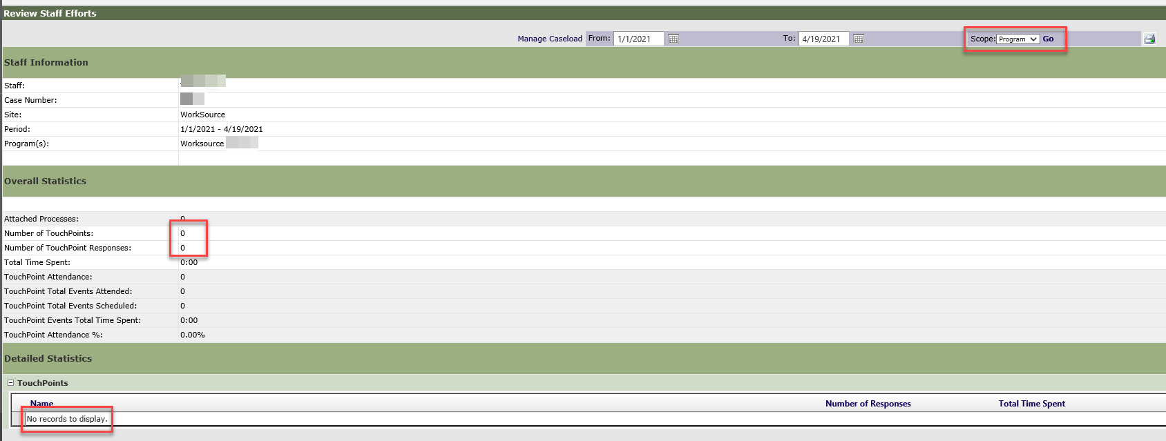

Step 7b: Click on the ‘Scope’ dropdown in the top right corner and change ‘Program’ to ‘Site’ and click on ‘Go’.
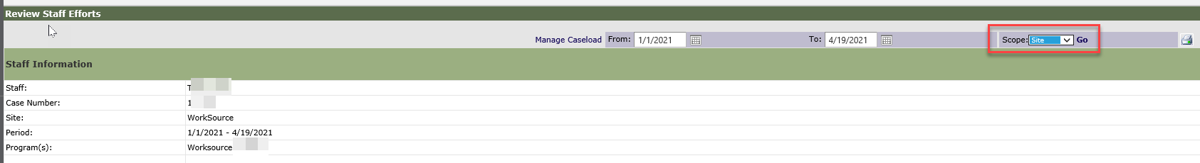

Step 8: Again, be patient, as it may take time for the search results to display. Once complete, the results should display as follows:
