Reopening a System Exited Program Enrollment

This process is used when a participant has been system exited due to a 90-day break in services.

NOTE: This process must be done in 2 consecutive days, or the desired Program of Enrollment (PE) will close again at midnight of the second day, and you will need to start the process over.

The process starts by logging into ETO, find your participant (must be logged into same office that participant is enrolled in) and select ‘View/Record TouchPoint’.

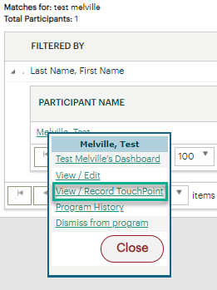

From the Review TouchPoints (TP) menu:
- Click ‘Take New’ from the Individualized Training and Supportive Services (ITSS) TP
  - If the ITSS TP isn’t listed, add it by clicking on the ‘Take New TouchPoint’ button at the bottom
- Choose and record a durational service (do not use a point in time service) using a date before the 90th day from the last qualifying service (you will not be able to select the desired “Active Program Enrollment” but that will be resolved on the second day).
  - If a Program of Enrollment is required to save the service, select any program in the “Other Program” field, complete the steps and save the TouchPoint.
- The ETO script will run overnight and remove the enrollment end date from the desired PE because the script detected the missing service*
- The next day the enrollment end date will be gone from the PE TP
  - Delete the service you recorded the day before
  - Re-record the provided service TP and add PE from the “Active Program Enrollment” drop down
- Case note the actions taken and the reasons why the service was not entered timely.
  - WIN0082 Guidance for ‘Real-Time Data Entry in the Efforts To outcomes (ETO) System

*More services may need to be recorded depending on the amount of time passed since the 90 days break in service. If this is the case, each of those services will need to be recorded as stated in item 2) above, and then deleted and re-recorded after the script runs as stated in item 4).

