Recording an Employer Event TouchPoint and Running the Report
At the request of Business Services, Rapid Response and TAA staff, the Employer Events TouchPoint (TP) was created to gather raw data for employer hiring events, job fairs, Rapid Response events, TAA Orientations and other events. The TouchPoint includes an Identifier field to call out the event, a dropdown to select the type of event and free form text boxes to record type of employer event, industry/sector, number of employers in attendance, number of seekers in attendance, number of seekers hired and notes.

Note: The TP can be edited, and the 14-day backdating rule doesn’t apply.
The process begins by logging into ETO. After logging in you will:
- Click the ETO left-hand Navigation bar to open menu
- Click on ‘TouchPoints’ to open the menu
- Select ‘View General TouchPoints’
- Click ‘Take New’ from Employer Events
Note: If Employer Events is not a selection, click the ‘Take New TouchPoint’ button at the bottom, and select ‘Employer Events’ from the drop-down menu
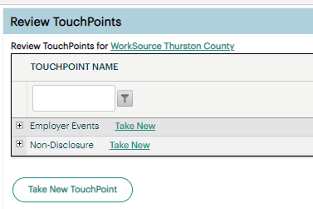
After landing on the Employer Events page enter the event information:
- Enter event identifying text here
- Select the type of event: Hiring Event, Job Fair, Other (opens text box to enter description), Rapid Response (opens text box to enter event number is applicable) or TAA Orientation
- Date of event (required)
- Describe the event details
  - Industry/Sector
  - Number of Employers in Attendance
  - Number of Seekers in Attendance
  - Number of Seekers Hired
    - This field allows you to edit it and add seekers hired at any time after the initial save
- Notes
- Save and record similar, allows to record another event without starting from the beginning
- Save, records this event and takes you back to your dashboard.
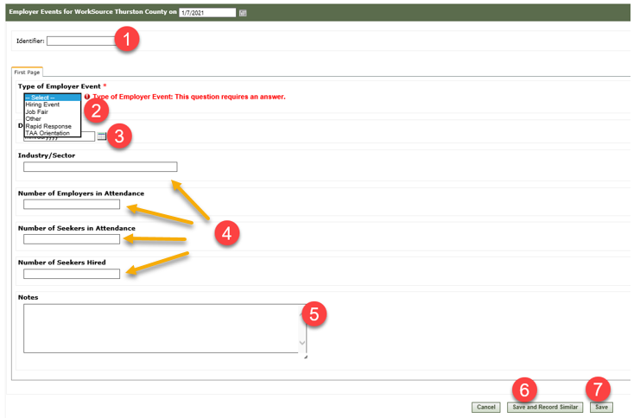
Report for Employer Events TouchPoint
- Click the ETO left-hand Navigation bar to expand menu
- Click on ‘Reports’
- Click ‘View Reports Menu’
- Click ‘Refresh Report List’
- Click the + to expand ‘Employer Events & Rapid Response’ and select ‘Employer Events Report’

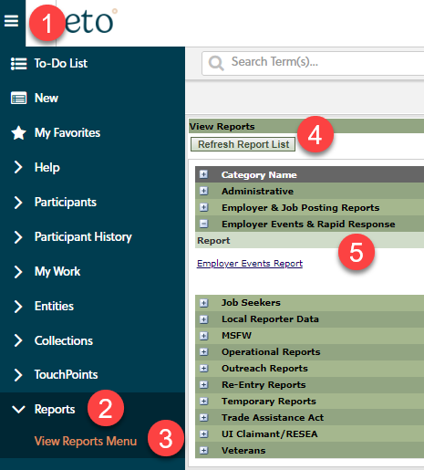

After the report opens, select:
- WDA
- Earliest and latest event dates
- Click OK
- When the report finishes, immediately export to Excel so you can add filters and save report
Guide for the report ribbon
