Recording a group service
Recording a group service is a feature of ETO which is used to record basic services provided to a group of participants at an event or workshop.
The process begins after logging into ETO
- From the user dashboard select ‘Click Record Services (Individuals or Groups)’ from the widget menu.
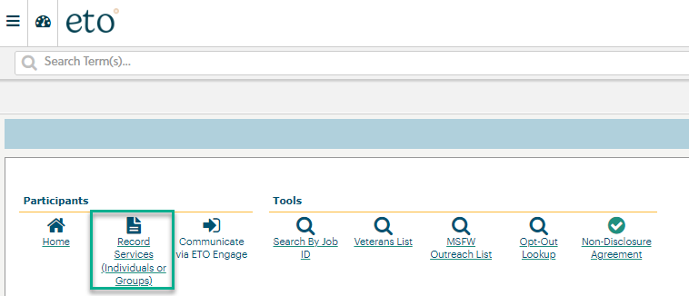
- On the ‘Record TouchPoint’ screen, click the dropdown arrow and select Basic Service’ TouchPoint (TP).
Note: Although there are other services available from the menu selection, the only service allowed to take as a group is ‘Basic Service’.
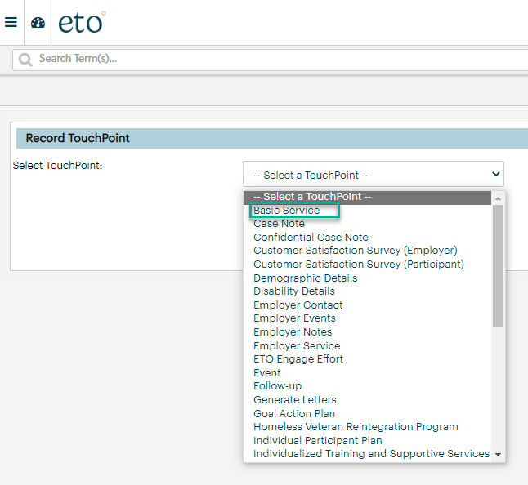
- After selecting ‘Basic Service’ the ‘Subject Type’ menu opens, select ‘Participant’.
Note: Although there are other subject types available from the menu selection, the only subject type allowed to take as a group is participant.
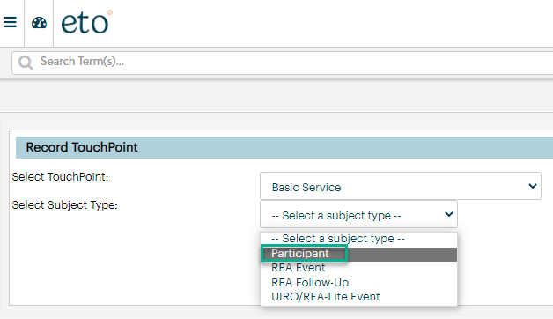
- You are now ready to build your collection for those who attended your event from the ‘Participant’ menu by typing the participant name, clicking the filter icon and click the box next to their name. Continue process 1-3 until you build the collection containing all the event or workshop participants. When finished click ‘Continue’.
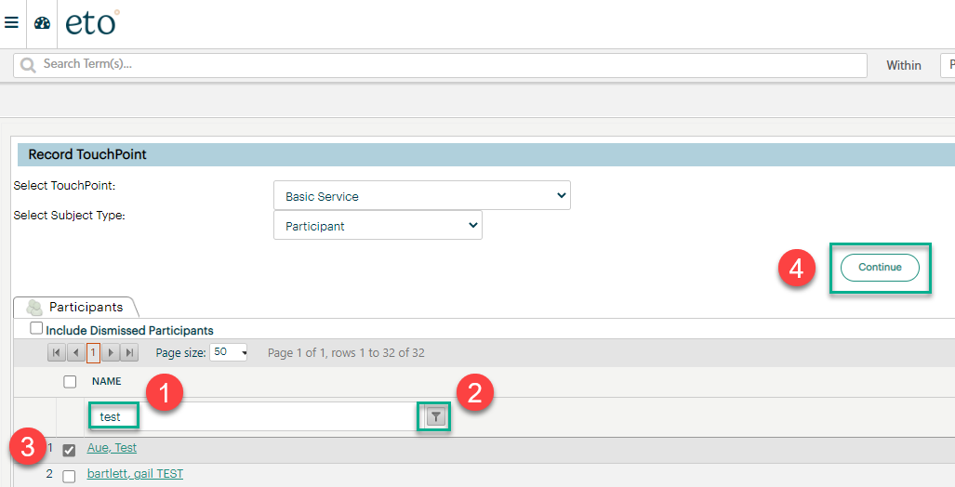
Steps to record a ‘Basic Service’ for a group of participants:
- Services can be taken on behalf of another staff.
- Participants in your group service collection.
  - Clicking the +Add allows you to add more participants.
  - Clicking the 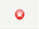 allows you to delete participants.
- If all participants are enrolled in the same Program Enrollments, Other Program, Local Program and Contract you can add it from this screen. If they are not enrolled in the same program or contract you add them individually by opening each participant record from the collection in step 2 and select the program or contract from the menus.
- Select the required ‘Service Provided’ by clicking the arrow and opening the menu.
- Select the Method of Contact by clicking the arrow and opening the menu.

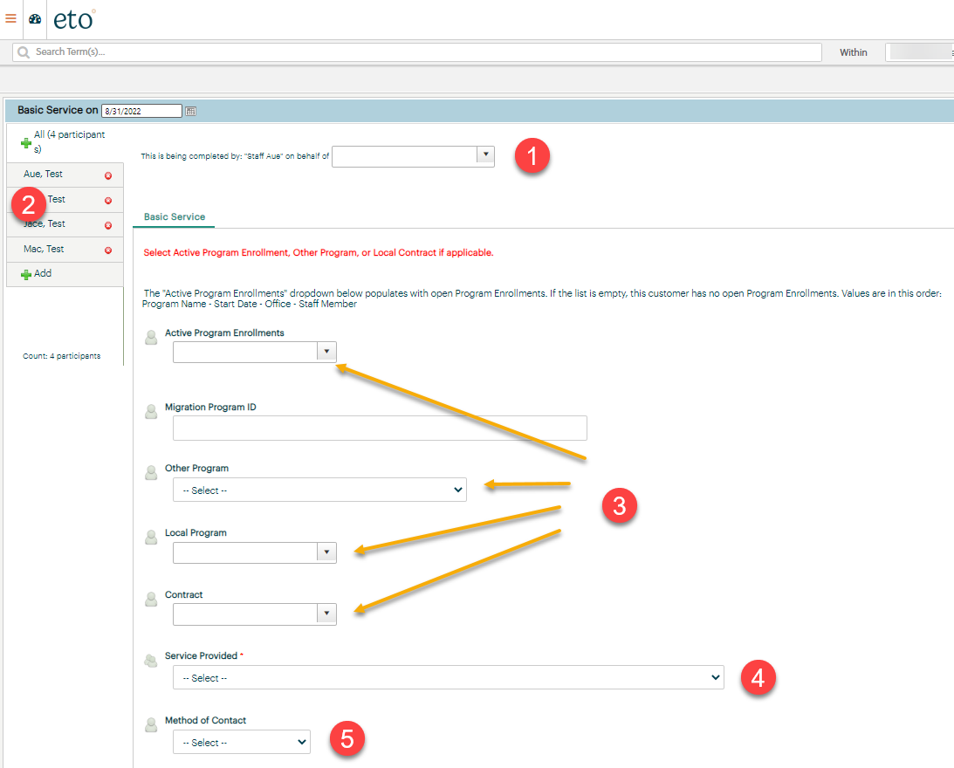

Steps to record a basic service for a group of participants, continued:
- If applicable, open drop-down menu and select a ‘Provider’.
  - If not in drop-down menu you can type in provider name and course name.
- Enter ‘Activity Date’.
- A ‘Basic Service’ is a transactional service so the start date autofils the end date (end date is locked).
- Enter up to 2000 character note.
  - The case note displays on the participants record within the collection.
  - The case note does not display from the participants account ‘Basic Service’ TP.
  - Note is included in the ‘Case Notes History’ report run from the participant dashboard.
- If applicable, upload any supporting documents.
- Schedule follow-up appointments that will be added to your ‘To Do’ list.
- Click ‘Save and record similar’ if you have more than 1 ‘Basic Service’ TP to record for this collection.
  - You will have the ability to add or remove participants from the original collection at this time or,
- Click ‘Save’ if you are done adding services to this collection

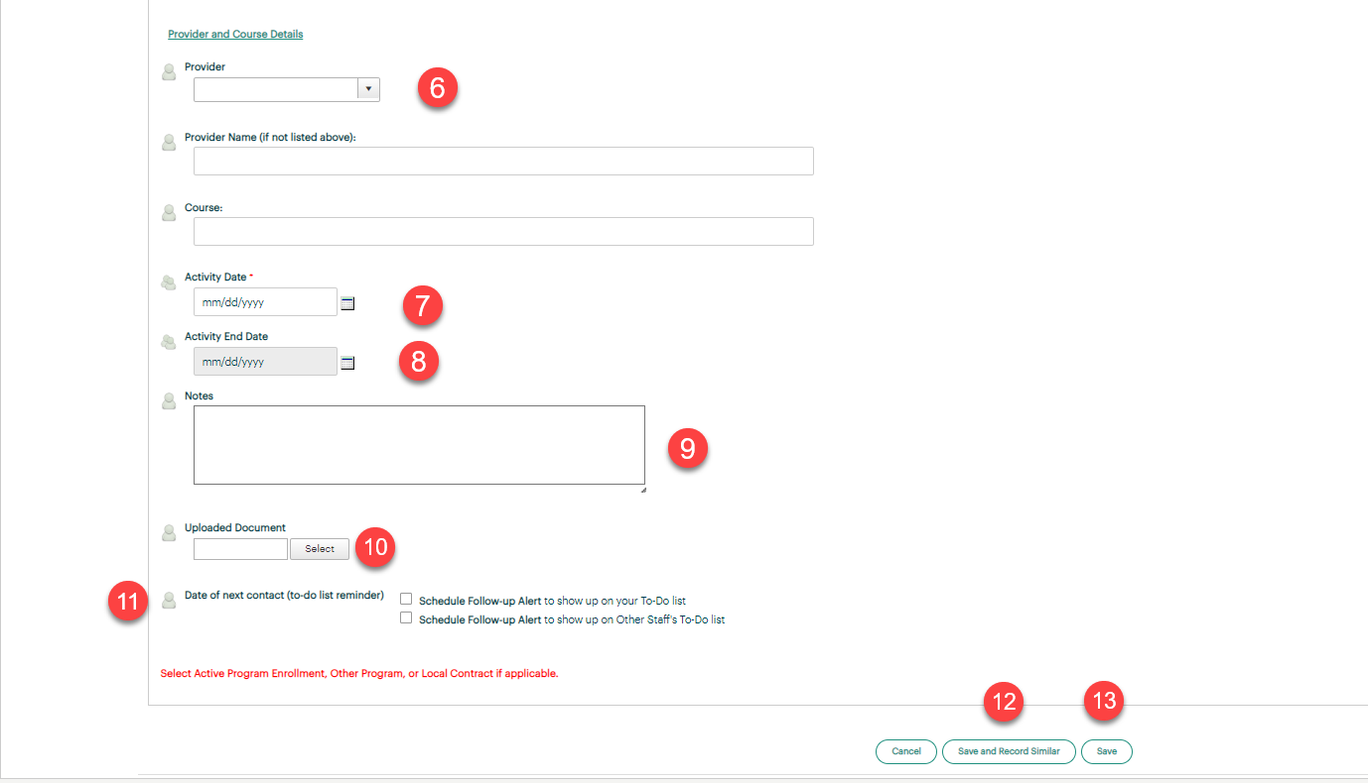

After saving your work you will see the new TP’s on the user dashboard under ‘My Most Recent (35) TouchPoints. Consider the following when accessing group services:
- The screen shot shows the collection and all the participants are connected to one another
- Clicking on any of the icons will open the entire collection
- Eye opens the collection for view only
- Pencil opens the collection for editing. This is where you can add or delete individual partipcants, add a program or contract and a case note
- + opens the collection to add individuals
- Garbage can will delete the entire collection.
Note: You will get a warning that this action will delete all members of the collection

