Opt-Out / Opt-In Process

There are times when those who work for a WorkSource (WS) partner agencies are unable to find a participant in ETO. Follow these steps to determine if the participant has opted out of sharing data with non-ESD staff.

Participants are by default ‘opted in’ to sharing data with both restricted and non-restricted staff. Claimants are given the option to opt-out of sharing their data with non-ESD staff when they create an unemployment insurance claim. Those claimants who select to not share their data can only be found in ETO by ESD staff.

- Type participant name, SSN or ETO customer ID in the Quick Search bar using the office you are logged into and click search. If the Total Participants result shows “0” they are:
  - Not enrolled in your office (in this case WSID); or
  - Opted Out of sharing data with non-ESD staff
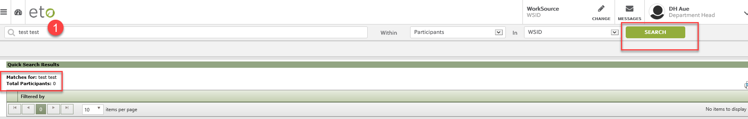

- To determine if the participant is enrolled in another office, change the “In” field to “WorkSource” to search all participants in ETO to determine if:
  - Participant is found, but needs to be added to your office; or
  - If you work for ESD and the participant is not found using either search means they are not in ETO.
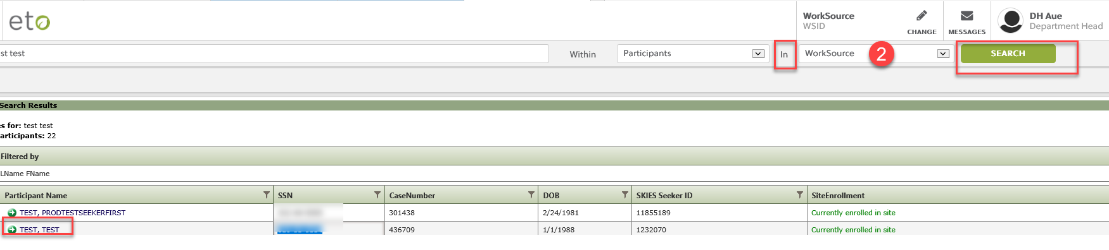
  - If you work for a non-ESD partner agency and the participant is not found using either search could suggest they opted out of data sharing, and you need to run the ‘Opt-Out Lookup’ widget found on your dashboard.
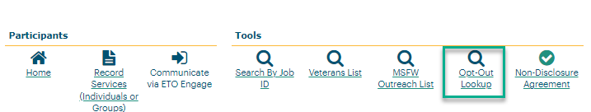
ADDING SEEKERS TO OFFICE
If participant is located, but not enrolled in your office, follow these steps:
- Open the menu on the Navigation bar menu
- Select “Participant”
- Add Seeker to Office

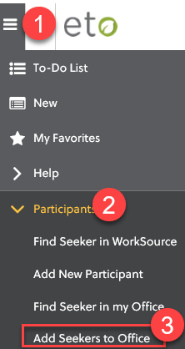

- Add seeker following the directions on the “Enroll Job Seekers into” (office you are logged into) click search
- Find seeker from the search results, check the box next to their name
- Click “Enroll Job Seeker”

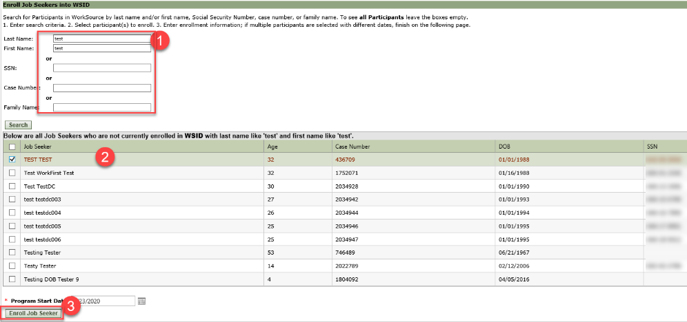

When complete click OK. Your participant is enrolled in the office you are logged into.

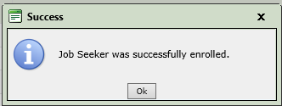

DETERMINING IF PARTICIPANT OPTED-OUT OF SHARING DATA (for non-ESD staff)

From your dashboard click the “Opt-Out Lookup” widget

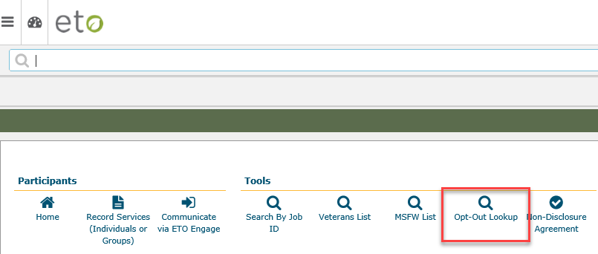

- Enter participants SSN
- Click > to move SSN to prepare search
- Click OK
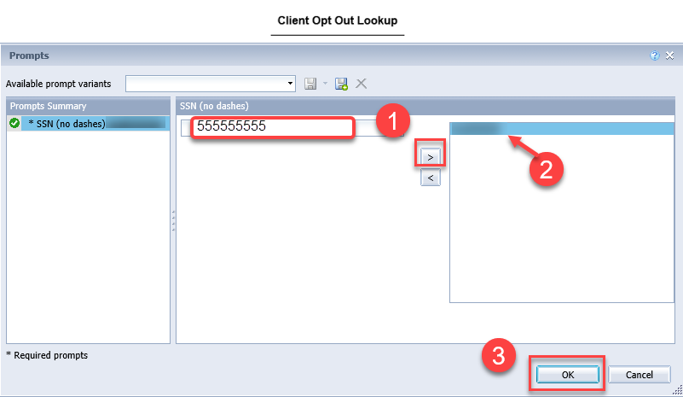

If the participant Opted Out of sharing data with non-ESD staff, the search will return the message – CLIENT OPTED OUT. Follow your local area’s policy on how to Opt a participant into sharing data in ETO if the participant wants to share data.
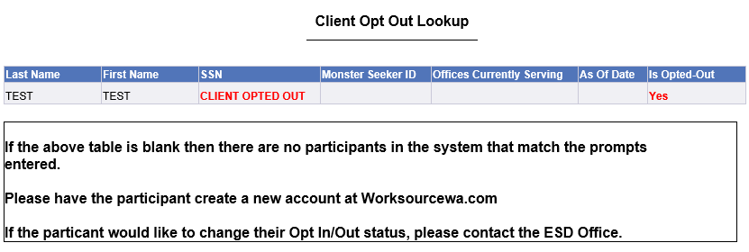

PROCESS FOR ESD STAFF TO OPT-IN PARTICIPANT TO ENABLE DATA SHARING

ESD staff can view and Opt-In participants who chose to Opt-Out of sharing data with non-ESD staff. Uncheck the Opt-Out box, scroll to the bottom of the page and click “Save”.

On the ‘View/Edit’ participant page, the opt-out feature will show, but only for staff who are not restricted users. If a participant changes their mind and wants to share data an ESD staff can make this change. Follow your local office procedure on this process.

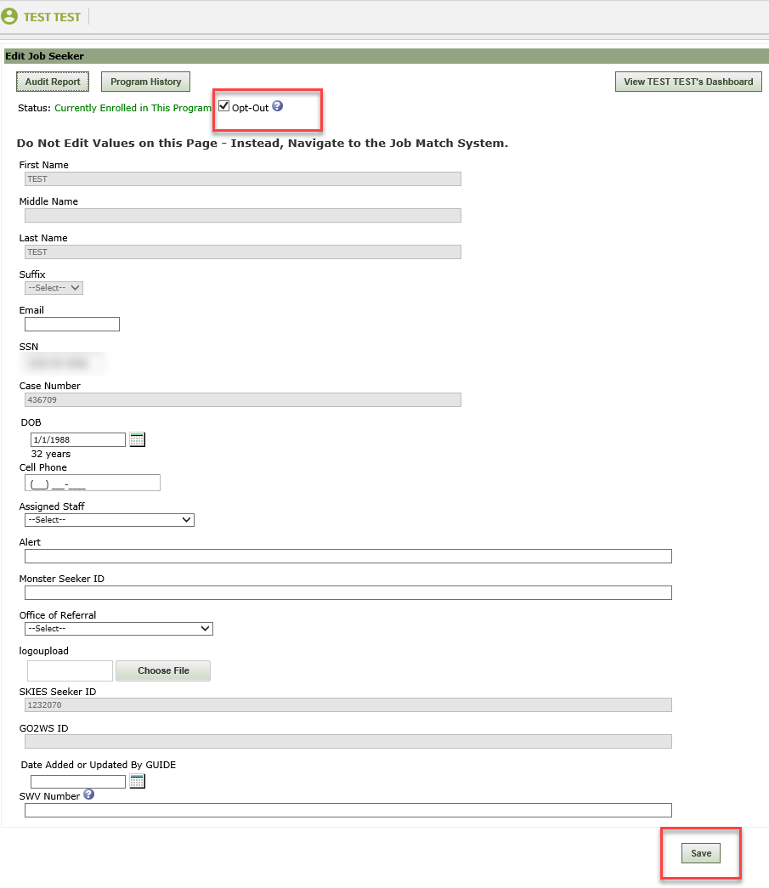
Note: Restricted users cannot make changes to a participant’s opt-in or opt-out selection.
Seekers default to Opt-In status when account is created in Job Match. Opt-out can be set by editing a participant record via View / Edit Participant.

Reminder: The participant has to be added to the office you are logged into or you will not be able to edit this screen and Save will be greyed out. Follow the instructions found above to add seeker to your office.

