How do I sign my non-disclosure agreement (NDA) in ETO?

This process describes how to sign your non-disclosure agreement (NDA) in Efforts-to-Outcomes (ETO).
This must be done the first time you log into ETO and then annually in compliance with state and federal law.

Failure to sign within one (1) week of the expiration in the NDA will result in the non-compliant account's deactivation.

- Log into ETO
- From your dashboard, click the Non-Disclosure Agreement widget
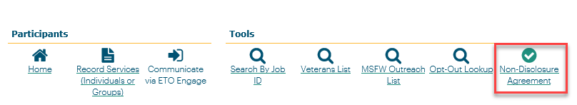
- Fully read the Notice of Non-Disclosure
- Click the Sign icon
- Sign your name
- Click Save
- Click Save again
- Click OK

You can verify if your NDA was successfully signed from your dashboard under ‘My Most Recent (35) TouchPoints’ section. Your recently signed NDA should be at the very top!

