Finding a Job Posting or Recruiter Using a Job Order Number
Employer Record Structure
Employers have the ability to create a WSWA account on Employment Security Department’s job match website. Creating a WSWA employer account establishes three account types described in the following structure:
  - Company Entity is the primary record. Think of this as the headquarters building.
  - Sub-Entity is the next level of record related to the Company Entity. Think of this as the worksite. If there is more than one worksite, there can be more than one Sub-Entity record under a Company Entity
  - Recruiter represents a person within the company.
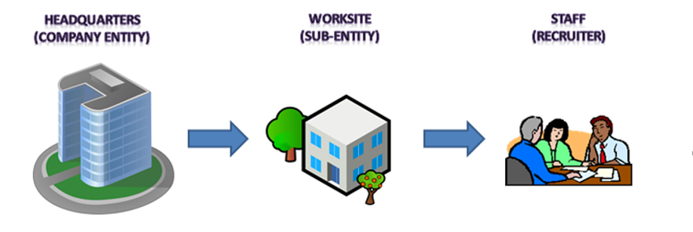

At times you may work with a job seeker who is asking for more information about a job posting on WSWA but only has the job order number for you to search with.
Begin by logging into ETO and clicking on the ‘Search By Job Order ID’ widget from the staff dashboard.
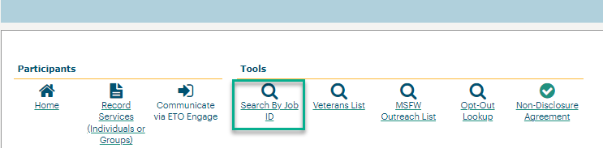
After the report opens enter the job order ID and click OK.
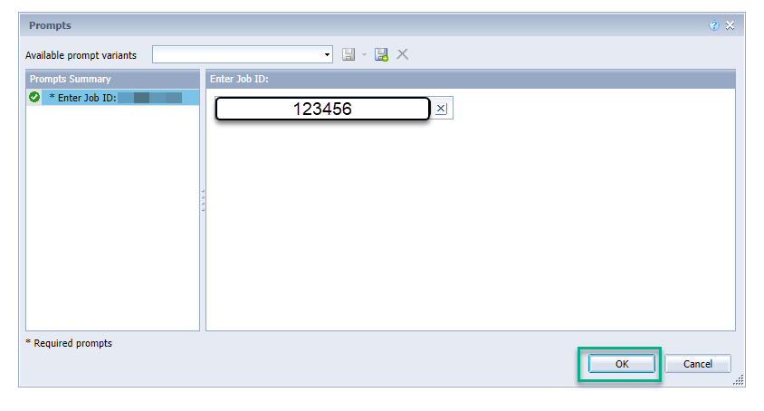
The job order will open and provide a link to take you to WSWA to review the job order details.

Workaround if the staff dashboard widget isn’t functioning:
- Open the ETO side navigation bar
- Click ‘Reports’ menu and ‘View Reports Menu’
- Click ‘Refresh Report List’
- Click the + to expand the ‘Employer & Job Posting Reports’ category
- Select ‘Job Posting Search’
- Enter the job order number and click OK
- The job order will open and provide a link to take you to WSWA to review the job order details.
Find Recruiter in ETO Using Company Name
To start an employer search, copy the company name on the job posting and enter it into the ETO quick search bar line. Change the ‘Within’ field to Entities and the ‘In’ field to WorkSource, click search.
My search resulted in several business’s called Acme Bakery. Select the account designated ‘Sub-Entity’ to land on the page where you can view company information, twenty most recent employer services, ten most recent job postings, enter or review case notes. 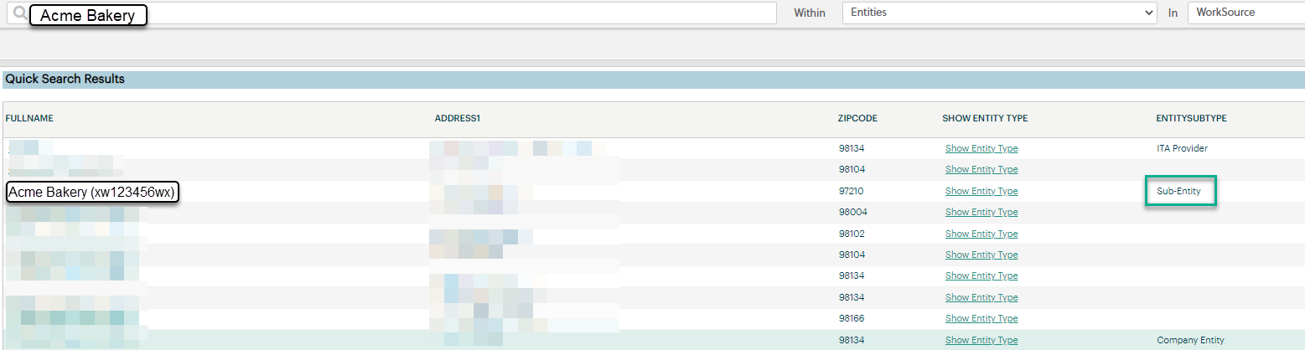
If you need to find the recruiter for a job posting, click the ‘Find Recruiter Match’ widget on the sub-entity dashboard to run a report to present all recruiters associated with the company. Links are built into the report to take you to the recruiter dashboard where you can view contact information, job postings, case notes or go to their WSWA account by impersonation.

Remember, always ask the employer for permission before accessing the account via impersonation
Resources
- Workforce Professional Center for WorkSource Technology
- Services Catalog of ETO business services TouchPoints and their descriptions
- WorkSource Systems Support Team (WSS) group email esdgpwssteam@esd.wa.gov

