Finding a Participant in ETO
There are 4 ways a participant account is created in ETO:
- Migrated from our previous case management system SKIES,
- Job seeker creates a WSWA account, and it interfaces into ETO and creates an account,
- Job seeker files an Unemployment Insurance (UI) claim, and it interfaces into ETO and creates account,
- Those with the ETO Department Head roll add a participant who doesn’t want to provide SSN per WIN0081, or
- Staff create an ETO account for those job seekers who are unable to create a WSWA account per WIN0120
The process begins by logging into ETO. The ETO Log-on link is found on the Workforce Professional Center (WPC).
After logging in, you will land on your staff dashboard. Below is a brief description of the staff dashboard and the Quick Search navigation bar functionality.
- The office you are logged into, and services will be recorded to
- Enter participant name, SSN, or ETO case number, if known
- Choose ‘Participants’ from the dropdown menu in the ‘Within’ field
- WorkSource office the search will look in for the participant.
  - If you conducted a search using the participant's name, confirm this is the correct participant by verifying the SSN and DOB are a match.
  - If this doesn’t check out, do the search described in bullet 5.
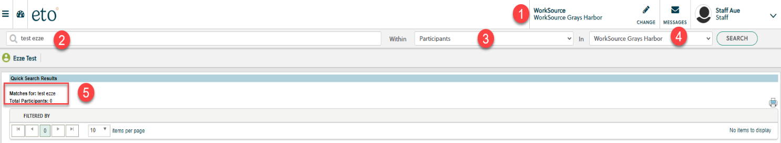

- If the search does not result in finding the participant, try searching again by changing ‘In’ field to ‘WorkSource’ so you will search for all seekers in all offices in ETO
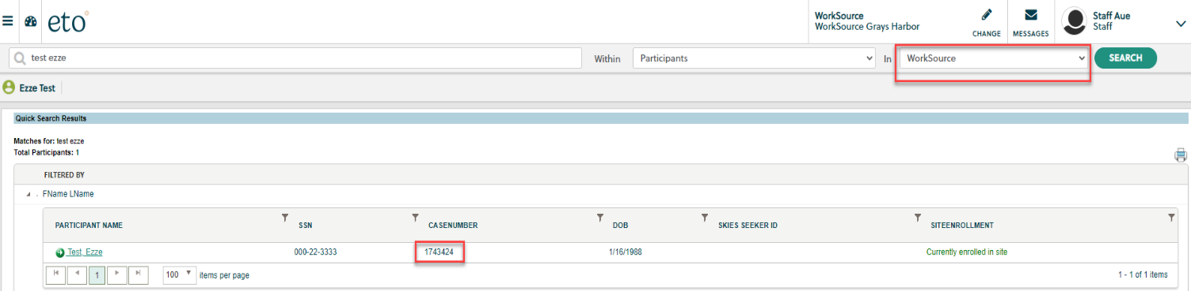

- If this search finds the participant, you will want to add them to your office by:
  - Open the side navigation bar
  - Open the ‘Participants’ menu
  - Select ‘Add Seekers to Office’
  - Enter the seekers Last-First Name, SSN or case number and click ‘Search’
  - Select the box with the desired participant and click ‘Enroll Job Seeker’
  - Click ‘OK’ to complete the action
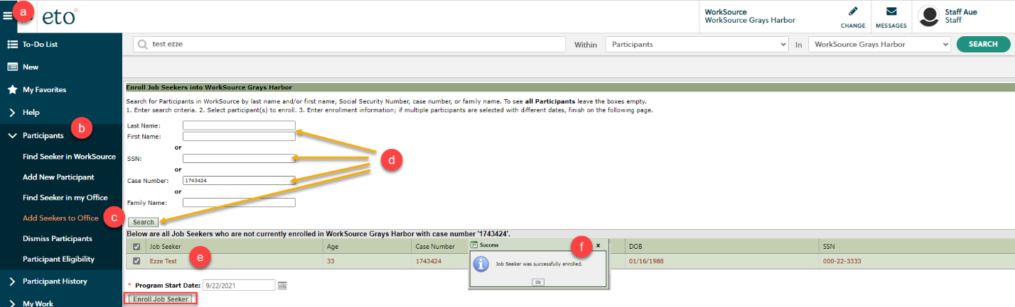

- If you work for a non-ESD agency and neither search effort results in finding your participant, you need to determine if the participant has opted-out of sharing data with non-ESD staff.
  - Open and run the ‘Opt-Out Lookup’ report on the staff dashboard and enter the SSN to determine if the seeker chose to opt-out of data sharing with non-ESD staff or is in ETO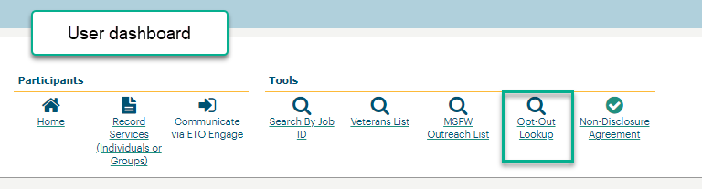
  - If the participant opted-out of data sharing, follow the guidance in the Opt-out of data sharing desk aid located on the WPC site
- If you determine the participant does not have an ETO account, assist them creating a WorkSourceWA account by directing them to WorkSourceWA.com. Training guides are built into the platform.
- Follow the guidance in WIN0081 if the participant isn’t willing to provide their SSN or the guidance in WIN0120 if they don’t have the abilty to navigate the technology to create a WSWA account.

