ETO Report Processes

Helpful hints for reports:
- Always click the ‘Refresh Report List’ every time you access the reports menu. Failure to do so means you could be pulling an older version of a report, or your report may time out.
- If you click on a report, and your screen flashes and goes back to the menu, you most likely are receiving a pop-up blocker. See Pop-up Blocker guidelines in this document or click here to open the stand-alone document.
- Some reports pull a large amount of data, which can cause the report to time out. While some of the smaller reports allow for running a larger start/end date parameter, it is best to try and run the larger reports for a smaller start/end date parameter.

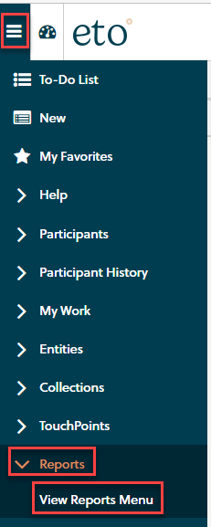
Accessing Reports
To run a report, open the left-side navigation bar, click on ‘Reports’ and then ‘View Reports Menu’.

When the report menu opens, click the ‘Refresh Reports List’ button.
After clicking on the button, click on the ‘+’ in front of the category for which you wish to run a report.
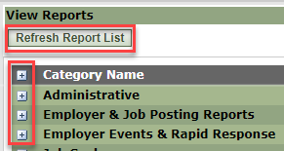
Locate the report and click on the report.
NOTE: If the screen flashes and goes back to the menu, remember to check for a pop-up blocker.

Initial Prompts
The Initial Prompt window for the select report opens.
NOTE: This window is different for various reports; however, some standard prompts are:
- WDA
- Start Date
- End Date
- Office – this is typically an optional field and not required; however, it may be required on certain reports.
Effective 4/17/2023, the look of the initial prompts screen has changed.
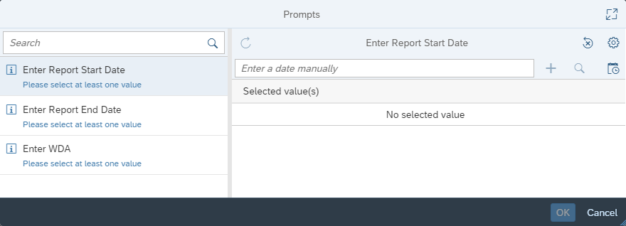

To enter the Start and End date parameters, click on the calendar icon to select the date you wish to run for both Begin and End:
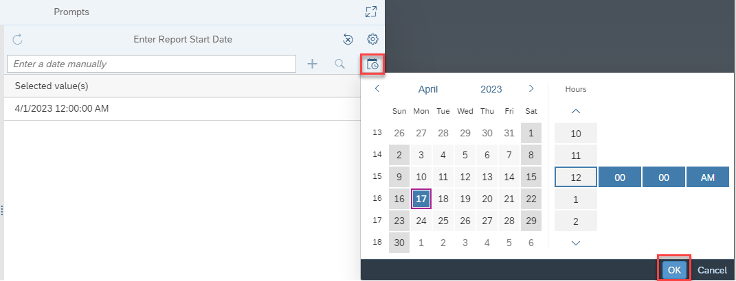
If there is a WDA, click on the checkboxes to select one or more WDAs. If the list doesn’t display, click on the ‘Refresh’ icon -- 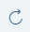.
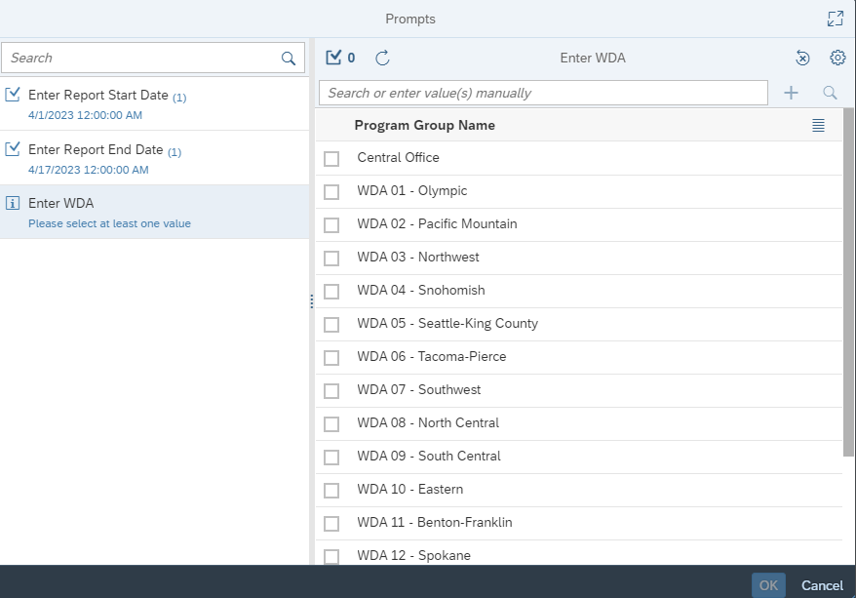
If there is an Office prompt, click on the ‘Refresh’ icon to display the list – ; then click on the checkboxes to select one or more offices.
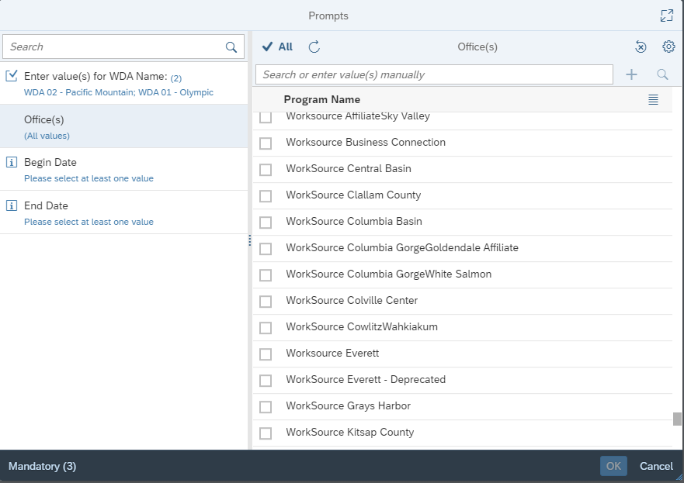
Running a Report
After entering initial prompts, click OK or Run. After clicking OK, you will see a ‘Refresh Document window which means the system is working on pulling the data into your report.
Once this pop-up window disappears, you will see a window with 3 dots and then the report data displays.
- If you realize you selected the incorrect prompts or wish to run a new WDA or start/end date, click on the Query icon -- 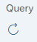.
- To export the report to Excel for filtering and sorting, click on the Export icon -- 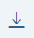.

Exporting a Report
Once you click on the Export icon, a new pop-up window displays.
For filtering and sorting your report, select Excel.
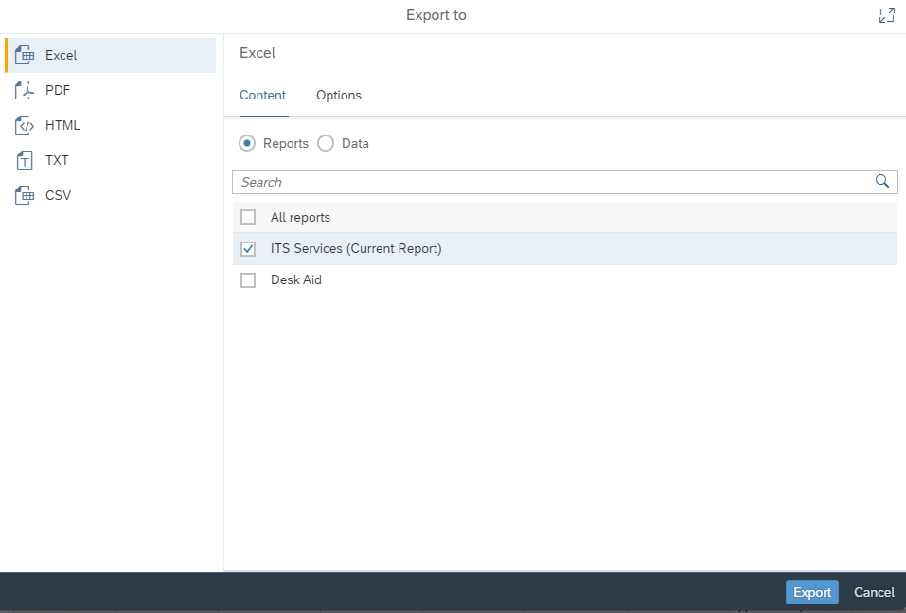
Some reports have just one tab, while others have multiple tabs that can contain various information for the report, and others include a ‘Query’, ‘Summary’ or ‘Desk Aid’ tab.
If you do not wish to export the Query, Summary or Desk Aid tab, uncheck the box as show below.
If you want all, check All reports.
Click the ‘Export’ button.

The report will export and be available in your ‘Download’ folder on your computer.
Pop-up Blocker
When running reports in ETO, you might experience an issue where you click on a report in the menu and the report menu refreshes and doesn’t open the actual report you selected.
This happens because you are receiving a pop-up blocker.

- Click on the mp4 icon below to watch a video; when you get the ‘Open Package Contents’ pop-up, click ‘Open’.
NOTE: When the report is selected, look up in the upper right corner of the address bar to see the ‘pop-up blocker’ message.
- Once the message disappears, you will see a red ‘x’.
- Click on the red ‘x’ and click on ‘Always allow pop-ups and redirects from https://wa.etosoftware.us’ to allow the pop-up blocker.
