ETO Print Pop-up Blocker

When printing something in ETO, you might experience an issue where you click on the Print button and the screen refreshes and doesn’t open the print dialog. This happens because you are receiving a pop-up blocker and could potentially happen every time you attempt to print after clearing your cache.
The steps below are specific for printing the RESEA Action Plan; however, these steps would be the same for anything you are attempting to print.
- Access the RESEA Action Plan and click on the ‘Print’ button.
- A ‘Pop-up blocked’ message displays at the top right area of your address bar.
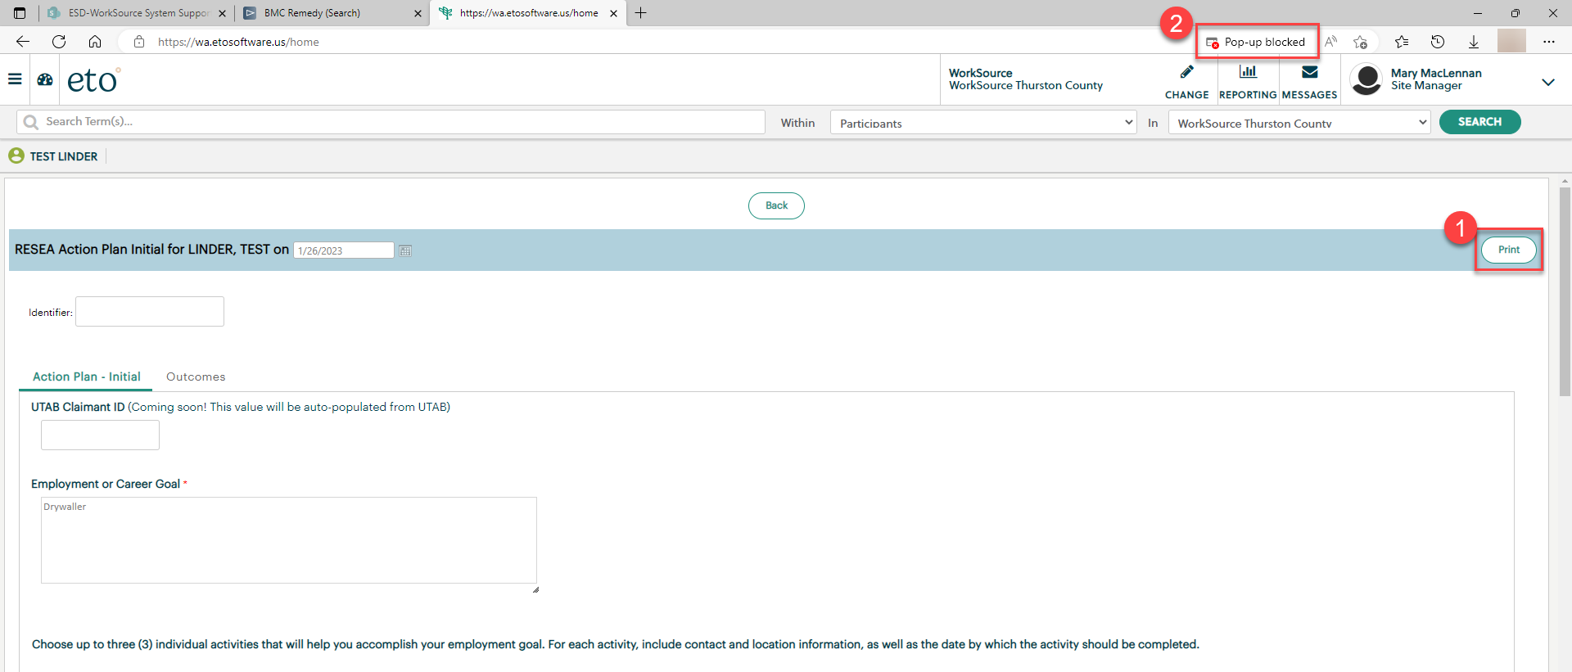
- The ‘Pop-up blocked’ message only displays for a very short period, so you may miss it. Once the message disappears, you will see a red ‘x’.
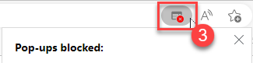

- Click the red ‘x’ and click on ‘Always allow pop-ups and redirects from https://wa.etosoftware.us’ to allow the pop-up blocker.
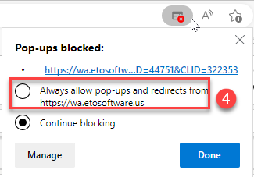

NOTE: Each time you clear your cache, you may experience this same pop-up blocker issue. So, you will need to follow these steps again if that happens.

