Efforts to Outcomes (ETO) Basic User Training
Workforce Professionals Center resources: The Workforce Professionals Center (WPC) contains resources from the WorkSource divisions, to assist all system users. Each tab has valuable information to help you in areas of Workforce development and case management. ETO basic training modules does a high-level overview of these resources with the expectation you take a deeper dive on your own time.

WPC resources to; Home page, One-stop system, Grants & contracts, Policy, Reporting, Monitoring, Employment Connections https://wpc.wa.gov

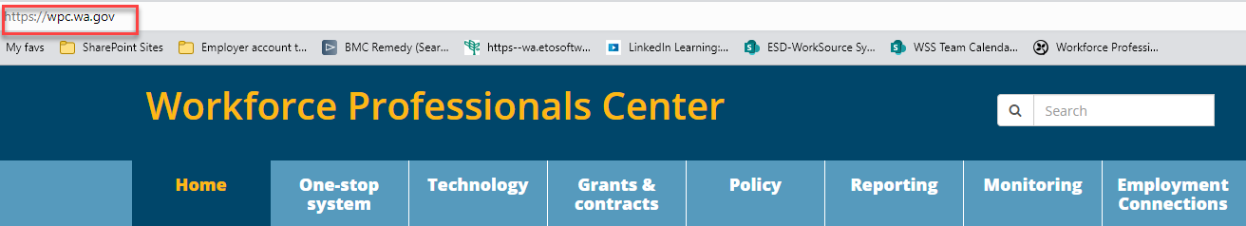

WPC Technology page https://wpc.wa.gov/tech
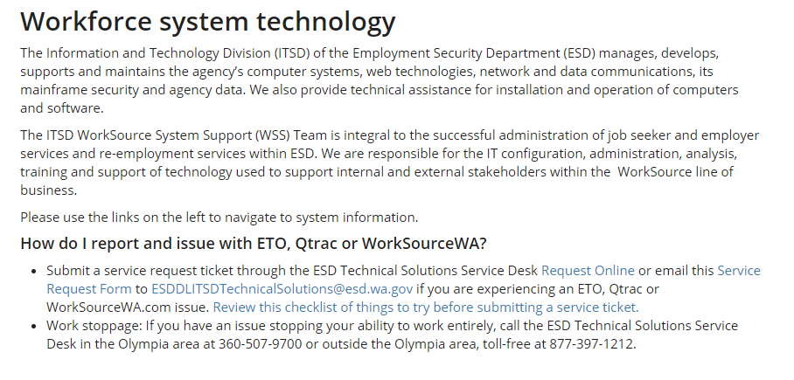
ETO training resources
The Employment Security Department and state Workforce Development Councils manage the current WorkSource customer management system known as Efforts to Outcomes, or ETO.

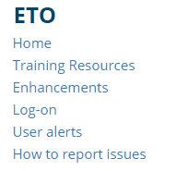
- WDA Contact-Trainers-Program Operators Contains WDA/WDC contacts, WDA Offices, Employment Connections Program Operators and Support Specialists, One-Stop Operators, Data Corrections Contacts. Each WDA is listed by area and includes contact information for their local trainers, program subject matter experts, and One Stop Operators.
- ETO basic and refresher training consists of 3 recorded training modules. ETO basic trainings are designed for new users to gain access to the case management system in accordance with ESD policy requirements and allow all staff to use as a refresher anytime. The modules cover ETO basic functionality, Workforce Professional Center resources and an overview of the WorkSourceWA job match system to assist staff in case management and business service delivery. The training modules do not cover policies, procedures, or program specifics. Program specific training is provided by Program Operators and specialists, supervisors, leads and program subject matter expert at your local office.
  - ETO Basic or refresher training agenda
  - ETO Basic training Module 1 is an overview of the WPC tabs covering workforce-development data, resources, policies, and events across Washington state.
  - ETO Basic training Module 2 details training resources for ETO, WSWA, Qtrac scheduler and important technology resources.
  - ETO Basic training Module 3 covers the ETO services catalog, and overview of ETO functionality, and resources found on the WSWA job board.
  - There are other training videos and desk aid under the following categories to help with case management or business services delivery
- Training Documents
- Adding a local program and contract guidance available for Department Head role
- CASAS - Customer's Educational Functioning Level desk aid for Test and Results TP
- Checklist of things to do before submitting a service request
- Create an ETO participant record
  - WIN0120 - Procedures for Adding Participants to Efforts to Outcomes (ETO) When Individuals Are Unable to Create a WSWA Account
  - WorkSource registration form
  - WorkSource Veteran registration form
  - Detail TP's required fields desk aid
  - Create a record PowerPoint process overview
    - PowerPoint recording
  - Coming Soon hands on training video
  - Staff training video
  - Manager/Supervisor training video
  - FAQ
- Customer management ETO guide - Staff version 3
- Customer management ETO TouchPoint quick guide
- Customer management glossary
- Economic Security for All Initiative (EcSA) guidance
- ETO Pop-up Blockers
- ETO Project-Program Management Training
- ETO Project-All User Refresher Training
- Finding a participant in ETO
- How do I sign my NDA?
- LinkedIn Learning
  - Recording a LinkedIn Learning touchpoint in ETO
  - Q & A
- Measurable Skills Gain (MSG) guidance - Documenting and recording progress
- MSG - Recording Measurable Skills Gain in ETO
- MSG - Running the Measurable Skills Gain report
- Opt-out of data sharing in ETO
- Recording an Employer Event touchpoint and running the report
- Reopening a closed program enrollment
- Review Staff Efforts for supervisors

Qtrac Scheduling training resources

The Employment Security Department and Washington State Workforce Development Councils manage the current WorkSource appointment scheduling tool, powered by Qtrac Scheduling. Please use the links on the left navigation to keep up to date on Qtrac. All training resources are found on this page. No further Qtrac training is provided during ETO Basic training.

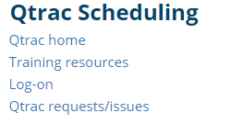
RESEA training resources
Reemployment Services & Eligibility Assessment Unit provides technical support, training, and quality assurance to WorkSource offices throughout Washington. The program focuses on individuals who are receiving unemployment insurance (UI) benefits, including those most likely to exhaust benefits. The goal of this program is assisting unemployment insurance claimants with returning to suitable work as quickly as possible.

WorkSourceWA training resources
- How do I report and issue with WSWA?
- Request for changes to WorkSourceWA content including WorkSource office locator information
- WorkSourceWA Job Match
- Job-match training
- Job-match PowerPoint
- Employer guide for posting jobs
- Employer guide for finding resumes
- WorkSourceWA.com users' guide job seekers and employers
- WorkSourceWA job match user guide for job seekers
- WorkSourceWA job match user guide for employers
- WorkSourceWA.com recruiters' desk aid
- Multi-factor authentication for employers
- WSWA Registration for New Employers with multi-factor authentication
- Updating your existing WSWA Employer account for multi-factor authentication
- Live Chat (Velaro)
  - Live Chat training intro
  - Live Chat engagement training
  - Live Chat Standard Operating Procedure Manual
  - Tips for a successful Live Chat
- Trumba
  - Online event calendar editor training
- 6Sense Technology
Guides to Monsters patented 6Sense technology for WSWA

Resources
- Technology resources
  - WorkSource resource and training room computers and printers for public use training resources
    - Computers for public use
    - Google tools
    - Microsoft tools
    - Other resources
  - Internet Explorer sunsetting
    - How to reset your default browser
    - Move your favorites
- System announcements
  - Employment Security Department launched a method for communications about Unemployment Insurance, Businesses, Rulemaking and Policy, Labor Market and Performance Analysis, WorkSource and WDA Virtual Job Fairs, and other business news. Stay up to date and receive these announcements by subscribing to GovDelivery
- How do I report and issue with ETO, Qtrac or WorkSourceWA?
  - Submit a service request ticket through the ESD Technical Solutions Service Desk Request Online or email this Service Request Form to ESDDLITSDTechnicalSolutions@esd.wa.gov if you are experiencing an ETO, Qtrac or WorkSourceWA.com issue. Review this checklist of things to try before submitting a service ticket.
  - Work stoppage: If you have an issue stopping your ability to work entirely, call the ESD Technical Solutions Service Desk in the Olympia area at 360-507-9700 or outside the Olympia area, toll-free at 877-397-1212.
- Teleworking resources
  - Refer to this guide for help with Teleworking Technical Reference Guide.
- Microsoft Teams
  - MS Teams quick start guide
  - MS Teams user basics
- Webex
  - Webex is a convenient application that connects you to online meetings and trainings. Unsure how to use this valuable tool? Browse this Webex handbook. The IT Division created some convenient how-to videos.
    - Set up your profile
    - Meeting basics
    - Advanced meetings
    - Delegates, alternate hosts, and meeting info
    - Recording meetings
- Other resources
  - Pin (save) an app to your taskbar
  - Tech security tips
  - Tech security news

- Services Catalog Link to the ETO services as outlined in WIN0077
- T12 documents
  - T12 is a 1-hour training call for all users of the ETO and WSWA systems. It occurs every Wednesday at 10am. Request an invitation to the meeting and be added to the mailing list by emailing the WSS Team at esdgpwssteam@esd.wa.gov.
  - 2022 T12 meeting minutes and recordings
- Security Administration
  - Requesting access to ETO or Qtrac, add change form, list of your local area access requester

Logging into the training environment in ETO and navigation the user dashboard

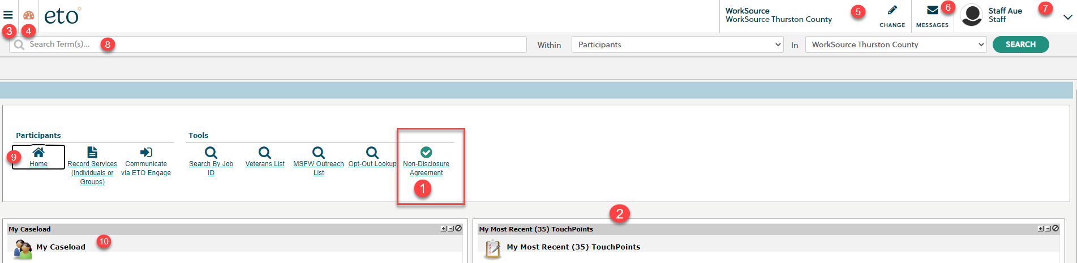
    - Go to the WPC Site and click the ETO Log-on
    - Signing training nondisclosure agreement (NDA)
      - How do I sign my NDA?
    - Remember to also sign an NDA in your production account when available
    - Accounts disabled for not signing NDA or inactivity of 90+ days
    - Your local Access Requester can reactivate account by submitting an ‘Add/Change’ request form to itbisecurityrequests @esd.wa.gov
    - My Most Recent (35) TouchPoints
    - Side navigation bar
    - Dashboard icon (takes you home)
    - Office assignment – change office
    - ETO email messages
    - Staff dashboard
    - Quick search for participants or entities (companies)
    - User Widgets

Search for participant (or company/recruiter)

- Finding a participant in ETO
- Opt-out of data sharing in ETO
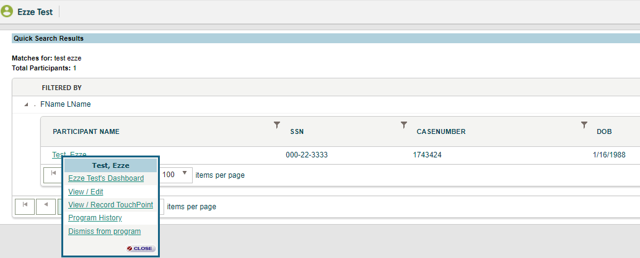
- Menu options from the participant dashboard icon
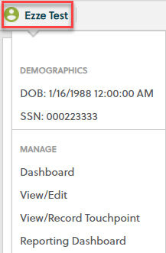
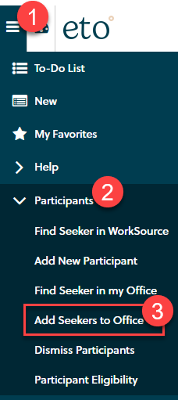

- Adding participant to your office
  - Open the side navigation menu
  - Open Participants menu
  - Select Add seekers to Office
  - Find seeker using SSN or ETO case number
  - Check the box next to participant name
  - Click Enroll Job Seeker

How to take a Touchpoint in ETO
- Program Enrollments
- Basic Services
- Group Service

ETO Reports
- Remember to click ‘Refresh Reports Menu’ before running all reports
- Export reports to Excel using the (.xlsx) extension
Note: If report menu open but quickly returns to the start you may have an issue with pop-up blockers. Watch this short video to guide you through adding ETO reports as a safe site.
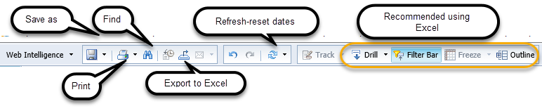

You’ve completed ETO Basic training. How do I get my production account?
Let your supervisor or lead know when you have completed the 3 training videos and the short quiz so they can complete the ETO ADD/Change form and send it to your local Access Requester. Find more information about gaining ETO access on the WPC site under Security Administration.

Additional Resources:
WorkSource Systems Support (WSS) Team esdgpwssteam@esd.wa.gov

State Guidance, Worksource Information Notices (WIN): https://wpc.wa.gov/policy/state/guidance
- WIN0077 WorkSource Services Catalog
- WIN0082(Rev1) Real-Time Data Entry

