Business Services Basics
- Employer record structure
  - Company Entity (parent) is the primary record. Think of this as the headquarters building.
  - Sub-Entity is the next level of record related to the Company Entity. Think of this as the worksite. If there is more than one worksite, there can be more than one Sub-Entity record under a Company Entity
  - Recruiter represents a person within the company.
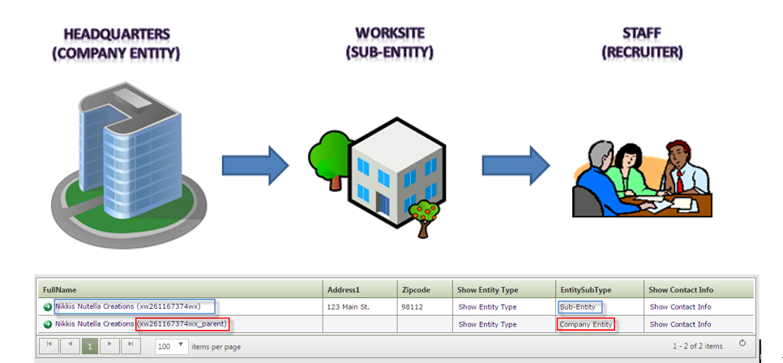

Entering a Business Services TouchPoint
Best practice: Employer services and case notes should be documented under the sub-entity not the recruiter account. The benefits of this practice are:
  - Locate recruiters associated employer record
  - Services are under a common record
  - Job postings display under the Sub-Entity record
Finding an employer sub-entity account
The process begins by logging into ETO:
- If you have access to multiple offices, select the office you want the service to be recorded in by clicking the drop-down menu select your office from the list of options
- Enter the company name or company ‘X’ code of the business you want to record a service to
  - ETO doesn’t support using the ‘ or & characters when searching for an employer name
- Change the ‘Within’ field to ‘Entities’
- Change the ‘In’ field to ‘WorkSource’ and click ‘Search’

Note: 'When you are searching by company name or franchise, multiple names of a business may appear in your search results
Click on the ‘Sub-Entity’ name from your search results to open the account menu and select dashboard
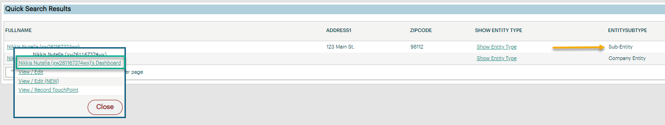

Employer Dashboard Features

Dashboard of a ‘Sub-Entity’ employer account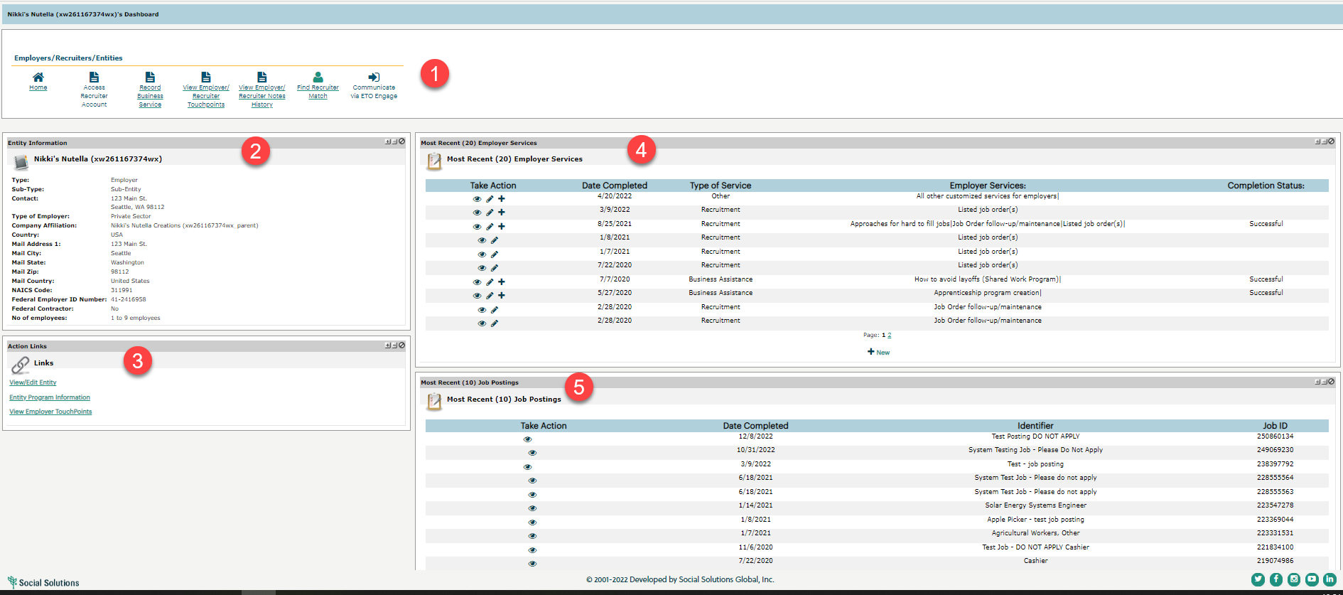

- Widgets
- Entity Information: overview of the employer account information, address, number of employee’s, FEIN, Sub-Type
- Action Links: View/Edit, Entity program information, view employer TP’s from this screen
- Most Recent (20) Employer Services: 20 of the employer’s most recent services, recruitments, job listings, and follow-up activities
- Job Postings: includes date completed, job order ID number, position identifier

If you need to find the recruiter(s) associated with an employer, click the ‘Find Recruiter Match’ widget to produce a report with recruiter names. Click on the link to go to the recruiter dashboard.

These are the results for a recruiter search from a sub-entity account

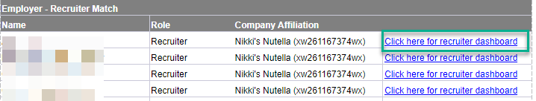

Impersonation and Error Messages
- “There was an error in impersonation”
  - The recruiter account was created but the account was not activated. Impersonate an active recruiter, click ‘Your Account’ tab, ‘Users’, ‘Pending users’, select recruiter account and send a reminder
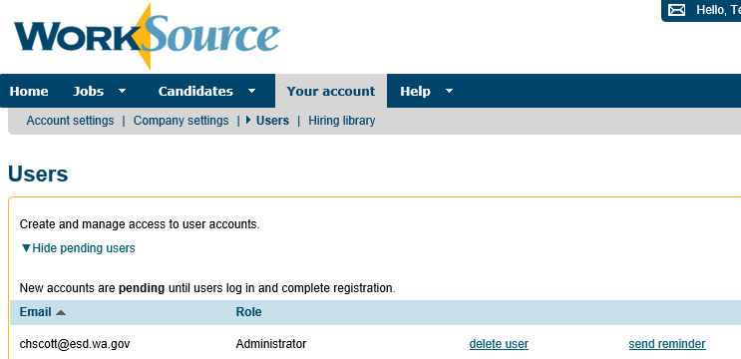
- Refresh session
  - ETO and WSWA are on separate timeout clocks. To refresh and sync ETO and WSWA for ‘Impersonation’ log out of and back into ETO

Entering a Business Services TouchPoint
Start from the ‘Sub-entity account, click on the ‘Record Business Service’ widget and land on the Employer Services tab
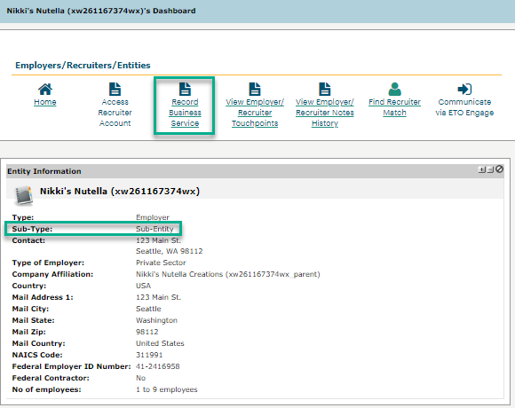

Employer Services tab
The TouchPoint opens on the ‘Employer Services’ tab where you can enter the following:
- Identifier allows you to enter a descriptions of the service
- Use the dropdown menu to enter service on behalf of another staff
- Contact Location/Method menu allows you to select method of service delivery
- Enter the business contact person
- Schedule follow-up alerts to add to your ‘To-do’ list
- Select how you want to record service
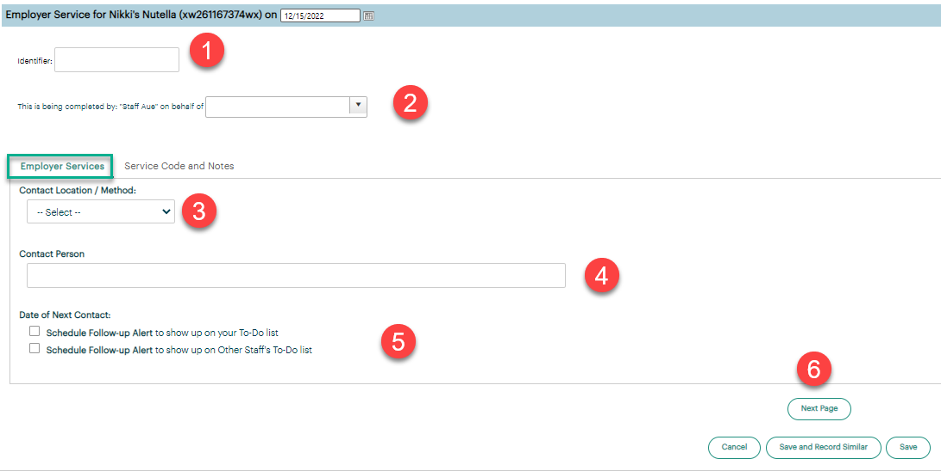

Service Code and Notes tab
Click this tab to select the type of service you provided to the employer.
- Identifier allows you to enter a description of the service
- Use the dropdown menu to enter service on behalf of another staff
- Type of Service (required field which opens interactive menus)
  - ‘Employer Services’ tab will open depending on the type of service selected.
  - Add a note
  - Service cannot be saved for these required fields
- Ignore Deactivated or legacy services code
- Upload Documents
- Select how you want to record service
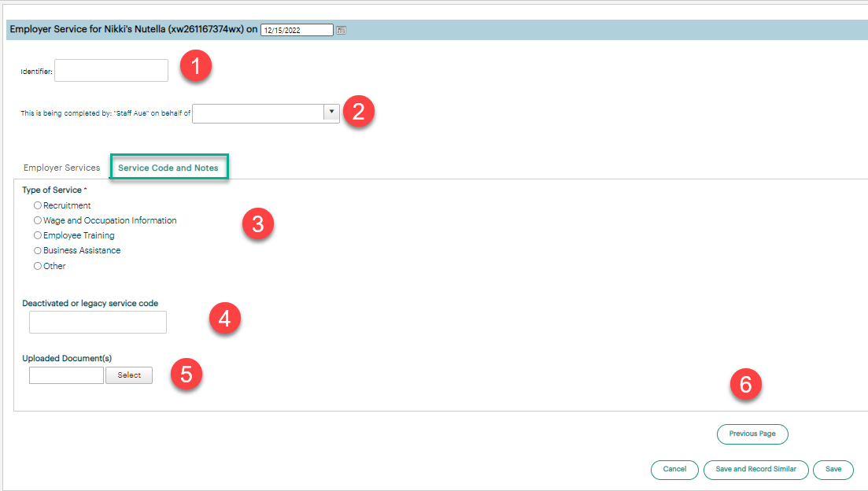

Review the new service(s) TouchPoint from your ‘Most Recent (20) Employer Services’ dashboard

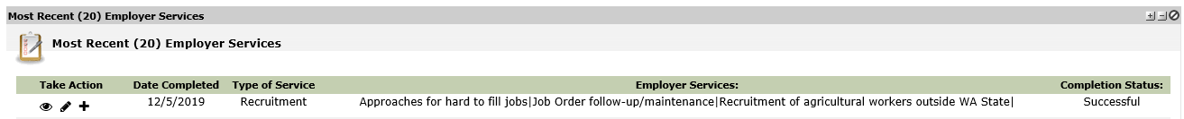

Resources
- Workforce Professional Center for WorkSource Technology
- Services Catalog of ETO business services TouchPoints and their descriptions
- WorkSource Systems Support Team (WSS) group email esdgpwssteam@esd.wa.gov

