Employer & Job Posting Reports for Business Services
- Click the bar to open the side navigation menu
- Click ‘Reports’ to open menu and click ‘View Reports Menu’
- Remember to always click the ‘Refresh Report List’ before running any ETO report
- Click the + to open the Employer & Job Posting Reports menu
- Employer reports menu will open to the selections
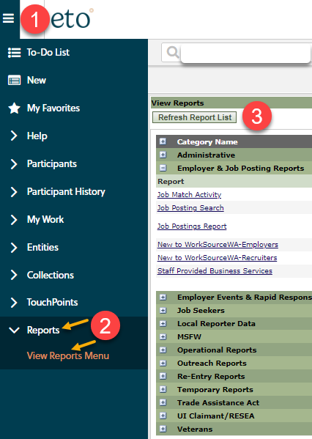
Available reports and description of what each report contains.
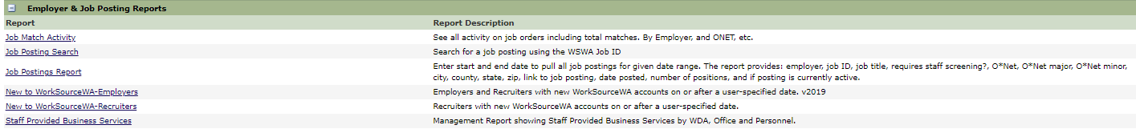
Guide for the reports ribbon
Hover over the report ribbon icons to see the options available to you after running a report. It is recommended you export all reports into Excel and save so you can filter results to fit your needs.
Resources
- Workforce Professional Center for WorkSource Technology
- Services Catalog of ETO business services TouchPoints and their descriptions
- WorkSource Systems Support Team (WSS) group email esdgpwssteam@esd.wa.gov

