WorkSource Washington Job Match System
Washington's award-winning job board employment website, WorkSourceWA.com (WSWA) is provided as a service to job seekers and employers in the state of Washington for informational purposes related to employment and job search only. Use of this service is limited to individual job seekers and employers who agree to hold the State of Washington and the Employment Security Department (ESD) harmless for any use of the information for reasons other than the stated purpose.
Employer Record Structure
Employers have the ability to create a WSWA account on Employment Security Department’s job match website. Creating a WSWA employer account establishes three account types described in the following structure:
- Company Entity is the primary record. Think of this as the headquarters building.
- Sub-Entity is the next level of record related to the Company Entity. Think of this as the worksite. If there is more than one worksite, there can be more than one Sub-Entity record under a Company Entity
- Recruiter represents a person within the company.
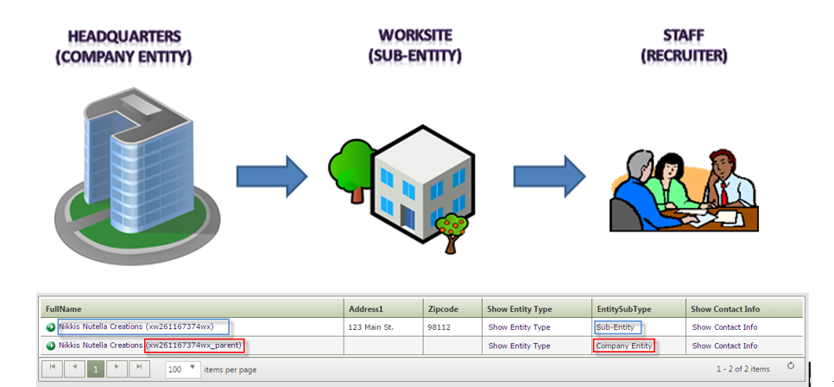+
Employer or Recruiter search
You can search for an employer by company or recruiter name, company ‘X’ code or recruiter ID number.

Log into ETO to begin searching by entering information in Quick Search:
- Enter company or recruiter name, company 'X' code, ID number
- Toggle the ‘Within’ field from Participant to Entities
- Change the ‘In’ field from your active office to ‘WorkSource’ to search the entire ETO system for the company or recruiter
This search produced the following results.
Select ‘Sub-Entity’ to land on the page where you can view company information, twenty most recent employer services, ten most recent job postings, enter or review case notes. Click the ‘Find Recruiter Match’ widget on the sub-entity dashboard to run a report to present all recruiters associated with the company.
Employer Services and Case Notes
Employer service activity can be documented under the sub-entity or recruiter record. However, when several business services staff work with the same employer or multiple recruiters for a company, it is a best practice to document all activity into the sub-entity record and not in the ‘Company Entity’ or recruiter record. The benefits of this are services are under a common record.

Impersonation
Impersonation is a feature in ETO where staff ask the recruiter for permission to access their WSWA account. Impersonation can only be done from a recruiter account. To ‘Impersonate’ an employer click the ‘Access Recruiter Account’ widget from the recruiter's dashboard.
Note: If you don’t know who the company recruiter(s) is, run the ‘Find Recruiter Match’ from the company sub-entity account.
When finished impersonating and employer be sure to click ‘End Session’ from the recruiters WSWA account. Not ending the session can cause issues with your ETO experience.
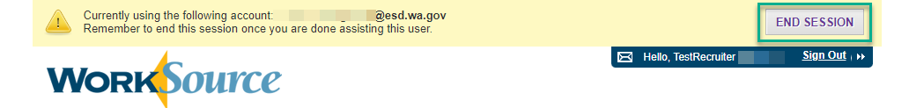
WSWA Recruiter Dashboard
Recruiters, or staff who are impersonating a recruiter, will be able to post jobs, search for potential candidates using the resume search feature and review applications from job seekers. Recruiters who are account Administrators can add or remove recruiters.
There is a help feature and links to system tutorials as well as help starting a business in Washington and links to Employment Security and WorkSource office resources.
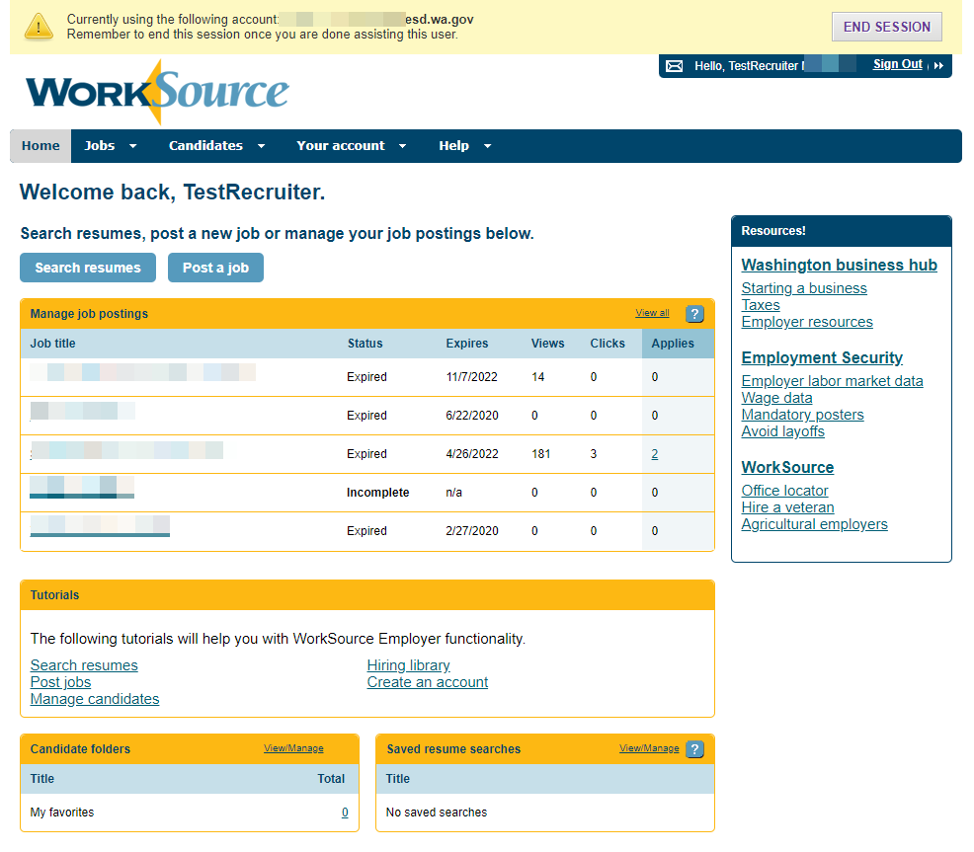
WorkSourceWA Job Match Training Resources
These additional WSWA training resources will assist staff when working with employers are found on the Workforce Professional Center

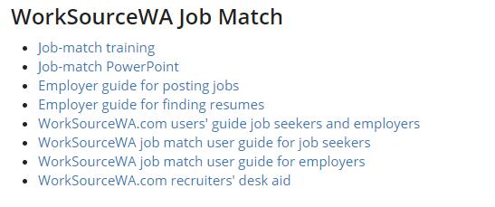
Recording Employer Events and Report
At the request of Business Services, Rapid Response and TAA staff, the Employer Events TouchPoint (TP) was created to gather raw data for employer hiring events, job fairs, Rapid Response events, TAA Orientations and other events. The TouchPoint includes an Identifier field to call out the event, a dropdown to select the type of event and free form text boxes to record type of employer event, industry/sector, number of employers in attendance, number of seekers in attendance, number of seekers hired and notes.
Follow the link to the desk aid for Employer Events TouchPoint and Running the Report
Resources
- Workforce Professional Center for WorkSource Technology
- Services Catalog of ETO business services TouchPoints and their descriptions
- WorkSource Systems Support Team (WSS) group email esdgpwssteam@esd.wa.gov

