Data Load Error on RESEA Dashboard

Staff may receive a ‘Data Load Error’ when attempting to access a participant’s RESEA Required Elements – Initial dashboard.
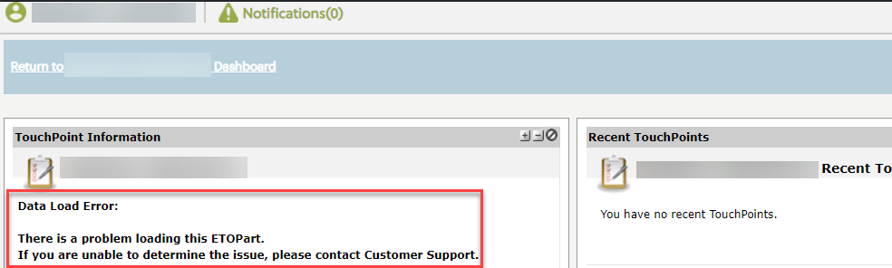

This happens when a .msg file is uploaded to either the RESEA Required Elements – Initial or RESEA Required Elements – Follow-up TouchPoints (TP).
There is a note at the top of each of these TPs on the Upload tab that states to not upload files with a .msg extension.
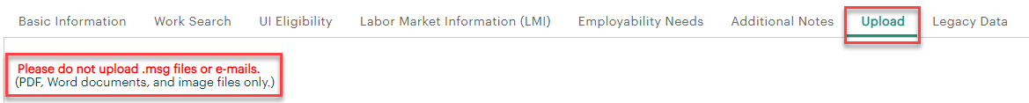

In order to access the dashboard and not get the ‘Data Load Error’, staff must remove the uploaded .msg file type.
Staff can re-save the .msg file type into a different format by copying into a Word document or save as a PDF file, in order to upload to the TP.

