Before submitting a service request try the following

Can’t log into ETO

- Clear your cache. Instructions are found on this document under Things to do to improve overall performance
- Try logging in using another browser, try both Edge and Chrome
  - Go to the WPC site (WPC.WA.GOV), select the Technology tab, under ETO click Log-on. If this link works, replace your ETO desktop shortcut or favorite with the ‘good link’
- Remember to log out of ETO the right way
  - Clicking the browser tab ‘X’, does not end your ETO session.

  - If you do not logout of ETO each time, this may cause issues when you log in the next time.
  - Open your profile menu and click ‘Logout’ to prevent future issues logging in
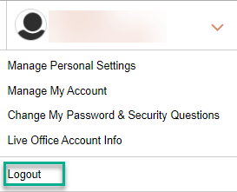

- Last time you impersonated an employer or job seeker, did you end the session or click off the browser?
  - If you were impersonating a job seeker or recruiter, remember to click ‘End session’ found in the upper left-hand corner for job seekers or in the right-hand corner for employers. Clicking off the browser tab does not end impersonation and will interfere with your ETO user experience! After you end the WSWA impersonation session you can click off the browser before returning to ETO.
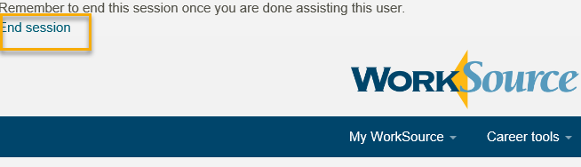

Issues running ETO reports
- Before running ETO reports always click ‘Refresh Report List’
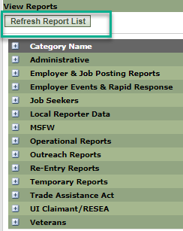
- Refer to the ‘ETO Report Pop-up Blockers’ desk aid if you click on a report, the screen flashes and you return to the report menu page.
- If you have issues with a report timing out? Are you using too large of a start/end date range? Narrowing down the date range might improve changes of the report running.

Things to do to improve overall performance

- Clear your cache weekly for best ETO and computer performance
  - Microsoft Edge
    - Click the More (three-dotted) button on the top-right corner
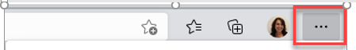
    - Select Settings
    - Click ‘Privacy, search, and services’
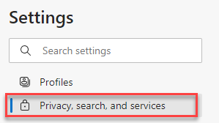
    - Under ‘Clear browsing data’, click the Choose what to clear button.
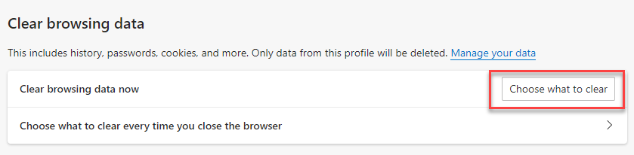

  - Chrome
    - Clearing your cache in Chrome starts from the top right side of the browser bar
    - Click the triple dots to open the Chrome tools menu
    - Hover over “More tools”
    - Click “Clear browsing data” which opens a new screen

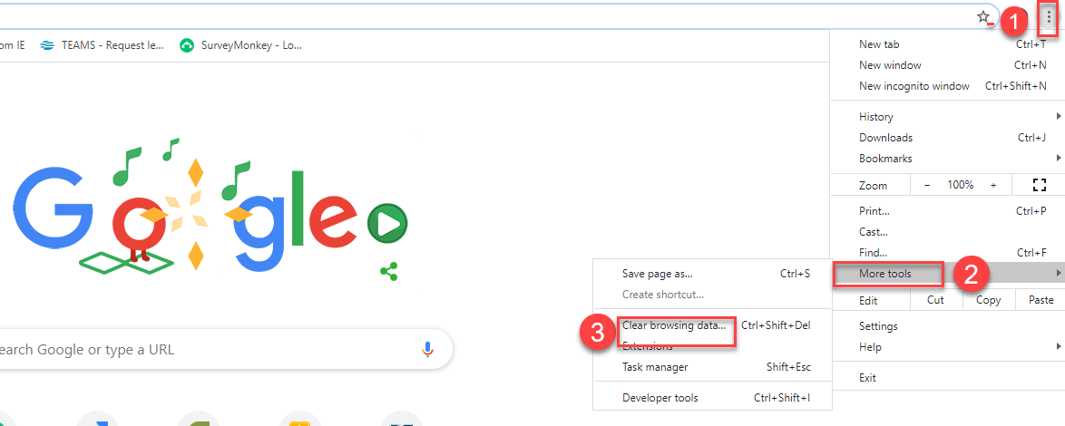

    - Select the actions you wish to take and then click ‘Clear data’
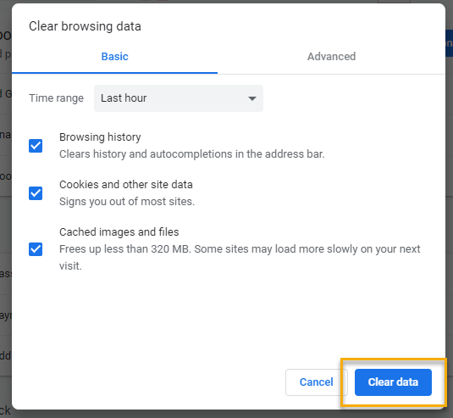

- Finish by restarting your computer
If you still experience issues, submit service requests for:
ETO - https://wpc.wa.gov/tech/issues
Qtrac - https://wpc.wa.gov/tech/qtrac-service-requests
WSWA - https://wpc.wa.gov/tech/wswa-service-requests

