Instructions for Adding or Disabling a Local Program and Contract
Local programs and contracts is an optional functionality in ETO allowing local areas to enter and track programs and contracts. When utilizing this functionality, please consider the following:
- What is a local program? – A local program is a grant or funding stream managed at the local level. This does not include grants managed at the state level, such as WIOA Title I programs or Trade Act. Local programs should never be created for programs already present in the statewide list.
- What is a local contract? – A local contract is used to identify a service provider. A service provider may provide services under one or more programs, including local programs.

The process begins:
- The functionality of adding a local program or contract is restricted to staff with the ETO user role “Department Head” (typically your local areas data correction, MIS staff, supervisor). If you don’t know who has this role in your area, submit a remedy ticket for assistance.
- Creating local programs and contracts will automatically be assigned to whatever office you are logged into when you create them. After the entity (local program or contract) is created you can add additional offices to them if needed.
  - Note: Additional offices can be a single office, all offices within your region or WDA, or all offices statewide.
- Adding a local program or contract:
  - Open the left side Navigation pane and select “Entities”
and “Add new Employer”

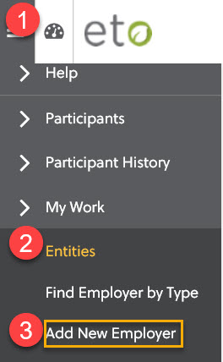

  - Enter an Entity Name and Type. You will always choose “Local” for your entity type. The Entity Name should be the name of the program or contract you are entering.
  - For entity subtype, choose either local program or contract as appropriate.
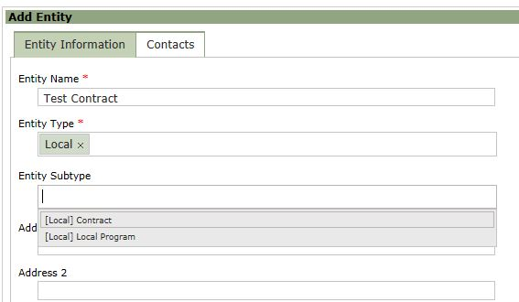
  - The other fields are optional, but it is recommended to put a description of the program or contract in the Entity Notes section rather than Description as this information can be seen when using the “View Entity” link next to the local program or contract. You will not use the fields or menus below “Entity Notes”.
- Once you click save, you land on the View/Edit Entity screen. Select the “Program Assignment” tab to assign your local program or contract to other offices.
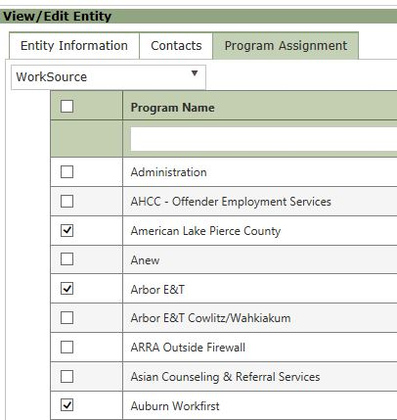
- Adding additional offices to your local program or contract:
  - Click on the Program Assignment tab.
  - Choose “WorkSource” from the Select Site menu.
  - Only offices you are assigned to will appear. You can select one or more offices to add your local program or contract to. This tab also allows you to filter by Program Name (Office Name). When finished, click save at the bottom to add them.
    - Note: before saving you can check and uncheck offices at will. However, once you save you are unable to deselect an office from this screen. Instructions on removing offices from a local program or contract are below.
  - After saving, you will stay on the Program Assignment screen.
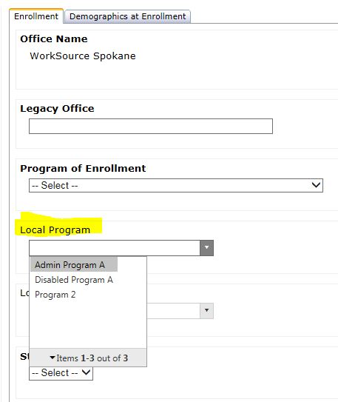
- When viewing a seeker’s touchpoints, any program or contract you added will be selectable from the drop-down menus. Only programs and contracts assigned to the office you are logged into will display.
  - Local Program: a local program must be assigned to a Program Enrollment touchpoint for it to be selectable on other touchpoints.
  - Contract: contracts do not have to be added to the Program Enrollment touchpoint to be selectable on other touchpoints.
- When filling out touchpoints with local program and contract fields, consider the following:
  - Both statewide and local programs will appear in the Program Affiliation fields on the various touchpoints.
  - Contracts can be assigned as needed.
- To view, edit, or remove a local program or contract:
  - Using the Navigation Pane, under Entities, select “Find Employer by Type”.
  - Select “Local” for Entity Type, choose the Entity Subtype and click Show Entities.
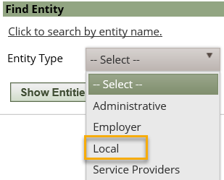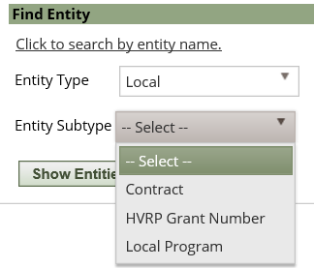
- Depending on your Entity Type or Subtype selection, all local programs or contracts will display statewide. Filter to the program or contract you’re looking for.
- Clicking on the name of the entity will open the view/edit entity screen. From this screen you can update the entity information or from the Program Assisgnment tab you can add additional offices or dismiss an office you no longer want attached to the program or contract.
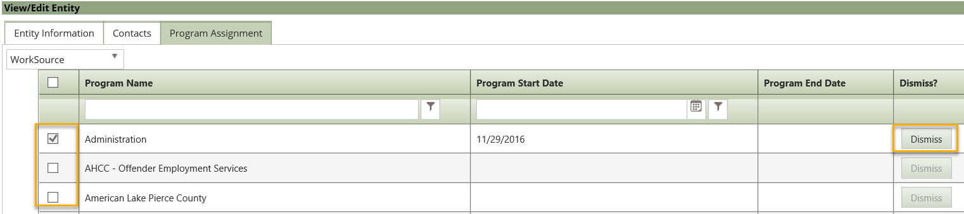
- Removing a program or contract from an office:
  - Find Entity following steps in bullet 8
  - Type in the name or partial name of the program or contract click search
  - Click “Disable” in the “Take Action” column
  - You will get a message that the Entity was disabled
  - Once disabled, the entity will no longer be available to select as a program or contract but will be visible in the TPs they were attached to.

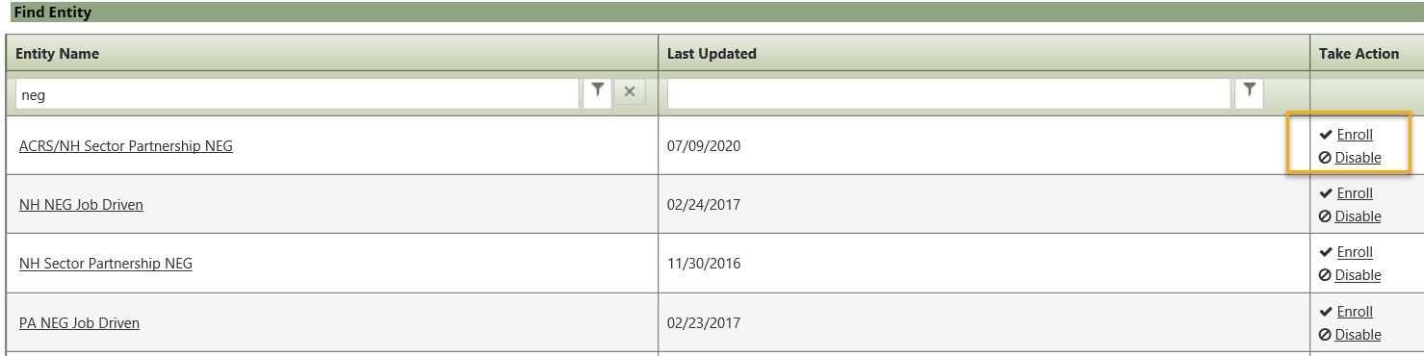

Note: You can also “Enroll” from the search screen, which will add the entity to the office you are currently logged in under.

