Good afternoon Team,

In lieu of the T12 training call this week I promised to send out helpful information pointing you toward important links to keep you connected with staff, job seekers, claimants, employers and help. I am including a check list of things to try before submitting service requests or remedy tickets. This information can be found on the Technology [WPC](https://wpc.wa.gov/tech) site for all users. Keep in mind some of the information is specifically for those inside the ESD firewall but most of the tools are general information useful to everyone.

**Teleworking:** This [Teleworking Technical Reference Guide](http://media.wpc.wa.gov/media/WPC/tech/COVID/Teleworking%20References.pdf) will help you.

**Webex:** Many of you are new to using Webex for meetings. It is a great tool to set up interviews with job seekers, employers, connect with other staff or attend meetings and trainings. There is a handbook and 5 videos on the WPC site. The handbook is 31 pages long but is a quick read consisting mostly of screen shots. I suggest you review the first 13 pages to learn about: setting up your account, meeting basics, inviting attendees, sharing your screen, muting attendees, locking a meeting, etc.

*During the Softphone meetings this week many struggled turning their video off and muting audio. It is important to turn these controls off as leaving them on can interfere with internet bandwidth.*

When in a Webex meeting you can hover over the bottom of your screen for the meeting controls menu to appear. Click on the Audio and Video to turn them on or off.

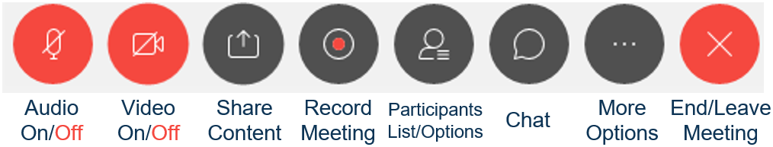

**Skype** is another application connecting you to online meetings and allows you to call other people signed into Skype. Instructions on setting up your Skype to make audio calls can be found [here](http://media.wpc.wa.gov/media/WPC/tech/COVID/Skype-audio-guide.pdf).

**You can sign into ESD email** through [mobile.wa.gov](https://mobile.wa.gov/owa/auth/logon.aspx?replaceCurrent=1&url=https%3a%2f%2fmobile.wa.gov%2fowa%2f). Remember to type **esd1/** before the username when you log into your computer or phone.

**Softphones** training will be conducted daily 10-11. Plan to attend a Webex training to learn more about using the desktop phone system. Check out the useful information in this guide [VoIP Cisco IP Communicator (Softphone) Setup Guide](http://insideesd.wa.gov/Media/Default/it/voip-cisco-IP-communicator-softphone-training-new-2020.pdf)

**FAQs** on how to submit service tickets, how to sign into your home Wi-Fi, connecting to Internet Explorer from a Mac computer and COVID19 updates.

The WorkSource Systems Support (WSS) Team is here to help you. Contact us at [esdgpwssteam@esd.wa.gov](mailto:esdgpwssteam@esd.wa.gov)