T12 Meeting Minutes 12-23-2020
Happy Holidays!
Remember: After starting a Webex meeting to mute your audio and disable the video feature. Too many attendee’s with active video can interfere with everyone’s audio quality. Hover over the lower edge of your monitor screen to find the icons.

Thanks to all who contribute to this weekly call!

New Business

- ETO Enhancements updates -
  - Create an ETO Participant record by staff so you can record services – on hold, implementation date TBD
- Tickets into production –
  - WA-4002; Staff reported in this ticket they were unable to create a group service list of class participants who attended a full week of classes. Ex: 5 different services in ETO, one for each day/class of attendance. Staff reported they were unable to choose “Save and Record Similar” to add all classes attended for a group of job seekers. MGS reports issue resolved 12/17/20. Demo’ d this process duping the class and group services are working as expected. More to follow on making a TP change to allow participants who are not added to the user’s office to be added.
- ETO maintenance – 3rd Saturday of every month
- WSWA maintenance – n/a
  - WSWA help desk holiday hours; close early 3PM on Christmas Eve and New Year’s Eve. Voicemail message will be updated to reflect early closure. Customers will receive return call the next business day.
- Velaro maintenance – n/a
- ETO Engage – We began work on enhancement of this tool. Getting closer to training material and delivery of training.
- What’s new on WPC –
  - Virtual training tools; Google tools, Microsoft tools, Public use computer https://wpc.wa.gov/tech/techrefresh
  - Report’s enhancements; check it out here https://wpc.wa.gov/intro_enhancements
  - ETO user role; check it out here https://wpc.wa.gov/tech/security
- ETO Basic and Refresher Training Next training 1/19/21 2-4PM
  - ETO Basic training is the 1st Monday 10-12 and 3rd Tuesday 2-4 of every month (except holidays). Send email to Lynn Aue to receive more information, training account if needed and be added to the training Webex call. Please do not be forward invites.
  - Training recordings and user guides are posted on the WPC website here https://wpc.wa.gov/tech/ETO-refresher-training
  - Submit a remedy ticket requesting additional training opportunities and resources
- Open discussion and training issue(s)–
  - Look for new T12 meeting invite for 1st quarter 2021 sent on 12/29/20
  - How to opt-in a participant who choose to op-out of data sharing when creating their UI claim http://media.wpc.wa.gov/media/WPC/tech/staff-resources/Opt%20Out%20Guidance-1.docx
  - Reminder: Submit remedy tickets for all work requests. My team cannot begin work without a service request. Reaching out to us directly can affect the time it takes to resolve your issue. Thanks! https://wpc.wa.gov/tech/issues
- UI announcements –
  - CARES act and decisions made around that – what does that mean for us and the customers?
  - Congress passed 5500-page extension of the CARES act, has a focus on extending UI benefits
    - Extends Pandemic Unemployment Assistance Act by 11 weeks – from 39 weeks to 50 weeks
    - Extends PEUC by 11 weeks – from 13 to 24 weeks
    - Additional “cash” in extension – was previously $600 but will be $300
    - Extends Shared Work program
    - Maintains waiver of wait week for unemployment claims
    - Higher screening/verification for qualifying for this assistance
  - Extension will go to at least March 12: clients can receive benefits through March 12, but if on that date the maximum weeks payable not reached, could go as far as April 10 (previous deadline was 12/26)
  - Will be waiting from DOL federal guidance policy letter (UIPL) for requirements to implement these extensions and all the documentation part of that
  - Job search information found here https://esd.wa.gov/unemployment/job-search-requirements /

  - Here is the information to provide feedback on Work Search Requirements
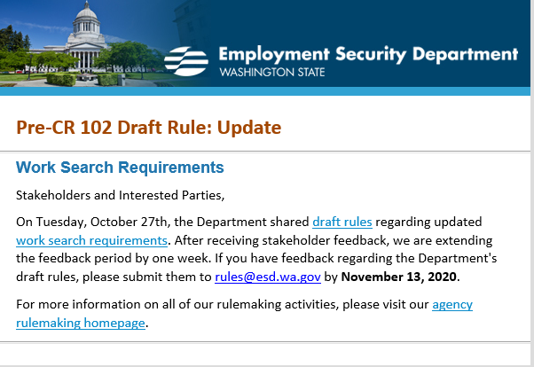

Initial unemployment claims for regular unemployment, Pandemic Unemployment Assistance (PUA) and continued claims decreased during the week of December 13 - December 19
During the week of December 13 – December 19, there were 17,596 initial regular unemployment claims (down 10.0 percent from the prior week) and 458,912 total claims for all unemployment benefit categories (down 6.6 percent from the prior week) filed by Washingtonians, according to the Employment Security Department (ESD).
- Initial regular claims applications remain at elevated levels and are at 99 percent above last year’s weekly new claims applications. (17,596 for the current week versus 8,829 for the same week the prior year).
- Initial claims for regular unemployment, Pandemic Unemployment Assistance (PUA), and continued/ongoing claims for regular benefits all decreased over the week.
- Decreases in regular initial claims over the week occurred across most industry sectors with the largest decreases over the week occurring in the Accommodation and food services (-963) and Manufacturing (-312) industry sectors. Increases in regular initial claims occurred in the construction sector (+352) during the week.
- The increase in initial claims for the PEUC program this week occurred mainly within Extended Benefit initial claims (+2,474 initial claims increase for prior week) while initial claims for PEUC were down 611 initial claims.
- The 30,708 decrease in continued/ongoing claims for all entitlement programs was primarily due to regular unemployment insurance benefits payments which decreased 19,175 over the week as well as PUA benefit payments which decreased by 13,617.
In the week ending December 19, ESD paid out over $154 million for 305,547 individual claims. Since the crisis began in March, ESD has paid more than $13.1 billion in benefits to over a million Washingtonians.
For current COVID-19 and UI information ESD.wa.gov or ESD Facebook page

- Before submitting a service ticket help see instructions at end of this document.
Review of ETO/WSWA and other resources (AKA old business)
- Encourage all staff who use ETO and WSWA to sign up for the T12 calls. These calls are not just for trainers but for all system users and a great way to stay up to date on changes or improvements to ETO and WSWA. Send requests to esdgpWSSteam@esd.wa.gov to be added to the ITSD Training Team’s distribution list
- WorkSource Systems resources found on the WPC Technology site https://wpc.wa.gov/tech
  - We try our best to make sure all the links are operational but depend on you to submit a remedy ticket if you find broken links!
- WSWA Virtual services to assist job seekers/employers to sharpen skills. There are many tools on WSWA but here are a couple of my favorites!
Check out these virtual classes under Resources>Training and other programs.

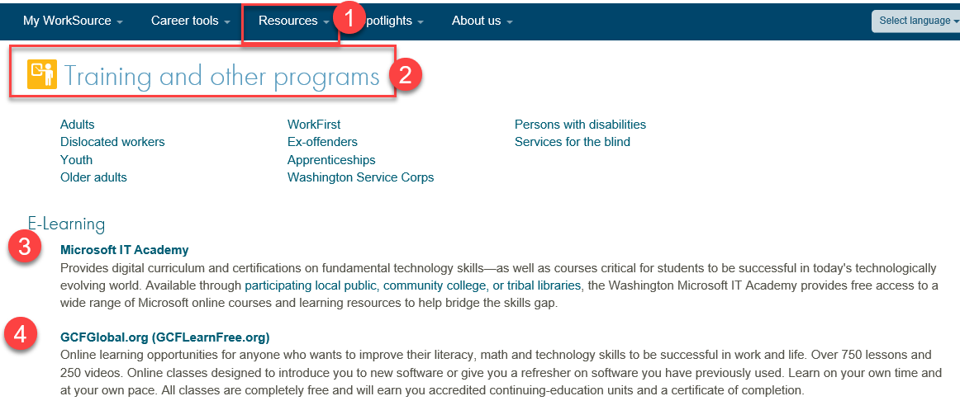

- Stay up to date on COVID19, teleworking and WorkSource Virtual services. Check out the information the WPC website to help all WorkSource staff telework.
  - IT service delivery
  - WebEx
    - Browse the Webex handbook and watch 5 videos on how to make the most out of this tool for conducting meetings with staff and customers.
  - Other resources include:
    - Now that you are teleworking reference guide
    - How to use SKYPE for online meetings
    - How to sign into ESD email from outside the network
    - How to sign into an off-site Wi-Fi from your computer
    - Can I access Internet Explorer from a MAC computer?
    - ESD service Desk information.
- UI Fraud help
  - www.esd.wa.gov/fraud
  - Fax information to claims centers 833-572-8423 –calling is not recommended due to the high volume of calls
  - Reviewing our web resources with them. Some helpful pages include:
- Employee FAQs
- Employee instructional videos
- How to file weekly claims
But you CAN’T help by:
  - Contacting an intake agent at the claims center and asking them to review your friend or family member’s claim or solve their issue.
  - Using your influence to move your friend or family member’s claim up the queue to be processed faster.
  - Using your influence to give any kind of advantage to your friend or family member.
  - Using your access to UTAB, if you have it, to give someone information about their claim.
  - Using your friend or family member’s SAW account and applying for benefits or submitting their weekly claims for them.
- Cisco Softphones training material Link http://insideesd.wa.gov/services/it-services
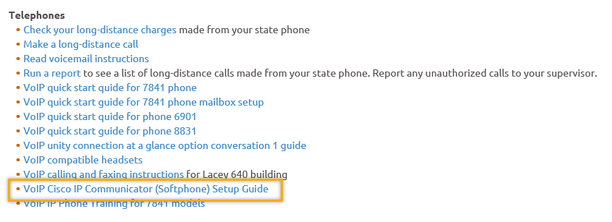
- Before submitting a service, request review these suggestions as the services desk will ask you to run through these steps. Many times, this resolves your issue without a service request!

  - Remember to log out of ETO, clicking off the browser tab here does not end your ETO session and will create issues when you log in again.
      - Always logout by opening your profile menu and clicking “Logout”
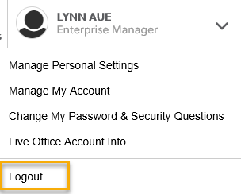
  - If you were impersonating a seeker or recruiter from ETO to WSWA remember to end the session, found in the upper left-hand corner. Clicking off your internet browser tab does not end impersonation!
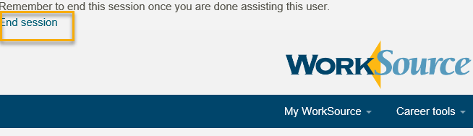

- For best performance clear your cache weekly

  - Internet Explorer (IE): Clearing IE cache starts from the top right side of the browser bar, click the settings icon and select Internet Options
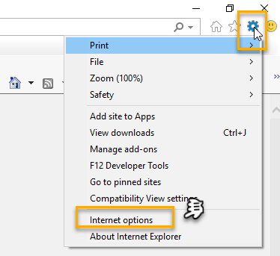

    - From the “General” tab click “Delete” which takes you to the “Delete Browsing History” screen. If not already checked click on the 2 boxes outlined here and click “Delete” you will return to the “General” tab

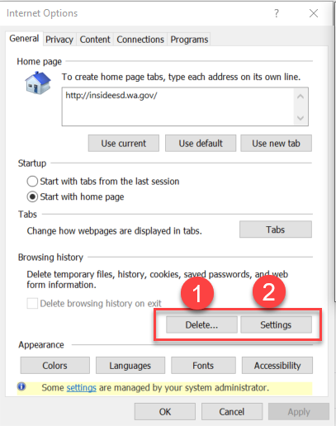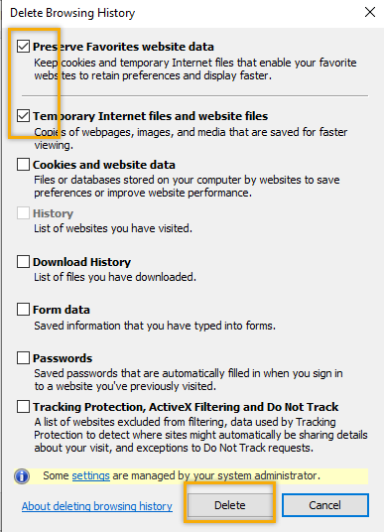

    - Next click “Settings” and if not selected click the radio button for “Every time I visit the webpage” This ensures you are using the most up to date version of ETO. Click OK
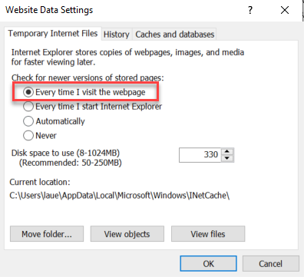
      - You will return to the General tab and click Apply and OK to complete the process of clearing your cache

  - Clearing Chrome cache starts from the top right side of the browser bar
- Click the triple dots to open the Chrome tools menu
- Hover over “More tools”
- Click “Clear browsing data” which opens a new screen
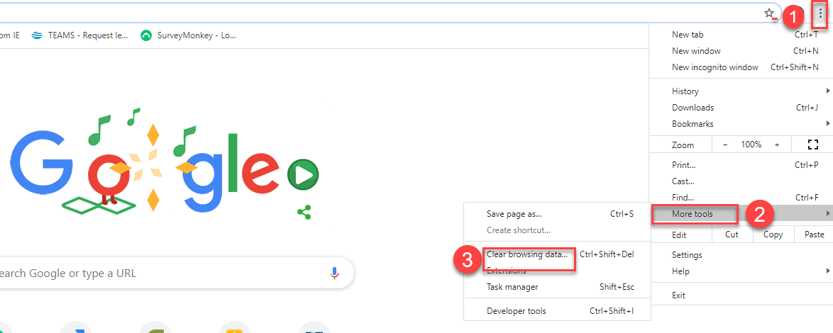

- Click “Clear data”
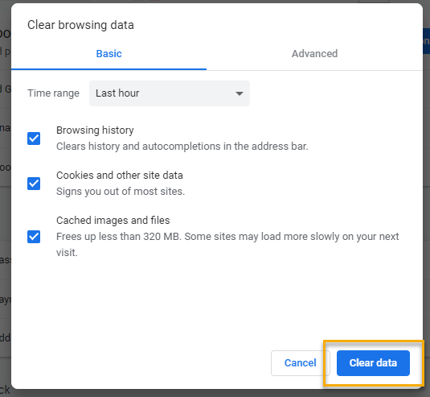

  - Finish by restarting your computer
  - If you still experience issues submit a service request https://wpc.wa.gov/tech/issues
CHAT

Regarding recording group services with 4+ participants:
from Catherine Geddis to everyone: 10:11 AM
If you change the area to the left of Search button to WORKSOURCE wouldn't it return participants from other offices/areas?
from Skyler Blumenthal to everyone: 10:13 AM
Yes, changing that dropdown to just WorkSource will broaden the search to all participants instead of just the office you've selected
[review] This is the case for searching participants, but when creating group services, it only works for participants in that given office, the full functionality is still being worked on
from Catherine Geddis to everyone: 10:14 AM
rats

from Teresa Anda to everyone: 10:22 AM
Regarding group services: When adding a program of enrollment to the tp, names of other participants will show up under the participant that is attached to that program enrollment. I have always questioned if that is ok since there should not be names of other participants located in the file (Miscellaneous Observations in Monitoring Tool)
from JOANIE LINDER to everyone: 10:24 AM
If Teresa can send us a couple of examples to review, that would be great!
from JOANIE LINDER to everyone: 10:24 AM
:) Thank you!
from Teresa Anda to everyone: 10:25 AM
I believe the tp appears on all participants

Lynn: Monster and WSS Team review this during the ticket review meeting but didn’t see all participant were tagged with the PE. Waiting for more input from Teresa so we can fully investigate.

Regarding Pulling up a specific report:
from vdamneun to everyone: 10:15 AM
Hi Lynn,
I have issue producing report under Operational Reports, I want to print all enrollments in King County by Zip code. It keeps loop back to Operational Reports option since yesterday.
If you are looking for a specific report or are having issues with a report, submit a remedy ticket. This is the best way to receive help in the fastest way possible as we use that information in our communication with SSG
from Teresa Anda to everyone: 10:37 AM
Reporting issue: this was also happening to me yesterday when trying to open the monitoring tools. The work around was to right click mouse and ask to open in a new tab.

To submit a remedy ticket:
Visit this page on the WPC site: https://wpc.wa.gov/tech/issues If you are an ESD partner, there is a downloadable form that you must fill out and send to the Technical Solutions service desk – their e-mail is ESDDLITBITechnicalSolutions@ESD.WA.GOV

ATTENDEES
Aaron Parrott
Alicia Freyer
Alicia SkillSource
Amanda Standley
Ariana
Barry Dickerson
Becky Smith
Boliveri
Catherine Geddis
Cori Ching
Craig Clark
Diane Luoma
Dorothy Rocha
Douglas Evans
Douglas Loney
Eileen Boylston
Elijah Wabnitz
Emeline Pahulu
Ione Turner
Jack Dryden
Jaide
jbrunkhorst
Joanie Linder
Jonathan Escamilla
Katherine Congleton
Luci Bench
Lux Dmitri
Maria Zaragoza
Maribel Dominguez
Megan Irwin
Melissa Maynard
Nelva March
Petru Mihaluta
Regina Cancel
Sean McElligott
Skyler Blumenthal
Teresa Anda
Tracy Ferrell
Vdamneun
Vicki
Vivian Rogers-Decker
Young Suh
Zoryana Bilous

Attended second half

