T12 Meeting Minutes 12-16-2020
Remember: After starting a Webex meeting to mute your audio and disable the video feature. Too many attendee’s with active video can interfere with everyone’s audio quality. Hover over the lower edge of your monitor screen to find the icons.

Thanks to all who contribute to this weekly call!

New Business

- ETO Enhancements updates -
  - Create an ETO Participant record by staff so you can record services – on hold, implementation date TBD
- Tickets into production – nothing this week
- ETO maintenance – 12/19/20 6PM to 12/20/20 3AM
  - ETO release 12/17/20. Should not affect Washington. If you notice system issues on 12/18/20 submit a remedy ticket.
- WSWA maintenance – n/a
  - WSWA help desk holiday hours; close early 3PM on Christmas Eve and New Year’s Eve. Voicemail message will be updated to reflect early closure. Customers will receive return call the next business day.
- Velaro maintenance – n/a
- Open discussion and training issue(s)–
  - How do I request training accounts? Submit a remedy ticket include your WDA, date and number of accounts needed. The WSS Team will send out accounts ready for use. We need 2 business days to prepare them
  - Reminder: Submit remedy tickets for all work requests. My team cannot begin work without a service request. Reaching out to us directly can affect the time it takes to resolve your issue. Thanks!
- ETO Engage – We began work on enhancement of this tool. Getting closer to training material and delivery of training.
- What’s new on WPC –
  - Report’s enhancements; check it out here https://wpc.wa.gov/intro_enhancements
  - ETO user role; check it out here https://wpc.wa.gov/tech/security
- ETO Basic and Refresher Training Next training 1/19/21 2-4PM
  - ETO Basic training is the 1st Monday 10-12 and 3rd Tuesday 2-4 of every month (except holidays). Send email to Lynn Aue to receive more information, training account if needed and be added to the training Webex call. Please do not be forward invites.
  - Training recordings and user guides are posted on the WPC website here https://wpc.wa.gov/tech/ETO-refresher-training
  - Submit a remedy ticket requesting additional training opportunities and resources
- UI announcements –
  - Optional job search extended through 1/19/21
  - Wait week waived through 12/21/20
  - RESEA will resume service delivery January 2021. Claimants selected for the RESEA program will begin receiving letters the week of January 11th.
  - Job search information found here https://esd.wa.gov/unemployment/job-search-requirements /
  - Here is the information to provide feedback on Work Search Requirements
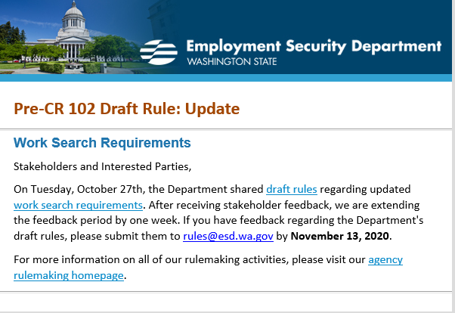

During the week of December 6 -December 12, there were 19,547 initial regular unemployment claims (down 20.5% from the prior week) and 491,261 total claims for all unemployment benefit categories (down .03% from the prior week) filed by Washingtonians, according to the Employment Security Department (ESD).
- Initial regular claims applications remain at elevated levels and are at 168 percent above last year’s weekly new claims applications.
- Pandemic Unemployment Assistance (PUA) initial claims, Pandemic Emergency Unemployment Compensation (PEUC) initial claims and continued/ongoing claims for regular benefits all increased over the week.
- Decreases in regular initial claims over the week occurred across most industry sectors with the largest decreases over the week occurring in the Accommodation and food services (-1,585) and Construction (-1,284) industry sectors.
In the week ending December 12, ESD paid out over $145 million for 300,225 individual claims. Since the crisis began in March, ESD has paid more than $12.9 billion in benefits to over a million Washingtonians.
- ESD.wa.gov or ESD Facebook page for current UI information
- Before submitting a service ticket help see instructions at end of this document.
Review of ETO/WSWA and other resources (AKA old business)
- Encourage all staff who use ETO and WSWA to sign up for the T12 calls. These calls are not just for trainers but for all system users and a great way to stay up to date on changes or improvements to ETO and WSWA. Send requests to esdgpWSSteam@esd.wa.gov to be added to the ITSD Training Team’s distribution list
- WorkSource Systems resources found on the WPC Technology site https://wpc.wa.gov/tech
  - We try our best to make sure all the links are operational but depend on you to submit a remedy ticket if you find broken links!
- WSWA Virtual services to assist job seekers/employers to sharpen skills. There are many tools on WSWA but here are a couple of my favorites!
Check out these virtual classes under Resources>Training and other programs.

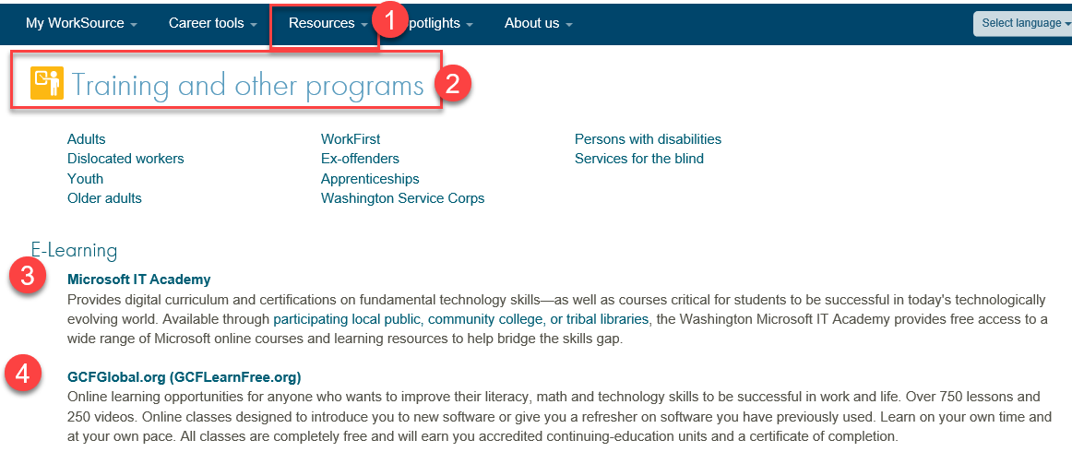

- Stay up to date on COVID19, teleworking and WorkSource Virtual services. Check out the information the WPC website to help all WorkSource staff telework.
  - IT service delivery
  - WebEx
    - Browse the Webex handbook and watch 5 videos on how to make the most out of this tool for conducting meetings with staff and customers.
  - Other resources include:
    - Now that you are teleworking reference guide
    - How to use SKYPE for online meetings
    - How to sign into ESD email from outside the network
    - How to sign into an off-site Wi-Fi from your computer
    - Can I access Internet Explorer from a MAC computer?
    - ESD service Desk information.
- UI Fraud help
  - www.esd.wa.gov/fraud
  - Fax information to claims centers 833-572-8423 –calling is not recommended due to the high volume of calls
  - Reviewing our web resources with them. Some helpful pages include:
- Employee FAQs
- Employee instructional videos
- How to file weekly claims
But you CAN’T help by:
  - Contacting an intake agent at the claims center and asking them to review your friend or family member’s claim or solve their issue.
  - Using your influence to move your friend or family member’s claim up the queue to be processed faster.
  - Using your influence to give any kind of advantage to your friend or family member.
  - Using your access to UTAB, if you have it, to give someone information about their claim.
  - Using your friend or family member’s SAW account and applying for benefits or submitting their weekly claims for them.
- Cisco Softphones training material Link http://insideesd.wa.gov/services/it-services
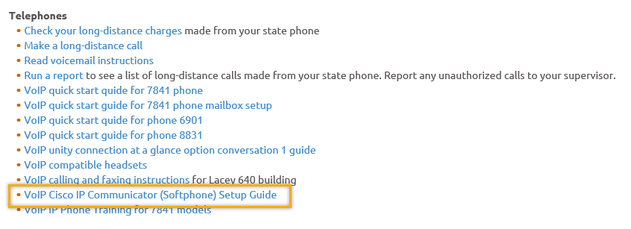
- Before submitting a service, request review these suggestions as the services desk will ask you to run through these steps. Many times, this resolves your issue without a service request!

  - Remember to log out of ETO, clicking off the browser tab here does not end your ETO session and will create issues when you log in again.
      - Always logout by opening your profile menu and clicking “Logout”
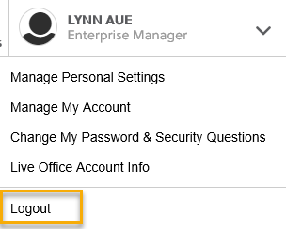
  - If you were impersonating a seeker or recruiter from ETO to WSWA remember to end the session, found in the upper left-hand corner. Clicking off your internet browser tab does not end impersonation!
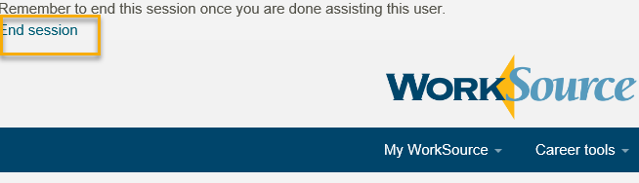

- For best performance clear your cache weekly

  - Internet Explorer (IE): Clearing IE cache starts from the top right side of the browser bar, click the settings icon and select Internet Options
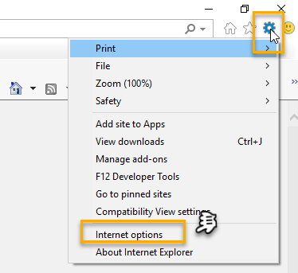

    - From the “General” tab click “Delete” which takes you to the “Delete Browsing History” screen. If not already checked click on the 2 boxes outlined here and click “Delete” you will return to the “General” tab

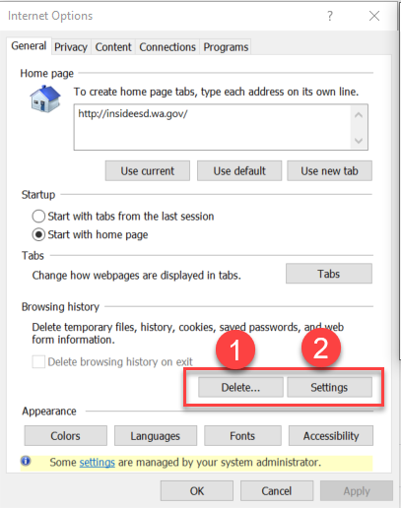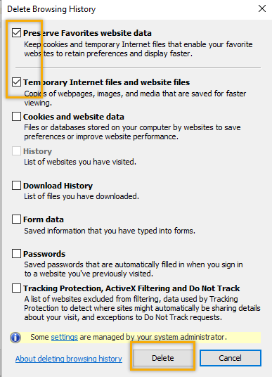

    - Next click “Settings” and if not selected click the radio button for “Every time I visit the webpage” This ensures you are using the most up to date version of ETO. Click OK
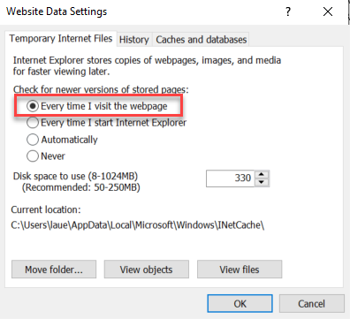
      - You will return to the General tab and click Apply and OK to complete the process of clearing your cache

  - Clearing Chrome cache starts from the top right side of the browser bar
- Click the triple dots to open the Chrome tools menu
- Hover over “More tools”
- Click “Clear browsing data” which opens a new screen
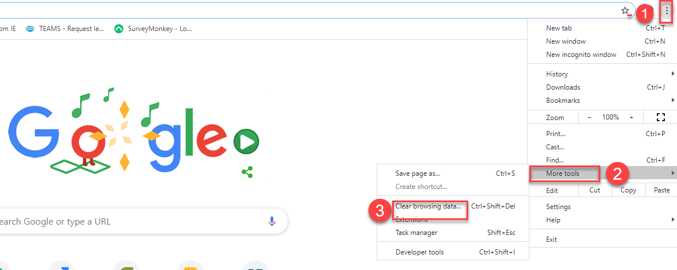

- Click “Clear data”
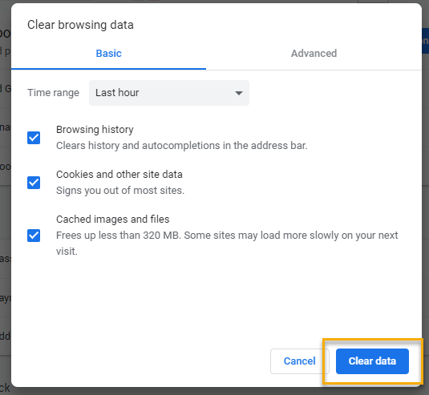

  - Finish by restarting your computer
  - If you still experience issues submit a service request https://wpc.wa.gov/tech/issues
CHAT
Regarding training accounts:
from Tracy Ferrell to everyone: 10:06 AM
Where are things on training, besides the Basic.? We could sure use it!!! There are refresher training videos and User guides found here https://wpc.wa.gov/tech/ETO-refresher-training Submit a remedy ticket if there are additional topics you would like training on.
from Tracy Ferrell to everyone: 10:07 AM
Thank you!!

from Mahre, Tanya (ESD) to everyone: 10:21 AM
Lynn I'm a new hire Tanya Mahre WSS3 to WSS4 Union Gap, WA. How do I do a remedy ticket?
Visit this page on the WPC site: https://wpc.wa.gov/tech/issues If you are an ESD partner, there is a downloadable form that you must fill out and send to the Technical Solutions service desk – their e-mail is ESDDLITBITechnicalSolutions@ESD.WA.GOV

from Katherine Congleton to everyone: 10:23 AM
When adding the process and information for ETO Training on the WPC website that you covered earlier, it would be helpful to have a list of training accounts names/numbers in production that we can use. I have known someone to accidentally use a real account in error because they had "Test" in their name.
[Review] We currently have these lists of accounts, but due to the WPC site being publicly facing we don’t want to have compromising information posted there even if for just the test environment. If you need access to these accounts for your office, submit a remedy ticket or e-mail our team: ESDGPWSSTeam@esd.wa.gov

from JOANIE LINDER to everyone: 10:45 AM
Test Dolvig (recruiter) is an Administration account that can be used for testing

Regarding WIT Integration / API Questions:
from Becky Smith to everyone: 10:49 AM
Can we get some clarity around the staff assisted seeker touchpoints that say “Integration (DO NOT EDIT), WIT”? Are these services staff-assisted? We want to know if we can count them on our reporting of Staff Assisted Services.
from Skyler Blumenthal to everyone: 10:51 AM
WIT Integration is the API responsible for transferring data from WorkSourceWA to ETO.
[Review] You'll see a touchpoint updated/created under that name anytime a participant has data saved to their record from WorkSourceWA. These services are only staff-assisted if staff was impersonating the account on behalf of the customer. Services that were done by the customer independently are not staff-assisted. You can differentiate the difference by looking at the ‘service provided’ section. Please see below:

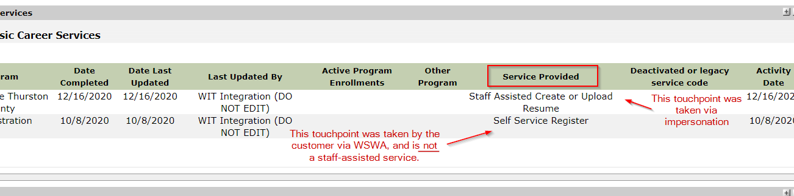

from Skyler Blumenthal to everyone: 10:32 AM
WSS team e-mail: ESDGPWSSTeam@esd.wa.gov
Website for any issues (i.e. how to submit a remedy ticket): https://wpc.wa.gov/tech/issues

ATTENDEES
A Hughes
Arturo Espinoza
Barry Dickerson
Becky Smith
Boliveri
Caller 3
Carl Peterson
Cori Ching
Craig Clark
Dawn Oakes
Diana Cook
Diane Luoma
Donetta McCormack
Donna Hendrickson
Donna Mack
Douglas Loney
Edward Cox
Emeline Pahulu
GDram
Gracie Troncoso
Heidi Lamers
Heidi Schauble
Hope Baker
Ione Turner
Jenny Capella
Joanie Linder
Katherine Congleton
Kimberly Newkirk
Kylie Bartlett
Luci Bench
Tanya Mahre
Maria Zaragoza
Melissa Maynard
Petru Mihaluta
Regina Cancel
Robbin Gard
Robert Jones
Sean McElligott
Selma Tekle
Shannon Booth
Skyler Blumenthal
Ton Nguyen
Tracy Ferrell
Vdamneun
Young Suh

Attended second half

