T12 Meeting Minutes 12-30-2020
Merry Holidays!
Remember: After starting a Webex meeting to mute your audio and disable the video feature. Too many attendee’s with active video can interfere with everyone’s audio quality. Hover over the lower edge of your monitor screen to find the icons.

Thanks to all who contribute to this weekly call!

New Business

- ETO Enhancements updates – Nothing to report this week
- Tickets into production – Nothing to report this week
- ETO maintenance – Schedule for 2021; begins 3rd Saturday of every month
- WSWA maintenance – n/a
  - WSWA help desk holiday hours; close early 3PM on New Year’s Eve. Voicemail message will be updated to reflect early closure. Customers will receive return call the next business day.
- Velaro maintenance – n/a
- ETO Engage – We continue work on the enhancement of this tool, creating training material and delivery of training.
- ETO Basic and Refresher Training Next training 1/19/21 2-4PM
  - ETO Basic training is the 1st Monday 10-12 and 3rd Tuesday 2-4 of every month (except holidays). Send email to Lynn Aue to receive more information, training account if needed and be added to the training Webex call. Please do not be forward invites.
  - Training recordings and user guides are posted on the WPC website here https://wpc.wa.gov/tech/ETO-refresher-training
  - Submit a remedy ticket requesting additional training opportunities and resources
- What’s new on WPC –
  - Virtual training tools; Google tools, Microsoft tools, Public use computer https://wpc.wa.gov/tech/techrefresh
  - Report’s enhancements; check it out here https://wpc.wa.gov/intro_enhancements
    - Changes added this week to; Employer & Job Posting Reports, Job seekers, Outreach, Re-Entry Reports, TAA Reports
  - ETO user role; check it out here https://wpc.wa.gov/tech/security
- Open discussion and training issue(s)–
  - New T12 meeting invite for 1st quarter 2021 sent this morning
  - Group service applicable to Basic services for participants only
  - Process of System Exit; If a qualifying service has not been taken for 90+ days the system will auto-exit the PE. The Exit TP will show the date the action occurred, but the system exit will go back to the date of the last qualifying service and enter that was the program enrollment end date.
    - Ex. Last qualifying service was 8/1/2020 90 days later 10/30/2020 the system will exit that participant PE to 8/1/2020. Note; system will adjust for months with 31 days
  - How to re-open a Program Enrollment
    - Remember this is a 2-day process. If you don’t follow-up on day 2 the system will auto close the PE after 24 hours and you will need to restart the process again.
    - Desk aid on WPC https://storemultisites.blob.core.windows.net/media/WPC/tech/staff-resources/Reopen%20Program%20enrollment.docx
  - Reminder: Submit remedy tickets for all work requests. My team cannot begin work without a service request. Reaching out to us directly can affect the time it takes to resolve your issue. Thanks! https://wpc.wa.gov/tech/issues
- UI announcements –
  - CARES act and decisions made around that – what does that mean for us and the customers?
  - Congress passed 5500-page extension of the CARES act, has a focus on extending UI benefits
    - Extends Pandemic Unemployment Assistance Act by 11 weeks – from 39 weeks to 50 weeks
    - Extends PEUC by 11 weeks – from 13 to 24 weeks
    - Additional “cash” in extension – was previously $600 but will be $300
    - Extends Shared Work program
    - Maintains waiver of wait week for unemployment claims
    - Higher screening/verification for qualifying for this assistance
  - Extension will go to at least March 12: clients can receive benefits through March 12, but if on that date the maximum weeks payable not reached, could go as far as April 10 (previous deadline was 12/26)
  - Will be waiting from DOL federal guidance policy letter (UIPL) for requirements to implement these extensions and all the documentation part of that
  - Job search information found here https://esd.wa.gov/unemployment/job-search-requirements /

  - Here is the information to provide feedback on Work Search Requirements
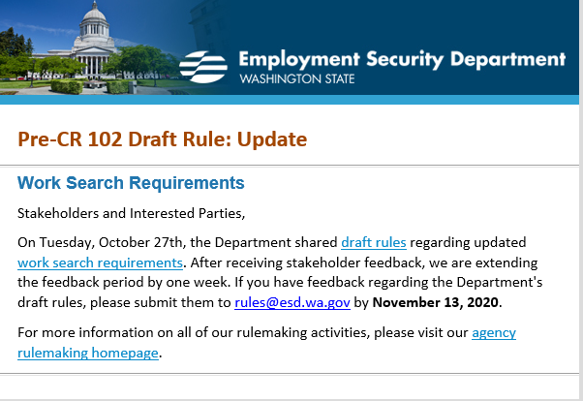

All initial unemployment claims and continued claims increased during the week of December 20 - December 26
During the week of December 20-26, there were 19,192 initial regular unemployment claims (up 9.1 percent from the prior week) and 497,370 total claims for all unemployment benefit categories (up 8.4 percent from the prior week) filed by Washingtonians, according to the Employment Security Department (ESD).
- Initial regular claims applications remain at elevated levels and are at 92 percent above last year’s weekly new claims applications.
- Initial claims for regular unemployment, Pandemic Unemployment Assistance (PUA), Pandemic Emergency Unemployment Compensation (PEUC), and continued/ongoing claims for regular benefits all increased over the week.
- Seasonal layoffs in construction and agriculture drove an increase in new jobless claims last week. Regular initial claims in the construction sector increased by 692 over the week to 3,329 total regular initial claims, while initial claims in the Agriculture, forestry, fishing and hunting sector increased by 286 over the week to 990 initial claims.
In the week ending December 26, ESD paid out over $139.0 million for 286,178 individual claims. Since the crisis began in March, ESD has paid more than $13.2 billion in benefits to over a million Washingtonians.
For current COVID-19 and UI information ESD.wa.gov or ESD Facebook page

- Before submitting a service ticket help see instructions at end of this document.
Review of ETO/WSWA and other resources (AKA old business)
- Encourage all staff who use ETO and WSWA to sign up for the T12 calls. These calls are not just for trainers but for all system users and a great way to stay up to date on changes or improvements to ETO and WSWA. Send requests to esdgpWSSteam@esd.wa.gov to be added to the ITSD Training Team’s distribution list
- WorkSource Systems resources found on the WPC Technology site https://wpc.wa.gov/tech
  - We try our best to make sure all the links are operational but depend on you to submit a remedy ticket if you find broken links!
- WSWA Virtual services to assist job seekers/employers to sharpen skills. There are many tools on WSWA but here are a couple of my favorites!
Check out these virtual classes under Resources>Training and other programs.

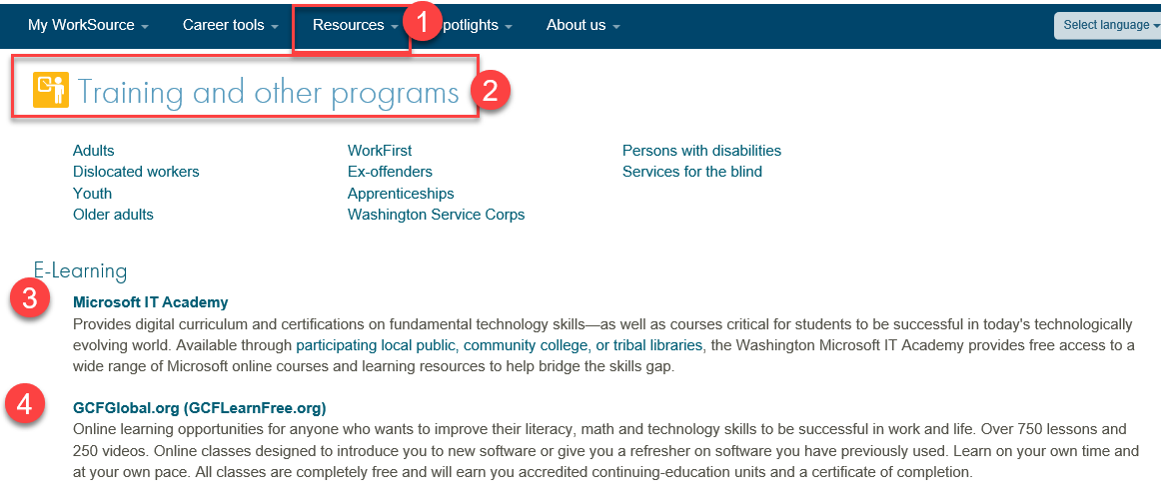

- Stay up to date on COVID19, teleworking and WorkSource Virtual services. Check out the information the WPC website to help all WorkSource staff telework.
  - IT service delivery
  - WebEx
    - Browse the Webex handbook and watch 5 videos on how to make the most out of this tool for conducting meetings with staff and customers.
  - Other resources include:
    - Now that you are teleworking reference guide
    - How to use SKYPE for online meetings
    - How to sign into ESD email from outside the network
    - How to sign into an off-site Wi-Fi from your computer
    - Can I access Internet Explorer from a MAC computer?
    - ESD service Desk information.
- UI Fraud help
  - www.esd.wa.gov/fraud
  - Fax information to claims centers 833-572-8423 –calling is not recommended due to the high volume of calls
  - Reviewing our web resources with them. Some helpful pages include:
- Employee FAQs
- Employee instructional videos
- How to file weekly claims
But you CAN’T help by:
  - Contacting an intake agent at the claims center and asking them to review your friend or family member’s claim or solve their issue.
  - Using your influence to move your friend or family member’s claim up the queue to be processed faster.
  - Using your influence to give any kind of advantage to your friend or family member.
  - Using your access to UTAB, if you have it, to give someone information about their claim.
  - Using your friend or family member’s SAW account and applying for benefits or submitting their weekly claims for them.
- Cisco Softphones training material Link http://insideesd.wa.gov/services/it-services
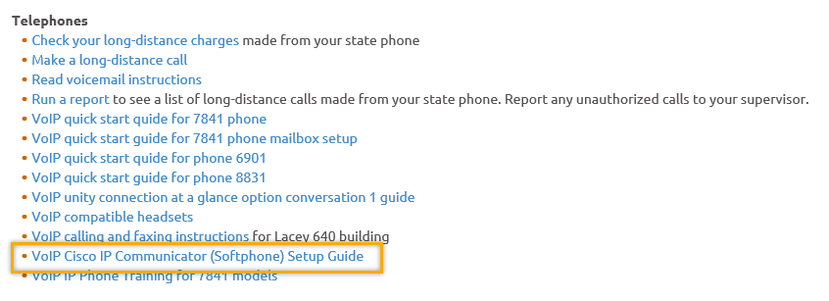
- Before submitting a service, request review these suggestions as the services desk will ask you to run through these steps. Many times, this resolves your issue without a service request!

  - Remember to log out of ETO, clicking off the browser tab here does not end your ETO session and will create issues when you log in again.
      - Always logout by opening your profile menu and clicking “Logout”
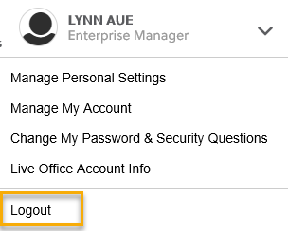
  - If you were impersonating a seeker or recruiter from ETO to WSWA remember to end the session, found in the upper left-hand corner. Clicking off your internet browser tab does not end impersonation!
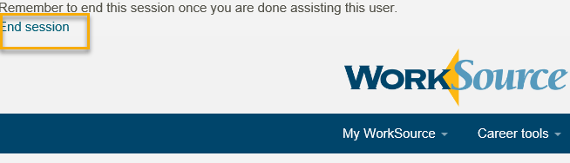

- For best performance clear your cache weekly

  - Internet Explorer (IE): Clearing IE cache starts from the top right side of the browser bar, click the settings icon and select Internet Options
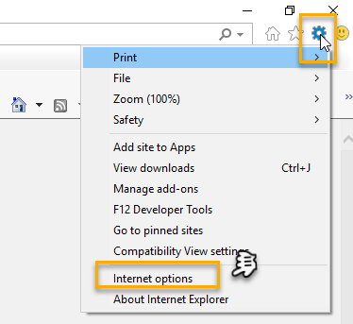

    - From the “General” tab click “Delete” which takes you to the “Delete Browsing History” screen. If not already checked click on the 2 boxes outlined here and click “Delete” you will return to the “General” tab

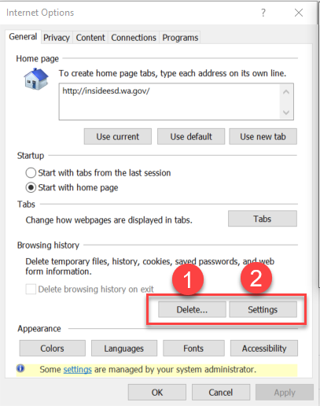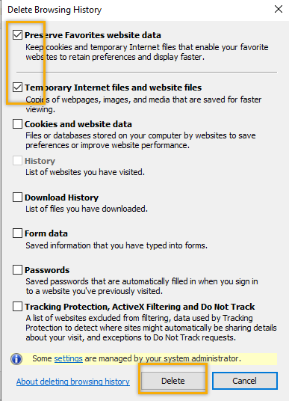

    - Next click “Settings” and if not selected click the radio button for “Every time I visit the webpage” This ensures you are using the most up to date version of ETO. Click OK
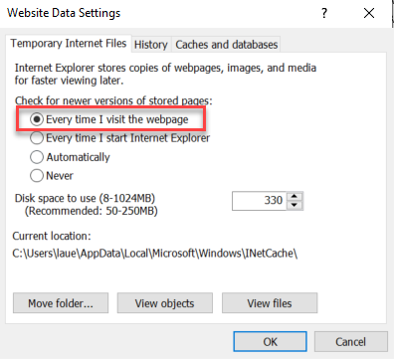
      - You will return to the General tab and click Apply and OK to complete the process of clearing your cache

  - Clearing Chrome cache starts from the top right side of the browser bar
- Click the triple dots to open the Chrome tools menu
- Hover over “More tools”
- Click “Clear browsing data” which opens a new screen
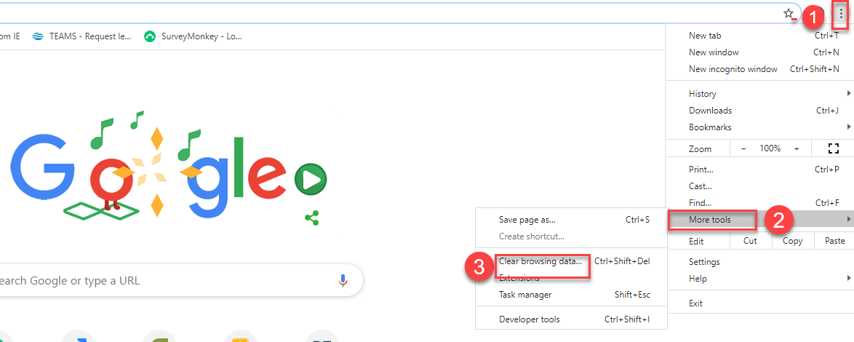

- Click “Clear data”
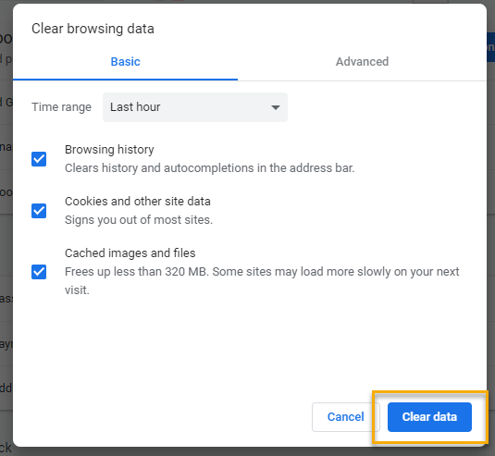

  - Finish by restarting your computer
  - If you still experience issues submit a service request https://wpc.wa.gov/tech/issues
CHAT
from Teresa Sparks to everyone: 10:05 AM
Thank you Lynn and Mary for the changes made to the Reentry reports!

Regarding Clearing cache:
from Adeline Kerns to everyone: 10:15 AM
Is there instructions on how to clear your cache? Does this still affect pulling reports?
from Skyler Blumenthal to everyone: 10:17 AM
instructions for clearing your cache should be in the T12 minutes each week
from Adeline Kerns (privately): 10:29 AM
One more comment on clearing Cache instructions. It is on the minutes but not all staff get the minutes. Is it possible to put this in the WPS site also?
to Adeline Kerns (privately): 10:30 AM
Yep! The link to the Check list of things to try before submitting a service/remedy ticket (including how to clear IE and Chrome cache) is here: https://storemultisites.blob.core.windows.net/media/WPC/tech/staff-resources/Check%20list%20of%20things%20to%20try%20before%20you%20submit%20a%20service%20ticket%20or%20call%20the%20help%20desk.docx
It's on the WPC -> Technology -> T12 Documents

from Robert Jonas to everyone: 10:21 AM
Lynn, can you remind us for Group services for BS where we want to do a touchpoint under BS Employer Touchpoint, where we send a group email to employers with reminding employer of our BS services we offer, or introducing ourselves?
We will be covering this in an upcoming training session. If you have any questions regarding this, please submit a remedy ticket and we will help any way we can.

Regarding training for Microsoft Teams:
from Rebecca McGinnis to everyone: 10:31 AM
If you're an ESD employee, I believe [Microsoft Teams training] is available to all staff in The Learning Center
from Sue Keltner to everyone: 10:32 AM
There is a training in the Learning Center - ESD HR TEAMS Training

To submit a remedy ticket:
Visit this page on the WPC site: https://wpc.wa.gov/tech/issues If you are an ESD partner, there is a downloadable form that you must fill out and send to the Technical Solutions service desk – their e-mail is ESDDLITBITechnicalSolutions@ESD.WA.GOV

ATTENDEES
Adeline Kerns
Alice Freyer
Ariana cordova
Barry Dickerson
Becky Smith
Boliveri
Brent Arbes
Call-in
Carl Peterson
Catherine Geddis
Christina Shaffer
Cori Ching
Craig Clark
Diane Luoma
Donna Mack
Elijah Wabnitz
Emeline Pahulu
Carly Farmer
Heidi Schauble
Ione Turner
Jack Dryden
Joanie Linder
Jonathan Escamilla
Kate Hesseltine
Kyle Bartlett
Maria Zaragoza
Megan Irwin
Melissa Maynard
Michael Ensor
Monique Martin
Nelva March
Phyllis Hall
Rebecca McGinnis
Robert Jonas
Sean McElligott
Sue Keltner
Tamela McNamee
Toni Burow
Vdamneun
Vivian Rogers-Decker

Attended second half

