T12 Meeting Minutes 1-6-2021
Remember: After starting a Webex meeting to mute your audio and disable the video feature. Too many attendee’s with active video can interfere with everyone’s audio quality. Hover over the lower edge of your monitor screen to find the icons.

Thanks to all who contribute to this weekly call!

New Business

- ETO Enhancements updates – Nothing to report this week
- Tickets into production – Nothing to report this week
- ETO maintenance –
  - Jan 14, 2021 release is not expected to affect Washington. Submit a remedy ticket if you experience issues after this date
  - Extended maintenance window 7AM 1/23/ to 2PM 1/24/21. SSG says this upgrade will drastically increase ETO performance for 2021. Submit a remedy ticket if you experience issues after this date
- WSWA maintenance – n/a
- Velaro maintenance – n/a
- ETO Engage – We continue work on the enhancement of this tool, creating training material and delivery of training.
- ETO Basic and Refresher Training Next training 1/19/21 2-4PM
  - ETO Basic training is the 1st Monday 10-12 and 3rd Tuesday 2-4 of every month (except holidays). Send email to Lynn Aue to receive more information, training account if needed and be added to the training Webex call. Please do not forward invites.
  - Training recordings and user guides are posted on the WPC website here https://wpc.wa.gov/tech/ETO-refresher-training
  - Submit a remedy ticket requesting additional training opportunities and resources
- What’s new on WPC –
  - Checklist of things to do before submitting a remedy ticket
  - Virtual training tools; Google tools, Microsoft tools, Public use computer https://wpc.wa.gov/tech/techrefresh
  - Report’s enhancements; check it out here https://wpc.wa.gov/intro_enhancements
    - Changes added this week to; Employer & Job Posting Reports, Job seekers, Outreach, Re-Entry Reports, TAA Reports
  - ETO user role; check it out here https://wpc.wa.gov/tech/security
- Open discussion and training issue(s)–
  - Reminder: Submit remedy tickets for all work requests. The WSS team cannot begin work without a service request. Reaching out to us directly can affect the time it takes to resolve your issue. Thanks! https://wpc.wa.gov/tech/issues
  - Open discussion topic;
- UI announcements –
  - RESEA will relaunch on January 11, 2021. Be prepared for claimants seeking reemployment prep even though job search is waived through at least January 19, 2021
  - CARES act and decisions made around that – what does that mean for us and the customers?
  - Congress passed 5500-page extension of the CARES act, has a focus on extending UI benefits
    - Extends Pandemic Unemployment Assistance Act by 11 weeks – from 39 weeks to 50 weeks
    - Extends PEUC by 11 weeks – from 13 to 24 weeks
    - Additional “cash” in extension – was previously $600 but will be $300
    - Extends Shared Work program
    - Maintains waiver of wait week for unemployment claims
    - Higher screening/verification for qualifying for this assistance
  - Extension will go to at least March 12: clients can receive benefits through March 12, but if on that date the maximum weeks payable not reached, could go as far as April 10 (previous deadline was 12/26)
  - Will be waiting from DOL federal guidance policy letter (UIPL) for requirements to implement these extensions and all the documentation part of that
  - Job search information found here https://esd.wa.gov/unemployment/job-search-requirements /

  - Here is the information to provide feedback on Work Search Requirements
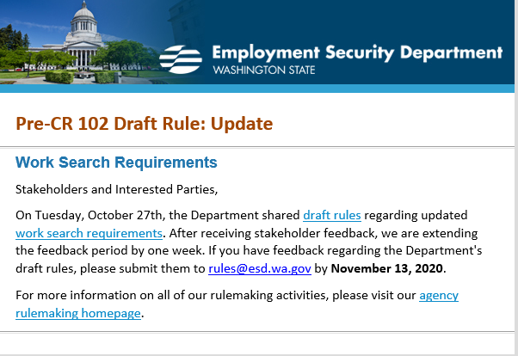

All initial unemployment claims and continued claims increased during the week of December 27 – January 2
OLYMPIA – During the week of December 27- January 2, there were 29,651 initial regular unemployment claims (up 54.5 percent from the prior week) and 557,419 total claims for all unemployment benefit categories (up 12.1 percent from the prior week) filed by Washingtonians, according to the Employment Security Department (ESD).
- Initial regular claims applications remain at elevated levels and are at 201 percent above last year’s weekly new claims applications.
- Initial claims for regular unemployment, Pandemic Unemployment Assistance (PUA), Pandemic Emergency Unemployment Compensation (PEUC), and continued/ongoing claims for regular benefits all increased over the week.
- The initial regular claims figures include new and restarted claims. The 54.5 percent increase in initial regular claims occurred across all industry sectors over the week.
  - Seasonal layoffs in construction and increases in initial claims from the accommodation and food services sector drove the largest increase in new jobless claims last week. Initial regular claims in the construction sector increased by 1,612 over the week to 4,941 total regular initial claims, while initial regular claims in the Accommodation and Food Services sector increased by 1,001 over the week to 3,096 initial claims.
  - The other industry sectors that experienced substantial increases in initial claims over the week were in Retail trade (+774) and Manufacturing (+707). The increases in retail trade are partly associated with post-holiday layoffs in the retail trade sector.
- A total of 90,846 Washingtonians have also received $49.9 million in Pandemic Relief Payments (PRP). The PRP is a one-time payment of $550 for some recipients of Pandemic Unemployment Assistance (PUA) benefits. You can learn more about these payments on our website.
In the week ending January 2nd, ESD paid out over $182.7 million for 316,175 individual claims. Since the crisis began in March, ESD has paid more than $13.4 billion in benefits to over a million Washingtonians. (this total does not include the $49.9 million in PRP payments sent last week).
- For current COVID-19 and UI information ESD.wa.gov or ESD Facebook page
- Before submitting a service ticket, review this desk aid “Check list: things to try before submitting a service/remedy ticket”
- Visit this page on the WPC site to submit a service request: https://wpc.wa.gov/tech/issues If you are an ESD partner, there is a downloadable form that you must fill out and send to the Technical Solutions service desk – their e-mail is ESDDLITBITechnicalSolutions@ESD.WA.GOV
Review of ETO/WSWA and other resources (AKA old business)
- Encourage all staff who use ETO and WSWA to sign up for the T12 calls. These calls are not just for trainers but for all system users and a great way to stay up to date on changes or improvements to ETO and WSWA. Send requests to esdgpWSSteam@esd.wa.gov to be added to the ITSD Training Team’s distribution list
- WorkSource Systems resources found on the WPC Technology site https://wpc.wa.gov/tech
  - We try our best to make sure all the links are operational but depend on you to submit a remedy ticket if you find broken links!
- WSWA Virtual services to assist job seekers/employers to sharpen skills. There are many tools on WSWA but here are a couple of my favorites!
Check out these virtual classes under Resources>Training and other programs.

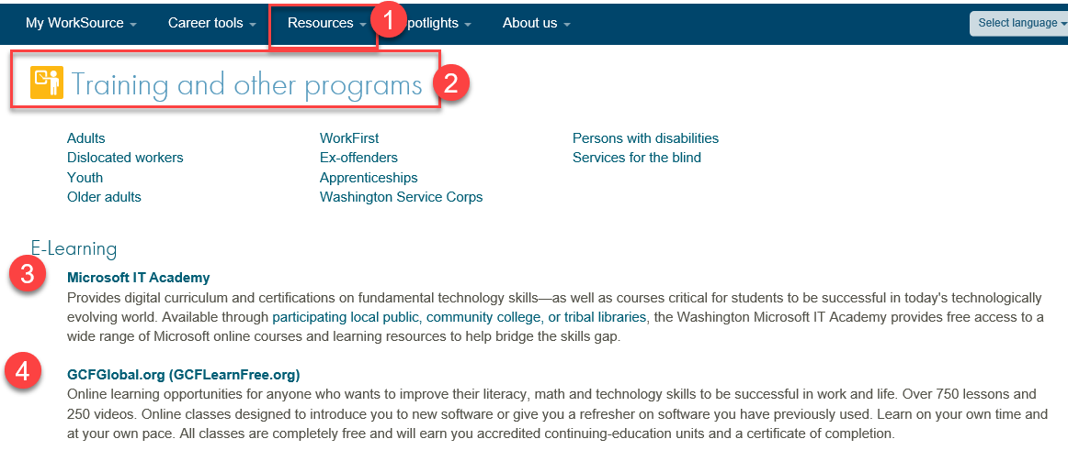

- Stay up to date on COVID19, teleworking and WorkSource Virtual services. Check out the information the WPC website to help all WorkSource staff telework.
  - IT service delivery
  - WebEx
    - Browse the Webex handbook and watch 5 videos on how to make the most out of this tool for conducting meetings with staff and customers.
  - Other resources include:
    - Now that you are teleworking reference guide
    - How to use SKYPE for online meetings
    - How to sign into ESD email from outside the network
    - How to sign into an off-site Wi-Fi from your computer
    - Can I access Internet Explorer from a MAC computer?
    - ESD service Desk information.
- UI Fraud help
  - www.esd.wa.gov/fraud
  - Fax information to claims centers 833-572-8423 –calling is not recommended due to the high volume of calls
  - Reviewing our web resources with them. Some helpful pages include:
- Employee FAQs
- Employee instructional videos
- How to file weekly claims
But you CAN’T help by:
  - Contacting an intake agent at the claims center and asking them to review your friend or family member’s claim or solve their issue.
  - Using your influence to move your friend or family member’s claim up the queue to be processed faster.
  - Using your influence to give any kind of advantage to your friend or family member.
  - Using your access to UTAB, if you have it, to give someone information about their claim.
  - Using your friend or family member’s SAW account and applying for benefits or submitting their weekly claims for them.
- Cisco Softphones training material Link http://insideesd.wa.gov/services/it-services
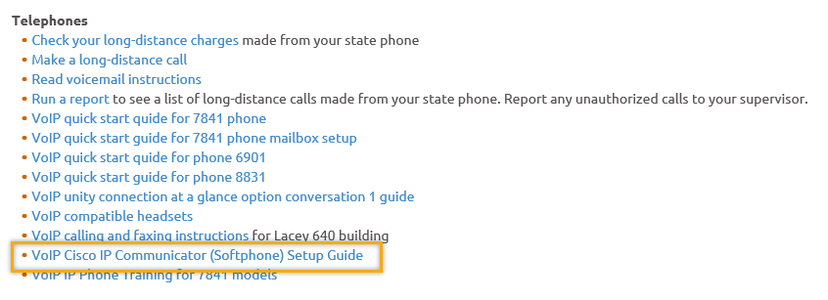

CHAT

ATTENDEES
Abby Taft
Adeline Kerns
A Hughes
A Johnson
Amanda Standley
Arturo Esponoza
Barry Dickerson
Boliveri
Brent Arbes
Brooklynn Zanto
Caller 3
Carl Peterson
Carolyn Holmes
Catherine Geddis
Christina Shaffer
Christopher File
Dan Cooling
Donna Mack
Dorothy Rocha
Eileen Boylston
Elijah Wabnitz
Emily Anderson
Heidi Lamers
Heidi Schauble
Irene Jordan
Jeffrey Flood
Jenny Capella
Jessica Hardy
Kate Hesseltine
Katherine Congleton
Kyle Bartlett
Luci Bench
Lux Dmitri
Maria Zaragoza
Megan Irwin
Michael Ensor
Miriam Cisneros
Monique martin
Nichole Can Nelson
Pochi Ostergren
Robert Jonas
Selma Tekle
Teresa Anda
Teresa Smith
Teresa Sparks
Tiffany Granillo
TonNguyen
Tracy Ferrell
Vdamneun
Young Suh
Zoryana Bilous

Attended second half

