**T12 Meeting Minutes 9-22-2021**

**Reminder:** After starting a Webex meeting to mute your audio and disable the video feature. Too many attendee’s with active video can interfere with everyone’s audio quality. Hover over the lower edge of your monitor screen to find the icons.



**These meetings will be recorded and posted on the WPC site.**

Please be advised your image will be captured and recorded during the videoconference.

Your participation in this videoconference equals consent to be recorded as required by law.

**New Business**

* ETO maintenance – nothing this week
* WSWA maintenance – nothing this week
* Velaro maintenance – WA-4202 system update complete. WSWA Live chat is now functional on mobile devices. There is a possibility that a customer might get disconnected on the mobile version if the chat team needs to type out a long response or is delayed in responding. The team will be monitoring for this.
* Tickets into production – Nothing this week
* Project updates – nothing this week
* What’s new on WPC –
  + Report enhancements – Nothing this week
* Training issues/open discussion –
  + Finding a participant in ETO and adding them to your office
    - WPC *NEW!* updated [desk aid](https://storemultisites.blob.core.windows.net/media/WPC/tech/staff-resources/Finding_a_participant_in_%20ETO_9.22.21.docx)
  + Reminder: Internet Explorer will be sunsetting October 2021
    - Prepare by transitioning to Chrome or Edge –
      * Transfer your favorites to new browser
      * Add sites to prevent pop up blockers
      * Remember; clearing cache can remove the allowed site(s) for pop-up blocking
    - Issues with Edge/VPN, use the Big-IP Edge Client app
      * Add this by typing ‘Big’ into Windows search and pin it to your task bar

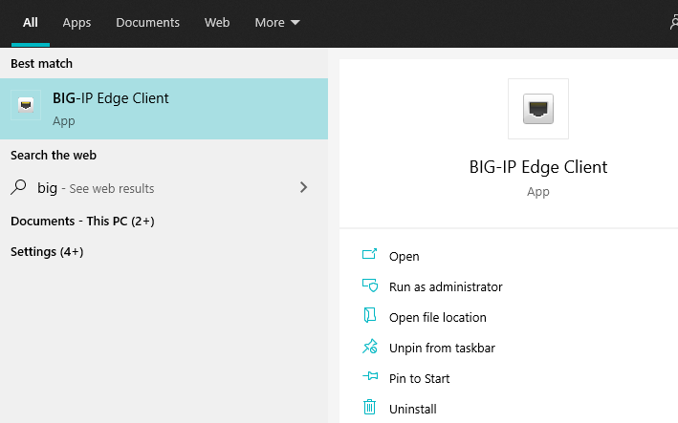

* + Future ETO report enhancements – Mary
    - Program Enrollment Report With Demographic and Veteran Details
      * This report continually times out due to the amount of data being pulled
      * Work will begin this week to create a slimmed down version of this report; we will keep the original
      * Columns to remove are starred:



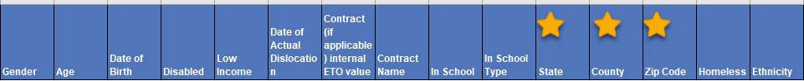







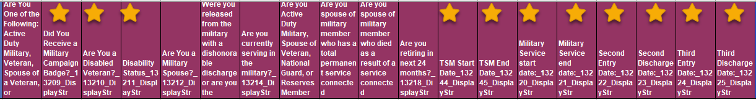



* + - Job Postings vs Job Posting ONET reports –
      * These 2 reports are almost identical; only difference is ONET version has O*NET Major and O*NET Minor columns
      * Discussion on 9/1 was whether we could remove the Job Postings version and keep the ONET version
      * Staff were to review ONET version of report and report back whether we can eliminate the Job Postings version
    - NEW—Also review the Job Postings Report and decide if we can combine all into one report

Job Posting columns –



Job Posting ONET columns –



Job Postings Report columns –



* ETO Basic and Refresher Training - Next training is on 10/04/21 9:30-11:50PM.
  + ETO Basic training is the 1st Monday 9:30-11:50 and 3rd Tuesday 1:30-3:50 of every month (except holidays). Send email to Lynn Aue to receive more information, training account if needed and be added to the training Webex call. *All ETO/WSWA system users are welcome to attend the training but please do not forward invites as I need to review all attendees and assign training accounts if needed.*
  + Training recordings and user guides are posted on the WPC website here <https://wpc.wa.gov/tech/ETO-refresher-training>
  + Submit a remedy ticket to request additional training opportunities and resources
* ***Reminder:*** Submit remedy tickets for all work requests [here](https://wpc.wa.gov/tech/issues). The WSS team cannot begin work without a service request. Reaching out to us directly can affect the time it takes to resolve your issue. Thanks!

**UI announcements –**

**Job-search activities** list can be found here <https://esd.wa.gov/unemployment/job-search-requirements>

**Initial regular claims and total claims for all benefits decreased during the week of September 12**

**OLYMPIA –** During the week of September 12 to September 18, there were 4,850 initial regular unemployment claims, down 0.2 percent from the prior week. Total claims filed by Washingtonians for all unemployment benefit categories numbered 112,948, down 55.4 percent from the prior week, primarily due to the expiration of federal pandemic benefit programs the previous week.

* Initial regular claims applications are 75 percent below weekly new claims applications for the same period last year during the pandemic.
* The 4-week moving average for regular initial claims was 4,997, a decrease of 127 from the previous week’s 4-week moving average. During the same time in 2019, it was 5,146.
* Decreases in layoffs in manufacturing & professional, scientific, and technical services contributed to a decrease of 10 regular initial claims over the previous week.
* Although federal benefit programs, including Pandemic Unemployment Assistance (PUA) and Pandemic Emergency Unemployment Compensation (PEUC) as well as the additional $300 per week for most claimants, expired the week ending Sept. 4, 2021, benefits will continue to be paid after 4, 2021 for individuals whose claims are pending in adjudication or on appeal if they are determined to be eligible for payment. Learn more at [esd.wa.gov/covid-19](https://lnks.gd/l/eyJhbGciOiJIUzI1NiJ9.eyJidWxsZXRpbl9saW5rX2lkIjoxMDAsInVyaSI6ImJwMjpjbGljayIsImJ1bGxldGluX2lkIjoiMjAyMTA5MjMuNDYzNjYzOTEiLCJ1cmwiOiJodHRwOi8vd3d3LmVzZC53YS5nb3YvY292aWQtMTk_dXRtX21lZGl1bT1lbWFpbCZ1dG1fc291cmNlPWdvdmRlbGl2ZXJ5In0.BGjdfUJHI9Crlq9Vc3Ri6hzKYQ6HIK_JwO0-hvfd1lw/s/1795819766/br/112818231485-l).

In the week ending September 18, the Employment Security Department (ESD) paid out over $52 million for 53,687 individual claims. Since the crisis began in March 2020, ESD has paid more than $21.3 billion in benefits to over 1.19 million Washingtonians.

**CHAT**

*from McKnight, Diana (ESD) to everyone: 10:10 AM* How did you copy your favorites? *Here are 2 things I recommend.*

Importing favorites from Internet Explorer and Chrome

1. Click on favorites star
2. Click on ellipses
3. Select ‘Import favorites’, open dropdown menu and select where you want to pull them in from or select ‘Export favorites’ to a designated folder on your computer locally (into Documents or Desktop folder)

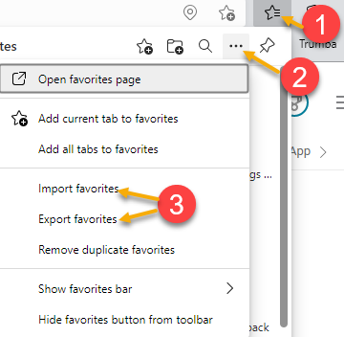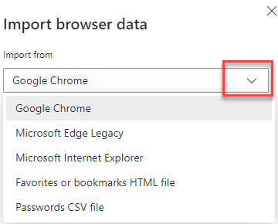

*from Dryden, Jack (ESD) to everyone: 10:11 AM*

There is also the option to transfer bookmarks from within Chrome (and presumably Edge). So you can pull them in, rather than pushing them in

*from McKnight, Diana (ESD) to everyone: 10:12 AM*

Thank you for that

*from Teresa Anda to everyone: 10:14 AM*

When I imported my Chrome favorites, the Other bookmarks folder did not get picked up. I still have not figured out how to import it to Edge.

*from Aue, Lynn (ESD) to everyone: 10:16 AM*

thanks for the feedback Teresa, I will look into this and add a solution in the minutes and keep it on the agenda for next week.

*from Vey Damneun to everyone: 10:18 AM*

You doing good job Lynn!

*from Aaron Parrott he/his/him to everyone: 10:19 AM*

Appreciate you, team!

**ATTENDEES**

Aaron Parrott

Aaron Pentland

Abplanalp, Christopher

Adriana Lopez

Amy Gimlin

Ariana Cordova

B Oliveri

Baker, Mirayia

Brian Doyle

Christina Shaffer

Dean Coxford

Dominguez, Maribel

Dorothy Rocha

Dryden, Jack

Emily Anderson

Enwall, Jo Ann

File, Christopher

Flores, Melisa

Freer, Mike

Gard, Robbin

Geddis, Catherine

Gillis, Deanna

Hesseltine, Kate

Holmes, Carolyn

Jackie Wetchler

Jessie Cardwell

Jim Brunkhorst

Johnson, Melinda

Jordan, Irene

Josefina Capetillo

Katherine Congleton

Kylie Bartlett

Lilia

Luci Bench

Maier, Seth

McKnight, Diana

Miriam Cisneros

Nelva March

Po Chi

Rivers, Michael

Selam

Smith, Jasmine

Susan Gustafson

Tamara

T Aphkas

Taylor Inman-Scott

Teresa Anda

Van Tassell, Nicole

Vey Damneun