**T12 Meeting Minutes 9-15-2021**

**Reminder:** After starting a Webex meeting to mute your audio and disable the video feature. Too many attendee’s with active video can interfere with everyone’s audio quality. Hover over the lower edge of your monitor screen to find the icons.



**These meetings will be recorded and posted on the WPC site.**

Please be advised your image will be captured and recorded during the videoconference.

Your participation in this videoconference equals consent to be recorded as required by law.

**New Business**

* ETO maintenance – nothing this week
* WSWA maintenance – nothing this week
* Velaro maintenance – nothing this week
  + Reminder: WA-4202 system updates 9/23/21 to resolve WSWA issues using live chat functionality on mobile devices. WSWA is using an outdated version of Velaro on the site.
* Tickets into production – Nothing this week
* Project updates
  + Reminder: Internet Explorer will be sunsetting October 2021
    1. Prepare by transitioning to Chrome or Edge –
       - Add sites to prevent pop up blockers
       - Clearing cache can remove the allowed site(s) for pop-up blocking
* What’s new on WPC –
  + Report enhancements –
    1. Employer & Job Postings Reports
       - New to WorksourceWA-Employers; Change report name so will be next to recruiter report on list
       - New to WorksourceWA-Recruiters; Change report name so will be next to employer report on list
    2. Local Reporter Data
       - Outcomes TPs based on Completion Date Value; Removed In Youth Program and Program Category columns; moved Opted-Out column after Case Number column
    3. Operational Reports
       - Seekers Served by Office; Removed 8/27/2021 from report name
       - Seekers Served by Office – ORIGINAL; Added ORIGINAL to report name since new report created
* Training issues/open discussion –
  + ETO [access requests](https://wpc.wa.gov/tech/security) information is found on the WPC site under System Administration
  + [Qtrac resources](https://wpc.wa.gov/tech/qtrac-home) on WPC
    - Asking for input on how your office uses the system or if you need additional training
  + ETO report enhancements – Mary
    - Program Enrollment Report With Demographic and Veteran Details
      * This report continually times out due to the amount of data being pulled
      * Work will begin this week to create a slimmed down version of this report; we will keep the original
      * Columns to remove are starred:



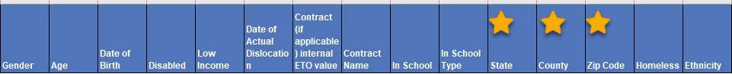







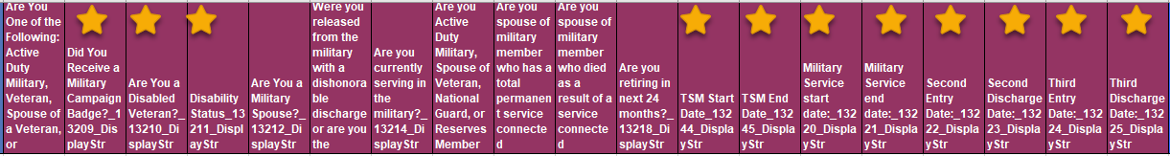



* + - Job Postings vs Job Posting ONET reports –
      * These 2 reports are almost identical; only difference is ONET version has O*NET Major and O*NET Minor columns
      * Discussion on 9/1 was whether we could remove the Job Postings version and keep the ONET version
      * Staff were to review ONET version of report and report back whether we can eliminate the Job Postings version
      * NEW—Also review the Job Postings Report and decide if we can combine all into one report

Job Posting columns –



Job Posting ONET columns –



Job Postings Report columns –



* ETO Basic and Refresher Training - Next training is on 9/21/21 1:30-3:50PM.
  + ETO Basic training is the 1st Monday 9:30-11:50 and 3rd Tuesday 1:30-3:50 of every month (except holidays). Send email to Lynn Aue to receive more information, training account if needed and be added to the training Webex call. *All ETO/WSWA system users are welcome to attend the training but please do not forward invites as I need to review all attendees and assign training accounts if needed.*
  + Training recordings and user guides are posted on the WPC website here <https://wpc.wa.gov/tech/ETO-refresher-training>
  + Submit a remedy ticket to request additional training opportunities and resources
* ***Reminder:*** Submit remedy tickets for all work requests [here](https://wpc.wa.gov/tech/issues). The WSS team cannot begin work without a service request. Reaching out to us directly can affect the time it takes to resolve your issue. Thanks!

**UI announcements –**

**Job-search activities** list can be found here <https://esd.wa.gov/unemployment/job-search-requirements>

**Initial regular claims and total claims for all benefits decreased during the week of Sept. 5**

**OLYMPIA –** During the week of Sept. 5, there were 4,860 initial regular unemployment claims, down 6.6 percent from the prior week. Total claims filed by Washingtonians for all unemployment benefit categories numbered 245,345, down 4.8 percent from the prior week.

* Initial regular claims applications are 74 percent below weekly new claims applications for the same period last year during the pandemic.
* The 4-week moving average for regular initial claims was 5,124, a decrease of 167 from the previous week’s 4-week moving average. During the same time in 2019, it was 5,012.
* Decreases in layoffs in construction and health care & social assistance contributed to a decrease of 345 regular initial claims over the previous week.
* There was a decrease in the combined total of initial claims and continued or ongoing claims for all benefits—which include regular unemployment insurance, Pandemic Unemployment Assistance (PUA) and Pandemic Emergency Unemployment Compensation (PEUC).
* Federal pandemic benefits programs, including PUA and PEUC as well as the additional $300 per week, expired the week ending Sept. 4, 2021. Learn more at [esd.wa.gov/covid-19](https://lnks.gd/l/eyJhbGciOiJIUzI1NiJ9.eyJidWxsZXRpbl9saW5rX2lkIjoxMDAsInVyaSI6ImJwMjpjbGljayIsImJ1bGxldGluX2lkIjoiMjAyMTA5MTYuNDYwMzA2MDEiLCJ1cmwiOiJodHRwOi8vd3d3LmVzZC53YS5nb3YvY292aWQtMTk_dXRtX21lZGl1bT1lbWFpbCZ1dG1fc291cmNlPWdvdmRlbGl2ZXJ5In0.ISBmMnf7YgfymAJKhzkortmKnu-nF5ZEfxNClsE3BRQ/s/1795819766/br/112472674292-l).

In the week ending Sept. 11, ESD paid out over $151 million for 180,372 individual claims. Since the crisis began in March 2020, ESD has paid more than $21.3 billion in benefits to over 1.19 million Washingtonians.

**CHAT**

*from Dryden, Jack (ESD) to everyone:* Where do you find the guidance on the new basic service called "Learn about Title 1 Services" *This information is found on the WPC site, Technology tab under Resources in the* [Services Catalog](mailto:https://storemultisites.blob.core.windows.net/media/WPC/wswa/support/worksource-services-catalog.xlsx)

*from Martin, Monique (ESD) to everyone:* When working in SharePoint, "open in File Explorer" is not available from chrome. do we have a work around? *SharePoint has compatibility issues with Chrome. @Monique - NO, we don't! That is one of the things I miss the most from IE. However, I find SP works best using Edge, not very user-friendly using Chrome. You can drag/drop files using Edge, and you can also move files easily if the structure is set up properly. Chrome doesn't work the same way.*

*from Teresa Anda to everyone:* New Outcomes report: Please change the tab name from report to Outcomes. Thank you. *Will do, thanks for alerting us to this!*

*from Teresa Anda to everyone: 10:22 AM*

Do we know where the information is being pulled from for the enrollment reports?

*from Martin, Monique (ESD) to everyone: 10:23 AM*

Thank you

*from Manson, Emily (ESD) to everyone: 10:24 AM*

I think it is in the application

*from Aue, Lynn (ESD) to everyone: Answer to private question about ETO not functioning in Chrome; ETO became browser neutral last year so work being dropped in Chrome is no longer an issue. ETO works great in Edge*

*Can we combine the 3 Job Posting reports? from Jonas, Robert (ESD) to everyone:* For me, combining all three is fine

*from Teresa Anda to everyone: 10:37 AM*

Where is Temporary Assistance to Needy Families (TANF) information being pulled from? Is it from Demographic Details tp: Are you receiving TANF?Where is Low Income Status at Program Entry (WIOA) information being pulled from? Is it from Demographic Details tp: Are you a member of a low-income household?Where is English Language Learner at Program Entry (WIOA) information being pulled from? Is it from Demographic Details tp: Do You Have Limited Proficiency in English?

*That information is prompted by the last question on the WSWA profile page. When the answer is yes, the following interactive questions are asked.*

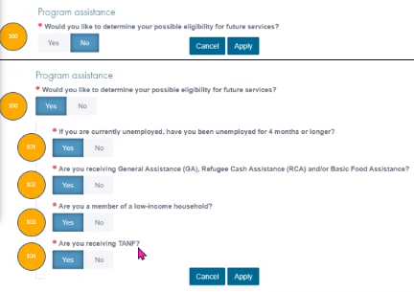

*from Ni Dufaigh, T. Jaide (ESD) to everyone:* Would this idea cross index on the other side (not Daily Hire), but under Program Outcome - Entered Employment information? If something could not be added on Employer Services, could a drop down for Program Outcome be from a hiring event? *Apologies Jaide, I missed this question. I will add it to next week’s agenda.*

**ATTENDEES**

Abigail Taft

Abplanalp, Christopher

Adriana Lopez

Aiman Memon

Anderson, Laura

Aparicio, Rudy

Arbes, Brent

Ariana Cordova

Arturo Espinoza

Barke, Tami

B Oliveri

Brian Doyle

Capella, Jenny

Christina Shaffer

Cook, Diana

Dawn Oakes

Dean Coxford

Dominguez, Maribel

Dryden, Jack

Emily Anderson

Enwall, Jo Ann

File, Christopher

Flores, Melisa

Geddis, Catherine

Heidi Schauble

Hesseltine, Kate

Holmes, Carolyn

Jessie Cardwell

Jim Brunkhorst

Joanie Linder

Jonas, Robert

Jordan, Irene

Luci Bench

Manson, Emily

Maricha Friedman

Martin, Monique

Metcalf, Kimberly

Ni Dufaigh, T. Jaide

Pahulu, Emeline

Rivers, Michael

Selam Tekle

Seth Maier

Smith, Jasmine

Soto, Raul

Sparks, Teresa

Standley, Amanda

Sue Keltner

Tamara

T Aphkas

Taylor InmanScott

Taylor, Mei-Ling

Toni Burow

Tracy Ferrell

Van Tassell, Nicole

Vey Damneun

Zander