T12 Meeting Minutes 9-1-2021
Reminder: After starting a Webex meeting to mute your audio and disable the video feature. Too many attendee’s with active video can interfere with everyone’s audio quality. Hover over the lower edge of your monitor screen to find the icons.

These meetings will be recorded and posted on the WPC site.
Please be advised your image will be captured and recorded during the videoconference.
Your participation in this videoconference equals consent to be recorded as required by law.

New Business
- Next week’s T12 meeting cancelled
- ETO maintenance – nothing this week
- WSWA maintenance – nothing this week
- Velaro maintenance – nothing this week
  - Reminder: WA-4202 system updates 9/23/21 to resolve WSWA issues using live chat functionality on mobile devices. WSWA is using an outdated version of Velaro on the site.
- Tickets into production – Nothing this week
- Project updates
  - Reminder: Internet Explorer will be sunsetting October 2021
    - Prepare by transitioning to Chrome or Edge –
      - Add sites to prevent pop up blockers
      - Clearing cache can remove the allowed site
      - Desk aid: coming soon and will be posted on WPC
- WIN 0123 ‘New ETO services to support expanded approved in-person WorkSource job search activities’
  - Basic Service
    - Job Fair or Hiring event attendance
    - Learn about WIOA Title l services
- What’s new on WPC –
  - Report enhancements –
    - Operational Reports
      - Seekers Served by Office 8/27/2021; Added WDA filter; built new version since old version kept timing out
- Training issues/open discussion –
  - Employer fraud alert for job seekers.
    - Recently there has been an increase of fraudulent employers scamming job seekers, interviews for jobs, hiring’s, sending them checks and asking for their bank accounts so they can buy equipment on their behalf to use for employment. See chat for additional information or watch the video for the complete discussion
  - Staff created participant accounts
    - 23 incomplete records since go live. Supervisors need to run the report for their area and ask staff to clean these records up. Report is found under Reports>Administrative>Staff Created Participant. Redo, due to last week’s VPN issues
  - ETO report enhancements – Mary
    - Job posting reports
      - Job Postings vs Job Posting ONET reports
  - Continue review from 8/4/21, redo, due to last week’s VPN issues and meeting ending without discussion
    - Discussion on program enrollment outcome report. Can we remove the green columns? What else can be removed to improve the report speed and results?
    - Program Enrollment with demographic and veteran details. This is a huge report, contains lots of data. Can we remove the green columns? What else can be removed to improve the report speed and results?
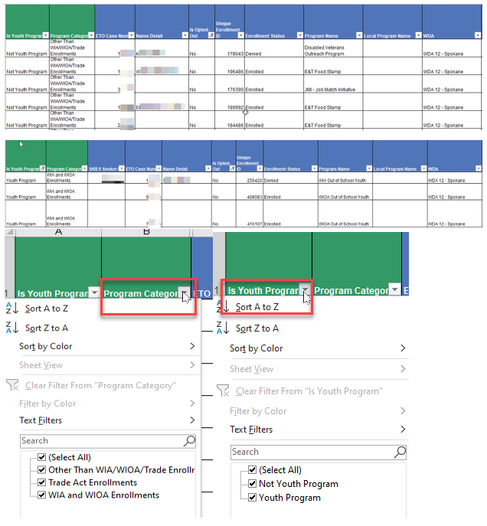
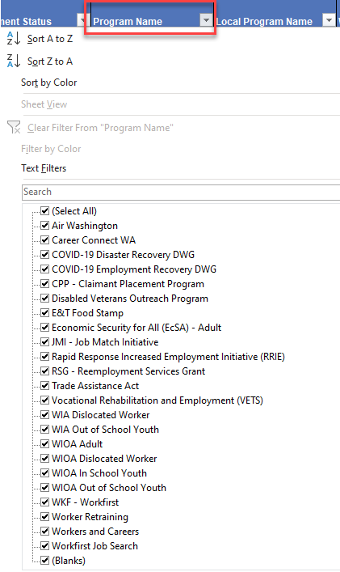

- ETO Basic and Refresher Training - Next training is on 9/21/21 1:30-3:50PM. There won’t be a training 9/6/21 due to the holiday.
  - ETO Basic training is the 1st Monday 9:30-11:50 and 3rd Tuesday 1:30-3:50 of every month (except holidays). Send email to Lynn Aue to receive more information, training account if needed and be added to the training Webex call. All ETO/WSWA system users are welcome to attend the training but please do not forward invites as I need to review all attendees and assign training accounts if needed.
  - Training recordings and user guides are posted on the WPC website here https://wpc.wa.gov/tech/ETO-refresher-training
  - Submit a remedy ticket to request additional training opportunities and resources
- Reminder: Submit remedy tickets for all work requests here. The WSS team cannot begin work without a service request. Reaching out to us directly can affect the time it takes to resolve your issue. Thanks!
UI announcements –
Job-search activities list can be found here https://esd.wa.gov/unemployment/job-search-requirements
Initial regular claims and total claims for all benefits decreased during the week of August 22
OLYMPIA – During the week of August 22 to 28, there were 5,073 initial regular unemployment claims, down 5.3 percent from the prior week. Total claims filed by Washingtonians for all unemployment benefit categories numbered 272,845, down 1.0 percent from the prior week.
- Initial regular claims applications are 72 percent below weekly new claims applications for the same period last year during the pandemic.
- The 4-week moving average for regular initial claims was 5,345, an increase of 39 from the previous week’s 4-week moving average. During the same time in 2019, it was 5,024.
- Decreases in layoffs in health care and social assistance, wholesale trade and retail trade contributed to a decrease of 284 regular initial claims over the previous week.
- There was a decrease in the combined total of initial claims and continued or ongoing claims for all benefits—which include regular unemployment insurance, Pandemic Unemployment Assistance (PUA) and Pandemic Emergency Unemployment Compensation (PEUC).
- Federal pandemic benefits programs, including PUA and PEUC as well as the additional $300 per week, are set to expire the week ending Sept. 4, 2021. Learn more at esd.wa.gov/covid-19.
In the week ending August 28, ESD paid out over $161 million for 198,030 individual claims. Since the crisis began in March 2020, ESD has paid more than $21 billion in benefits to over 1.1 million Washingtonians.
CHAT
Employer fraud
from File, Christopher (ESD) to everyone: Is there a list of these fake employers? No, they come into the system using one name and then reach out to job seekers using legitimate company names. The identified employer account has been deleted from WSWA but they still have the resumes containing job seekers contact information.
Does the privacy setting of job-seekers matter when they upload their resume? There are 2 settings, viewable and not viewable.
from McKnight, Diana (ESD) to everyone: Is there a fix in place to prevent this from happening? We have beefed up our approval process. We started calling all employers who accounts look suspicious and ask for verification.
from Mack, Donna R (ESD) to everyone: Are Indeed or other job boards also experiencing this? Good question, I don’t know
from Noll, Pamela (ESD) to everyone: With limited their uploaded resume does not show their contact information the company HAS to go through WorkSourceWA to connect with them. Thanks for sharing that information.
from File, Christopher (ESD) to everyone: So they can only scrape resumes that are made fully public? Yes
from Sparks, Teresa A (ESD) to everyone: Can the system somehow "Flag" those accounts that appear suspicious or not legit. Yes, the system does flag suspicious IP addresses. Once ID’d we take a very close look at the request and call the employer to verify.

Can’t run reports – I can’t get any reports to run. If you are having issues with reports check to see if your machine is blocking access. Remember, the pop-up blocker can return after you clear your cache. We talked about this during the 7/28/21 T 12 meeting.
from Cancel, Regina B (ESD) to everyone: Yes I just had to fix this in Chrome

Changes to report for performance improvement (Mary’s discussion)
from Jackie Wetchler she/hers to everyone: The "is youth program" column is helpful for me, but it would not be the end of the world if it wasn't there. Mostly helpful for finding EET participants (WDA 7 - Employment and Education Training CCJC)
from Nelva March to everyone: Hi Mary, is it possible to add a "Date Last Updated" column to either the Local Reporter Services report or Individualized Training and Support Services report? With new reporting requirements for PY21, this would be helpful. from Mary MacLennan to everyone: @Nelva - could you submit a remedy ticket for that request, and I'll see what I can do? Thank you!
from Teresa Anda to everyone: the EET information is a local program, not the program of enrollment.
So no, the Is Youth Program adds no value. I use the office and program name to check for data entry errors.

Where are the new WIN’s 0123 & 0081? Find them on the WPC site on the Policy tab under State Guidance. Thanks for reminding me Diana!

ATTENDEES

Abigail Taft
Allen, Shanika
Angela Johnson
Aparicio, Rudy
Arbes, Brent
Ariana Cordova
B Oliveri
Cancel, Regina
Capella, Jenny
Cheyenne
Christina Shaffer
Cook, Diana
Cori Ching
Dawn Oakes
Dean Coxford
Dickerson, Barry
Dorothy Rocha
Dryden, Jack
Ensor, Michael
Enwall, Jo Ann
Farmer, Carly
File, Christopher
Heather Shin
Holmes, Carolyn
Jackie Wetchler
Jessie Cardwell
Joanie Linder
Jonas, Robert
Jordan, Irene
Kerns, Adeline
Kylie Bartlett
Li-Chin, Kwani
Lucy Bench
Mack, Donna
Malmi Peiris
Matranga, Carol
McKnight, Diana
Nelva March
Noll, Pamela
Pahulu, Emeline
Peterson, Carl
Soto, Raul
Sparks, Teresa
Standley, Amanda
Sue Keltner
Tamara
T Aphkas
Teresa Anda
Toni Burow
Tracy Ferrell
Van Tassell, Nicole
Vey Damneun
Wood, Lora
Zander

