**T12 Meeting Minutes 8-4-2021**

**Reminder:** After starting a Webex meeting to mute your audio and disable the video feature. Too many attendee’s with active video can interfere with everyone’s audio quality. Hover over the lower edge of your monitor screen to find the icons.



**These meetings will be recorded and posted on the WPC site.**

Please be advised your image will be captured and recorded during the videoconference.

Your participation in this videoconference equals consent to be recorded as required by law.

**New Business**

* ETO maintenance – nothing this week
* WSWA maintenance – nothing this week
* Velaro maintenance – nothing this week
  + WA-4202 system updates 9/23/21 to resolve WSWA issues using live chat functionality on mobile devices. WSWA is using an outdated version of Velaro on the site.
* Tickets into production –
  + WA-3794, WA-4170, WA-4220 - Change to the look of the ETO dashboard, adding an RESEA dashboard. This work also includes adding 2 RESEA TouchPoints. *These changes affect only those who work in the RESEA program. This is for awareness for all other ETO users*.
  + Training for these changes was done by RESEA staff. Information about these new TPs and other RESEA information can be found on the WPC site on the [RESEA Employment Connections](https://wpc.wa.gov/ec/WSPD/RESEA) tab

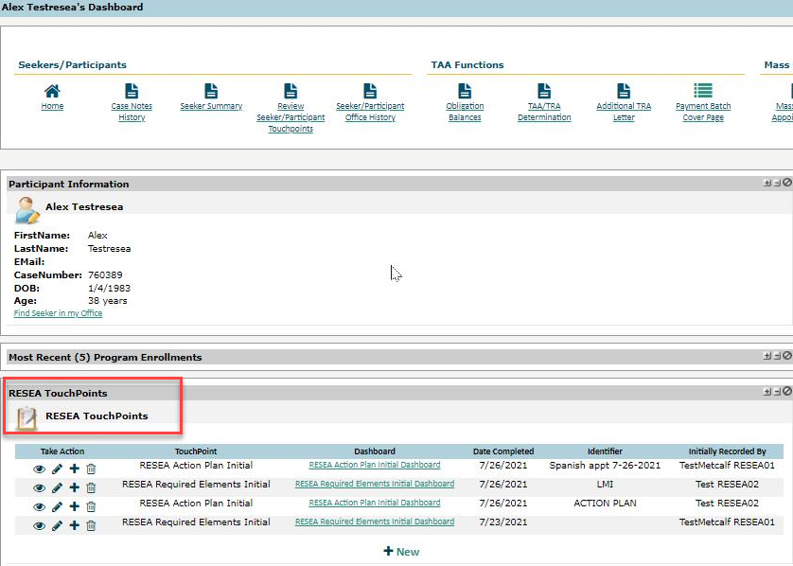

* WA-4251 widget bug – issue is resolved at this time. Please submit a remedy ticket if you experience the issue asking for the PID
  + Seeker summary report
  + Case note summary (history)
  + TAA/TRA determination

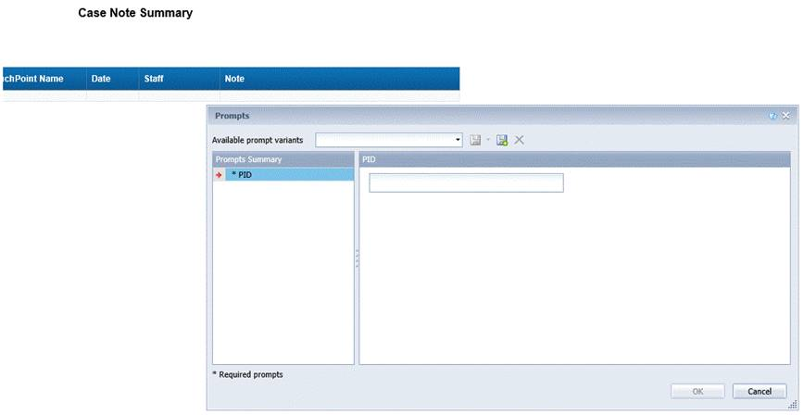

* Project updates
  + Reminder: Internet Explorer will be sunsetting October 2021
    1. Prepare by transitioning to Chrome or Edge –
       - Add sites to prevent pop up blockers
       - Clearing cache can remove the allowed site
       - Desk aid: coming soon and will be posted on WPC
* What’s new on WPC –
  + Reports – no changes this week
  + WDC contacts list updated and moved to the top of the [ETO ‘Training Resources’](https://wpc.wa.gov/tech/ETO-refresher-training) page
  + ‘How do I sign my NDA’ desk aid added to training resources page

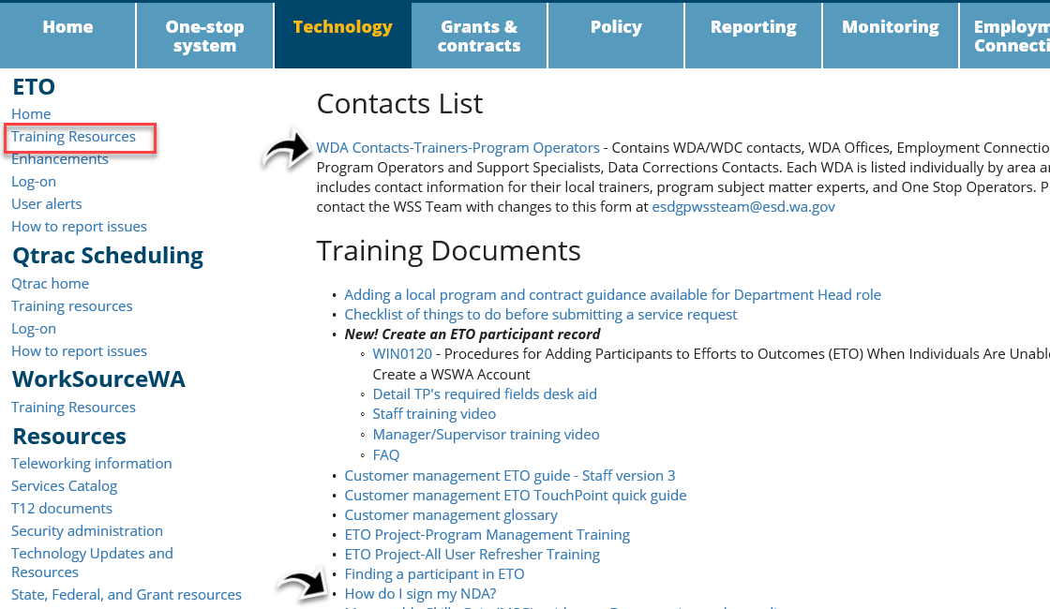

* Training issues/open discussion –
  + ETO report enhancements – Mary
    - Discussion on program enrollment outcome report. Can we remove the green columns? What else can be removed to improve the report speed and results?
    - Program Enrollment with demographic and veteran details. This is a huge report, contains lots of data. Can we remove the green columns? What else can be removed to improve the report speed and results?

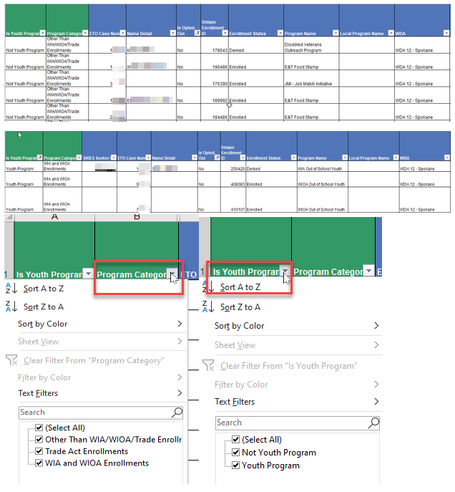

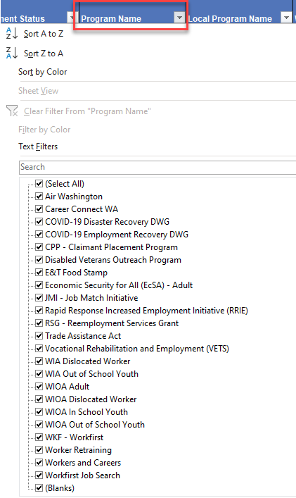

* + - Starting in September the WSS team will begin working on the WIT replacement project and will have a limited amount of time to work on report enhancements. Please submit a remedy ticket if you use reports that could be enhanced.
* ETO Basic and Refresher Training - Next training is on 8/17/21 1:30-3:50PM. There won’t be a training 9/6/21 due to the holiday.
  + ETO Basic training is the 1st Monday 9:30-11:50 and 3rd Tuesday 1:30-3:50 of every month (except holidays). Send email to Lynn Aue to receive more information, training account if needed and be added to the training Webex call. *All ETO/WSWA system users are welcome to attend the training but please do not forward invites as I need to review all attendees and assign training accounts if needed.*
  + Training recordings and user guides are posted on the WPC website here <https://wpc.wa.gov/tech/ETO-refresher-training>
  + Submit a remedy ticket to request additional training opportunities and resources
* ***Reminder:*** Submit remedy tickets for all work requests [here](https://wpc.wa.gov/tech/issues). The WSS team cannot begin work without a service request. Reaching out to us directly can affect the time it takes to resolve your issue. Thanks!

**UI announcements –**

**Job-search activities** list can be found here <https://esd.wa.gov/unemployment/job-search-requirements>

**Initial regular claims increased while continued claims decreased during the week of July 25**

**OLYMPIA –** During the week of July 25 to 31, there were 4,919 initial regular unemployment claims, up 8.0 percent from the prior week. Total claims filed by Washingtonians for all unemployment benefit categories numbered 308,266, down 0.9 percent from the prior week.

* Initial regular claims applications are now 80 percent below weekly new claims applications for the same period last year during the pandemic.
* The 4-week moving average for initial claims is 5,006. During the same time in 2019, it was 5,242. This is the lowest level of initial claims for regular benefits since the onset of the COVID-19 pandemic last year, and the eighth consecutive week the four-week moving average for initial claims has reached a new pandemic low.
* Layoffs in agriculture and construction contributed to an increase of 365 regular initial claims over the previous week.
* There was a decrease in the combined total of initial claims **and** continued or ongoing claims for all benefits—which include regular unemployment insurance, Pandemic Unemployment Assistance (PUA) and Pandemic Emergency Unemployment Compensation (PEUC).

In the week ending July 31, ESD paid out over $188 million for 229,878 individual claims. Since the crisis began in March 2020, ESD has paid more than $20.4 billion in benefits to over 1.1 million Washingtonians.

**CHAT**

from Aaron Parrott he/his/him to everyone: Is "PID" commonly used in the app backend for "ETO Case Number"? Some of our staff were flummoxed by that. *Yes, PID (Participant), is known as Case Number in ETO and can be found in the ‘Participant Information’ area.*

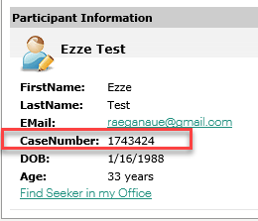

from Aaron Parrott he/his/him to everyone: 10:07 AM

Add it to my wish list Lynn :)

from Teresa Anda to everyone: No, please do not remove the unique program id. It is used to link other reports.

from Aaron Parrott he/his/him to everyone: First two fields are unnecessary clutter IMO, they don't provide worthwhile sort info

from Vey Damneun to everyone: @Teresa Anda , I agree

from Kylie Bartlett to everyone: I know that myself and my staff do not utilize the starred fields. I would be perfectly fine with that.

from Tracy Ferrell to everyone: I do not use those starred fields, and would prefer more contact info.

from Luci Bench to everyone: I agree with those deletion

from Dorothy Rocha to everyone: Agree first two fields are unnecessary

from Teresa Anda to everyone: You can actually use the unique program id to link the outcomes report with the enrollment id to get the contact information.

from Teresa Sparks to everyone: Yes

from Aaron Parrott he/his/him to everyone: I never use "Is/Is Not Youth" because I can simply filter for that in Program of Enrollment. Same with Is/Is Not WIA/WIOA. I use that one less because it would exclude things like RRIE and NDWGs that i still need in the bucket.

from Aaron Parrott he/his/him to everyone: Lynn, can we look at the Program Enrollment reports ourselves and send suggestions for unused or redundant fields if we see any? *Absolutely! Please take a look and send feedback for Mary MacLennan and me.*

**ATTENDEES**

Aaron Parrott

Abigail Taft

Adriana Lopez

Allen, Shanika

Aparicio, Rudy

B Oliveri

Bonnie Rodrigez

Capella, Jenny

Chase, Kim

Cheeseman, Maria

Cheyenne

Cori Ching

Diane Luoma

Dickerson, Barry

Dominguez, Maribel

Donna Hendrickson

Dorothy Rocha

Douglas Evans

Dryden, Jack

Dudley, Karen

Estella Segura

File, Christopher

Flores, Melisa

Heather Shin

Heidi Lamers

Hesseltine, Kate

Holmes, Carolyn

Jessie Cardwell

Joanie Linder

Jordan, Irene

J Revelle

Kylie Bartlett

Luci Bench

Malmi

Mariya Kazantseva

Metcalf, Kimberly

Michael Rivers

Nelva March

Peterson, Carl

Selam Tekle

Susan Gustafson

T Aphkas

Taylor

Teresa Anda

Teresa Sparks

Tina Newcomer

Ton

Tracy Ferrell

Vey Damneun

Zander