**T12 Meeting Minutes 8-18-2021**

**Reminder:** After starting a Webex meeting to mute your audio and disable the video feature. Too many attendee’s with active video can interfere with everyone’s audio quality. Hover over the lower edge of your monitor screen to find the icons.



**These meetings will be recorded and posted on the WPC site.**

Please be advised your image will be captured and recorded during the videoconference.

Your participation in this videoconference equals consent to be recorded as required by law.

**New Business**

* ETO maintenance – nothing this week
* WSWA maintenance – nothing this week
* Velaro maintenance – The Velaro Product Team will be performing maintenance activity on Friday, August 20, at 6:30:00 AM ET, the estimated duration is 1 hour. We do not expect any impact to your service, yet in some cases, there may be a brief interruption. Please submit a remedy ticket if you see Velaro issues after maintenance.
  + New! Agents chatting with customers will now be able to reference that customers previous chats in the history section of the engagement screen to better assist them, even if a different agent handled the previous chat
  + WA-4202 system updates 9/23/21 to resolve WSWA issues using live chat functionality on mobile devices. WSWA is using an outdated version of Velaro on the site.
* Tickets into production – Monday 8/23/21
  + WA-3794, WA-4170, WA-4220 - New RESEA dashboard added to user dashboard. This work also includes adding 2 RESEA TouchPoints. *This is for awareness for all ETO users*, t*hese changes affect only those who work in the RESEA program.*
  + Training for these changes was done by RESEA staff. Information about these new TPs and other RESEA information can be found on the WPC site on the [RESEA Employment Connections](https://wpc.wa.gov/ec/WSPD/RESEA) tab
  + Questions or need access to the RESEA SharePoint? Contact the [RESEA Program Specialists](https://wpc.wa.gov/ec/WSPD/RESEA) Teresa Sparks and Josh Gray.

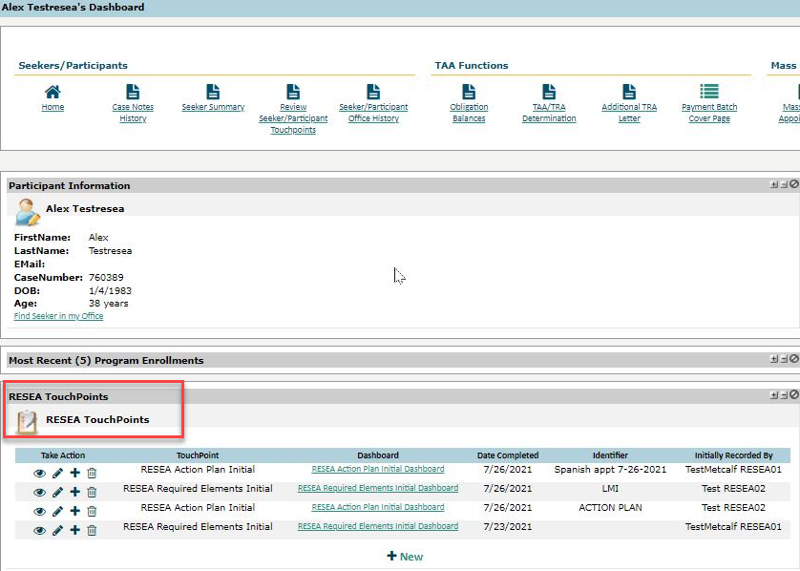

* Project updates
  + Reminder: Internet Explorer will be sunsetting October 2021
    1. Prepare by transitioning to Chrome or Edge –
       - Add sites to prevent pop up blockers
       - Clearing cache can remove the allowed site
       - Desk aid: coming soon and will be posted on WPC
* What’s new on WPC –
  + Reports –
    1. Administrative
       - Staff Created Participants; Had to combine 'Complete' and 'Incomplete' on one tab in order to correct bad opt-out logic
    2. Local Reporter Data
       - Program Enrollment Outcomes; Added email, phone & preferred contact method; deleted 3 unused columns
  + Employment Connections>Programs>[RESEA](https://wpc.wa.gov/ec/WSPD/RESEA)
  + YouTube videos not working. Velaro, ETO project training, WSWA Job-match training. These videos now work!
* Training issues/open discussion –
  + ETO report enhancements – Mary, review from 8/4/21, will review next meeting
    - Discussion on program enrollment outcome report. Can we remove the green columns? What else can be removed to improve the report speed and results?
    - Program Enrollment with demographic and veteran details. This is a huge report, contains lots of data. Can we remove the green columns? What else can be removed to improve the report speed and results?

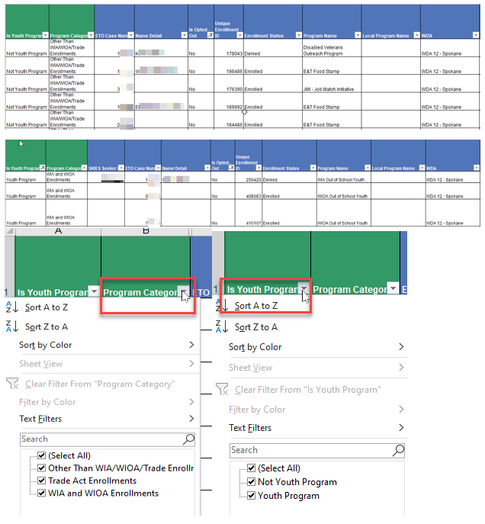

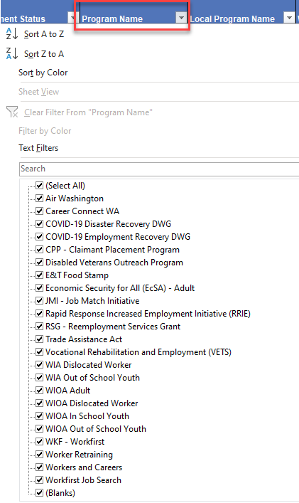

* + Starting in September the WSS team will begin working on the WIT replacement project and will have a limited amount of time to work on report enhancements. Please submit a remedy ticket if you use reports that could be enhanced.
* ETO Basic and Refresher Training - Next training is on 9/21/21 1:30-3:50PM. There won’t be a training 9/6/21 due to the holiday.
  + ETO Basic training is the 1st Monday 9:30-11:50 and 3rd Tuesday 1:30-3:50 of every month (except holidays). Send email to Lynn Aue to receive more information, training account if needed and be added to the training Webex call. *All ETO/WSWA system users are welcome to attend the training but please do not forward invites as I need to review all attendees and assign training accounts if needed.*
  + Training recordings and user guides are posted on the WPC website here <https://wpc.wa.gov/tech/ETO-refresher-training>
  + Submit a remedy ticket to request additional training opportunities and resources
* ***Reminder:*** Submit remedy tickets for all work requests [here](https://wpc.wa.gov/tech/issues). The WSS team cannot begin work without a service request. Reaching out to us directly can affect the time it takes to resolve your issue. Thanks!

**UI announcements –**

**Job-search activities** list can be found here <https://esd.wa.gov/unemployment/job-search-requirements>





**CHAT**

**Nothing this week**

**ATTENDEES**

Aaron Parrott

Abigail Taft

Aiman Memon

Aparicio, Rudy

Ariana Cordova

Arturo Espinoza

Cancel, Regina

Cauthron, Carol

Chase, Kim

Christina Shaffer

Cori Ching

Dawn Oakes

Diane Luoma

Dorothy Rocha

Dudley, Karen

Dryden, Jack

Emily Anderson

Enwall, Jo Ann

Flores, Melisa

Geddis, Catherine

Heidi Lamers

Heidi Schauble

Holmes, Carolyn

J Revelle

Jessie Cardwell

Joanie Linder

Jonas, Robert

Jordan, Irene

Kerns, Adeline

King, Kendall

Kylie Bartlett

Lisa Pietkauskis

Loney, Doug

Luci Bench

Mack, Donna

Malmi Peiris

Mariya Kazantseva

McKnight, Diana

Meredith, Amy

Nelva March

Noll, Pamela

Selem Tekle

Standley, Amanda

Susan Gustafson

T Aphkas

Tamara WSW

Teresa Sparks

Toni Burow – SCWDC

Tracy Ferrell

Vey Damneun

Wood, Lora