T12 Meeting Minutes 7-7-2021
Reminder: After starting a Webex meeting to mute your audio and disable the video feature. Too many attendee’s with active video can interfere with everyone’s audio quality. Hover over the lower edge of your monitor screen to find the icons.

These meetings will be recorded and posted on the WPC site

New Business
- Tickets into production – CHANGE
  - WA-4105 leave the “Follow-up Type” box open to add a case note for all contact types. Previously this feature was only available when you selected “No Contact”
- Create an ETO participant record is now live.
  - Training materials, procedure, FAQ, and videos on WPC
  - WIN0120
  - “Staff Created Participants” report.
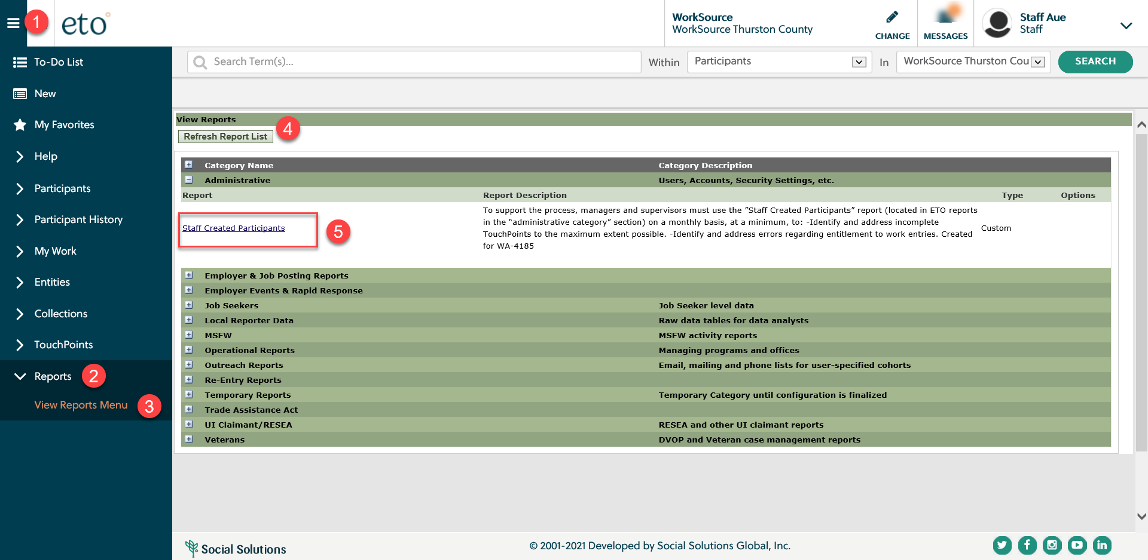

- ETO Basic and Refresher Training - Next training is on 7/20/21 1:30-3:50PM
  - ETO Basic training is the 1st Monday 9:30-11:50 and 3rd Tuesday 1:30-3:50 of every month (except holidays). Send email to Lynn Aue to receive more information, training account if needed and be added to the training Webex call. All ETO/WSWA system users are welcome to attend the training but please do not forward invites as I need to review all attendees and assign training accounts if needed.
  - Training recordings and user guides are posted on the WPC website here https://wpc.wa.gov/tech/ETO-refresher-training
  - Submit a remedy ticket to request additional training opportunities and resources
- Project updates
  - RESEA TouchPoints Initial/follow-up– projected go live July 2021
    - Training provided by RESEA

- Qtrac scheduler training materials are now on WPC site
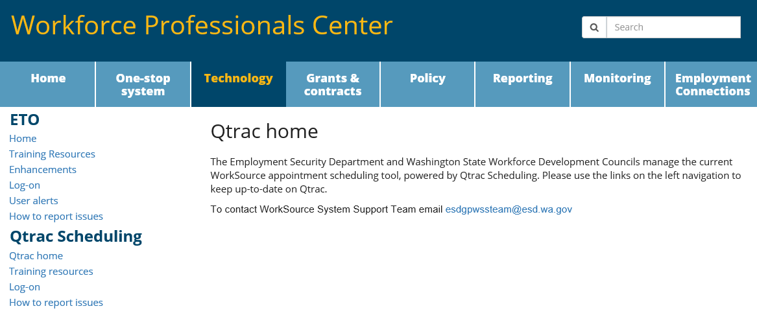
- What’s new on WPC –
  - Reports -nothing to report this week
  - Qtrac Scheduling training material
- Open discussion – training
  - Create a record training. Training materials on WPC site
- Reminder: Submit remedy tickets for all work requests here. The WSS team cannot begin work without a service request. Reaching out to us directly can affect the time it takes to resolve your issue. Thanks!
UI announcements –
Job-search activities list can be found here https://esd.wa.gov/unemployment/job-search-requirements
OLYMPIA – During the week of June 27 – July 3, there were 5,924 initial regular unemployment claims (down 21.1 percent from the prior week) and 343,246 total claims for all unemployment benefit categories (down 7.0 percent from the prior week) filed by Washingtonians, according to the Employment Security Department (ESD).
- Initial regular claims applications are now 79 percent below weekly new claims applications during the same period last year during the pandemic.
- The 4-week moving average for initial claims is at 6,966 (as compared to the 4-week moving average of initial claims pre-pandemic of 6,071 initial claims). That level represents the lowest levels of initial claims for regular benefits since the onset of the COVID-19 pandemic last year, and the fourth consecutive week initial claims have reached a new pandemic low.
- Initial claims applications for Pandemic Unemployment Assistance (PUA) increased over the week. Increases in applications from those in Management occupations as well as from Office and Administrative Support occupations drove some of the increase in PUA applications over the week.
- Initial claims applications for Pandemic Emergency Unemployment Compensation (PEUC) and continued/ongoing claims for all benefits decreased over the week.
- Decreases in layoffs in Accommodation and Food Services and Construction contributed to the decrease in regular initial claims last week.
In the week ending July 3, ESD paid out over $221 million for 268,719 individual claims. Since the crisis began in March 2020, ESD has paid more than $19.7 billion in benefits to over a million Washingtonians.

CHAT
Create a record training, Q&A added to the FAQs
ATTENDEES

Not adding attendance here. If needed Lynn can provide it.

