**T12 Meeting Minutes 7-14-2021**

**Reminder:** After starting a Webex meeting to mute your audio and disable the video feature. Too many attendee’s with active video can interfere with everyone’s audio quality. Hover over the lower edge of your monitor screen to find the icons.



**These meetings will be recorded and posted on the WPC site**

**New Business**

* Tickets into production –
  + 7/7/2021 WA-4105 leave the “Follow-up Type” box open to add a case note for all contact types. Previously this feature was only available when you selected “No Contact”

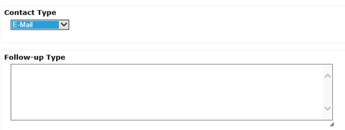

* + WA-4217 – Add years to the Sections Details TP of the TAA Obligation Dashboard allowing TAA case managers to add obligations for training through 2030.
  + WA-4218 – Add ITSS Outcome “Unknown Outcome – Historical Data Cleanup”
    1. Part of the ETO data cleanup effort to close out old open durational services. This change provides an option in ETO to easily identify record with an unknown outcome. Staff are directed to only use this as a last resort when the true outcome cannot be determined. After cleanup is completed this option will be removed from the selections. This outcome will roll up to and be recognized as *Did Not Complete*

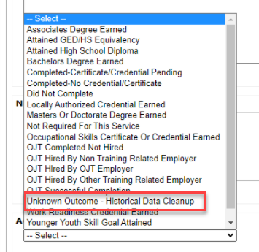

* ETO Basic and Refresher Training - Next training is on 7/20/21 1:30-3:50PM
  + ETO Basic training is the 1st Monday 9:30-11:50 and 3rd Tuesday 1:30-3:50 of every month (except holidays). Send email to Lynn Aue to receive more information, training account if needed and be added to the training Webex call. *All ETO/WSWA system users are welcome to attend the training but please do not forward invites as I need to review all attendees and assign training accounts if needed.*
  + Training recordings and user guides are posted on the WPC website here <https://wpc.wa.gov/tech/ETO-refresher-training>
  + Submit a remedy ticket to request additional training opportunities and resources
* Project updates
  + RESEA TouchPoints Initial/follow-up– projected go live August 2021
    1. Training provided by RESEA
  + SKYPE will be sunsetting 7/30/2021
    1. Scheduled meetings will still work, but you should not schedule new meetings. Prepare for the change by transitioning now to Teams or Webex.
       - [Microsoft Teams Training](https://support.microsoft.com/en-us/office/microsoft-teams-video-training-4f108e54-240b-4351-8084-b1089f0d21d7) on the Microsoft support site
       - [Webex training](https://wpc.wa.gov/tech/teleworking) on WPC Teleworking page
  + Internet Explorer will be sunsetting October 2021
    1. Prepare by transitioning to Chrome or Edge
       - Add sites to prevent pop up blockers
* What’s new on WPC –
  + Reports –
    1. Administrative:
       - Staff Created Details; Moved here from the 'Operational Reports' category
       - UniqueProgramEnrollmentNames; Moved here from the 'Operational Reports' category
    2. Job Seekers
       - All Seeker Services History; Updated description; added 'History' to report name; and made report available to all staff
    3. Local Reporter Data
       - Chronological Seeker Services; Deleted report; duplicate of All Seeker Services History report under 'Job Seekers' category
    4. Operational Reports
       - Staff Account Details; Moved to the 'Administrative' category
       - UniqueProgramEnrollmentNames; Moved to the 'Administrative' category
* Training issues/open discussion –
  + Create an ETO participant record – incomplete records
    - Training materials, procedure, FAQ, and videos on WPC
    - Follow WIN0120
    - “Staff Created Participants” report.

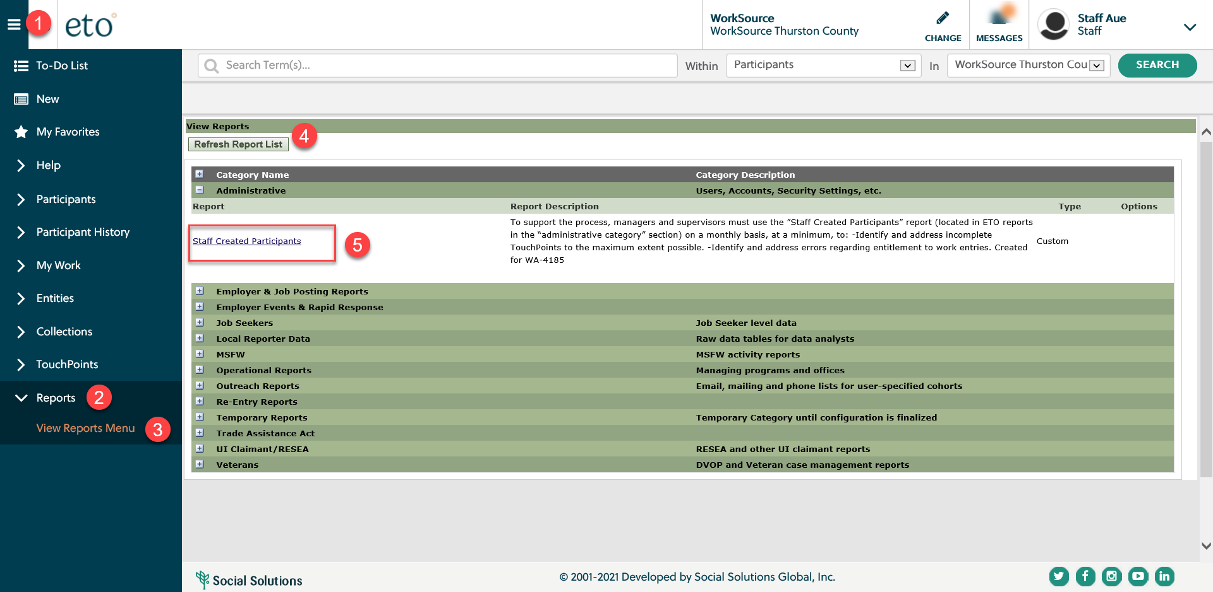

* + Question: *This came up when searching for my participant in WorkSource w/o an office attached, is there something I should be doing with this? Its does not come up when searching in WorkSource Redmond\*\*\**

This is the View/Edit page. You only land here when you view a participant record who is not enrolled into the office you are logged into. If you enter a participant account who is enrolled into the office you are searching from you have the option to land in several areas. View/Edit, Dashboard, View/Record TouchPoint, and Reporting Dashboard.

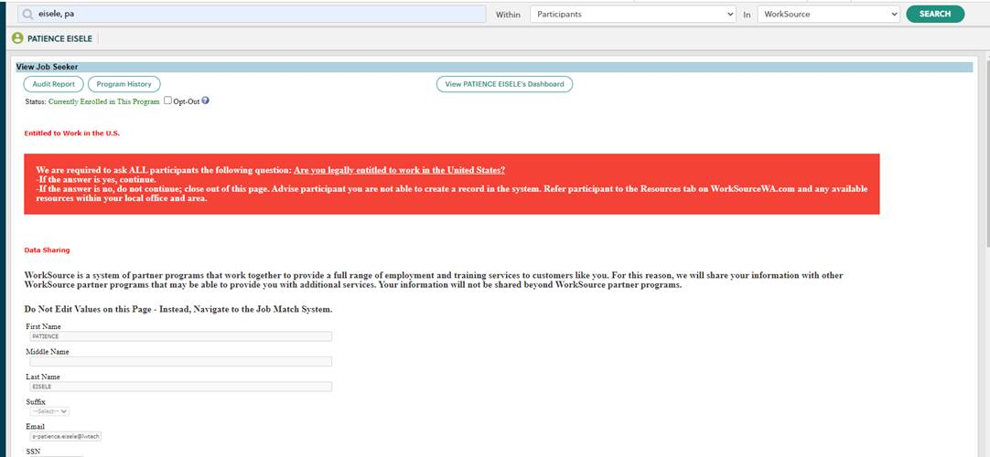

* ***Reminder:*** Submit remedy tickets for all work requests [here](https://wpc.wa.gov/tech/issues). The WSS team cannot begin work without a service request. Reaching out to us directly can affect the time it takes to resolve your issue. Thanks!

**UI announcements –**

**Job-search activities** list can be found here <https://esd.wa.gov/unemployment/job-search-requirements>



**CHAT**

from Kerns, Adeline (ESD): *Inside ESD opens with Internet Explorer will it now open with Chrome.* *I defaulted to Chrome already, but it still does not open Inside ESD.* You need to set Chrome as your default to automatically open in Chrome. Then you add Inside ESD as your home page and click the house icon on the left side of the task bar.

from Tracy Ferrell: *Is there a preference (Chrome or Edge) for opening ETO?* ETO is browser neutral, meaning you can access ETO from IE, Chrome, Edge. An issue we get tickets about is pop-up blockers for ETO in Edge and Chrome. Remember to configure your browser to allow access to ETO

**ATTENDEES**

Adriana Lopez

Laura Anderson

Rudy Aparicio

Mirayia Baker

Becky Smith

Brett Oliveri

Josie Capetillo

Diane Luoma

Donna Hendrickson

Barry Dickerson

Jo Ann Enwall

Christopher File

Jack Dryden

Catherine Geddis

Heidi Lamers

Heidi Schauble

Jenny Capella

Robert Jonas

Irene Jordan

J Revelle

Adeline Kerns

Lisa Pietkauskis

Luci Bench

Malmi Peiris

Nelva March

Pochi Ostergren

Carl Peterson

Teresa Sparks

Tamara

Teresa Anda

Toni Burow

Tracy Ferrell

Talitha Cassidy

Dorothy Rocha

Douglas Evans

Arturo Espinoza

Heather Shin

Jackie Wetchler

Melisa Flores

Melinda Johnson

Lora Wood

Carol Matranga

Seth Maier

Heidi Lamers

Christina Shaffer

Cori Ching

Dean Coxford

Michael Ensor

Christina Tovar-Hamernik

Selam Tekle

Abigail Taft

A Johnson

Joanie Linder

Jaclyn Cascio

Kylie Bartlett

Monique Martin

Deanna Gillis

Donna Mack

Attended second half