T12 Meeting Minutes 6-16-2021
Remember: After starting a Webex meeting to mute your audio and disable the video feature. Too many attendee’s with active video can interfere with everyone’s audio quality. Hover over the lower edge of your monitor screen to find the icons.

These meetings will be recorded and posted on the WPC site

New Business
- WorkSource public -use equipment training ended after 13 training sessions in May. You can find the training material, PowerPoint presentations, video recordings, and FAQ’s on the WPC site for self-directed refresher trainings.
- Tickets into production – Create an ETO participant record goes live tomorrow morning.
  - Training materials, procedure, FAQ and videos on WPC
  - WIN0120
  - “Staff Created Participants” report.
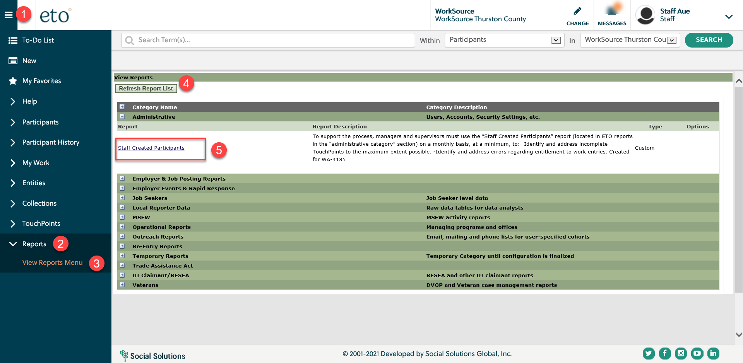
- ETO changes – This change was implemented on the morning of Friday, June 4th. The colors, fonts, logos, and login screen looks different and there are some known issues.
  - Reported issues;
    - Issues performing tasks when using Internet Explorer. Clearing cache usually resolves issue.
    - Taking TPs from the side navigation bar is a known issue and the dev team is working on resolution. Take TP from the participant dashboard.
    - Unable to reset the password if you let it expire or respond to the notice it is about to expire. Work around is to Ctrl – to reduce the screen size so you can change PW. If you are unable to log in submit a remedy ticket for assistance.
    - Color change is hard to read. We are working with vendor on this issue.
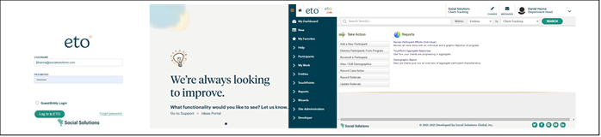

- WSWA maintenance – nothing this week
- Velaro maintenance – The Velaro Product Team will be performing maintenance activity on Friday, June 18, at 6:30:00 AM ET, the estimated duration is 1 hour. We do not expect any impact to your service, yet in some cases, there may be a brief interruption. This is the link for the release notes for the details.
- ETO Basic and Refresher Training - Next training is on 7/20/21 1:30-3:50PM
  - ETO Basic training is the 1st Monday 9:30-11:50 and 3rd Tuesday 1:30-3:50 of every month (except holidays). Send email to Lynn Aue to receive more information, training account if needed and be added to the training Webex call. All ETO/WSWA system users are welcome to attend the training but please do not forward invites as I need to review all attendees and assign training accounts if needed.
  - Training recordings and user guides are posted on the WPC website here https://wpc.wa.gov/tech/ETO-refresher-training
  - Submit a remedy ticket to request additional training opportunities and resources
- Project updates
  - Create an ETO participant record-go live 6/17/2021
    - Training sessions for all staff are 6/23 and 7/7, sign-up.
    - Training material on WPC
  - RESEA TouchPoints Initial/follow-up– projected go live July 2021
    - Training provided by RESEA staff
  - Multi Factor Authentication for WSWA recruiters, not staff using ETO - projected go live 7/7/21
- What’s new on WPC –
  - Home page has announcement and sign-up for Create a Record training.
  - Reports – Nothing new this week.
- Open discussion – training
  - Create a record training. Training materials on WPC site
- Reminder: Submit remedy tickets for all work requests here. The WSS team cannot begin work without a service request. Reaching out to us directly can affect the time it takes to resolve your issue. Thanks!
UI announcements –
Job-search activities list can be found here https://esd.wa.gov/unemployment/job-search-requirements
OLYMPIA – During the week of June 6 – June 12, there were 6,892 initial regular unemployment claims (down 22.3 percent from the prior week) and 383,776 total claims for all unemployment benefit categories (down 0.7 percent from the prior week) filed by Washingtonians, according to the Employment Security Department (ESD).
- Initial regular claims applications are now 76 percent below weekly new claims applications during the same period last year during the pandemic.
- The 4-week moving average for initial claims remains elevated at 9,378 (as compared to the 4-week moving average of initial claims pre-pandemic of 6,071 initial claims) and remains at similar levels of initial claims filed during the Great Recession.
- Initial claims applications for regular benefits, Pandemic Emergency Unemployment Compensation (PEUC) and continued/ongoing claims for regular benefits all decreased over the week.
- Initial claims applications for Pandemic Unemployment Assistance (PUA) increased slightly over the week.
- Decreases in layoffs in Retail Trade, Manufacturing and Administrative and Support Services contributed to the decrease in regular initial claims last week.
In the week ending June 12th, ESD paid out over $226 million for 287,334 individual claims. Since the crisis began in March 2020, ESD has paid more than $19 billion in benefits to over a million Washingtonians.
CHAT
Create a record training, Q&A added to the FAQs
ATTENDEES

Not adding attendance here. If needed Lynn can provide it.

