T12 Meeting Minutes 05/18/2022

Reminder: Mute your audio and disable the video feature after starting this Webex meeting. Too many attendee’s with active video can interfere with everyone’s audio quality. Hover over the lower edge of your monitor screen to find the icon and disable your video.

These meetings will be recorded and posted on the WPC site.
Please be advised your image will be captured and recorded during the video conference.
Your participation in this videoconference equals consent to be recorded as required by law.
New Business
- ETO maintenance – ETO maintenance will take place Saturday 5/21 6PM PT to Sunday 5/22 at 3AM PT. The environment will be intermittently unavailable during this timeframe.
- WSWA maintenance – nothing this week
- Velaro maintenance – nothing this week
- Qtrac – nothing this week
- Tickets into production – nothing this week
- ETO report enhancement updates – nothing this week.
- What’s new on WPC – nothing this week
- Training issues/open discussion/ticket updates
  - T12 cancelled next week 5/25/22
  - Recently the ETO participant dashboard wasn’t working as expected causing a work stoppage by some staff. Did you know there are other ways to besides from the participant dashboard to take TPs?
    - Start by clicking opening the side navigation menu #1 (AKA pancake or hamburger )
    - Select the TP, TP subject type, a participant from the list and enter the service provided
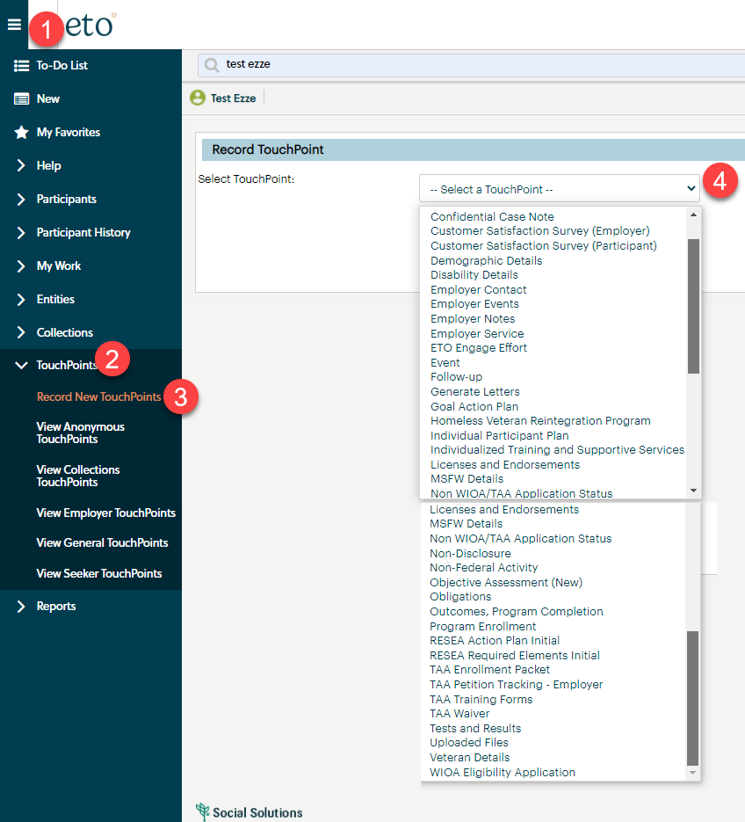
  - WIT replacement suggestions—use the link at the bottom of this page on the WPC site: https://wpc.wa.gov/wswa/wit-replacement-project
  - WA-4488 Interface 19 was not updating TAA obligations. The files are updated, and we are looking at the root cause and updating the PIRL. Issue under review.
  - WA-4338 RESEA Required Elements TP – There is a reported dashboard issue caused by the type of file uploaded to the parent TP. The .msg file type caused the issue. Issue under review.
  - WA-4438 Known issue with some participants RESEA dashboard not accessible to some users. Trying to determine if this is a dashboard bug. The TP is functioning as designed. In order to record the child response the users will need access to the program where the parent response was recorded, and it will need to be recorded in that same office. We will need to work out a solution with the RESEA team.
    - Ex: You were logged into WS Yakima when you created the TPs. You also work in WS Sunnyside and have access to that office. When you are logged into WS Sunnyside you will not have the ability to edit the TP because it was created in WS Yakima.
  - Internet Explorer (IE) will be sunsetting June 8, 2022
    - The default browser will be Edge
    - Prepare now by transitioning to Edge or Chrome and move your favorites!
    - Many have experienced caching issues with Chrome. Remember when you clear your Chrome cache it clears your safe sites which blocks opening ETO reports and other applications. Check out this short Report Pop-up Blockers video found on the WPC site
  - WA-4454 RESEA Required Elements Initial Response form not printing correctly. Issue under review
  - WA-4465 We received a ticket concerning that the WSWA Qtrac scheduler and WorkSource Office Locator don’t work correctly using IE browser. On the locater the drop-down menus are missing. Talking with live chat agents it was discovered this also is occurring when using Chrome. The issue is resolved by clearing the cache. I will be submitting a ticket asking why the sudden issue is resolved by clearing cache. Issue under review.
  - WA-4426 Recently we made enhancements to the Case Note reports by adding the ‘Identifier’ column. This change made columns so narrow it caused the PDF to be more pages. We are asking if the report can be changed from portrait view to landscape view to resolve this issue but now there is an issue with ‘white space’ or all the note areas are the same size to the note with the largest amount of text. Nothing to report this week but continue to use these workarounds:
    - Tip: If you export to report to Excel, you can change the row height to remove the white space.
    - When printing to PDF, ‘uncheck’ Report 2 (the query logic), so you won’t get the query logic pages within their PDF and this shortens the length of the report
    - There is an issue with the left-side navigation window causing the report not to run, time out. To resolve this issue, close the left-side navigation window.
      - During this testing we discovered this is an issue with the Case Note History widget and at time causing this report to time out. The widget does not allow you to close out the left-side navigation window so you will need to run the Case not history report starting form the report menu.
  - WA-4437 Missing elements when printing ‘Outcomes, Program Completion’ TP is a known bug. SSG has a fix and will notify us when they plan to push it out in a future release. Still waiting for the change date

- ETO Basic and Refresher Training - Next training is 6/6/22 9-12
  - ETO Basic training is the 1st Monday 9:00-12 and 3rd Tuesday 1:30-4:30 of every month (except holidays). Send email to Lynn Aue to receive more information, get a training account if needed and be added to the training Webex call. All ETO/WSWA system users are welcome to attend the training but please do not forward invites as I need to review all attendees and assign training accounts if needed.
  - Refresher training recordings and user guides are posted on the WPC website here https://wpc.wa.gov/tech/ETO-refresher-training
  - Submit a remedy ticket to request additional training opportunities and resources
Old Business
- Employer fraud and impact to job seekers, leaving this here for awareness
  - Talk to your employers about including their ESR numbers (UI tax ID number) in the account creation. We cannot approve accounts with verifying this information or speaking with the employer.
  - Submit remedy ticket if job seekers report they have been contacted by fraudster. Gather and include as much information from the job seeker, text messages, screen shots from online interviews, ‘employer’ emails and phone numbers, etc.
  - Working on new process and changes to WSWA to warn job seekers about employer scams.
  - Direct job seekers to Washington State Office of the Attorney General for information on employment scams
  - Job seekers can contact the Attorney General’s office and file a complaint ‘Contact Us’
    - The AG’s office is now recommending job seekers and employers contact the FBI
    - Question raised during a previous call; Is this fraud to the point where we should be encouraging customers to keep their resumes and contact info private on WorkSourceWa.com?
      - That is a decision the job seeker needs to make for themselves. The WSWA website provides information about resumes, avoiding scams, terms of use and risks. Protect job seekers by advising them to not include DOB, SSN, street address and references in resumes. Some still do that! Ask them to review the employment scam information on the Attorney General’s web site.
    - Remember, job seekers can upload resumes on WSWA and can keep them private. The disadvantage to this is employers cannot do a resume match using key words.
    - Tip from the USAJOBS website
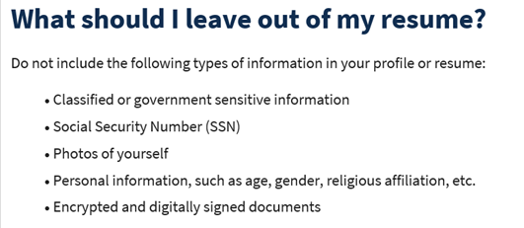
- Reminder: Submit remedy tickets for all work requests here. The WSS team cannot begin work without a service request. Reaching out to us directly can affect the time it takes to resolve your issue. Thanks!
  - Submitting remedy tickets – help us by providing enough details to work your issue. Suggestions help to speed up discovering and resolving the issue without lots of back-and-forth emails.
    - Screen shots include the entire screen, browser bar, not just a pinpoint of the TP that isn’t correct.
    - Screen shots of error messages
    - What you were doing when you got the ‘Robot’ or error message
    - Report tickets need the WDA, office and start and end dates parameters you used to run the problematic report
    - We will send you 2 emails asking for additional information. Second request for response will advise you the ticket will close in 24 hours.
  - Duplicate accounts and SSN correction tickets are a high priority, needing an immediate fix so staff can record services provided to customers timely. You can reach out to the service desk asking for a ticket status update here ESDDLITBITechnicalSolutions@ESD.WA.GOV or if you don’t receive a response within 24 hours from the WSS team about your ticket, email us at esdgpwssteam@esd.wa.gov so we can locate the ticket and start working on it.
  - Submit remedy ticket to update the WS locator with office closures, changes to office hours, contact information or location.
  - Remember if you suggest an enhancement at T12, submit a remedy ticket.
- Desk aid on things to try before submitting a remedy ticket; includes instructions for clearing your cache
- Internet Explorer (IE) will sunset June 8, 2022
  - The default browser will be Edge
  - Prepare now by transitioning to Edge or Chrome.
  - Don’t forget to transfer your favorites to Edge or Chrome and also add a copy to your document folder for recovery purposes!
    - How to import Favorites from IE to Chrome video
    - How to import Favorites from IE to Edge
        - Click on Favorites ‘star’
        - Click on ellipses (3 dots)
        - Select either Import (from Chrome or IE) or Export a copy to a local folder

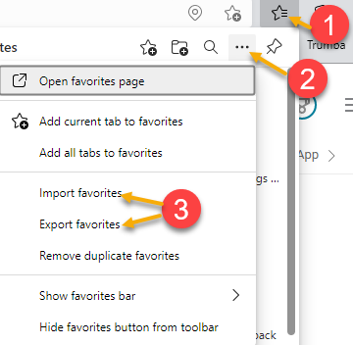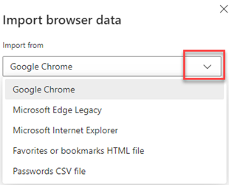

Unemployment Insurance (UI) claim and data information can be found on the UI page here https://esd.wa.gov/

CHAT

Discussion:

ETO Basic Training—
from Teresa Anda to everyone: 10:01 AM
Lynn, can you go over the process for training new staff going forward.
- Lynn creating 3 modules as videos; they will be posted on the WPC site under ETO > Training Resources > ETO Basic and Refresher Training.
- There are 10 training accounts for each WDA; if need access to area training videos, submit a remedy ticket to ask for training accounts. Once form completed, Lynn will set accounts us and provide password. Once the date ends, the passwords will be reset and ready for the next group of trainees.
- Lynn will create a desk aid walking through the step-by-step process for the self-training process. Videos are exactly the same as the live training, so staff will not be missing out on anything reviewing these modules vs. what they received live.
  - Module 1 – overview of WPC resources
  - Module 2 – technology tab
  - Module 3 – hands-on training – review of services catalog; logging into a training account & signing NDA; going to production & signing NDA; user dashboard; searching for participants; running opt-out report; side navigation bar; doing a program enrollment; adding a qualifying service so participation starts; overview of WSWA.

Dashboard issue for recording services—
- You can select ‘Review Seeker/Participant TouchPoints’ from seeker dashboard, and you can add services from that screen, either by selecting ‘Take New next to ‘Basic Service’ or click on the ‘Take New TouchPoint’ button at the bottom of the page.
- You can also use left-hand navigation – TouchPoints > Record New TouchPoints.

ETO tickets—no movement; leaving on agenda for awareness.

Internet Explorer sunsetting—
- Edge seems to work better for caching issues; however, you can use either Edge or Chrome.
from Mack, Donna R (ESD) to everyone: 10:18 AM
Is the agency communicating about the IE sunset? I am not seeing it in all-staff communications
- They are preparing to roll out the communications soon.
from Gillis, Deanna F. (ESD) to everyone: 10:20 AM
Something is supposed to be coming out tomorrow in the weekly letter
from Gillis, Deanna F. (ESD) to everyone: 10:23 AM
From Famous Atkinson: Thursday May 19, we will be letting everyone know in an all-staff message.
We will also be sending reminder all-staff messages on June 2 and June 7.
Thursday May 19, we will be letting everyone know in an all-staff message.
We will also be sending reminder all-staff messages on June 2 and June 7.
And of course, we would appreciate you reinforcing the all-staff message to your direct reports.

WIT replacement suggestions—use the link at the bottom of this page on the WPC site: https://wpc.wa.gov/wswa/wit-replacement-project

ATTENDEES

Abplanalp, Christopher
Aparicio, Rudy
Ariana Cordova
Baker, Mirayia
Bonnie Rodriguez
Cascio, Jaclyn
Chase, Kim
Christopher File
Cori-Ann Ching
Dawn Oakes
Donna Hendrickson
Dorothy Rocha
Dzenita Musabegovic
Emily Anderson
Erickson, Tristan
Gillis, Deanna
Griffith, Michelle
Heidi Lamers
Herrin, Janice
Holmes, Carolyn
Jessie Cardwell
Jordan, Irene
Kerns, Adeline
Kluth, Crystina
Lolade Fapohunda
Luci Bench
Lux Dmitri
Mack, Donna
Maidadi, Ismaila
Maricha Friedman
Mark Chase
Martin, Monique
Maya Anderson
Natalya
Ni Dufaigh, T. Jaide
Pelot, Paul
Pochi
Robinson, Melissa
Smith, Jasmine
Sparks, Teresa
Sue Keltner
Susan Gustafson
Tamara Toles
Teresa Anda
Tina Newcomer
Tracy Ferrell
Zander

