T12 Meeting Minutes 4-7-2021
Remember: After starting a Webex meeting to mute your audio and disable the video feature. Too many attendee’s with active video can interfere with everyone’s audio quality. Hover over the lower edge of your monitor screen to find the icons.

These meeting will be recorded. Recordings will be posted on the WPC site

New Business
- Tickets into production –
  - Postponed until 4/15/21 WA-4113 new follow-up service; change to services catalog, policy
    - Follow-Up Services-Supportive Assistance
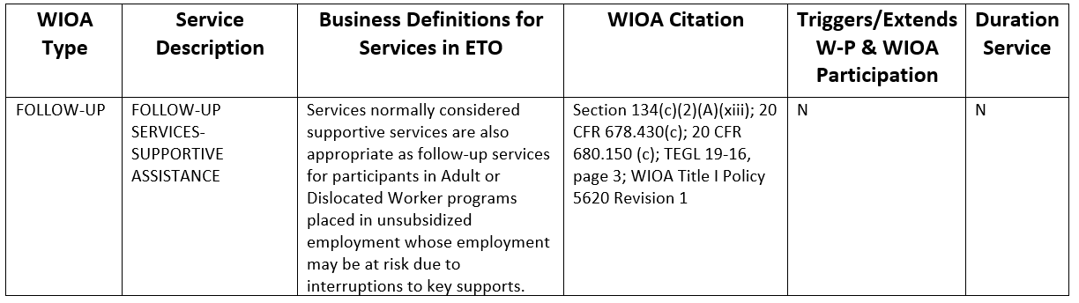
  - WA-4117 Report found under Program Administration called Review Staff Efforts not functioning as expected, used by those with Program manager and Department Head ETO roles. Mary will update us on 4/14/21
- ETO maintenance – nothing to report this week
- WSWA maintenance – nothing to report this week
- Velaro maintenance – nothing to report this week
- ETO Basic and Refresher Training - Next training is on 4/20/21 2-4PM
  - ETO Basic training is the 1st Monday 10-12 and 3rd Tuesday 2-4 of every month (except holidays). Send email to Lynn Aue to receive more information, training account if needed and be added to the training Webex call. All ETO/WSWA system users are welcome to attend the training but please do not forward invites as I need to review all attendees and assign training accounts if needed.
  - Training recordings and user guides are posted on the WPC website here https://wpc.wa.gov/tech/ETO-refresher-training
  - Submit a remedy ticket requesting additional training opportunities and resources
- What’s new on WPC –
  - New content coming soon for WS resource and training room training material
- Public -use equipment training will begin on 4/19/21 through 5/13/21. Sign-up on the Staff Development Calendar or type this into your browser https://wpc.wa.gov/tech/staff/trainingcalendar
- Open discussion – training issues
  - Nothing this week
- Reminder: Submit remedy tickets for all work requests. The WSS team cannot begin work without a service request. Reaching out to us directly can affect the time it takes to resolve your issue. Thanks! https://wpc.wa.gov/tech/issues
- UI announcements –
- OLYMPIA – During the week of March 28 – April 3, there were 11,863 initial regular unemployment claims (up 3.6 percent from the prior week) and 426,803 total claims for all unemployment benefit categories (down 0.8 percent from the prior week) filed by Washingtonians, according to the Employment Security Department (ESD).
  - Initial regular claims applications are now 93 percent below weekly new claims applications during the same period last year at the start of the pandemic.
  - Initial claims remain elevated (as compared to the 4-week moving average of initial claims pre-pandemic of 6,071 initial claims) and remain at similar levels of initial claims filed during the Great Recession.
  - Increases in layoffs in the Professional, Scientific and Technical Services as well as Administrative Support Services sectors contributed to the increase in regular initial claims last week.
  - Initial claims applications for Pandemic Unemployment Assistance (PUA) and Pandemic Emergency Unemployment Assistance (PEUC) as well as continued claims for regular benefits all decreased over the week.
  - In the week ending April 3, ESD paid out over $250.0 million for 305,707 individual claims. Since the crisis began in March 2020, ESD has paid more than $16.6 billion in benefits to over a million Washingtonians.
- For current COVID-19 and UI information ESD.wa.gov or ESD Facebook page
- UI Fraud help
  - www.esd.wa.gov/fraud
  - Fax information to claims centers 833-572-8423 –due to the high volume, calling is not recommended
- Before submitting a service ticket, review this desk aid “Check list: things to try before submitting a service/remedy ticket”
- Visit this page on the WPC site to submit a service request: https://wpc.wa.gov/tech/issues If you are an ESD partner, there is a downloadable form that you must fill out and send to the Technical Solutions service desk – their e-mail is ESDDLITBITechnicalSolutions@ESD.WA.GOV
Review of ETO/WSWA and other resources (AKA old business)
- Encourage all staff who use ETO and WSWA to sign up for the T12 calls. These calls are not just for trainers but for all system users and a great way to stay up to date on changes or improvements to ETO and WSWA. Send requests to esdgpWSSteam@esd.wa.gov to be added to the ITSD Training Team’s distribution list
- WorkSource Systems resources found on the WPC Technology site https://wpc.wa.gov/tech
  - We try our best to make sure all the links are operational but depend on you to submit a remedy ticket if you find broken links!
- Check out the information the WPC website to help all WorkSource staff telework stay up to date on COVID19, teleworking and WorkSource Virtual services including;
  - IT service delivery
  - WebEx
    - Browse the Webex handbook and watch 5 videos on how to make the most out of this tool for conducting meetings with staff and customers.
  - Other resources include:
    - Now that you are teleworking reference guide
    - How to use SKYPE for online meetings
    - How to sign into ESD email from outside the network
    - How to sign into an off-site Wi-Fi from your computer
    - Can I access Internet Explorer from a MAC computer?
    - ESD service Desk information.
CHAT
Nothing this week

ATTENDEES

Ariana Cordova
Boliveri
Carl Peterson
Carly Farmer
Carolyn Holmes
Catherine Geddis
Christopher File
CMatranga
Cori Ching
Craig Clark
Dawn Oakes
Dean
Diane
Donna Hendrickson
Donna Mack
Douglas Evans
Emily Anderson
Gena Garcia
Heidi Lamers
Heidi Schauble
Irene Jordan
Jack Dryden
Jackie Wetchler
Jenny Capella
Jessie Cardwell
Jo Ann Enwall
Melinda Johnson
Kate Hesseltine
Kimberly Chase
Eric Kindvall
Kylie Bartlett
Laura Anderson
Luci Bench
Lux Dmitri
Maria Zaragoza
Maribel Dominguez
Melisa Flores-Sanchez
Natasha Bradley
Nelva March
Pochi Ostergren
Robbin Gard
Robert Jonas
Selma Tekle
Matthew Shields
Tamela McNamee
Teresa Sparks
Theresa Rogers
Tim Robison
Tim Woodward
Tina Newcomer
Ton Nguyen
Toni Burow
Tracy Ferrell
Tracy Ollgaard
Vey Damneun
Attended second half

