T12 Meeting Minutes 04-06-2022

Reminder: Mute your audio and disable the video feature after starting this Webex meeting. Too many attendee’s with active video can interfere with everyone’s audio quality. Hover over the lower edge of your monitor screen to find the icon and disable your video.

These meetings will be recorded and posted on the WPC site.
Please be advised your image will be captured and recorded during the video conference.
Your participation in this videoconference equals consent to be recorded as required by law.
New Business
- ETO maintenance – nothing this week
- WSWA maintenance – SAW, maintenance Tuesday April 19, 2022, 5:30-6:30am. This will prevent job seekers and employers from logging into WSWA
- Velaro maintenance – nothing this week
- Tickets into production – nothing this week
- ETO report enhancement updates – nothing this week.
- What’s new on WPC – nothing this week
- Training issues/open discussion
  - Continue discussion on ETO access requests SLA
    - ETO account requests come from access requesters to the IAM team and the procedure is to notify the account requester when the account is ready. The notification includes the username and password making it a security risk to send the notification to anyone else. It is the responsibility of the access requester to notify the person asking for access.
  - WA-4444 – six new services added and 1 service deactivated
    - Adding 3 Basic services that don’t trigger or extend participation
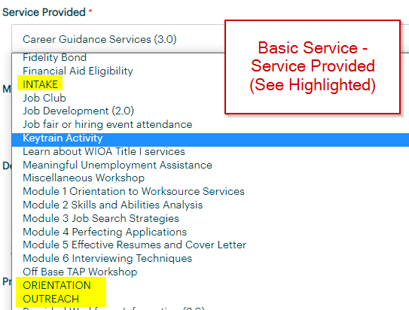
    - Adding 3 ITSS that trigger and/or extend participation and are durational services
      - Adult Alternative High School Diploma/GED
      - Entrepreneurship
      - Unpaid Work Experience With Academic/Education Component – job shadowing (Youth Only)
    - Deactivating 1 ITSS
      - Paid and Unpaid Work Experience with Academic/Education Component – job shadowing (Youth Only)
  - WA-4454 Required elements Initial Response form not printing correctly. Actively working on issue this week.
  - WA-4447 We received a ticket concerning WSWA tools Qtrac scheduler and WS Office Locator don’t work using IE browser. On the locater the drop-down menus are missing. Talking with live chat agents it was discovered this also is occurring when using Chrome. The issue is resolved by clearing the cache. Nothing to report this week
  - WA-4426 Recently we made enhancements to the Case Note reports by adding the ‘Identifier’ column. This change made columns so narrow it caused the PDF to be more pages. We are asking if the report can be changed from portrait view to landscape view to resolve this issue. Continue to work on changes
  - WA-4437 The missing elements when printing ‘Outcomes, Program Completion’ TP is a known bug. SSG has a fix and will notify us when they plan to push it out in a future release. Nothing to report out this week
  - Multi-Factor Authentication (MFA) for WSWA employers, has been delayed to 4/26/22. This change applies only to employers, not job seekers, when logging into WSWA. Training material is on the WPC, Technology, WorkSourceWA page.
    - Multi-factor authentication for employers: What to expect (PowerPoint)
  - WA-4438 Known issue with some participants RESEA dashboard not accessible to some users. Nothing to report out this week
    - Dashboard TPs require you be logged into the office the TP was created in to have the ability to edit it. WE are looking into seeing if this configuration can be changed.
      - Ex: You were logged into WS Yakima when you created the TPs. You also work in WS Sunnyside and have access to that office. When you are logged into WS Sunnyside you will not have the ability to edit the TP because it was created in WS Yakima.
  - When searching for a recruiter in ETO you need to change the ‘In’ field from The office you are logged into to ‘WorkSource’ to return a search of all employers/recruiters with the name you are seeking. Further testing shows there are only a handful of employers who don’t appear when you are searching in the office you are logged into. Those employer accounts had issue during data migration from SKIES.
  - Reminder: Link to claimants 1099’s available in eServices

- Remedy tickets
  - We are getting a lot of duplicate account and SSN correction tickets which are a high priority, needing an immediate fix so staff can record services provided to customers timely. You can reach out to the service desk asking for a ticket status update here ESDDLITBITechnicalSolutions@ESD.WA.GOV or if you don’t receive a response within 24 hours from the WSS team about your ticket, email us at esdgpwssteam@esd.wa.gov so we can locate the ticket and start working on it.
  - Office closures or changes to office hours, contact or location. Submit remedy ticket to update the WS locator
  - Submit remedy tickets vs sending email to team, emails slow down the response time of helping you.
  - Remember if you suggest an enhancement at T12, submit a remedy ticket.
- ETO Basic and Refresher Training - Next training is on 4/19/22 1:30-4:30
  - ETO Basic training is the 1st Monday 9:00-12 and 3rd Tuesday 1:30-4:30 of every month (except holidays). Send email to Lynn Aue to receive more information, training account if needed and be added to the training Webex call. All ETO/WSWA system users are welcome to attend the training but please do not forward invites as I need to review all attendees and assign training accounts if needed.
  - Refresher training recordings and user guides are posted on the WPC website here https://wpc.wa.gov/tech/ETO-refresher-training
  - Submit a remedy ticket to request additional training opportunities and resources
Old Business
- Employer fraud and impact to job seekers, leaving this here for awareness
  - Talk to your employers about including their ESR numbers (UI tax ID number) in the account creation. We cannot approve accounts with verifying this information or speaking with the employer.
  - Submit remedy ticket if job seekers report they have been contacted by fraudster. Gather and include as much information from the job seeker, text messages, screen shots from online interviews, ‘employer’ emails and phone numbers, etc.
  - Working on new process and changes to WSWA to warn job seekers about employer scams.
  - Direct job seekers to Washington State Office of the Attorney General for information on employment scams
  - Job seekers can contact the Attorney General’s office and file a complaint ‘Contact Us’
    - The AG’s office is now recommending job seekers and employers contact the FBI
    - Question raised during a previous call; Is this fraud to the point where we should be encouraging customers to keep their resumes and contact info private on WorkSourceWa.com?
      - That is a decision the job seeker needs to make for themselves. The WSWA website provides information about resumes, avoiding scams, terms of use and risks. Protect job seekers by advising them to not include DOB, SSN, street address and references in resumes. Some still do that! Ask them to review the employment scam information on the Attorney General’s web site.
    - Remember, job seekers can upload resumes on WSWA and can keep them private. The disadvantage to this is employers cannot do a resume match using key words.
    - Tip from the USAJOBS website
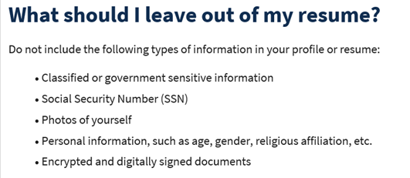
- Reminder: Submit remedy tickets for all work requests here. The WSS team cannot begin work without a service request. Reaching out to us directly can affect the time it takes to resolve your issue. Thanks!
  - Submitting remedy tickets – help us by providing enough details to work your issue. Suggestions to speed up discovering and resolving issue without lots of back-and-forth emails.
    - Screen shots include the entire screen, browser bar, not just a pinpoint of the TP that isn’t correct.
    - Report tickets need the WDA, office and start and end dates parameters you used to run the problematic report
    - We will send you 2 emails asking for additional information. Second request for response will advise you the ticket will close in 24 hours.
- Desk aid on things to try before submitting a remedy ticket; includes instructions for clearing your cache
- Internet Explorer (IE) will be deprecated after the SharePoint migration project completes but before Windows 11 is deployed (Summer 2022). It will occur sometime between those two projects.
  - Prepare now by transitioning to Edge or Chrome.
  - Don’t forget to transfer your favorites to Edge or Chrome and also add a copy to your document folder for recovery purposes!
    - How to import Favorites from IE to Chrome video
    - How to import Favorites from IE to Edge
        - Click on Favorites ‘star’
        - Click on ellipses (3 dots)
        - Select either Import (from Chrome or IE) or Export a copy to a local folder

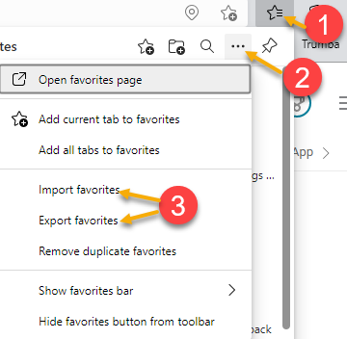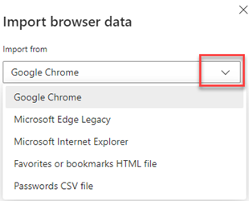

Unemployment Insurance (UI) claim and data information can be found on the UI page here https://esd.wa.gov/

CHAT
from Peabody, Deborah (ESD) to everyone: 10:08 AM Is that for Job Seekers or Employers? – The SLA (Service Level Agreement) is for staff to gain access to ETO; it doesn’t have anything to do with job seekers or employers
from Aaron Parrott he/his/him to everyone: 10:10 AM Are the full descriptions of these services in the Services Catalog yet? The services catalog is currently in draft but will be provided to everyone at next week’s meeting.
from Teresa Anda to everyone: 10:12 AM Do you know what the difference is between the entrepreneurial training service and this new entrepreneurship service? – I reached out to policy and will update you on 4/12/22 during the call. Thx

WPC user alerts
from Aue, Lynn (ESD) to everyone: 10:12 AM https://wpc.wa.gov/tech/user-alerts This link is broken, I will take a look at it and report back next week.
from Mack, Donna R (ESD) to everyone: 10:13 AM You can also join the GovDelivery distro list for WARN notices. :)
from Natalya - Workforce Snohomish (privately): 10:18 AM I do not see "WS System Announcements" when I go to sign up for GovDelivery lists The link on the WPC site isn’t working. I will take a look at it and make any repairs. Thx

ATTENDEES

Aaron Parrott he/his/him
Abigail Taft
Abplanalp, Christopher T (ESD)
Ariana Cordova - SCWDC
Barbara
Carya Bair
Cascio, Jaclyn (ESD)
Cauthron, Carol (ESD)
Cori-Ann Ching
Dawn Oakes
Diana
Donna Hendrickson - Skill Source
Douglas Evans
Dryden, Jack (ESD)
Dzenita Musabegovic
Erickson, Tristan ESD Partner
Gillis, Deanna F. (ESD)
Granillo, Tiffany (ESD)
Griffith, Michelle (ESD)
Heather Brink WFS
Heidi Lamers
Holmes, Carolyn (ESD)
Hudgens, Sheila (ESD)
Ismaila Maidadi
Jim - Business Solutions
Jordan, Irene (ESD)
Kerns, Adeline (ESD)
King, Kendall (ESD)
Kluth, Crystina (ESD)
Lux Dmitri
Mack, Donna R (ESD)
MacLennan, Mary (ESD)
Maricha Friedman
Mariya Kazantseva
Maya Anderson
Natalya - Workforce Snohomish
Nelson, Isiaih (ESD Partner)
Noll, Pamela (ESD)
Peabody, Deborah (ESD)
pocho
Robinson, Melissa J (ESD)
Smith, Jasmine (ESD)
Sue Keltner
Teresa Anda
Teresa Sparks
Tristån Erickson
Vey Damneun
Zander

