T12 Meeting Minutes 4-28-2021
Remember: After starting a Webex meeting to mute your audio and disable the video feature. Too many attendee’s with active video can interfere with everyone’s audio quality. Hover over the lower edge of your monitor screen to find the icons.

These meeting will be recorded. Recordings will be posted on the WPC site

New Business
- Public -use equipment training began on 4/19/21 through 5/13/21. I increased the session capacity and all sessions have room for more attendees. If you can’t attend a live session the training material is posted on the WPC site. Videos of the training will be posted soon. Sign-up on the Staff Development Calendar or type this into your browser https://wpc.wa.gov/tech/staff/trainingcalendar
- Tickets into production – went live on 4/14/21
  - WA-4113 new follow-up service.
    - This new service includes changes to:
    - Policy: 5602 Revision 3, Supportive Services and Needs-Related Payments
    - Policy: 5620 Revision 1, Follow-up Services for Adults and Dislocated Workers
    - WIN Number: 0077 Change 10, WorkSource Services Catalog
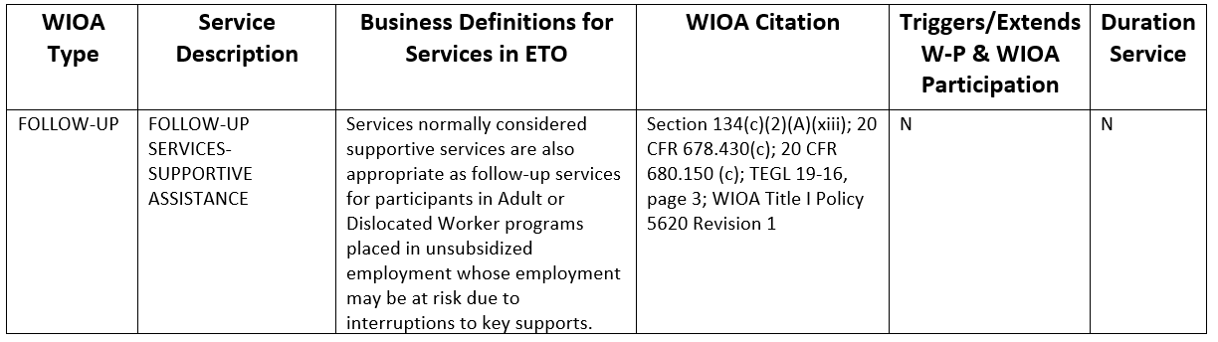
- ETO maintenance – nothing this week
- WSWA maintenance – nothing this week
- Velaro maintenance – The Velaro Product Team will be performing maintenance activity on Friday, April 30, at 3:30:00 AM PT, the estimated duration is 1 hour. We do not expect any impact to your service, yet in some cases, there may be a brief interruption.
- ETO Basic and Refresher Training - Next training is on 5/3/21 9:30-11:50AM
  - ETO Basic training is the 1st Monday 9:30-11:50 and 3rd Tuesday 1:30-3:50 of every month (except holidays). Send email to Lynn Aue to receive more information, training account if needed and be added to the training Webex call. All ETO/WSWA system users are welcome to attend the training but please do not forward invites as I need to review all attendees and assign training accounts if needed.
  - Training recordings and user guides are posted on the WPC website here https://wpc.wa.gov/tech/ETO-refresher-training
  - Submit a remedy ticket requesting additional training opportunities and resources
- What’s new on WPC –
  - Project updates: Create an ETO Record
  - New content for WS resource and training room training material here
  - Review Staff Efforts desk aid
  - Reports
    - Program Enrollment Outcomes – Added ‘Is Opted-Out’ column and removed ‘SKIES Seeker ID’ column
- Open discussion – training issues
- Reminder: Submit remedy tickets for all work requests here. The WSS team cannot begin work without a service request. Reaching out to us directly can affect the time it takes to resolve your issue. Thanks!
- UI announcements –
OLYMPIA – During the week of April 18 – April 24, there were 11,629 initial regular unemployment claims (down 12.0 percent from the prior week) and 408,001 total claims for all unemployment benefit categories (down 1.5 percent from the prior week) filed by Washingtonians, according to the Employment Security Department (ESD).
- Initial regular claims applications are now 91 percent below weekly new claims applications during the same period last year during the pandemic.
- The 4-week moving average for initial claims remain elevated at 13,497 (as compared to the 4-week moving average of initial claims pre-pandemic of 6,071 initial claims) and remains at similar levels of initial claims filed during the Great Recession.
- Decreases in layoffs in Manufacturing and Educational Services contributed to the decrease in regular initial claims last week.
- Initial claims applications for regular benefits, Pandemic Emergency Unemployment Assistance (PEUC), Pandemic Unemployment Assistance (PUA) as well as continued claims for regular benefits all decreased over the week.
In the week ending April 24, ESD paid out over $230 million for 295,464 individual claims. Since the crisis began in March 2020, ESD has paid more than $17.2 billion in benefits to over a million Washingtonians.
- For current COVID-19 and UI information ESD.wa.gov or ESD Facebook page
- UI Fraud help here
  - Fax information to claims centers 833-572-8423 –due to the high volume, calling is not recommended
- Visit this page on the WPC site to submit a service request: https://wpc.wa.gov/tech/issues Before submitting a service ticket, review this desk aid “Check list: things to try before submitting a service/remedy ticket”
  - If you are an ESD partner, there is a downloadable form that you must fill out and send to the Technical Solutions service desk – their e-mail is ESDDLITBITechnicalSolutions@ESD.WA.GOV
Review of ETO/WSWA and other resources (AKA old business)
- Encourage all staff who use ETO and WSWA to sign up for the T12 calls. These calls are not just for trainers but for all system users and a great way to stay up to date on changes or improvements to ETO and WSWA. Send requests to esdgpWSSteam@esd.wa.gov to be added to the ITSD Training Team’s distribution list
- WorkSource Systems (ETO and WSWA) resources are found on the WPC Technology site here
  - We try our best to make sure all the links are operational but depend on you to submit a remedy ticket if you find broken links!
CHAT
from Talia Ni Dufaigh to everyone: Is there anyway searches can be enabled for items such as Public Use? Yes, and it is fixed. Thanks for reporting it was broken!

ATTENDEES

Abigail Taft
Adeline Kerns
Ariana Cordova
Arturo Espinosa
BA
Becky Smith
Catherine Geddis
Christina Shaffer
Christopher File
Cori Ching
Cynthia Kressin
Dean
Deanna Gillis
Diane Luoma
Donna Mack
Dorothy Rocha
Heidi Lamers
Irene Jordan
Jack Dryden
Jenny Capella
Jo Ann Enwall
Kate Hesseltine
Kimberly Metcalf
Kylie Bartlett
Laura Anderson
Lux Dmitri
Mahre Tanya
Maria Zaragoza
Maribel Dominguez
Mary MacLennan
Lei-Ling Taylor
Melisa Flores-Sanchez
Mirayia Chacon-Baker
Pamela Noll
Parker Coffey
Pochi Ostergren
Regina Cancel
Robert Jonas
Rodolfo Aparicio
Susan Mbatudde-Gustafson
Talia Ni Dufaigh
Tamela McNamee
Teresa Adna
Teresa Smith
Theresa Rogers
Tina Newcomer
Toni Burow
Tracy Ferrall
Vey Damneun
Zoryana Bilous

Attended second half
Short meeting, no second half

