T12 Meeting Minutes 04-27-2022

Reminder: Mute your audio and disable the video feature after starting this Webex meeting. Too many attendee’s with active video can interfere with everyone’s audio quality. Hover over the lower edge of your monitor screen to find the icon and disable your video.

These meetings will be recorded and posted on the WPC site.
Please be advised your image will be captured and recorded during the video conference.
Your participation in this videoconference equals consent to be recorded as required by law.
New Business
- ETO maintenance – nothing this week
- WSWA maintenance – nothing this week
- Velaro maintenance – nothing this week
- Qtrac – nothing this week
- Tickets into production –
  - WA-4103 Multi-Factor Authentication (MFA) for WSWA employers scheduled went live 4/26/22. This change applies only to employers, not job seekers, when logging into WSWA.
    - Banner on WSWA notifying employers that MFA has been added to sign in
    - Email notification was sent to 13,351 employer recruiters who have been active on WSWA in the past year
    - Desk aid for Multi-factor authentication for employers on WPC: What to expect (PowerPoint)
    - Impact to employers has been minimal!
- ETO report enhancement updates – nothing this week.
- What’s new on WPC – nothing this week
- Training issues/open discussion/ticket updates
  - Revised WIOA Title l Policy 5617, Revision 2
    - This policy reflects the requirement to co-enroll Trade Adjustment Assistance (TAA) participants into the Workforce Innovation and Opportunity Act (WIOA) Title I-B Dislocated Worker program if they are eligible, unless they decline.
  - System exit causes
    - Last service provided wasn’t a qualifying service causing exit to be attached to the last qualifying service added
    - Refer to the Services Catalog to verify the service is qualifying or not
  - Internet Explorer (IE) will be sunsetting June 15, 2022
    - The default browser will be Edge
    - Prepare now by transitioning to Edge or Chrome and move your favorites!
    - Many have experienced caching issues with Chrome. Remember when you clear your Chrome cache it clears your safe sites which blocks opening ETO reports and other applications. Check out this short Report Pop-up Blockers video found on the WPC site
  - WA-4454 RESEA Required Elements Initial Response form not printing correctly. Nothing to report this week.
  - WA-4465 We received a ticket concerning that the WSWA Qtrac scheduler and WorkSource Office Locator don’t work correctly using IE browser. On the locater the drop-down menus are missing. Talking with live chat agents it was discovered this also is occurring when using Chrome. The issue is resolved by clearing the cache. I will be submitting a ticket asking why the sudden issue is resolved by clearing cache. Nothing to report this week.
  - WA-4426 Recently we made enhancements to the Case Note reports by adding the ‘Identifier’ column. This change made columns so narrow it caused the PDF to be more pages. We are asking if the report can be changed from portrait view to landscape view to resolve this issue but now there is an issue with ‘white space’ or all the note areas are the same size to the note with the largest amount of text. Nothing to report this week but continue to use these workarounds:
    - Tip: If you export to report to Excel, you can change the row height to remove the white space.
    - When printing to PDF, ‘uncheck’ Report 2 (the query logic), so you won’t get the query logic pages within their PDF and this shortens the length of the report
    - There is an issue with the left-side navigation window causing the report not to run, time out. To resolve this issue, close the left-side navigation window.
      - During this testing we discovered this is an issue with the Case Note History widget and at time causing this report to time out. The widget does not allow you to close out the left-side navigation window so you will need to run the Case not history report starting form the report menu.
  - WA-4437 Missing elements when printing ‘Outcomes, Program Completion’ TP is a known bug. SSG has a fix and will notify us when they plan to push it out in a future release. Still waiting for the change date
  - WA-4438 Known issue with some participants RESEA dashboard not accessible to some users. Trying to determine if this is a dashboard bug. Nothing new to report this week.
    - Dashboard TPs require you be logged into the office the TP was created in to have the ability to edit it. We are looking into seeing if this configuration can be changed.
      - Ex: You were logged into WS Yakima when you created the TPs. You also work in WS Sunnyside and have access to that office. When you are logged into WS Sunnyside you will not have the ability to edit the TP because it was created in WS Yakima.

- Remedy tickets
  - Duplicate accounts and SSN correction tickets are a high priority, needing an immediate fix so staff can record services provided to customers timely. You can reach out to the service desk asking for a ticket status update here ESDDLITBITechnicalSolutions@ESD.WA.GOV or if you don’t receive a response within 24 hours from the WSS team about your ticket, email us at esdgpwssteam@esd.wa.gov so we can locate the ticket and start working on it.
  - Submit remedy ticket to update the WS locator with office closures, changes to office hours, contact information or location.
  - Submit remedy tickets vs sending email to team, emails slow down the response time of helping you.
  - Remember if you suggest an enhancement at T12, submit a remedy ticket.
- ETO Basic and Refresher Training - Next training is on 5/2/22 9-12
  - ETO Basic training is the 1st Monday 9:00-12 and 3rd Tuesday 1:30-4:30 of every month (except holidays). Send email to Lynn Aue to receive more information, get a training account if needed and be added to the training Webex call. All ETO/WSWA system users are welcome to attend the training but please do not forward invites as I need to review all attendees and assign training accounts if needed.
  - Refresher training recordings and user guides are posted on the WPC website here https://wpc.wa.gov/tech/ETO-refresher-training
  - Submit a remedy ticket to request additional training opportunities and resources
Old Business
- Employer fraud and impact to job seekers, leaving this here for awareness
  - Talk to your employers about including their ESR numbers (UI tax ID number) in the account creation. We cannot approve accounts with verifying this information or speaking with the employer.
  - Submit remedy ticket if job seekers report they have been contacted by fraudster. Gather and include as much information from the job seeker, text messages, screen shots from online interviews, ‘employer’ emails and phone numbers, etc.
  - Working on new process and changes to WSWA to warn job seekers about employer scams.
  - Direct job seekers to Washington State Office of the Attorney General for information on employment scams
  - Job seekers can contact the Attorney General’s office and file a complaint ‘Contact Us’
    - The AG’s office is now recommending job seekers and employers contact the FBI
    - Question raised during a previous call; Is this fraud to the point where we should be encouraging customers to keep their resumes and contact info private on WorkSourceWa.com?
      - That is a decision the job seeker needs to make for themselves. The WSWA website provides information about resumes, avoiding scams, terms of use and risks. Protect job seekers by advising them to not include DOB, SSN, street address and references in resumes. Some still do that! Ask them to review the employment scam information on the Attorney General’s web site.
    - Remember, job seekers can upload resumes on WSWA and can keep them private. The disadvantage to this is employers cannot do a resume match using key words.
    - Tip from the USAJOBS website
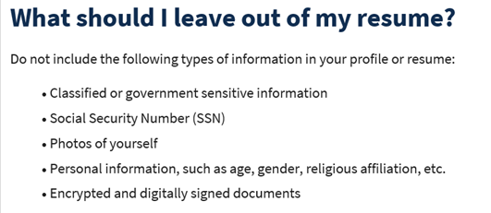
- Reminder: Submit remedy tickets for all work requests here. The WSS team cannot begin work without a service request. Reaching out to us directly can affect the time it takes to resolve your issue. Thanks!
  - Submitting remedy tickets – help us by providing enough details to work your issue. Suggestions help to speed up discovering and resolving the issue without lots of back-and-forth emails.
    - Screen shots include the entire screen, browser bar, not just a pinpoint of the TP that isn’t correct.
    - Screen shots of error messages
    - What you were doing when you got the ‘Robot’ or error message
    - Report tickets need the WDA, office and start and end dates parameters you used to run the problematic report
    - We will send you 2 emails asking for additional information. Second request for response will advise you the ticket will close in 24 hours.
- Desk aid on things to try before submitting a remedy ticket; includes instructions for clearing your cache
- Internet Explorer (IE) will sunset June 15, 2022
  - The default browser will be Edge
  - Prepare now by transitioning to Edge or Chrome.
  - Don’t forget to transfer your favorites to Edge or Chrome and also add a copy to your document folder for recovery purposes!
    - How to import Favorites from IE to Chrome video
    - How to import Favorites from IE to Edge
        - Click on Favorites ‘star’
        - Click on ellipses (3 dots)
        - Select either Import (from Chrome or IE) or Export a copy to a local folder

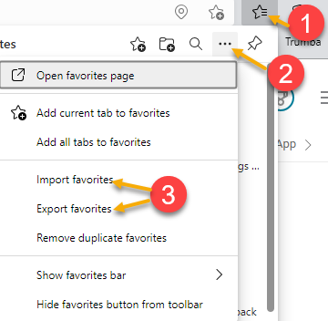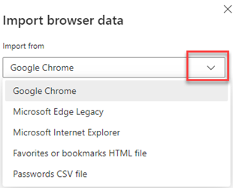

Unemployment Insurance (UI) claim and data information can be found on the UI page here https://esd.wa.gov/

CHAT
from Olson, Ashley ESD to everyone: 10:06 AM Thank you so much to you and your team for the great customer support process for our teams at the local offices and Live Chat.
from Olson, Ashley ESD to everyone: 10:07 AM No need for mentioning that, just wanted to appreciate your team for the hard work that you all have done to help support us <3

Where do you find the T12 minutes? T12 minutes and video recordings for meetings are found on the WPC site

ATTENDEES

Aaron Pentland
Abplanalp, Christopher
Bair, Carya
Barbara
Cascio, Jaclyn
Cauthron, Carol
Christopher File
Cori-Ann Ching
Dunning, Shellie
Enwall, Jo Ann
Erickson, Tristan
Gillis, Deanna
Heather Brink
Heidi Lamers
Holmes, Carolyn
Ismaila Maidadi
Jessie Cardwell
Jordan, Irene
Kluth, Crystina
Kylie Bartlett
Linda Rowling
Lisa Pietkauskis
Lolade Fapohunda
Lux Dmitri
Mack, Donna
Maricha Friedman
Mariya Kazantseva
Mark Chase
Natalya
Nelson, Isiaih
Oliveri, Brett
Olson, Ashley
Pelot, Paul
PoChi
Rafelita Tijerina
Smith, Jasmine
Sparks, Teresa
Teresa Anda
Tracy Ferrell
Vey Damneun
Zander

