T12 Meeting Minutes 4-14-2021
Remember: After starting a Webex meeting to mute your audio and disable the video feature. Too many attendee’s with active video can interfere with everyone’s audio quality. Hover over the lower edge of your monitor screen to find the icons.

These meeting will be recorded. Recordings will be posted on the WPC site

New Business
- Cancelling 4/21/21 T12 meeting due to public-use computer training
- Public -use equipment training will begin on 4/19/21 through 5/13/21. 4/19-4/29 are almost full but there is a wait list. Room for the May classes. If you can’t attend a live session the training material is posted on the WPC site. A video of the live training will be posted soon. Sign-up on the Staff Development Calendar or type this into your browser https://wpc.wa.gov/tech/staff/trainingcalendar
- Tickets into production –
  - Postponed WA-4113 new follow-up service; change to services catalog, policy
    - Follow-Up Services-Supportive Assistance
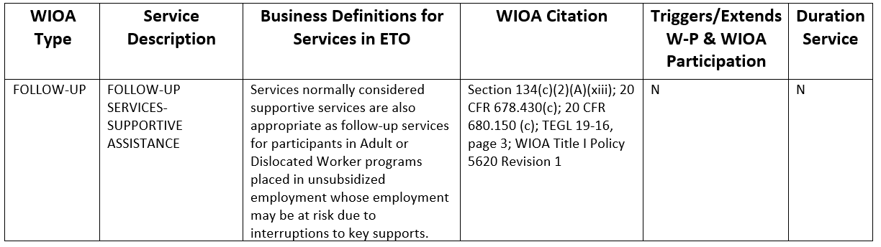
  - WA-4117 Report found under Program Administration called Review Staff Efforts not functioning as expected, used by those with Program manager and Department Head ETO roles. Mary will update us on 4/14/21. A desk aid will be posted to this weeks minutes.
- ETO maintenance – evening and morning of April 17-18th. We don’t expect any issues but if you experience a change in ETO on Monday, please submit a remedy ticket.
- WSWA maintenance – nothing to report this week
- Velaro maintenance – nothing to report this week
- ETO Basic and Refresher Training - Next training is on 4/20/21 2-4PM
  - ETO Basic training is the 1st Monday 10-12 and 3rd Tuesday 2-4 of every month (except holidays). Send email to Lynn Aue to receive more information, training account if needed and be added to the training Webex call. All ETO/WSWA system users are welcome to attend the training but please do not forward invites as I need to review all attendees and assign training accounts if needed.
  - Training recordings and user guides are posted on the WPC website here https://wpc.wa.gov/tech/ETO-refresher-training
  - Submit a remedy ticket requesting additional training opportunities and resources
- What’s new on WPC –
  - New content for WS resource and training room training material
  - Reports
    - Outreach Re-Entry Program Based on Audit Date; updated to add phone number
    - Outreach Re-Entry Program Based on Service Date; updated to add phone number
- Open discussion – training issues
  - Timely responses to remedy tickets emails is critical to the WSS Team in fixing your issues.
  - Issues with recording Outcomes Touchpoint, and the system still has the participant enrolled? This issue has been resolved.
- Reminder: Submit remedy tickets for all work requests. The WSS team cannot begin work without a service request. Reaching out to us directly can affect the time it takes to resolve your issue. Thanks! https://wpc.wa.gov/tech/issues
- UI announcements –
OLYMPIA – During the week of April 4 – April 10, there were 17,281 initial regular unemployment claims (up 45.7 percent from the prior week) and 428,521 total claims for all unemployment benefit categories (up 0.4 percent from the prior week) filed by Washingtonians, according to the Employment Security Department (ESD).
- The increase in initial claims was partly driven by claimants that have reached the end of their benefit year. For those that applied for unemployment early in the pandemic, they have reached the end of their 52-week benefit year and must reapply for unemployment to continue receiving benefits.
- Initial regular claims applications are now 88 percent below weekly new claims applications during the same period last year during the pandemic.
- The 4-week moving average for initial claims remain elevated at 12,999 (as compared to the 4-week moving average of initial claims pre-pandemic of 6,071 initial claims) and remains at similar levels of initial claims filed during the Great Recession.
- Increases in layoffs in the Health Care and Social Assistance; Manufacturing; Agriculture, Forestry, Fishing & Hunting sectors also contributed to the increase in regular initial claims last week.
- Initial claims applications for Pandemic Emergency Unemployment Assistance (PEUC) as well as continued claims for regular benefits decreased over the week while initial claims applications for Pandemic Unemployment Assistance (PUA) increased slightly over the week.
In the week ending April 10, ESD paid out over $233 million for 300,117 individual claims. Since the crisis began in March 2020, ESD has paid more than $16.8 billion in benefits to over a million Washingtonians.
- For current COVID-19 and UI information ESD.wa.gov or ESD Facebook page
- UI Fraud help
  - www.esd.wa.gov/fraud
  - Fax information to claims centers 833-572-8423 –due to the high volume, calling is not recommended
- Before submitting a service ticket, review this desk aid “Check list: things to try before submitting a service/remedy ticket”
- Visit this page on the WPC site to submit a service request: https://wpc.wa.gov/tech/issues If you are an ESD partner, there is a downloadable form that you must fill out and send to the Technical Solutions service desk – their e-mail is ESDDLITBITechnicalSolutions@ESD.WA.GOV
Review of ETO/WSWA and other resources (AKA old business)
- Encourage all staff who use ETO and WSWA to sign up for the T12 calls. These calls are not just for trainers but for all system users and a great way to stay up to date on changes or improvements to ETO and WSWA. Send requests to esdgpWSSteam@esd.wa.gov to be added to the ITSD Training Team’s distribution list
- WorkSource Systems resources found on the WPC Technology site https://wpc.wa.gov/tech
  - We try our best to make sure all the links are operational but depend on you to submit a remedy ticket if you find broken links!
- Check out the information the WPC website to help all WorkSource staff telework stay up to date on COVID19, teleworking and WorkSource Virtual services including;
CHAT
(privately): 10:05 AM
FYI... Might be noteworthy.... ESD is changing our Outlook meeting Settings to auto populate a 5 to 10 break time.. Basically, it will end a meeting 5 or 10 before the meeting was to finish. BUT, you have to click "new meeting for this feature to work, if you just click WebEx for new meeting it will not add the 5/10 break in it. I think a lot of people will do the old normal process to create a new event… BUT – THAT WON’T WORK. The built-in break will not work if you don’t just click “WebEx” for example…..
****THE IMPORTANT FIRST STEP****…
You MUST Click - New Appointment or New Meeting in the ribbon bar of your Outlook calendar. This is an important first step!
If you first select, the Webex, Skype or Teams shortcuts on the ribbon bar, the new settings WON’T APPLY!
The new settings apply only to new meetings and appointments; any meetings you’ve already made will not be affected by the change.

ATTENDEES

Abigail Taft
Adeline Kerns
AJohnson
Arturo Espinoza
Barke, Tami
Barry Dickerson
Boliveri
Brian Doyle
C
Carl Peterson
Carolyn Holmes
Christopher File
CMatranga
Dawn Oakes
Dean
Deborah Kavanaugh
Donna Mack
Douglas Evans
Douglas Loney
Eileen Boylston
Emily Anderson
Farmer, Carly
Heidi Lamers
Irene Jordan
Jack Dryden
Jackie Wetchler
JBrunkhorst
Jenny Capella
Jo Ann Enwall
Jordan Meyenburg
Kate Hesseltine
Kimberly Chase
Kylie Bartlett
Laura Anderson
Lisa Pietkauskis
Luci Bench
Lux Dmitri
Mahre, Tanya
Maria Zaragoza
Mary MacLendon
Melisa Flores-Sanchez
Mirayia Chacon-Baker
Nelva March
Parker Coffey
Robert Jonas
Rodolfo Aparicio
Sean McElligott
Matthew Shields
Teresa Smith
Teresa Sparks
Theresa Rogers
Tim Robison
Tim Woodward
Toni Burrow
Ton Nguyen
Tracy Ferrell
Tracy Ollgaard
Van Nelson, Nicole
Vey Damneun
Zoryana Bilous

Attended second half

