T12 Meeting Minutes 03-09-2022

Reminder: Mute your audio and disable the video feature after starting this Webex meeting. Too many attendee’s with active video can interfere with everyone’s audio quality. Hover over the lower edge of your monitor screen to find the icon and disable your video.

These meetings will be recorded and posted on the WPC site.
Please be advised your image will be captured and recorded during the video conference.
Your participation in this videoconference equals consent to be recorded as required by law.
New Business
- ETO maintenance – nothing this week
- WSWA maintenance – nothing this week
  - There is an expected SAW outage for Tuesday, March 15 between 5:30 and 6:30 a.m. We will be placing a banner on the SEAP sign-in page alerting job seekers to the outage the Friday prior.
- Velaro maintenance – nothing this week
- Tickets into production – WA 3794 Enhancements to RESEA Required Elements – Initial and RESEA Required Elements – Follow-up TP.
- With the new ETO/ENA revisions expected to be launched tomorrow, the RESEA team will be available to provide assistance on Friday March 11 from 9-10 and again from 3-4. An email did go out this morning with the links to join TEAMS should you need help. The email went out to RESEA staff, supervisors, and administrators.
- Heads up/date change: Wednesday, March 30, at 6am, Multi-Factor Authentication (MFA) will be implemented on WSWA for employers. This change applies only to employers, not job seekers, when logging into WSWA. We will do a demo and provide more information here before going live.
- ETO report enhancement updates –
  - Operational Reports
    - Case Notes 4.0-Only Basic Services; Added 'Is Opted-Out' column and removed 'SKIES Seeker ID' column; deleted SSN column
    - Case Notes 4.0 (No WIT Integration); Added 'Identifier' and 'Service Provided' columns; removed OPTIMIZED from report name
    - Case Notes 4.0-No Basic Services Included; Added 'Identifier' and 'Service Provided' columns
  - UI Claimant/RESEA
    - RESEA Action Plan Follow-up – Printable; NEW-printable copy of RESEA action plan follow-up TP
    - RESEA Action Plan Initial – Printable; NEW-printable copy of RESEA action plan initial TP
  - Note: Changes were made to the descriptions of many of the reports. This update provides a good description of the information that is included in the report you are running.
- What’s new on WPC – nothing this week
- Training issues/open discussion
  - Potential issue with WSWA job postings
  - Remember, that with these report changes you need to click the ‘Refresh Report Menu’ before running reports. A best practice for the best experience with reports is to refresh reports list before running reports – Every time you run a report!
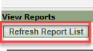
  - Change to Program Enrollment dashboard discussion; would it be helpful to add ‘Draft’ here. It was suggested here that instead of adding this to the PE dashboard we create a report and notify staff so they can make the corrections. The WSS team ran a query and discovered there are only 24 draft PE in the system. Soon, we will reach out to the WDA 12 area data corrections team to clean these up. Thanks for the suggestion!
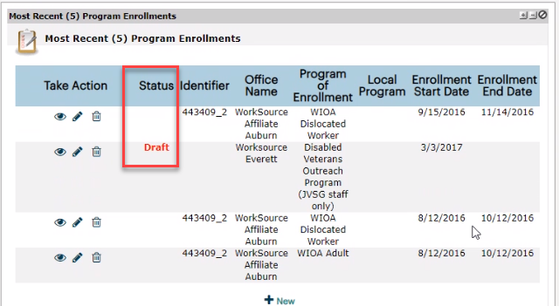

  - Enrolling participant in your local office so you can find them in ETO and edit TPs
    - Finding a participant in ETO desk aid
    - For non-ESD staff, Opt-out of data sharing in ETO desk aid
  - Reminder: Link to claimants 1099’s available in eServices

  - Employer fraud and impact to job seekers, leaving this here for awareness
    - Talk to your employers about including their ESR numbers (UI tax ID number) in the account creation. We cannot approve accounts with verifying this information or speaking with the employer.
    - Submit remedy ticket if job seekers report they have been contacted by fraudster. Gather and include as much information from the job seeker, text messages, screen shots from online interviews, ‘employer’ emails and phone numbers, etc.
    - Working on new process and changes to WSWA to warn job seekers about employer scams.
    - Direct job seekers to Washington State Office of the Attorney General for information on employment scams
    - Job seekers can contact the Attorney General’s office and file a complaint ‘Contact Us’
      - The AG’s office is now recommending job seekers and employers contact the FBI
    - Question raised during a previous call; Is this fraud to the point where we should be encouraging customers to keep their resumes and contact info private on WorkSourceWa.com?
      - That is a decision job seekers need to make for themselves. The WSWA website provides information about resumes, avoiding scams, terms of use and risks. Protect job seekers by advising them to not include DOB, SSN, street address and references in resumes. Some still do that! Ask them to review the employment scam information on the Attorney General’s web site.
    - Remember, job seekers can upload resumes on WSWA and can keep them private. The disadvantage to this is employers cannot do a resume match using key words.
    - Tip from the USAJOBS website
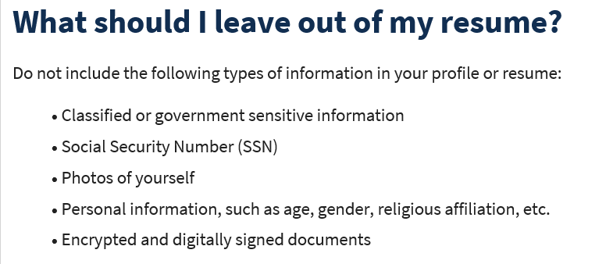
  - Office closures or changes to office hours, contact or location
    - Submit remedy ticket to update the WS locator
  - Submit remedy tickets vs sending email to team, emails slow down the response time of helping you.
    - Remember if you suggest an enhancement at T12, submit a remedy ticket.
- Remedy tickets – We are getting a lot of duplicate account and SSN correction tickets which are a high priority, needing an immediate fix so staff can record services provided to customers timely. You can reach out to the service desk asking for a ticket status update here ESDDLITBITechnicalSolutions@ESD.WA.GOV or if you don’t receive a response within 24 hours from the WSS team about your ticket, email us at esdgpwssteam@esd.wa.gov so we can locate the ticket and start working on it.
- ETO Basic and Refresher Training - Next training is on 3/15/22 1:30-4:30
  - ETO Basic training is the 1st Monday 9:00-12 and 3rd Tuesday 1:30-4:30 of every month (except holidays). Send email to Lynn Aue to receive more information, training account if needed and be added to the training Webex call. All ETO/WSWA system users are welcome to attend the training but please do not forward invites as I need to review all attendees and assign training accounts if needed.
  - Refresher training recordings and user guides are posted on the WPC website here https://wpc.wa.gov/tech/ETO-refresher-training
  - Submit a remedy ticket to request additional training opportunities and resources
Old Business
- Reminder: Submit remedy tickets for all work requests here. The WSS team cannot begin work without a service request. Reaching out to us directly can affect the time it takes to resolve your issue. Thanks!
  - Submitting remedy tickets – help us by providing enough details to work your issue. Suggestions to speed up discovering and resolving issue without lots of back-and-forth emails.
    - Screen shots include the entire screen, browser bar, not just a pinpoint of the TP that isn’t correct.
    - Report tickets need the WDA, office and start and end dates parameters you used to run the problematic report
    - We will send you 2 emails asking for additional information. Second request for response will advise you the ticket will close in 24 hours.
- Desk aid on things to try before submitting a remedy ticket; includes instructions for clearing your cache
- Internet Explorer (IE) will be deprecated after the SharePoint migration project completes but before Windows 11 is deployed (Summer 2022). It will occur sometime between those two projects, approximately 3-6 months.
  - Prepare now by transitioning to Edge or Chrome.
  - Don’t forget to transfer your favorites to Edge or Chrome and also add a copy to your document folder for recovery purposes!
    - How to import Favorites from IE to Chrome video
    - How to import Favorites from IE to Edge
        - Click on Favorites ‘star’
        - Click on ellipses (3 dots)
        - Select either Import (from Chrome or IE) or Export a copy to a local folder

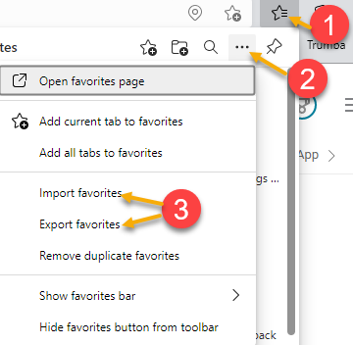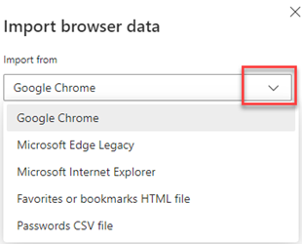

Unemployment Insurance (UI) claim and data information can be found on the UI page here https://esd.wa.gov/

CHAT
Case note enhancements
from Kerns, Adeline (ESD) to everyone: 10:07 AM I notice that the Case Notes report does not run until you export it. This issue has been resolved. Remember to refresh the Report menu before running reports
from Teresa Anda to everyone: 10:07 AM Yes, thank you for the changes! Love being able to see the service provided on the case notes report.
from Kerns, Adeline (ESD) to everyone: 10:08 AM I am referring to the Case History report in the Dashboard. That may be different.
from Teresa Anda to everyone: 10:10 AM I ran it just a few minutes ago and the widget report worked fine for me.

RESEA TP changes
from Sparks, Teresa A (ESD) to everyone: 10:08 AM With the new ETO/ENA revisions expected to be launched tomorrow, the RESEA team will be available to provide assistance on Friday March 11 from 9-10 and again from 3-4. An email did go out this morning with the links to join TEAMS should you need help. The email went out to RESEA staff, supervisors, and administrators.

Adding ‘Draft’ to the PE dashboard
The PE currently in ETO are from the period before the ability to save a PE as a draft was removed in 2017. We ran a query and there are only 24 PE drafts in the system. We will not be adding ‘Draft’ to the PE dashboard but sending out notice to the data corrections team to ask staff to clean this up. Thanks for your input on this!
from Monique Martin to everyone: 10:16 AM good idea
from Kerns, Adeline (ESD) to everyone: 10:16 AM Why would we enter a draft? Are you saying this is to find draft enrollments?
from Dryden, Jack (ESD) to everyone: 10:16 AM I'm definitely fine with having a draft label.
from Lane, Marcus (ESD) to everyone: 10:16 AM Good idea!
from Tracy Ferrell to everyone: 10:16 AM Sounds good!!
from Dryden, Jack (ESD) to everyone: 10:16 AM How does one even save a Program Enrollment touchpoint as a draft though?
from Kerns, Adeline (ESD) to everyone: 10:16 AM Remove draft option
from Lane, Marcus (ESD) to everyone: 10:16 AM Do it! Do it now! :)
from Dorothy Rocha to everyone: 10:16 AM Yes definitely a good idea
from Monique Martin to everyone: 10:16 AM I like Adeline's suggestion too
from Christina Shaffer to everyone: 10:16 AM Agree with Adeline
from Kerns, Adeline (ESD) to everyone: 10:17 AM Drafts often get left which creates PIRL issues later on and other services taken not attached to a program enrollment.
from kylie bartlett to everyone: 10:17 AM I also like Adeline’s suggestion!
from Dryden, Jack (ESD) to everyone: 10:17 AM I think knowing which enrollments a draft is fine. It sounds like (as my experience has been) you can no longer save the touchpoint as a draft.
from Kerns, Adeline (ESD) to everyone: 10:18 AM No. That is not an enrollment if forms are not turned in for some programs
from Monique Martin to everyone: 10:18 AM could we just run a report, and clear all of the existing drafts? it would clean it up.
from Monique Martin to everyone: 10:19 AM run a report for PEs with no identifier?
from Sparks, Teresa A (ESD) to everyone: 10:19 AM Lynn, for RESEA, the ENA (Employability Needs Assessment) is at times are left in draft, but offices have been notified to run those reports to make the changes, if they are left in draft, does this also impact the PIRL report for RESEA? This discussion was concerning PE drafts. Please submit a ticket if you don’t want RESEA TP to have the ability to save a draft.
from Sparks, Teresa A (ESD) to everyone: 10:22 AM Got it. Thank you!
from Emily Anderson to everyone: 10:22 AM I would NOT like to see older enrollments removed.
from Emily Anderson to everyone: 10:22 AM It is nice to see customer history at times. Agreed, we aren’t going to remove any records. Sorry for the scare Emily!

Data clean-up efforts More to follow on this effort
from Emily Anderson to everyone: 10:20 AM We would be really supportive of data cleanup if we knew who the problems are.
from Teresa Anda to everyone: 10:21 AM Can we get rid of old enrollments like the ones going back to 1991?
from Teresa Anda to everyone: 10:23 AM More precise, close out open program enrollments
from Teresa Anda to everyone: 10:24 AM
Need to figure out why they do not close out after 90 days without a service.
from Monique Martin to everyone: 10:26 AM I can work any draft PEs for DVOP or VRE programs.
from Teresa Anda to everyone: 10:27 AM :(
from Mack, Donna R (ESD) to everyone: 10:27 AM Sometimes the "new system" feels like a phantom/unicorn. I will be excited when it happens! :)

Employer fraud
from Monique Martin to everyone: 10:34 AM if our staff is actively working with an employer, besides ensuring they add their ESR number, is there anything our staff can do to expedite the process? send you an email or something? If you are working directly with an employer, can verify that it is truly a real employer and not a fraudster, yes please give the team a heads up!
from Frost, Jennifer (ESD) to everyone: 10:38 AM They are getting very savvy I am hearing about fraudsters calling individuals pretending to be their bank
from Maier, Seth (ESD) to everyone: 10:39 AM Remove physical home addresses from a resume too...
from Frost, Jennifer (ESD) to everyone: 10:39 AM oh that’s good Seth

Missing ticket
from Jessie Cardwell-BFWDC to everyone: 10:42 AM Lynn, I have a question about The UI Claimant Status drop down in ETO This ticket ask was moved forward to EC leadership and the ticket requester sent an update. Thanks for asking!

ATTENDEES

Aaron Pentland
Abigail Taft
Anderson, Laura J (ESD)
Aparicio, Rudy (ESD)
Ariana Cordova - SCWDC
Boliveri
Cascio, Jaclyn (ESD)
Chaney Carriker She/Her/They
Chase, Kim (ESD)
Christina Shaffer
Dawn Oakes
DEAN COXFORD
Dorothy Rocha
Dryden, Jack (ESD)
Dunning, Shellie (ESD)
Elias Zafar
Emily Anderson
EMovsesyan
Enwall, Jo Ann (ESD)
Frost, Jennifer (ESD)
Holmes, Carolyn (ESD)
Jessie Cardwell-BFWDC
Jordan, Irene (ESD)
Keely Christ
Kerns, Adeline (ESD)
kylie bartlett
Lane, Marcus (ESD)
Linda Rowling
Lisa Pietkauskis
Luci Bench
Mack, Donna R (ESD)
Maier, Seth (ESD)
Mariya Kazantseva
Maya Anderson
Monique Martin
Natalya - Workforce Snohomish
Peiris, Malmi ESD
pochi
Robinson, Melissa J (ESD)
Selam
Sparks, Teresa A (ESD)
Tamara Toles WSW
Teresa Anda
Tina Newcomer
Tracy Ferrell
Vey Damneun
Wood, Lora A ESD

