T12 Meeting Minutes 03-30-2022

Reminder: Mute your audio and disable the video feature after starting this Webex meeting. Too many attendee’s with active video can interfere with everyone’s audio quality. Hover over the lower edge of your monitor screen to find the icon and disable your video.

These meetings will be recorded and posted on the WPC site.
Please be advised your image will be captured and recorded during the video conference.
Your participation in this videoconference equals consent to be recorded as required by law.
New Business
- ETO maintenance – nothing this week
- WSWA maintenance – nothing this week
- Velaro maintenance – nothing this week
- Tickets into production – nothing this week
- ETO report enhancement updates – nothing this week.
- What’s new on WPC – nothing this week
- Training issues/open discussion
  - WA-4450 WSWA new employer accounts were disrupted Monday morning through Tuesday morning. This issue is resolved. However, if you speak to employers who experienced issues activating their accounts during this time, ask them to click on the link in the activation email to finalize account activation.
  - WA-4447 We received a ticket concerning WSWA tools Qtrac scheduler and WS Office Locator don’t work using IE browser. On the locater the drop-down menus are missing. Talking with live chat agents it was discovered this is also occurring when using Chrome. The issue is resolved by clearing the cache. We will report out during future calls on this. Clearing your cache information is found in this desk aid
  - WA-4426 Recently we made enhancements to the Case Note reports by adding the ‘Identifier’ column. This change made columns so narrow it caused the PDF to be more pages. We are asking if the report can be changed from portrait view to landscape view to resolve this issue.
  - WA-4437 The missing elements when printing ‘Outcomes, Program Completion’ TP is a known bug. SSG has a fix and will notify us when they plan to push it out in a future release.
  - Multi-Factor Authentication (MFA) for WSWA employers, has been delayed to 4/26/22. This change applies only to employers, not job seekers, when logging into WSWA. What to expect training material is on the WPC, Technology, WorkSourceWA page.
    - Multi-factor authentication for employers: What to expect (PowerPoint)
  - WA-4438 Known issue with some participants RESEA dashboard(s) not accessible to users who don’t have access to so cannot be logged into the office the TP was created in.
    - Dashboard TPs require you be logged into the office the TP was created in to have the ability to edit it. We are looking into seeing if this configuration can be changed.
      - Ex: You were logged into WS Yakima when you created the TPs. You also work in WS Sunnyside and have access to both offices. When you are logged into WS Sunnyside you will not have the ability to edit the TP because it was created in WS Yakima.
  - Benefits of adding a participant to your office
    - Adding a participant to the office(s) you are assigned to allows you to edit other users TP’s for that participant. Meaning you will have the ability to edit any TP included in the ‘View/Record TouchPoint, from the Basic Career Services. This will not allow you to edit those TPs on the RESEA dashboards
  - New T12 quarterly meeting invite sent out this morning
  - When searching for a recruiter in ETO you need to change the ‘In’ field from The office you are logged into to ‘WorkSource’ to return a search of all employers/recruiters with the name you are seeking.
  - What is the process for notifying new users that their ETO access is completed? The SLA for working these requests is 7 days but they are usually
  - Question; WIOA eligibility TP. Can we create a report? There isn’t currently a report, but we may be able to modify and existing one or create a new one. There are around 200 fields in the TP, to create the report we need to identify what fields you need in the report. Submit a remedy ticket with your ask
    - @ 41:56 Recent monitoring issue caused because the PE was created before the WIOA eligibility application was created. This statement demonstrates the importance of following the process when enrolling participants into programs. This process can include a WIOA eligibility basic or full application TPs and making sure the participants demographics are accurate before saving the PE and adding a qualifying service. Failure to follow the process can result in data integrity issues and possibly requiring you to delete services, PE and reenter them.
    - @47:50 When there is more than one PE’s and a Basic and a Full WIOA Eligibility app, how do we know which WIOA App the PE is attached to?
      - Go to your participant, go to the PE’s and WIOA App’s and check dates. The PE will attach to the most recent WIOA App.
      - When you are doing the PE click on the Demographics at Enrollment tab, 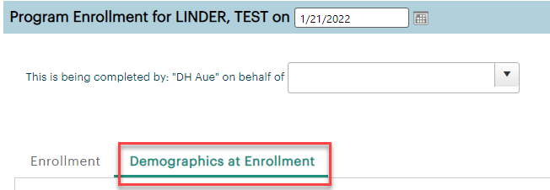

      - Scroll down to Selective Service area to see type of WIOA enrollment full or basic
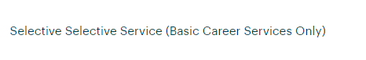
  - Suggestion: ask your Supervisor to present this issue and solution for it at the P-to-P call for Title l
  - Integrated Service Delivery (ISD) training material on WPC
  - Reminder: Link to claimants 1099’s available in eServices

- Remedy tickets
  - We are getting a lot of duplicate account and SSN correction tickets which are a high priority, needing an immediate fix so staff can record services provided to customers timely. You can reach out to the service desk asking for a ticket status update here ESDDLITBITechnicalSolutions@ESD.WA.GOV or if you don’t receive a response within 24 hours from the WSS team about your ticket, email us at esdgpwssteam@esd.wa.gov so we can locate the ticket and start working on it.
  - Office closures or changes to office hours, contact or location. Submit remedy ticket to update the WS locator
  - Submit remedy tickets vs sending email to team, emails slow down the response time of helping you.
  - Remember if you suggest an enhancement at T12, submit a remedy ticket.
- ETO Basic and Refresher Training - Next training is on 4/4/22 9-12
  - ETO Basic training is the 1st Monday 9:00-12 and 3rd Tuesday 1:30-4:30 of every month (except holidays). Send email to Lynn Aue to receive more information, training account if needed and be added to the training Webex call. All ETO/WSWA system users are welcome to attend the training but please do not forward invites as I need to review all attendees and assign training accounts if needed.
  - Refresher training recordings and user guides are posted on the WPC website here https://wpc.wa.gov/tech/ETO-refresher-training
  - Submit a remedy ticket to request additional training opportunities and resources
Old Business
- Employer fraud and impact to job seekers, leaving this here for awareness
  - Talk to your employers about including their ESR numbers (UI tax ID number) in the account creation. We cannot approve accounts with verifying this information or speaking with the employer.
  - Submit remedy ticket if job seekers report they have been contacted by fraudster. Gather and include as much information from the job seeker, text messages, screen shots from online interviews, ‘employer’ emails and phone numbers, etc.
  - Working on new process and changes to WSWA to warn job seekers about employer scams.
  - Direct job seekers to Washington State Office of the Attorney General for information on employment scams
  - Job seekers can contact the Attorney General’s office and file a complaint ‘Contact Us’
    - The AG’s office is now recommending job seekers and employers contact the FBI
    - Question raised during a previous call; Is this fraud to the point where we should be encouraging customers to keep their resumes and contact info private on WorkSourceWa.com?
      - That is a decision the job seeker needs to make for themselves. The WSWA website provides information about resumes, avoiding scams, terms of use and risks. Protect job seekers by advising them to not include DOB, SSN, street address and references in resumes. Some still do that! Ask them to review the employment scam information on the Attorney General’s web site.
    - Remember, job seekers can upload resumes on WSWA and can keep them private. The disadvantage to this is employers cannot do a resume match using key words.
    - Tip from the USAJOBS website
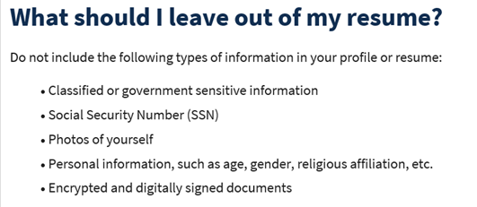
- Reminder: Submit remedy tickets for all work requests here. The WSS team cannot begin work without a service request. Reaching out to us directly can affect the time it takes to resolve your issue. Thanks!
  - Submitting remedy tickets – help us by providing enough details to work your issue. Suggestions to speed up discovering and resolving issue without lots of back-and-forth emails.
    - Screen shots include the entire screen, browser bar, not just a pinpoint of the TP that isn’t correct.
    - Report tickets need the WDA, office and start and end dates parameters you used to run the problematic report
    - We will send you 2 emails asking for additional information. Second request for response will advise you the ticket will close in 24 hours.
- Desk aid on things to try before submitting a remedy ticket; includes instructions for clearing your cache
- Internet Explorer (IE) will be deprecated after the SharePoint migration project completes but before Windows 11 is deployed (Summer 2022). It will occur sometime between those two projects, approximately 3-6 months.
  - Prepare now by transitioning to Edge or Chrome.
  - Don’t forget to transfer your favorites to Edge or Chrome and also add a copy to your document folder for recovery purposes!
    - How to import Favorites from IE to Chrome video
    - How to import Favorites from IE to Edge
        - Click on Favorites ‘star’
        - Click on ellipses (3 dots)
        - Select either Import (from Chrome or IE) or Export a copy to a local folder

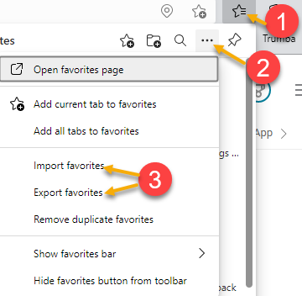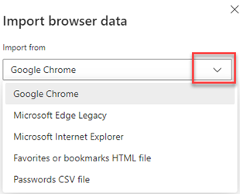

Unemployment Insurance (UI) claim and data information can be found on the UI page here https://esd.wa.gov/

CHAT
Clearing cache Recently there have been many reported issues that are resolved by clearing cache. Check out the desk aid on the WPC
WSWA Employer issues
from File, Christopher (ESD) to everyone: 10:04 AM Sent our new Business Services Rep here at North Seattle to our first in-person hiring event since the pandemic yesterday. He received a number of employer complaints about getting locked out of their existing WorkSourceWA account, inability to post new job listings, etc. Just anecdotal, but seems there are issues?
RESEA dashboard issue and moving services to the services catalog
from Gard, Robbin (ESD) to everyone: 10:18 AM Lynn, is this referring to the RESEA Required Elements TP POSSIBLY reverting to Saved as Draft status when the changes were added?
from Gard, Robbin (ESD) to everyone: 10:22 AM Yes, if an initial is done in another WDA but we do the follow up/vice-versa, this will be an issue.
from Gard, Robbin (ESD) to everyone: 10:26 AM
Any idea when the RESEA Required elements will move to the Basic Services catalog?
from Gard, Robbin (ESD) to everyone: 10:27 AM
Before Dina left she explained that this was moving towards that.
from Sparks, Teresa A (ESD) to everyone: 10:28 AM
Robbin, just sent Erin an email on your question.

Adding participants to your office and what that allows you to do
from Peabody, Deborah (ESD) to everyone: 10:20 AM You can add the customer to your office even after you have posted the TP from Peabody, Deborah (ESD) to everyone: 10:20 AM I do it often.
from Kerns, Adeline (ESD) to everyone: 10:23 AM It seems that there are some TP's that you cannot edit and would have to take a new one. Is editing unique to RESEA TPs? Editing is not unique to RESEA. Services TPs can be edited by anyone as long as the participant has been added to your office. There are restrictions to what you can edit on a PE TP. PE TP’s start date cannot be edited.
from Kerns, Adeline (ESD) to everyone: 10:26 AM Thank you.

Proof of ETO training
from File, Christopher (ESD) to everyone: 10:34 AM For staff in Professional Pathways, they need to "Be sure to retain proof of completion" of ETO training. How is that obtained? After ETO training provided by Lynn, an email is sent to all attendees stating they completed it and includes next steps on finding local access requester and the ETO add/change form, and where to send it to get your production account. I cannot speak on the process local trainers use.
from File, Christopher (ESD) to everyone: 10:35 AM Thank you!

WIOA Eligibility Application report and other related questions
from Dryden, Jack (ESD) to everyone: 10:36 AM I've got some questions :) (see open discussion for questions and comments)
from Teresa Anda to everyone: 10:40 AM Yes! I second that!
from Teresa Anda to everyone: 10:40 AM No there is not
from Teresa Anda to everyone: 10:41 AM there is not a report for eligibility
from Ariana Cordova - SCWDC to everyone: 10:41 AM No there is not.
from Samba, Ngenarr 'Samba' (ESD) to everyone: 10:41 AM Yes great idea!
from Dryden, Jack (ESD) to everyone: 10:42 AM It would be a great thing to have a report based in the WIOA Eligibility Application, specifically to focus in on basic vs full eligibility.
from Heidi Lamers to everyone: 10:44 AM If an eligibility report could include all the items that are PIRL reportable, that would be very helpful.
from Sparks, Teresa A (ESD) to everyone: 10:46 AM https://wpc.wa.gov/reports/pirl-reporting

What is ISD?
from Aue, Lynn (ESD) to everyone: 10:54 AM link to the training guidance on integrated Service Delivery https://wpc.wa.gov/wswa/ISD

ATTENDEES

Aaron Pentland
Abigail Taft
Anderson, Laura J (ESD)
Aparicio, Rudy (ESD)
Ariana Cordova - SCWDC
Aue, Lynn (ESD)
Baker, Mirayia (ESD)
Ballinger, Charles (ESD)
Barbara
Cascio, Jaclyn (ESD)
Cauthron, Carol (ESD)
Chase, Kim (ESD)
Dawn Oakes
Dean
Donna Hendrickson
Dorothy Rocha
Douglas Evans
Dryden, Jack (ESD)
Dunning, Shellie (ESD)
Dzenita Musabegovic
Eileen Boylston
Elias Zafar
Emily Anderson
Ensor, Michael (ESD)
Enwall, Jo Ann (ESD)
File, Christopher (ESD)
Gard, Robbin (ESD)
Gillis, Deanna F. (ESD)
Granillo, Tiffany (ESD)
Heather Brink WFS
Heidi Lamers
Holmes, Carolyn (ESD)
Ismaila Maidadi
Jessie Cardwell-BFWDC
Jordan, Irene (ESD)
Kaiser, Deb (ESD)
Kerns, Adeline (ESD)
King, Kendall (ESD)
Lane, Marcus (ESD)
Linda Rowling
Lopez, Mary L (ESD)
Lux Dmitri
Mack, Donna R (ESD)
Maier, Seth (ESD)
Maricha Friedman
Martin, Monique (ESD)
Name
Natalya - Workforce Snohomish
Peabody, Deborah (ESD)
Peiris, Malmi ESD
Pochi
Robinson, Melissa J (ESD)
Samba, Ngenarr 'Samba' (ESD)
Schoepp, Hannah (ESD)
Smith, Jasmine (ESD)
Soto, Raul (ESD)
Sparks, Teresa A (ESD)
Sutton, Terry ESD Partner
Tai
Tamara Toles WSW
Teresa Anda
Tracy Ferrell
Tristan Erickson
Veitenheimer, Lori (ESD Partner)
Vey Damneun
Wood, Lora A ESD

