T12 Meeting Minutes 3-24-2021
Remember: After starting a Webex meeting to mute your audio and disable the video feature. Too many attendee’s with active video can interfere with everyone’s audio quality. Hover over the lower edge of your monitor screen to find the icons.

Thanks to all who contribute to this weekly call!

New Business
- Tickets into production –
  - WA-4109; changes to the Outcomes, Program Completion TP, Youth tab to match the credentials for attained degree or certificate allowed by DOL
    - Added:
      - AA or AS Diploma/Degree
BA or BS Diploma/Degree
Occupational Licensure
Occupational Certificate
Occupational Certification
Attained other recognized certificate or post-secondary degree/diploma
    - Removed:
      - Attained a certificate or other post-secondary degree/diploma
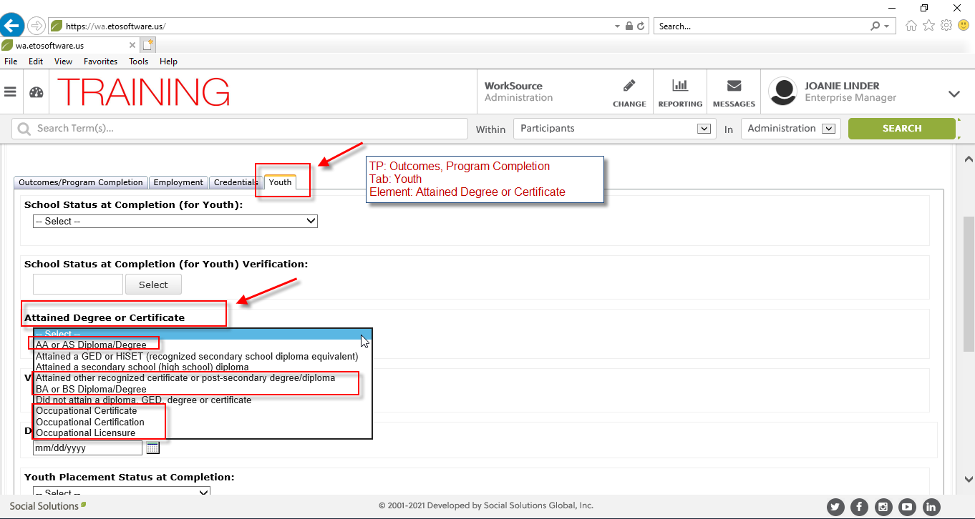

Additional guidance from System Performance on the difference of an occupational certificate, occupational certification and occupation licensure.
Training and Education Notice (TEN) 25-19 https://wdr.doleta.gov/directives/attach/TEN/TEN_25-19.pdf for additional information about postsecondary credentials. Here is the pertinent information regarding the differences between occupational certificate; an occupational certification; and occupational licensure.

Attachment I – Credential Resources

d. Characteristics of Other Certificates Professional or industry associations may award occupational certificates. The terms “certificates” and “certifications” are often confused. Some of the major distinctions are:

Certificates are completion-based and denote participation in a defined course of study.

Certificates are often related to discrete skills within one or more industries or occupations (such as writing, leadership, etc.). Such certificates may have value and are occasionally required; however, as explained in TEGL 10-16, Change 1, they are typically not eligible to be counted towards the credential attainment indicator since they do not prepare individuals with the competencies required to perform a specific occupation. Examples include certificates for discrete skills such as general hygiene (handwashing), general safety, cardiopulmonary resuscitation (CPR), work readiness, and foodhandling certificates. I-7

Certifications attest to attainment of competence through a rigorous examination or demonstration, and may also have a work experience requirement. Certifications are usually considered to be more rigorous and indicate a higher level of competence or proficiency than a certificate.

f. Characteristics of Occupational Licenses: An occupational license is a credential awarded by a government agency that constitutes legal authority to do a specific job. Licenses are based on some combination of degree or certificate attainment, certifications, assessments, or work experience; are time limited; and must be renewed periodically.

Open discussion on MSG for youth;
Tina – question about MSG for older youth OJT and WEX paid by employer not by program, why not counted as MGS?
    - Amy Gimlin it’s a DOL rule, OJT is not considered training for the MGS measure for the youth program. You can enter the measure, but it will not be counted as MGS by DOL. If an older youth meets the requirements for the adult program you can co-enroll them in that program and record the OJT for the MSG measure. Also go to your own WDC to ask for guidance as every area has a local policy.
    - Luci Bench agrees with Amy, it is a Dol rule, but youth cannot be counted as MGS for an OJT.
    - Craig appreciates Amy & Luci chiming in, he is hoping Lynn can add this response in the minutes to make sure stated by SP or Policy that it’s not based off what we state in meeting, but want to make sure it’s correct information/answer. Agrees with both Amy and Luci.
    - Aaron Parrott: That's what I was just about to say - co-enroll over-18 youth in WIOA Adult to capture OJT as an MSG, but no dice with younger youth
  - I reached out to system performance and received this guidance:
Here is the statement from TEGL 10-16, Change 1 of youth in the denominator for measurable skill gains.

Title I Youth – All ISY are included in the measurable skill gains indicator since they are attending secondary or postsecondary school. Only OSY who are in one of the following are included in the indicator: - the program element occupational skills training - secondary education at or above the 9th grade level during participation in the title I Youth program - postsecondary education during participation in the title I Youth program - Title II-funded adult education at or above the 9th grade level during participation in the title I Youth program - the YouthBuild program during participation in the title I Youth program - Job Corps during participation in the title I Youth program

TEGL 10-16, Change 1 – Attachment 7 gives details about youth services and how they are reported on the PIRL. Occupational Skills Training is the only youth service that is reported as Training.

Here is the citation from the WIOA law for additional information and additional TEGL information (I took this right out of the service catalog).
Section 129(c)(2)(C); 20 CFR 681.460(a)(3)
20 CFR 681.600
TEGL 23-14 Section 7(3)
20 CFR 681.590
20 CFR 681.480
TEGL 21-16, Section 7

  - WA-4113 new follow-up service, coming next week; change to services catalog, policy
    - Follow-Up Services-Supportive Assistance
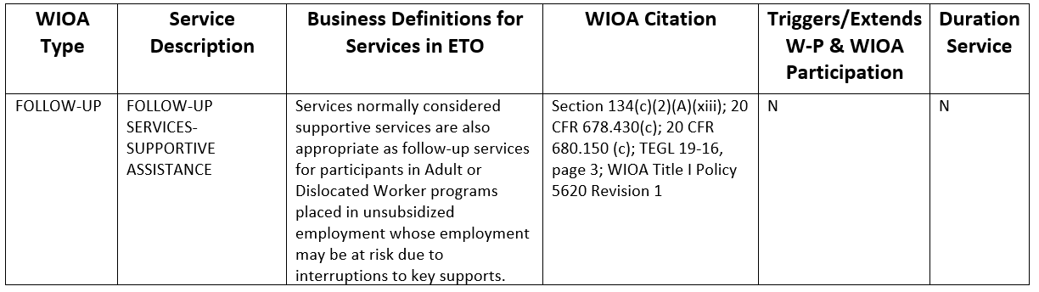

Monique – chat question – is the follow-up service a basic service? This is a follow-up service, and will be found in the services catalog under WIOA Type>FOLLOW-UP and also in the ETO Follow-up TP
- ETO maintenance – nothing to report this week
- WSWA maintenance – nothing to report this week
- Velaro maintenance – nothing to report this week
- ETO Basic and Refresher Training - Next training is on 4/5/21 10-12PM
  - ETO Basic training is the 1st Monday 10-12 and 3rd Tuesday 2-4 of every month (except holidays). Send email to Lynn Aue to receive more information, training account if needed and be added to the training Webex call. All ETO/WSWA system users are welcome to attend the training but please do not forward invites as I need to review all attendees and assign training accounts if needed.
  - Training recordings and user guides are posted on the WPC website here https://wpc.wa.gov/tech/ETO-refresher-training
  - Submit a remedy ticket requesting additional training opportunities and resources
- What’s new on WPC –
  - Report enhancements by category
    - Trade Assistance Act
      - Training Waivers; Corrected bad report logic for various date columns
      - Petition Activity; Corrected bad report logic; removed all WorkSource Offices since all data reported under Administrative
- Open discussion – training issues
  - What is the process when a job is posted advertising the salary below minimum wage?
    - Robert Jonas, we contact WSWA and report it there
  - Do you go into the employer account through impersonation without the employer’s consent?
    - Always get permission before impersonation. Need consent.
  - Question; Is there a best practice for taking a business services TP for an employer who came into ETO via data migration from the old system but does not have a wswa.com account and therefore doesn't yet have a sub-entity account in ETO or when you are working with the corporate office HR (not the recruiter on the account)?
    - Using the company name, address, and zip code, determine which employer you are working with and enter the TP and case note under the parent(Company entity)

Note: For employers who have WSWA>ETO accounts always take all services under the sub-entity account. For more information on this process check out the 9/26/2019 Employer account training on WPC https://wpc.wa.gov/tech/ETO-refresher-training

  - Ticket to Monster’s help desk. Job seeker was concerned the resume builder view (really ugly, don’t have a screen shot) was the view employer’s see when searching for candidates. It is not the view employers see. When employers use the search engine to find potential candidates they see the recruiter view shown here. Case for encouraging your job seekers to include buzz words, include words describing their job skills.
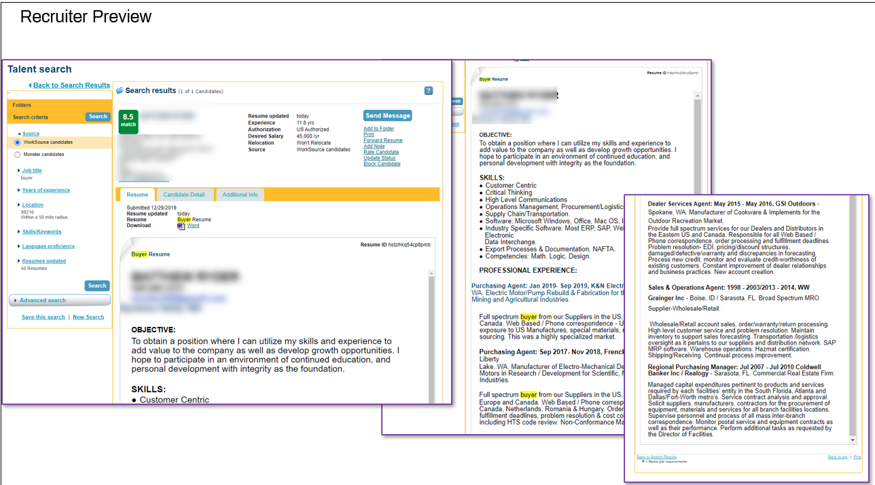

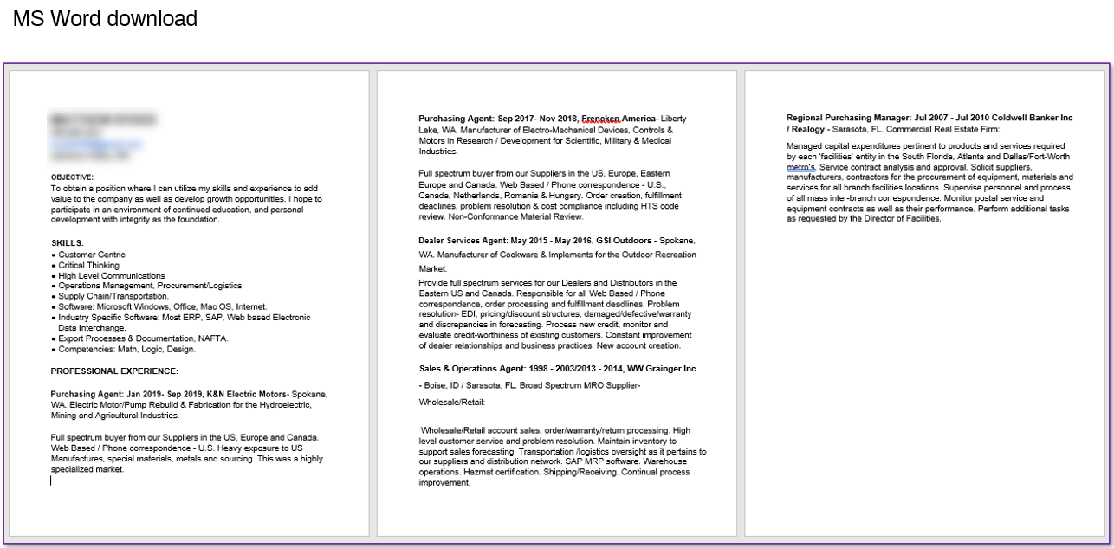

TIP from Robert – work he works w/job seekers to build resume, they are only allowed 5,000 characters. Robert recommends seeker build the master first, and advise they save it as either an HTML or Digital. Then he advises to use the Monster resume to build their master and use the master to build Target version. Building the master to include all your skills optimizes Monster’s search engine rules so employers find the right candidate for the job.

- Reminder: Submit remedy tickets for all work requests. The WSS team cannot begin work without a service request. Reaching out to us directly can affect the time it takes to resolve your issue. Thanks! https://wpc.wa.gov/tech/issues
OLYMPIA – During the week of March 14 – March 20, there were 11,398 initial regular unemployment claims (down 2.6 percent from the prior week) and 435,675 total claims for all unemployment benefit categories (down 3.1 percent from the prior week) filed by Washingtonians, according to the Employment Security Department (ESD).
- Initial regular claims applications are now 91 percent below weekly new claims applications during the same period last year at the start of the pandemic.
- Initial claims remain elevated (as compared to the 4-week moving average of initial claims pre-pandemic of 6,071 initial claims) and remain at similar levels of initial claims filed during the Great Recession.
- Decreases in layoffs in Retail trade, Manufacturing and Construction led the overall decrease in regular initial claims last week.
- Pandemic Unemployment Assistance (PUA) initial claims increased slightly over the week.
In the week ending March 20, ESD paid out over $249.6 million for 307,364 individual claims. Since the crisis began in March 2020, ESD has paid more than $16.0 billion in benefits to over a million Washingtonians.
- For current COVID-19 and UI information ESD.wa.gov or ESD Facebook page
- UI Fraud help
  - www.esd.wa.gov/fraud
  - Fax information to claims centers 833-572-8423 –due to the high volume, calling is not recommended
- Before submitting a service ticket, review this desk aid “Check list: things to try before submitting a service/remedy ticket”
- Visit this page on the WPC site to submit a service request: https://wpc.wa.gov/tech/issues If you are an ESD partner, there is a downloadable form that you must fill out and send to the Technical Solutions service desk – their e-mail is ESDDLITBITechnicalSolutions@ESD.WA.GOV
Review of ETO/WSWA and other resources (AKA old business)
- Encourage all staff who use ETO and WSWA to sign up for the T12 calls. These calls are not just for trainers but for all system users and a great way to stay up to date on changes or improvements to ETO and WSWA. Send requests to esdgpWSSteam@esd.wa.gov to be added to the ITSD Training Team’s distribution list
- WorkSource Systems resources found on the WPC Technology site https://wpc.wa.gov/tech
  - We try our best to make sure all the links are operational but depend on you to submit a remedy ticket if you find broken links!
- Check out the information the WPC website to help all WorkSource staff telework stay up to date on COVID19, teleworking and WorkSource Virtual services including;
  - IT service delivery
  - WebEx
    - Browse the Webex handbook and watch 5 videos on how to make the most out of this tool for conducting meetings with staff and customers.
  - Other resources include:
    - Now that you are teleworking reference guide
    - How to use SKYPE for online meetings
    - How to sign into ESD email from outside the network
    - How to sign into an off-site Wi-Fi from your computer
    - Can I access Internet Explorer from a MAC computer?
    - ESD service Desk information.
- Cisco Softphones training material Link http://insideesd.wa.gov/services/it-services
CHAT
Private question: I begin teaching JS classes April 6th for the Kick Start. Resume, Cover Letter, Master Application, 60 Sec Commercial and Interviewing Techniques. Could use handouts and video training ideas Lynn. Thank you. :) The person best suited to help you with these training needs and resources is Jaclyn Cascio the statewide trainer.

Private question: I have a ETO emaill communication question. Should I submit a remedy ticket? Yes please!

ATTENDEES

Aaron Parrott
Abigail Taft
AJohnson
Amy Gimlin
Barry Dickerson
Becky Smith
Boliveri
Brian Doyle
Carly Farmer
CCauthron
Christina Shaffer
Christopher File
CMatranga
Cori Ching
Craig Clark
Dawn Oakes
Dean Coxford
Diane Luoma
Donna Mack
Eileen Boyston
Emeline Pahulu
Haley Hubbard
Heidi Schauble
Irene Jordan
Jack Dryden
Jenny
Jo Ann Enwall
Joanie Linder
Kate Hesseltine
KDowning
Kendall King
Kylie Bartlett
Lisa Pietkauskis
Luci Bench
Lux Dmitri
Lynn Aue
Maria Zaragoza
Maribel Dominguez
Marla McMackin
Mary MacLennan
Matthew Shields
Melinda Johnson
Melisa Flores-Sanchez
Melissa
Michael Ensor
Monique Martin
Nelva March
Nicole Van Nelson
Phyllis Hall
Pochi Ostergren
Regina Cancel
Robert Jonas
Selam Tekle
Tami Barke
Tanya Mahre
Teresa Anda
Teresa Spark
Theresa Rogers
Tim Woodward
Tina Newcomer
Toni Burow
Tracy Ferrell
Vey Damneun
Wendy Yunker
Zoryana Bilous

Attended second half

