T12 Meeting Minutes 03-23-2022

Reminder: Mute your audio and disable the video feature after starting this Webex meeting. Too many attendee’s with active video can interfere with everyone’s audio quality. Hover over the lower edge of your monitor screen to find the icon and disable your video.

These meetings will be recorded and posted on the WPC site.
Please be advised your image will be captured and recorded during the video conference.
Your participation in this videoconference equals consent to be recorded as required by law.
New Business
- ETO maintenance – nothing this week
- WSWA maintenance – nothing this week
- Velaro maintenance – The Velaro Product Team will be performing maintenance activity on Friday, March 25, at 3:30:00 AM PT, the estimated duration is 1 hour. We do not expect any impact to your service, yet in some cases, there may be a brief interruption.
- Tickets into production – nothing this week
- ETO report enhancement updates – nothing this week.
- What’s new on WPC – nothing this week
- Training issues/open discussion
  - New T12 quarterly meeting invite will be sent out next week.
  - WA-4437 The missing elements when printing ‘Outcomes, Program Completion’ TP is a known bug. SSG has a fix and will notify us when they plan to push it out in a future release.
  - Multi-Factor Authentication (MFA) for WSWA employers, will be implemented on Wednesday, March 30, at 6am. This change applies only to employers, not job seekers, when logging into WSWA. Training material is on the WPC, Technology, WorkSourceWA page.
    - Adding a recruiter to an existing account in WorkSourceWA (PowerPoint)
    - Adding a recruiter to an existing account in WorkSourceWA (video)
    - Multi-factor authentication for employers: What to expect
  - WA-4438 Known issue with some participants RESEA dashboard not accessible to some users.
    - Dashboard TPs require you be logged into the office the TP was created in to have the ability to edit it. WE are looking into seeing if this configuration can be changed.
      - Ex: You were logged into WS Yakima when you created the TPs. You also work in WS Sunnyside and have access to that office. When you are logged into WS Sunnyside you will not have the ability to edit the TP because it was created in WS Yakima.
  - Enrolling participant in your local office so you can find them in ETO and edit TPs
    - Finding a participant in ETO desk aid
    - For non-ESD staff, Opt-out of data sharing in ETO desk aid
  - When searching for a recruiter in ETO you need to change the ‘In’ field from The office you are logged into to ‘WorkSource’ to return a search of all employers/recruiters with the name you are seeking
  - Reminder: Link to claimants 1099’s available in eServices

- Remedy tickets
  - We are getting a lot of duplicate account and SSN correction tickets which are a high priority, needing an immediate fix so staff can record services provided to customers timely. You can reach out to the service desk asking for a ticket status update here ESDDLITBITechnicalSolutions@ESD.WA.GOV or if you don’t receive a response within 24 hours from the WSS team about your ticket, email us at esdgpwssteam@esd.wa.gov so we can locate the ticket and start working on it.
  - Office closures or changes to office hours, contact or location. Submit remedy ticket to update the WS locator
  - Submit remedy tickets vs sending email to team, emails slow down the response time of helping you.
  - Remember if you suggest an enhancement at T12, submit a remedy ticket.
- ETO Basic and Refresher Training - Next training is on 4/4/22 9-12
  - ETO Basic training is the 1st Monday 9:00-12 and 3rd Tuesday 1:30-4:30 of every month (except holidays). Send email to Lynn Aue to receive more information, training account if needed and be added to the training Webex call. All ETO/WSWA system users are welcome to attend the training but please do not forward invites as I need to review all attendees and assign training accounts if needed.
  - Refresher training recordings and user guides are posted on the WPC website here https://wpc.wa.gov/tech/ETO-refresher-training
  - Submit a remedy ticket to request additional training opportunities and resources
Old Business
- Employer fraud and impact to job seekers, leaving this here for awareness
  - Talk to your employers about including their ESR numbers (UI tax ID number) in the account creation. We cannot approve accounts with verifying this information or speaking with the employer.
  - Submit remedy ticket if job seekers report they have been contacted by fraudster. Gather and include as much information from the job seeker, text messages, screen shots from online interviews, ‘employer’ emails and phone numbers, etc.
  - Working on new process and changes to WSWA to warn job seekers about employer scams.
  - Direct job seekers to Washington State Office of the Attorney General for information on employment scams
  - Job seekers can contact the Attorney General’s office and file a complaint ‘Contact Us’
    - The AG’s office is now recommending job seekers and employers contact the FBI
    - Question raised during a previous call; Is this fraud to the point where we should be encouraging customers to keep their resumes and contact info private on WorkSourceWa.com?
      - That is a decision the job seeker needs to make for themselves. The WSWA website provides information about resumes, avoiding scams, terms of use and risks. Protect job seekers by advising them to not include DOB, SSN, street address and references in resumes. Some still do that! Ask them to review the employment scam information on the Attorney General’s web site.
    - Remember, job seekers can upload resumes on WSWA and can keep them private. The disadvantage to this is employers cannot do a resume match using key words.
    - Tip from the USAJOBS website
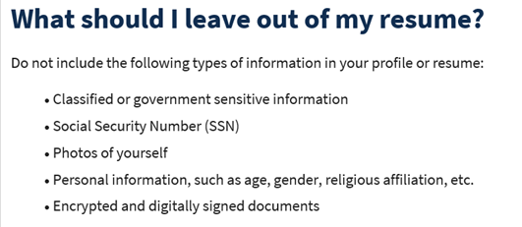
- Reminder: Submit remedy tickets for all work requests here. The WSS team cannot begin work without a service request. Reaching out to us directly can affect the time it takes to resolve your issue. Thanks!
  - Submitting remedy tickets – help us by providing enough details to work your issue. Suggestions to speed up discovering and resolving issue without lots of back-and-forth emails.
    - Screen shots include the entire screen, browser bar, not just a pinpoint of the TP that isn’t correct.
    - Report tickets need the WDA, office and start and end dates parameters you used to run the problematic report
    - We will send you 2 emails asking for additional information. Second request for response will advise you the ticket will close in 24 hours.
- Desk aid on things to try before submitting a remedy ticket; includes instructions for clearing your cache
- Internet Explorer (IE) will be deprecated after the SharePoint migration project completes but before Windows 11 is deployed (Summer 2022). It will occur sometime between those two projects, approximately 3-6 months.
  - Prepare now by transitioning to Edge or Chrome.
  - Don’t forget to transfer your favorites to Edge or Chrome and also add a copy to your document folder for recovery purposes!
    - How to import Favorites from IE to Chrome video
    - How to import Favorites from IE to Edge
        - Click on Favorites ‘star’
        - Click on ellipses (3 dots)
        - Select either Import (from Chrome or IE) or Export a copy to a local folder

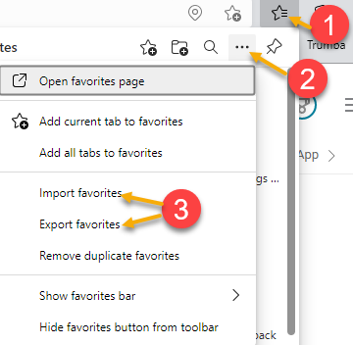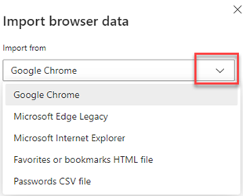

Unemployment Insurance (UI) claim and data information can be found on the UI page here https://esd.wa.gov/

CHAT
from Aparicio, Rudy (ESD) to everyone: 10:21 AM To prevent employer fraudulent accounts. Are the ESR number (UI tax ID numbers) in the account creation a requirement to complete the process? Some staff indicate push back or hesitation from ERs when this information is being requested. At this time the ESR UI tax ID number is an optional field. We are asking employers to include it to expedite the account approval process. We are looking into making it a required field but that may prevent out of state employers or 1099 employers from creating a WSWA account. If the employer doesn’t include the ESR number the account needs to go through a rigorous approval review process to ensure authenticity. It may include an email and/or a phone call to speak to the employer for account approval.

from Aue, Lynn (ESD) to everyone: 10:51 AM RESEA staff are reporting issues printing the RESEA Action Plan Initial. The issue is due to pop-up blockers and safe sites. Check out this desk aid for guidance on how to clear pop-up blockers and allow safe sites. Remember, when you clear your cache in Chrome it also clears your safe sites and you will need to add them again.

ATTENDEES

Abigail Taft
Abplanalp, Christopher T (ESD)
Aparicio, Rudy (ESD)
Arbes, Brent W ESD
Ariana Cordova - SCWDC
Barbara
Carya Bair
Christopher File
Cori-Ann Ching
Dawn Oakes
Donna Hendrickson
Eileen Boylston
Emitt Thrower
Freer, Mike(ESD)
Frost, Jennifer (ESD)
Gillis, Deanna F. (ESD)
Heather Brink WFS
Heidi Lamers
Holmes, Carolyn (ESD)
Irvin Lugo
Jessie Cardwell-BFWDC
Jordan, Irene (ESD)
Josie Capetillo
Kerns, Adeline (ESD)
King, Kendall (ESD)
Linda Rowling
Lisa Pietkauskis
Lux Dmitri
Mack, Donna R (ESD)
Maier, Seth (ESD)
Malmi Peiris
Mariya Kazantseva
Maya Anderson
Natalya - Workforce Snohomish
Nelson, Isiaih (ESD Partner)
Noll, Pamela (ESD)
Oliveri, Brett (ESD)
Peiris, Malmi ESD
Pelot, Paul (ESD)
Pochi
Schoepp, Hannah (ESD)
Selam
Sutton, Terry ESD Partner
Tamara Toles WSW
Teresa Anda
Teresa Sparks
Tina Newcomer
Ton Nguyen
Tristån Erickson
Vey Damneun
Zander

