T12 Meeting Minutes 03-02-2022

Reminder: Mute your audio and disable the video feature after starting this Webex meeting. Too many attendee’s with active video can interfere with everyone’s audio quality. Hover over the lower edge of your monitor screen to find the icon and disable your video.

These meetings will be recorded and posted on the WPC site.
Please be advised your image will be captured and recorded during the video conference.
Your participation in this videoconference equals consent to be recorded as required by law.

New Business
- ETO maintenance – nothing this week
- WSWA maintenance – nothing this week
  - There is an expected SAW outage for Tuesday, March 15 between 5:30 and 6:30 a.m. We will be placing a banner on the SEAP sign-in page alerting job seekers to the outage the Friday prior.
- Velaro maintenance –
  - The Velaro Product Team will be performing maintenance activity on Friday, March 4, at 3:30:00 AM PT, the estimated duration is 1 hour. We do not expect any impact to your service, yet in some cases, there may be a brief interruption. We don’t expect an interruption of service beyond the planned outage, but if you do submit a remedy ticket.
- Tickets into production – nothing this week
- Heads up: Wednesday, March 23, at 6am, Multi-Factor Authentication (MFA) will be implemented on WSWA for employers. This change applies only to employers, not job seekers, when logging into WSWA. We will do a demo and provide more information here before going live.
- ETO report enhancement updates – Mary demo’ d adding services provided into reports for Basic and ITS services. Need input from T12
  - Operational Reports
    - Case Notes 4.0 (No WIT Integration) OPTIMIZED
    - Case Notes 4.0-No Basic Services Included
    - Case Notes 4.0-Only Basic Services
- What’s new on WPC – nothing this week
- Training issues/open discussion
  - Future refresher trainings
    - Please provide feedback/topics for trainings (see chat)
  - Reminder: Link to claimants 1099’s available in eServices

  - Employer fraud and impact to job seekers Leaving this here for awareness. There are more details on WPC in the 2/16/22 & 2/23/22 minutes and video’s here
    - Talk to your employers about including their ESR numbers (UI tax ID number) in the account creation. We cannot approve accounts with verifying this information or speaking with the employer.
    - Submit remedy ticket if job seekers report they have been contacted by fraudster. Gather and include as much information from the job seeker, text messages, screen shots from online interviews, ‘employer’ emails and phone numbers, etc.
    - Working on new process and changes to WSWA to warn job seekers about employer scams.
    - Direct job seekers to Washington State Office of the Attorney General for information on employment scams
    - Job seekers can contact the Attorney General’s office and file a complaint ‘Contact Us’
    - Question raised during a previous call; Is this fraud to the point where we should be encouraging customers to keep their resumes and contact info private on WorkSourceWa.com?
      - That is a decision job seekers need to make for themselves. The WSWA website provides information about resumes, avoiding scams, terms of use and risks. Protect job seekers by advising them to not include DOB, SSN, street address in resumes and personal references. Some still do that! Ask them to review the employment scam information on the Attorney General’s web site.
    - Federal resumes are the job application. They contain more information that may put the job seeker at risk of ID theft or an employment scam. It is OK for job seekers to upload those resumes on WSWA but suggested you advise job seekers to keep them private.
    - Tip from the USAJOBS website
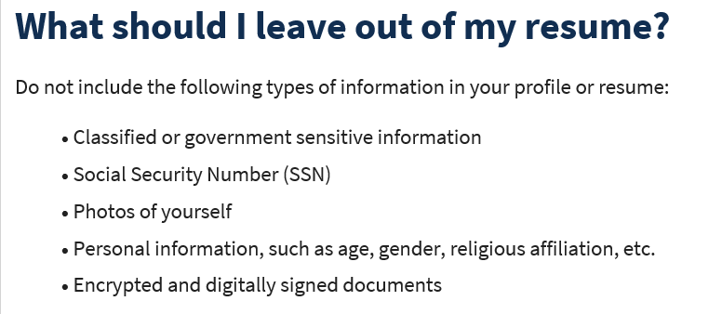
  - Office closures or changes to office hours, contact or location
    - Submit remedy ticket to update the WS locator
  - Submit remedy tickets vs sending email to team, emails slow down the response time of helping you.
    - Remember if you suggest an enhancement at T12, submit a remedy ticket.
- Remedy tickets – We are getting a lot of duplicate account and SSN correction tickets which are a high priority, needing an immediate fix so staff can record services provided to customers timely. You can reach out to the service desk asking for a ticket status update here ESDDLITBITechnicalSolutions@ESD.WA.GOV or if you don’t receive a response within 24 hours from the WSS team about your ticket, email us at esdgpwssteam@esd.wa.gov so we can locate the ticket and start working on it.
- ETO Basic and Refresher Training - Next training is on 3/7/22 9-12
  - ETO Basic training is the 1st Monday 9:00-12 and 3rd Tuesday 1:30-4:30 of every month (except holidays). Send email to Lynn Aue to receive more information, training account if needed and be added to the training Webex call. All ETO/WSWA system users are welcome to attend the training but please do not forward invites as I need to review all attendees and assign training accounts if needed.
  - Refresher training recordings and user guides are posted on the WPC website here https://wpc.wa.gov/tech/ETO-refresher-training
  - Submit a remedy ticket to request additional training opportunities and resources
Old Business
- Reminder: Submit remedy tickets for all work requests here. The WSS team cannot begin work without a service request. Reaching out to us directly can affect the time it takes to resolve your issue. Thanks!
  - Submitting remedy tickets – help us by providing enough details to work your issue. Suggestions to speed up discovering and resolving issue without lots of back-and-forth emails.
    - Screen shots include the entire screen, browser bar, not just a pinpoint of the TP that isn’t correct.
    - Report tickets need the WDA, office and start and end dates parameters you used to run the problematic report
    - We will send you 2 emails asking for additional information. Second request for response will advise you the ticket will close in 24 hours.
- Desk aid on things to try before submitting a remedy ticket; includes instructions for clearing your cache
- Internet Explorer (IE) will be deprecated after the SharePoint migration project completes but before Windows 11 is deployed (Summer 2022). It will occur sometime between those two projects, approximately 3-6 months.
  - Prepare now by transitioning to Edge or Chrome.
  - Don’t forget to transfer your favorites to Edge or Chrome and also add a copy to your document folder for recovery purposes!
    - How to import Favorites from IE to Chrome video
    - How to import Favorites from IE to Edge
        - Click on Favorites ‘star’
        - Click on ellipses (3 dots)
        - Select either Import (from Chrome or IE) or Export a copy to a local folder

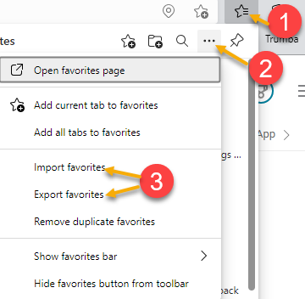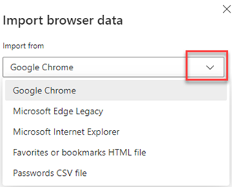

Unemployment Insurance (UI) claim and data information can be found on the UI page here https://esd.wa.gov/

CHAT
Case Note Reports—
from Teresa Anda to everyone: 10:09 AM Can we include the service description (provided) to the report? That is what we are suggesting adding.
from Aue, Lynn (ESD) to everyone: 10:09 AM (going there Teresa :)
from Teresa Anda to everyone: 10:11 AM
Yes, that helps to know what the participation period is (the identifier).
from Natalya - Workforce Snohomish to everyone: 10:12 AM That would be great!
from Teresa Anda to everyone: 10:12 AM What will be very helpful would be to add the service date and the date entered. The report provides the date the case note was entered, not the date of the service. We will look into adding dates of service, but remember, this is for case notes and was not intended to be used for late data entry.
from Pelot, Paul (ESD) to everyone: 10:12 AM ITS = Intensive Service?
from Teresa Anda to everyone: 10:13 AM Right now we have the date recorded.
from Heather Brink WFS to everyone: 10:13 AM Yes to identifiers.
from Aue, Lynn (ESD) to everyone: 10:13 AM Individualized Training Support Service
from Maier, Seth (ESD) to everyone: 10:14 AM Helpful to include days between individualized services that trigger the 90-day restart. On the system exit report
from Pelot, Paul (ESD) to everyone: 10:14 AM Sounds like a great idea!
from McNamee, Tamela (ESD) to everyone: 10:14 AM It would be nice to be able to create our own identifier on the Basic Service Touchpoint like we can on a Case Note. Also nice to have this info included in Report.
from Anderson, Laura J (ESD) to everyone: 10:19 AM Yes to identifiers! It definitely supports the distinction between services and case notes and allows us to see at a glance (services) where we need to look. Is there a consideration for a report for the ITSS T/P?

Refresher Training—
from Emily Anderson to everyone: 10:21 AM Business Services, especially helping employers navigate WSWA
from McNamee, Tamela (ESD) to everyone: 10:22 AM Finding recruiter for business accounts

Other—
from Peabody, Deborah (ESD) to everyone: 10:23 AM
Can we get a link to the video, please? (to last week’s T12 call)
from Aue, Lynn (ESD) to everyone: 10:26 AM
https://storemultisites.blob.core.windows.net/media/WPC/tech/staff-resources/T12-20220223%201809-1.mp4
from Peabody, Deborah (ESD) to everyone: 10:27 AM
Thank you! :)
from Peabody, Deborah (ESD) to everyone: 10:27 AM I'm new so I didn't know about those links, thanks
from Kylie Bartlett to everyone: 10:23 AM Has anyone else experienced issues with the WIOA eligibility app touchpoint not saving? It is an intermittent issue. Over time, tickets have been submitted but a root cause has not been discovered to fix this. The work around is to save progress, go back in and add more information and save. A possible reason for this occurring is the TP is so large and there is so much information for the system to ‘look’ at that the TP times out before saving all the tabs. Another cause can be your internet speed.
from Peabody, Deborah (ESD) to everyone: 10:24 AM They also list personal references like family/friends names and phone numbers on their resumes
from Peabody, Deborah (ESD) to everyone: 10:26 AM I think it was about fraud?
from Cancel, Regina B (ESD) to everyone: 10:27 AM
Thanks Lynn!
from Lilia to everyone: 10:28 AM Yes, I am also experiencing problems right now with the upload documents touchpoint.
from Lilia to everyone: 10:28 AM since yesterday.
from Granillo, Tiffany (ESD) to everyone: 10:29 AM A bit off topic, but speaking of intermittent, we've seen a large increase of employer 404/monster issues over the last 2 weeks. A ticket wasn't put in because it isn't every single employer, but we do get a few each day/week. We will review this at the 11am meeting with MGS.
from Granillo, Tiffany (ESD) to everyone: 10:29 AM I should clarify that this issue is seen more often on wswa.com Live Chat
from MacLennan, Mary (ESD) to everyone: 10:29 AM If something isn't working, please submit a remedy ticket. Even if it's intermittent - and you found a work-around - submit a ticket so we can research it. Tickets help us to determine if there is a pattern and not just a one off
from Emily Anderson to everyone: 10:30 AM We don't ever save documents but still have the issue from time to time
from Granillo, Tiffany (ESD) to everyone: 10:30 AM Thank you Mary
from Smick, Rikki (ESD) to everyone: 10:32 AM Kelso employers are struggling with that too in posting a job.
from McNamee, Tamela (ESD) to everyone: 10:34 AM Is there a report to find a list of recruiters for a business?
from Peabody, Deborah (ESD) to everyone: 10:34 AM Yes Deborah sent a desk aid on how to find recruiters
from Smick, Rikki (ESD) to everyone: 10:35 AM I will have BSU pull the report.
from McNamee, Tamela (ESD) to everyone: 10:35 AM
Thank you!!!
from Granillo, Tiffany (ESD) to everyone: 10:36 AM Not really, it can be a bit of a bear
from Peabody, Deborah (ESD) to everyone: 10:39 AM What is the Widget people are talking about?
from Pelot, Paul (ESD) to everyone: 10:39 AM Great for LVER's.
from Frost, Jennifer (ESD) to everyone: 10:39 AM Yep I like it
from Teresa Anda to everyone: 10:39 AM I have a question for WIOA Youth folks, what outcome reason is used for participants that move on to Youthbuild? Kylie added that for PacMtn’ s WIOA Youth program they co-enroll with the Youthbuild staff and work sharing information with the other case manager until the youth achieve an outcome or disengages from the programs. To ensure correct data entry and avoid corrections, go to Policy for the correct answer to these types of questions.
from Frost, Jennifer (ESD) to everyone: 10:39 AM Agreed Paul
from Pelot, Paul (ESD) to everyone: 10:39 AM Awesome!
from Granillo, Tiffany (ESD) to everyone: 10:40 AM Tammy said she lost her VPN
from Abigail Taft to everyone: 10:44 AM
Post-Secondary maybe? Not sure if you can exit off of youth build
from Selam to everyone: 10:44 AM Advance Training

ATTENDEES

Aaron Pentland
Abigail Taft
Anderson, Laura
Ariana Cordova
Arturo Espinoza
Baker, Mirayia
Barbara
B Oliveri
Cancel, Regina
Cascio, Jacyln
Chaney Carriker
Chase, Kim
Dawn Oakes
Dean Coxford
Donna Hendrickson
Douglas Evans
Dunning, Shellie
Dzenita Musabegovic
Eileen Boylston
Elias Zafar
Emily Anderson
Erickson, Tristan
Frost, Jennifer
Granillo, Tiffany
Heather Brink
Heidi Lamers
Hudgens, Sheila
Ismaila Maidadi
Jessie Cardwell
Johnson, Angela
Jordan, Irene
Josie Capetillo
Kaiser, Deb
Kerns, Adeline
Kylie Bartlett
Lilia
Linda Rowling
Lisa Pietkauskis
Luci Bench
Mack, Donna
Mariya Kazantseva
Maya Anderson
McNamee, Tamela
Mimi Reeves
Natalya
Peabody, Deborah
Peiris, Malmi
Pelot, Paul
Pochi
Robinson, Melissa
Samba, Ngenarr
Selam
Smith, Jasmine
Smick, Rikki
Sue Keltner
Sutton, Terry
Tamara Toles
Teresa Anda
Tracy Ferrell
Valerie
Vey Damneun
Zander

