T12 Meeting Minutes 3-17-2021
Remember: After starting a Webex meeting to mute your audio and disable the video feature. Too many attendee’s with active video can interfere with everyone’s audio quality. Hover over the lower edge of your monitor screen to find the icons.

Thanks to all who contribute to this weekly call!

New Business
- Tickets into production – nothing to report this week
- ETO maintenance – 3/20/2021 We do not expect any impact to your service, yet in some cases, there may be a brief interruption. If you notice issues with your ETO experience, please submit as remedy ticket.
- WSWA maintenance – nothing to report this week
- Velaro maintenance – The Velaro Product Team will be performing maintenance activity on Friday, March 19, at 6:30:00 AM ET, the estimated duration is 1 hour. We do not expect any impact to your service, yet in some cases, there may be a brief interruption. If you notice issues with your ETO experience, please submit as remedy ticket.
- ETO Basic and Refresher Training - Next training is on 4/5/21 10-12PM
  - ETO Basic training is the 1st Monday 10-12 and 3rd Tuesday 2-4 of every month (except holidays). Send email to Lynn Aue to receive more information, training account if needed and be added to the training Webex call. All ETO/WSWA system users are welcome to attend the training but please do not forward invites as I need to review all attendees and assign training accounts if needed.
  - Training recordings and user guides are posted on the WPC website here https://wpc.wa.gov/tech/ETO-refresher-training
  - Submit a remedy ticket requesting additional training opportunities and resources
- What’s new on WPC – Mary
  - Report enhancements by category
    - Administrative Reports (Available for ETO users with the role of Department Head and above)
      - Added new report logic on new tab to include users logged in between 89-60 days; modified initial prompt by WDA instead of Office; modified report name and description
      - Login Report; Moved to 'Uncategorized' category; report only available to Enterprise and Site Managers
    - Job Seekers
      - Services Planned End Date; Deleted report, reported out at 2/24 T12 this is no longer used.
  - What’s in the works
- Open discussion – training issues
  - Test and results vs Outcomes when recording GED
    - Recently there have been a few instances of staff recording GED completions in the Test and Results TP. System Performance’s provided guidance for us.
Staff should not record the completion of a GED on the Test and Results TP. The Test and Results TouchPoint is used to capture pre and post-tests results from the administered tests.
The MSG would be best captured for PIRL 1806 - Date of Most Recent Measurable Skill Gains: Educational Functioning Level (EFL), which has 3 ways to obtain the skill gain (see definition below). The obtainment of the GED meets criteria 2 of the definition, which is reported when the credential is reported when data is entered on the ITS TP and the outcome indicates the obtainment of High School Diploma/GED or on the Outcomes, Program Completion TP, Credential tab and the credential type is High School Diploma/GED or it's equivalency.
DOL's definition for Element 1806:
Record the most recent date the participant who received instruction below the postsecondary education level achieved at least one EFL. EFL gain may be documented in one of three ways: 1) by comparing a participant’s initial EFL as measured by a pre-test with the participant’s EFL as measured by a participant’s post-test; or 2) for States that offer secondary school programs that lead to a secondary school diploma or its recognized equivalent, an EFL gain may be measured through the awarding of credits or Carnegie units: or 3) States may report an EFL gain for participants who exit the program and enroll in postsecondary education or training during the program year.
What does this mean to you? The Test and Results TP is intended to capture Measurable Skills Gain (MGS). If a GED is part of the MGS then you should record it in this TP. If it isn’t part of MGS, then you can capture the completion in the ITSS TP or the Outcomes TP. AS always, follow your local area policies.
From Tim: Use the ‘exam’ option and also take a ‘credential’ attached to the service
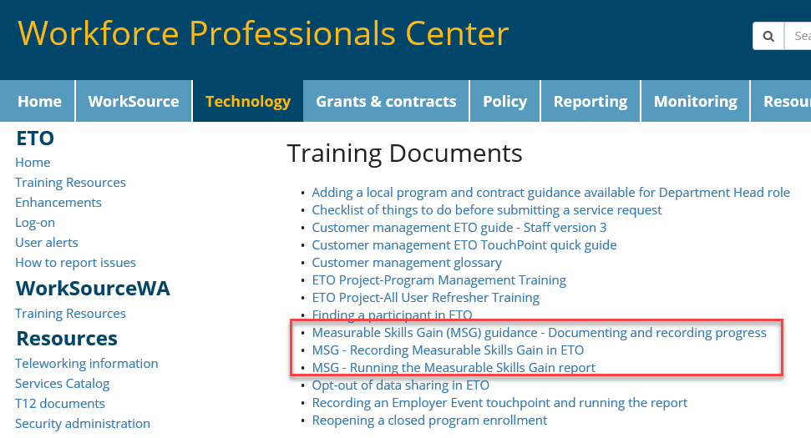
MGS training guides are on the WPC site under ETO>Training Resources
From Teresa Anda: Can we add to MSG that it’s to be recorded during participation.

- Reminder: Submit remedy tickets for all work requests. The WSS team cannot begin work without a service request. Reaching out to us directly can affect the time it takes to resolve your issue. Thanks! https://wpc.wa.gov/tech/issues
- UI announcements –
  - Extended benefits (EB) in Washington state triggered off as of February 20, 2021 due to a decrease in our unemployment rate. This occurred because our 13-week average Insured Unemployment Rate (IUR) dropped below 5%.
  - Under current legislation, after EB triggers off, we must remain off for at least 13 weeks. However, DOL has provided states the option to remove this 13-week requirement. While new legislation is pending the 13-week requirement is still in effect. If this changes, policy will send out an email update with the necessary information.
OLYMPIA – During the week of March 7 – March 13, there were 11,699 initial regular unemployment claims (down 0.5 percent from the prior week) and 449,838 total claims for all unemployment benefit categories (down 0.8 percent from the prior week) filed by Washingtonians, according to the Employment Security Department (ESD).
- Initial regular claims applications are now 17 percent below weekly new claims applications during the same period last year at the start of the pandemic.
- Initial claims remain elevated (as compared to the 4-week moving average of initial claims pre-pandemic of 6,071 initial claims) and are now at similar levels of initial claims filed during the Great Recession.
- Decreases in layoffs in the Administrative Support Services sector and Arts, Entertainment & Recreation led the overall decrease in regular initial claims last week.
- Pandemic Emergency Unemployment Compensation (PEUC) and Pandemic Unemployment Assistance (PUA) initial claims increased over the week.
In the week ending March 13th, ESD paid out over $249.5 million for 310,552 individual claims. Since the crisis began in March, ESD has paid more than $15.8 billion in benefits to over a million Washingtonians.
- For current COVID-19 and UI information ESD.wa.gov or ESD Facebook page
- UI Fraud help
  - www.esd.wa.gov/fraud
  - Fax information to claims centers 833-572-8423 –due to the high volume, calling is not recommended
- Before submitting a service ticket, review this desk aid “Check list: things to try before submitting a service/remedy ticket”
- Visit this page on the WPC site to submit a service request: https://wpc.wa.gov/tech/issues If you are an ESD partner, there is a downloadable form that you must fill out and send to the Technical Solutions service desk – their e-mail is ESDDLITBITechnicalSolutions@ESD.WA.GOV
Review of ETO/WSWA and other resources (AKA old business)
- Encourage all staff who use ETO and WSWA to sign up for the T12 calls. These calls are not just for trainers but for all system users and a great way to stay up to date on changes or improvements to ETO and WSWA. Send requests to esdgpWSSteam@esd.wa.gov to be added to the ITSD Training Team’s distribution list
- WorkSource Systems resources found on the WPC Technology site https://wpc.wa.gov/tech
  - We try our best to make sure all the links are operational but depend on you to submit a remedy ticket if you find broken links!
- Check out the information the WPC website to help all WorkSource staff telework stay up to date on COVID19, teleworking and WorkSource Virtual services including;
  - IT service delivery
  - WebEx
    - Browse the Webex handbook and watch 5 videos on how to make the most out of this tool for conducting meetings with staff and customers.
  - Other resources include:
    - Now that you are teleworking reference guide
    - How to use SKYPE for online meetings
    - How to sign into ESD email from outside the network
    - How to sign into an off-site Wi-Fi from your computer
    - Can I access Internet Explorer from a MAC computer?
    - ESD service Desk information.
- Cisco Softphones training material Link http://insideesd.wa.gov/services/it-services

CHAT
from Teresa Sparks to everyone: 10:06 AM
Has there been reports of staff not being able to run ETO reports ? I have not been able to run the reentry reports. I did submit a remedy ticket.
from Christina Shaffer to everyone: 10:11 AM
I can pass that along to Katherine and Kylie
from Teresa Sparks to everyone: 10:12 AM
The message I get is that there is no data available.
from Christina Shaffer to everyone: 10:14 AM
Will do!
from Teresa Sparks to everyone: 10:15 AM
Thank you Lynn and Mary. You two are great!
from Mahre, Tanya (ESD) to everyone: 10:15 AM
If I input TP's for the Microsoft classes I teach, do I still need to generate a report?
from Kelly Charlton to everyone: 10:23 AM
I tried to ask a question but my mic isn't functioning properly. To clarify, can the obtainment of a GED be taken as a MSG and as a credential in Outcomes, Program Completion?
from Teresa: We do with Adult, but not directly with Youth. But yes, for adults that get credentials or MSG, we record it as MSG and outcomes touchpoint. One to show they had MSG and the Outcomes is to show outcome of training service provided. We actually record 3 times, we record as service in outcome; outcomes TP and then also MSG.
From Tim: The only way it counts as credential is individual is employed; a secondary diploma by itself doesn’t count unless you have education or employment.
Marla: For Youth, we do follow-up TP; if they exited, get GED, we take it as a follow-up TP.
I thought Follow-Up TP's were only used for clients who have been exited to employment?....
from Amanda Standley to everyone: 10:27 AM
Maybe I heard that wrong...
from Christina Shaffer to everyone: 10:28 AM
I believe youth does follow-up for all types of exits. Adult/DW only does follow-up for employed exits
from Christina Shaffer to everyone: 10:28 AM
Could be wrong though. I don't do youth
from Kelly Charlton to everyone: 10:29 AM
Thanks Tim - that provided a lot of clarification for me!
from Lynn Aue to everyone: 10:29 AM
Tim suggested reviewing TEGL 10-16 I will add the TEGL to the minutes

ATTENDEES

Abigail Taft
Adeline Kerns
Alice Freyer
Amanda Standley
Arturo Espinoza
Barry Dickerson
Becky Smith
Carl Peterson
Carolyn Holmes
Catherine Geddis
Christa Shaffer
Christopher File
Dawn Oakes
Dean Coxford
Donna Mack
Dorothy Roca
Heidi Lamers
Heidi Schauble
Jack Dryden
Jenny Capella
Jo Ann Enwall
Joanie Linder
Jordan Meyenburg
Kelly Charlton
Kendall King
Laura Anderson
Lynn Aue
Maria Zaragoza
Maribel Dominguez
Marla McMackin
Mary MacLennan
Mei-Ling Taylor
Melisa Flores-Sanchez
Michael Ensor
Monique Martin
Nelva March
Phyllis Hall
Pochi Ostergren
Regina Cancel
Selam Tekle
Shannon Booth
Tanya Mahre
Teresa Anda
Teresa Sparks
Tim Robison
Tim Woodward
Tina Newcomer
Ton Nguyen
Tracy Ferrell
Vey Damneun
Zoryana Bilous

Attended second half

