T12 Meeting Minutes 03-15-2022

Reminder: Mute your audio and disable the video feature after starting this Webex meeting. Too many attendee’s with active video can interfere with everyone’s audio quality. Hover over the lower edge of your monitor screen to find the icon and disable your video.

These meetings will be recorded and posted on the WPC site.
Please be advised your image will be captured and recorded during the video conference.
Your participation in this videoconference equals consent to be recorded as required by law.
New Business
- ETO maintenance – nothing this week
- WSWA maintenance – nothing this week
- Velaro maintenance – nothing this week
- Tickets into production – nothing this week
- Heads up/date change: Wednesday, March 30, at 6am, Multi-Factor Authentication (MFA) will be implemented on WSWA for employers. This change applies only to employers, not job seekers, when logging into WSWA. We will do a demo and provide more information here before going live. PowerPoint and video training next meeting.
- ETO report enhancement updates – nothing this week.
- What’s new on WPC –
  - Create a Record Video
  - WDC contacts list updated
- Training issues/open discussion
  - WA-4438 Known issue with some participants RESEA required elements dashboard not accessible to some users.
    - Working on finding the cause and resolution
  - Potential issue with WSWA indexing job postings has been resolved. Job postings are now up to date.
  - Recently we made several report changes which will cause issues when you run then if you don’t click the ‘Refresh Report Menu’ before running reports. A best practice for the best experience with reports is to refresh reports list before running reports – Every time you run a report!
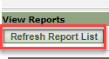
  - Follow-up to last week’s discussion.
    - Change to Program Enrollment dashboard discussion; would it be helpful to add ‘Draft’ here. It was suggested here that instead of adding this to the PE dashboard we create a report and notify staff so they can make the corrections. The WSS team ran a query and discovered there are only 24 draft PE in the system. Soon, we will reach out to the WDA 12 area data corrections team to clean these up. Thanks for the suggestion!
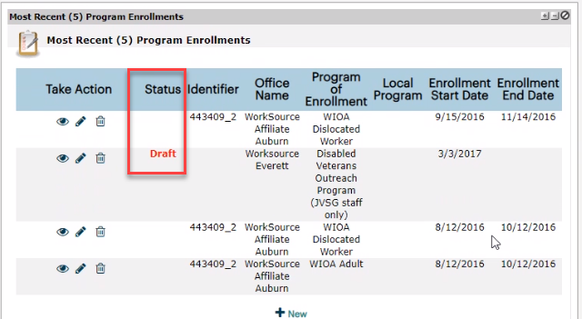

  - Enrolling participant in your local office so you can find them in ETO and edit TPs
    - Finding a participant in ETO desk aid
    - For non-ESD staff, Opt-out of data sharing in ETO desk aid
  - Reminder: Link to claimants 1099’s available in eServices

  - Employer fraud and impact to job seekers, leaving this here for awareness
    - Talk to your employers about including their ESR numbers (UI tax ID number) in the account creation. We cannot approve accounts with verifying this information or speaking with the employer.
    - Submit remedy ticket if job seekers report they have been contacted by fraudster. Gather and include as much information from the job seeker, text messages, screen shots from online interviews, ‘employer’ emails and phone numbers, etc.
    - Working on new process and changes to WSWA to warn job seekers about employer scams.
    - Direct job seekers to Washington State Office of the Attorney General for information on employment scams
    - Job seekers can contact the Attorney General’s office and file a complaint ‘Contact Us’
      - The AG’s office is now recommending job seekers and employers contact the FBI
    - Question raised during a previous call; Is this fraud to the point where we should be encouraging customers to keep their resumes and contact info private on WorkSourceWa.com?
      - That is a decision job seekers need to make for themselves. The WSWA website provides information about resumes, avoiding scams, terms of use and risks. Protect job seekers by advising them to not include DOB, SSN, street address and references in resumes. Some still do that! Ask them to review the employment scam information on the Attorney General’s web site.
    - Remember, job seekers can upload resumes on WSWA and can keep them private. The disadvantage to this is employers cannot do a resume match using key words.
    - Tip from the USAJOBS website
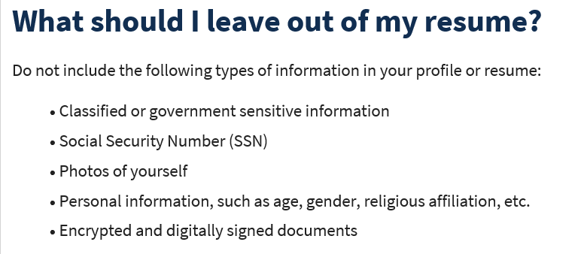
  - Office closures or changes to office hours, contact or location
    - Submit remedy ticket to update the WS locator
  - Submit remedy tickets vs sending email to team, emails slow down the response time of helping you.
    - Remember if you suggest an enhancement at T12, submit a remedy ticket.
- Remedy tickets – We are getting a lot of duplicate account and SSN correction tickets which are a high priority, needing an immediate fix so staff can record services provided to customers timely. You can reach out to the service desk asking for a ticket status update here ESDDLITBITechnicalSolutions@ESD.WA.GOV or if you don’t receive a response within 24 hours from the WSS team about your ticket, email us at esdgpwssteam@esd.wa.gov so we can locate the ticket and start working on it.
- ETO Basic and Refresher Training - Next training is on 4/4/22 9-12
  - ETO Basic training is the 1st Monday 9:00-12 and 3rd Tuesday 1:30-4:30 of every month (except holidays). Send email to Lynn Aue to receive more information, training account if needed and be added to the training Webex call. All ETO/WSWA system users are welcome to attend the training but please do not forward invites as I need to review all attendees and assign training accounts if needed.
  - Refresher training recordings and user guides are posted on the WPC website here https://wpc.wa.gov/tech/ETO-refresher-training
  - Submit a remedy ticket to request additional training opportunities and resources
Old Business
- Reminder: Submit remedy tickets for all work requests here. The WSS team cannot begin work without a service request. Reaching out to us directly can affect the time it takes to resolve your issue. Thanks!
  - Submitting remedy tickets – help us by providing enough details to work your issue. Suggestions to speed up discovering and resolving issue without lots of back-and-forth emails.
    - Screen shots include the entire screen, browser bar, not just a pinpoint of the TP that isn’t correct.
    - Report tickets need the WDA, office and start and end dates parameters you used to run the problematic report
    - We will send you 2 emails asking for additional information. Second request for response will advise you the ticket will close in 24 hours.
- Desk aid on things to try before submitting a remedy ticket; includes instructions for clearing your cache
- Internet Explorer (IE) will be deprecated after the SharePoint migration project completes but before Windows 11 is deployed (Summer 2022). It will occur sometime between those two projects, approximately 3-6 months.
  - Prepare now by transitioning to Edge or Chrome.
  - Don’t forget to transfer your favorites to Edge or Chrome and also add a copy to your document folder for recovery purposes!
    - How to import Favorites from IE to Chrome video
    - How to import Favorites from IE to Edge
        - Click on Favorites ‘star’
        - Click on ellipses (3 dots)
        - Select either Import (from Chrome or IE) or Export a copy to a local folder

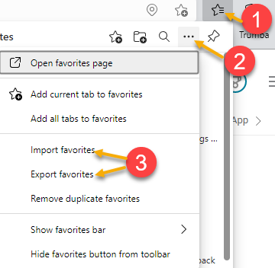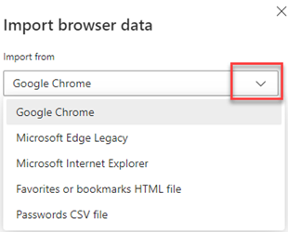

Unemployment Insurance (UI) claim and data information can be found on the UI page here https://esd.wa.gov/

CHAT – Chat was not copied and pasted here. I captured what was included in the video
Janice Herrin: Is there a training video for Cisco Finesse? It is the new phone service, contact Al Horton. The training material is found on Inside ESD under phone services
Adeline: When you discover a draft PE, do you only have to save it, or do you need to re-enter all the services? You only need to go into the PE and click ‘Save’. All the services will be attached to the PE.
Adeline: Can we still use the Historical Data outcome for ITSS that are still open? Asking because in TAA we have old ITSS that are still open because other programs have an open durational service. That is a question for System Performance and policy
Follow-up to question from last week about closing old open durational services. We asked DOL if we could choose a date to system exit using a specified outcome. The response from them was no, we need to record accurately what actually happened. We are not asking you to start working on the old services, there will be further guidance on cleaning up the data before the new system goes live.

ATTENDEES

Aaron Pentland
Abigail Taft
Abplanalp, Christopher T (ESD)
Aparicio, Rudy (ESD)
Ariana Cordova - SCWDC
Baker, Mirayia (ESD)
Barbara
Cascio, Jaclyn (ESD)
Chase, Kim (ESD)
DEAN COXFORD
Donna Hendrickson
Dorothy Rocha
Dunning, Shellie (ESD)
Emily Anderson
Erickson, Tristan ESD Partner
Gard, Robbin (ESD)
Gillis, Deanna F. (ESD)
Heather Brink WFS
Heidi Lamers
Herrin, Janice (ESD)
Holmes, Carolyn (ESD)
Ihrig, Louis (ESD)
Irvin Lugo
Jessie Cardwell-BFWDC
Jordan, Irene (ESD)
Kerns, Adeline (ESD)
kylie bartlett
Linda Rowling
Lisa Pietkauskis
Luci Bench
Mack, Donna R (ESD)
Maier, Seth (ESD)
Maricha Friedman
Mariya Kazantseva
Martin, Monique (ESD)
Maya Anderson
Natalya - Workforce Snohomish
Oliveri, Brett (ESD)
Peiris, Malmi ESD
Pelot, Paul (ESD)
Pochi
Robinson, Melissa J (ESD)
Schoepp, Hannah (ESD)
Sparks, Teresa A (ESD)
Sue Keltner
Sutton, Terry ESD Partner
Tamara Toles WSW
Teresa Anda
Tina Newcomer
Valerie
Zafar, Elias ESD Partner

