T12 Meeting Minutes 3-10-2021
Remember: After starting a Webex meeting to mute your audio and disable the video feature. Too many attendee’s with active video can interfere with everyone’s audio quality. Hover over the lower edge of your monitor screen to find the icons.

Thanks to all who contribute to this weekly call!

New Business
- Tickets into production – nothing to report this week
- ETO maintenance – nothing to report this week
- WSWA maintenance – nothing to report this week
- Velaro maintenance – nothing to report this week
- ETO Basic and Refresher Training - Next training is on 3/16/21 2-4PM
  - ETO Basic training is the 1st Monday 10-12 and 3rd Tuesday 2-4 of every month (except holidays). Send email to Lynn Aue to receive more information, training account if needed and be added to the training Webex call. All ETO/WSWA system users are welcome to attend the training but please do not forward invites as I need to review all attendees and assign training accounts if needed.
  - Training recordings and user guides are posted on the WPC website here https://wpc.wa.gov/tech/ETO-refresher-training
  - Submit a remedy ticket requesting additional training opportunities and resources
- What’s new on WPC – Mary
  - Report enhancements by category
    - Administrative Reports (Available for ETO users with the role of Department Head and above)
      - Login Report; Moved to 'Uncategorized' category; report only available to Enterprise and Site Managers.
      - Enabled User Greater than 90 Days AND Less than 90 Days Since Login; Use to view staff login activity by WDA. Tab 1=users who haven’t logged in for 90 days or greater; tab 2=users who haven’t logged in between 89-60 days.
    - Job Seekers
      - Services Planned End Date; Deleted report, reported out at 2/24 T12 this is no longer used.
    - In the works – Mary
- Open discussion – training issues
  - Test and results vs Outcomes when recording GED
    - Recently there have been a few instances of staff recording GED completions in the Test and Results TP. System Performance’s provided guidance for us.
Staff should not record the completion of a GED on the Test and Results TP. The Test and Results TouchPoint is used to capture pre and post-tests results from the administered tests.
The MSG would be best captured for PIRL 1806 - Date of Most Recent Measurable Skill Gains: Educational Functioning Level (EFL), which has 3 ways to obtain the skill gain (see definition below). The obtainment of the GED meets criteria 2 of the definition, which is reported when the credential is reported when data is entered on the ITS TP and the outcome indicates the obtainment of High School Diploma/GED or on the Outcomes, Program Completion TP, Credential tab and the credential type is High School Diploma/GED or it's equivalency.
DOL's definition for Element 1806:
Record the most recent date the participant who received instruction below the postsecondary education level achieved at least one EFL. EFL gain may be documented in one of three ways: 1) by comparing a participant’s initial EFL as measured by a pre-test with the participant’s EFL as measured by a participant’s post-test; or 2) for States that offer secondary school programs that lead to a secondary school diploma or its recognized equivalent, an EFL gain may be measured through the awarding of credits or Carnegie units: or 3) States may report an EFL gain for participants who exit the program and enroll in postsecondary education or training during the program year.
What does this mean to you? The Test and Results TP is intended to capture Measurable Skills Gain (MGS). If a GED is part of the MGS then you should record it in this TP. If it isn’t part of MGS, then you can capture the completion in the ITSS TP or the Outcomes TP. AS always, follow your local area policies.
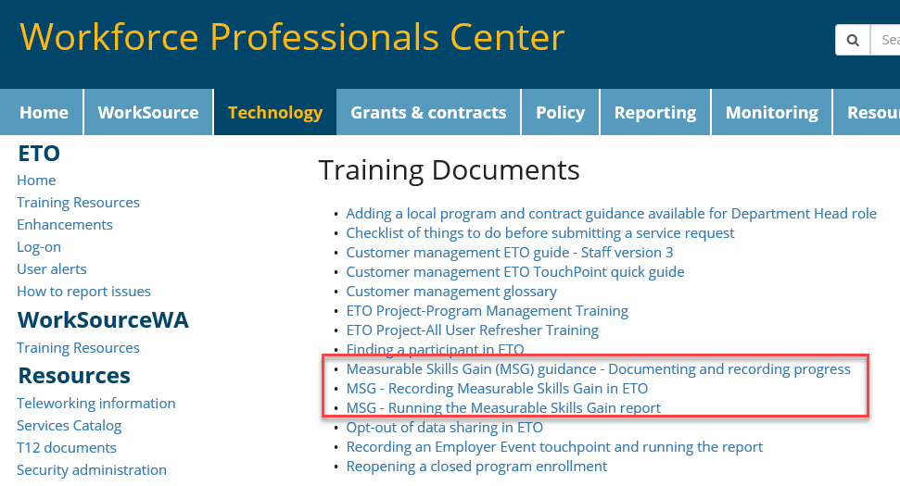
MGS training guides are on the WPC site under ETO>Training Resources

- Reminder: Submit remedy tickets for all work requests. The WSS team cannot begin work without a service request. Reaching out to us directly can affect the time it takes to resolve your issue. Thanks! https://wpc.wa.gov/tech/issues
- UI announcements –
  - Extended benefits (EB) in Washington state triggered off as of February 20, 2021 due to a decrease in our unemployment rate. This occurred because our 13-week average Insured Unemployment Rate (IUR) dropped below 5%.
  - Under current legislation, after EB triggers off, we must remain off for at least 13 weeks. However, DOL has provided states the option to remove this 13-week requirement. While new legislation is pending the 13-week requirement is still in effect. If this changes, policy will send out an email update with the necessary information.
From last week OLYMPIA – During the week of February 21 - 27, there were 12,958 initial regular unemployment claims (down 7.7 percent from the prior week) and 459,328 total claims for all unemployment benefit categories (down 0.6 percent from the prior week) filed by Washingtonians, according to the Employment Security Department (ESD).
- Initial regular claims applications remain at elevated levels and are at 128 percent above last year’s weekly new claims applications.
- Initial claims for Pandemic Emergency Unemployment Compensation (PEUC), initial claims for regular benefits and continued claims for regular benefits all decreased over the week.
- Initial claims applications for Pandemic Unemployment Assistance (PUA) increased slightly at 1.3 percent over the week.
- Decreases in layoffs in Accommodation & Food Services and Construction led the overall decrease in regular initial claims last week. Regular initial claims in the Accommodation & Food Services sector decreased by 400 initial claims over the week to 1,052 total regular initial claims. Initial claims for regular benefits in the Construction sector decreased by 325 initial claims over the week to 2,441 initial claims.
In the week ending February 27, ESD paid out over $255 million for 315,399 individual claims. Since the crisis began in March, ESD has paid more than $15.3 billion in benefits to over a million Washingtonians.
- For current COVID-19 and UI information ESD.wa.gov or ESD Facebook page
- UI Fraud help
  - www.esd.wa.gov/fraud
  - Fax information to claims centers 833-572-8423 –due to the high volume, calling is not recommended
- Before submitting a service ticket, review this desk aid “Check list: things to try before submitting a service/remedy ticket”
- Visit this page on the WPC site to submit a service request: https://wpc.wa.gov/tech/issues If you are an ESD partner, there is a downloadable form that you must fill out and send to the Technical Solutions service desk – their e-mail is ESDDLITBITechnicalSolutions@ESD.WA.GOV
Review of ETO/WSWA and other resources (AKA old business)
- Encourage all staff who use ETO and WSWA to sign up for the T12 calls. These calls are not just for trainers but for all system users and a great way to stay up to date on changes or improvements to ETO and WSWA. Send requests to esdgpWSSteam@esd.wa.gov to be added to the ITSD Training Team’s distribution list
- WorkSource Systems resources found on the WPC Technology site https://wpc.wa.gov/tech
  - We try our best to make sure all the links are operational but depend on you to submit a remedy ticket if you find broken links!
- Check out the information the WPC website to help all WorkSource staff telework stay up to date on COVID19, teleworking and WorkSource Virtual services including;
  - IT service delivery
  - WebEx
    - Browse the Webex handbook and watch 5 videos on how to make the most out of this tool for conducting meetings with staff and customers.
  - Other resources include:
    - Now that you are teleworking reference guide
    - How to use SKYPE for online meetings
    - How to sign into ESD email from outside the network
    - How to sign into an off-site Wi-Fi from your computer
    - Can I access Internet Explorer from a MAC computer?
    - ESD service Desk information.
- Cisco Softphones training material Link http://insideesd.wa.gov/services/it-services
CHAT
Included in report enhancements and open discussion

ATTENDEES

Didn’t take attendance, Lynn and Mary’s power failure ended meeting

Attended second half

