T12 Meeting Minutes 02-09-2022

Reminder: Mute your audio and disable the video feature after starting this Webex meeting. Too many attendee’s with active video can interfere with everyone’s audio quality. Hover over the lower edge of your monitor screen to find the icon and disable your video.

These meetings will be recorded and posted on the WPC site.
Please be advised your image will be captured and recorded during the video conference.
Your participation in this videoconference equals consent to be recorded as required by law.

New Business
- ETO maintenance – nothing this week
- WSWA maintenance – nothing this week
- Velaro maintenance – The Velaro Product Team will be performing maintenance activity on Friday, February 11, at 3:30:00 AM PT, the estimated duration is 1 hour. We do not expect any impact to your service, yet in some cases, there may be a brief interruption. Please submit a remedy ticket if you experience an issue with live chat.
- Tickets into production –
  - WA-4411 change the UI type drop down selection menu in the WIOA Eligibility Application from acronyms to full spelling
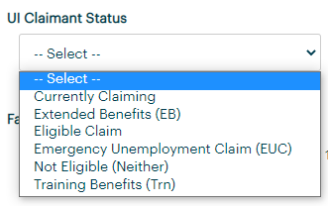
  - WA-4413 a 6th area to the General information dashboard has been added to allow the 4 detail TPS, Guide Claimant Information and Target Occupation to populate. The work to remove the migrated Target Occupation TPs from the menu is still in the works.
  - WA-4314 the employer landing page has been updated so employers will not land on the Monster paid page. MGS is still investigating the caching issue causing employers landing here and not landing in their WSWA page. When contact, advise them to clear cache.
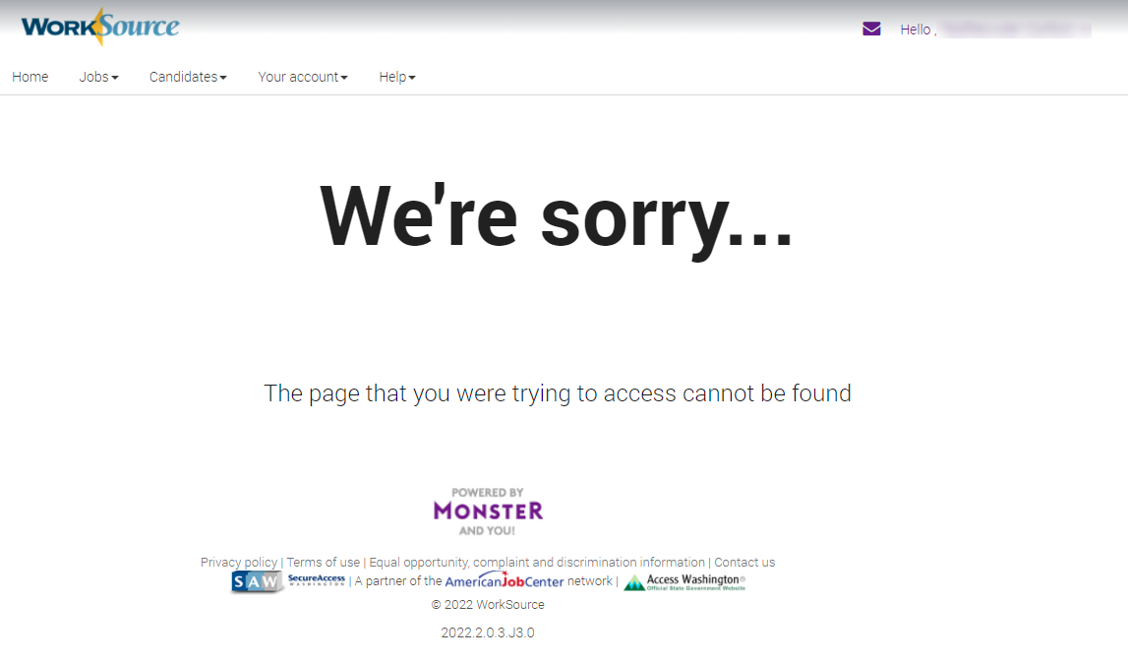
- Project updates – nothing this week
- What’s new on WPC –
  - Report enhancements – nothing this week
- Training issues/open discussion
  - I am receiving feedback from staff you are hesitant in contacting me because I am busy.
    - While I truly appreciate all of your consideration of my workload, PLEASE don’t hesitate to submit tickets so I can address your issues or concerns. I am never too busy to support all of you!
  - Reminder: Link to claimants 1099’s available in eServices

  - Clearing cache guidance for IE, Edge and Chrome is included in the ‘Checklist of things to do before submitting a service request’ desk aid
  - Finding participants in ETO desk aid
    - For non-ESD staff, finding a participant who has opted out of data sharing desk aid
  - Unable to edit TPs created by other staff
    - Participants need to be added to your office so you can edit TPs. Guidance is included in ‘Finding a participant in ETO’ desk aid
  - Employer fraud
    - Talk to your employers about including their ESR numbers in the account creation. We cannot approve accounts with verifying this information or speaking with the employer.
    - Submit remedy ticket if job seekers report they have been contacted by fraudster. Gather and include as much information from the job seeker, text messages, screen shots from online interviews, ‘employer’ emails and phone numbers, etc.
    - Working on new process and changes to WSWA to warn job seekers about employer scams.
    - Direct job seekers to Washington State Office of the Attorney General for information on employment scams
    - Job seekers can contact the Attorney General’s office and file a complaint ‘Contact Us’
  - Process for requesting ETO training accounts
    - New process implemented October 2021 (included in minutes)
    - Submit remedy ticket including WDA, number of accounts needed, start and end date of training.
    - Account form will be emailed to you to complete and return, including trainees names
    - Account passwords will be reset after the last day of training
    - Send email if you need end date extended
  - Office closures
    - Submit remedy ticket to update the WS locator
  - Submit remedy tickets vs sending email to team, emails slow down the response time of helping you.
    - Remember if you suggest an enhancement at T12, submit a remedy ticket.
- Remedy tickets – Recently the service desk has been back logged with tickets which delays ETO/WSWA ticket assignment to our team. SSN correction tickets are a high priority, needing an immediate fix so staff can record services provided to customers timely. Email us at esdgpwssteam@esd.wa.gov if you receive a response within 24 hours. We can locate the ticket and start working on it.
- ETO Basic and Refresher Training - Next training is on 2/15/22 1:30-4:30
  - ETO Basic training is the 1st Monday 9:00-12 and 3rd Tuesday 1:30-4:30 of every month (except holidays). Send email to Lynn Aue to receive more information, training account if needed and be added to the training Webex call. All ETO/WSWA system users are welcome to attend the training but please do not forward invites as I need to review all attendees and assign training accounts if needed.
  - Refresher training recordings and user guides are posted on the WPC website here https://wpc.wa.gov/tech/ETO-refresher-training
  - Submit a remedy ticket to request additional training opportunities and resources
Old Business
- Reminder: Submit remedy tickets for all work requests here. The WSS team cannot begin work without a service request. Reaching out to us directly can affect the time it takes to resolve your issue. Thanks!
  - Submitting remedy tickets – help us by providing enough details to work your issue. Suggestions to speed up discovering and resolving issue without lots of back-and-forth emails.
    - Screen shots include the entire screen, browser bar, not just a pinpoint of the TP that isn’t correct.
    - Report tickets need the WDA, office and start and end dates parameters you used to run the problematic report
    - We will send you 2 emails asking for additional information. Second request for response will advise you the ticket will close in 24 hours.
- Desk aid on things to try before submitting a remedy ticket; includes instructions for clearing your cache
- Internet Explorer (IE) will be deprecated after the SharePoint migration project completes but before Windows 11 is deployed (Summer 2022). It will occur sometime between those two projects, approximately 3-6 months.
  - Prepare now by transitioning to Edge or Chrome.
  - Don’t forget to transfer your favorites to Edge or Chrome and also add a copy to your document folder for recovery purposes!
    - How to import Favorites from IE to Chrome video
    - How to import Favorites from IE to Edge
        - Click on Favorites ‘star’
        - Click on ellipses (3 dots)
        - Select either Import (from Chrome or IE) or Export a copy to a local folder

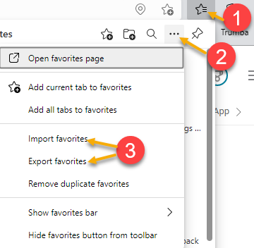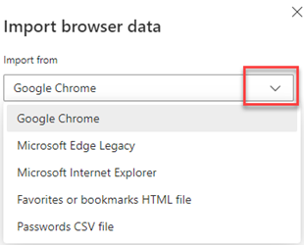

Unemployment Insurance (UI) claim and data information can be found on the UI page here https://esd.wa.gov/

CHAT
Question--Do you know why some participants ETO dashboards are not configured the "normal" way even though they are added to the 'office" didnt know if you wanted me to share a participants name but the dashbord isnt configured correctly and there isnt a :new" option to add a touchpoint on the dashboard? i told the staff to put in a ticket but not sure why this happens? Yes, please submit a remedy ticket and we will research

ATTENDEES

Aaron Pentland
Abigail Taft
Aparicio, Rudy
Arbes, Brent
Ariana Cordova
Baker, Mirayia
B Oliveri
Chase, Kim
Christina Shaffer
Dawn Oakes
Dean Coxford
Dorothy Rocha
Dunning, Shellie
Eileen Boylston
Elias Zafar
Heather Brink
Heidi Lamers
Holmes, Carolyn
Ish
Jackie Wetchler
Jessie Cardwell
Johnson, Angela
Jordan, Irene
Kerns, Adeline
Kylie Bartlett
Linda Rowling
Luci Bench
Lux Dmitri
Mack, Donna
Maier, Seth
Malmi Peiris
Mariya Kazantseva
Maya Anderson
Mimi Reeves
Paul Pelot
PoChi
Robinson, Melissa
Samba, Ngenarr
Selam
Sparks, Teresa
Sue Keltner
Tamara Toles
Teresa Anda
Tina Newcomer
Tracy Ferrell
Vey Damneun
Wood, Lora

