T12 Meeting Minutes 02-23-2022

Reminder: Mute your audio and disable the video feature after starting this Webex meeting. Too many attendee’s with active video can interfere with everyone’s audio quality. Hover over the lower edge of your monitor screen to find the icon and disable your video.

These meetings will be recorded and posted on the WPC site.
Please be advised your image will be captured and recorded during the video conference.
Your participation in this videoconference equals consent to be recorded as required by law.

New Business
- ETO maintenance – nothing this week
- WSWA maintenance – nothing this week
- Velaro maintenance – nothing this week
- Tickets into production – nothing this week
- Project updates – nothing this week
- What’s new on WPC –
  - Added the service desk email address for both ETO and Qtrac under ‘How to report issues’
  - Report enhancements – Working on adding an identifier column to case note reports
- Training issues/open discussion
  - Submit remedy tickets to merge duplicate accounts. Don’t add SSN to ticket, if needed upload the SS card into a case note to the participants record.
    - My process to merge the accounts is merge to the one associated with the WSWA account, if applicable. After merging, I correct DOB, SSN, names, etc. I cannot delete TPs or case notes. I work with staff and direct them to do that cleanup if needed.
  - Reminder: Link to claimants 1099’s available in eServices

  - Employer fraud and impact to job seekers
    - Talk to your employers about including their ESR numbers (UI tax ID number) in the account creation. We cannot approve accounts with verifying this information or speaking with the employer.
    - Submit remedy ticket if job seekers report they have been contacted by fraudster. Gather and include as much information from the job seeker, text messages, screen shots from online interviews, ‘employer’ emails and phone numbers, etc.
    - Working on new process and changes to WSWA to warn job seekers about employer scams.
    - Direct job seekers to Washington State Office of the Attorney General for information on employment scams
    - Job seekers can contact the Attorney General’s office and file a complaint ‘Contact Us’
    - Question raised last week; Is this fraud to the point where we should be encouraging customers to keep their resumes and contact info private on WorkSourceWa.com?
      - That is a decision job seekers need to make for themselves. The WSWA website provides information about resumes, avoiding scams, terms of use and risks. Protect job seekers by advising them to not include DOB, SSN, and street address in resumes. Some still do that! Ask them to review the employment scam information on the Attorney General’s web site.
    - Federal resumes are the job application. They contain more information that may put the job seeker at risk of ID theft or an employment scam. It is OK for job seekers to upload those resumes on WSWA but suggested you advise job seekers to keep them private.
    - Tip from the USAJOBS website
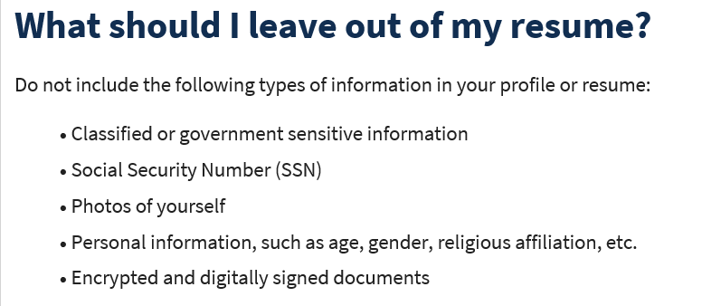
  - Office closures or changes to office hours, contact or location
    - Submit remedy ticket to update the WS locator
  - Submit remedy tickets vs sending email to team, emails slow down the response time of helping you.
    - Remember if you suggest an enhancement at T12, submit a remedy ticket.
- Remedy tickets – Recently the service desk has been back logged with tickets which delays ETO/WSWA ticket assignment to our team. We are getting a lot of duplicate account and SSN correction tickets which are a high priority, needing an immediate fix so staff can record timely services provided to customers. You can reach out to the service desk asking for a ticket status update here ESDDLITBITechnicalSolutions@ESD.WA.GOV or
  - If you don’t receive a response within 24 hours from the WSS team about your ticket, email us at esdgpwssteam@esd.wa.gov so we can locate the ticket and start working on it.
- ETO Basic and Refresher Training - Next training is on 3/7/22 9-12
  - ETO Basic training is the 1st Monday 9:00-12 and 3rd Tuesday 1:30-4:30 of every month (except holidays). Send email to Lynn Aue to receive more information, training account if needed and be added to the training Webex call. All ETO/WSWA system users are welcome to attend the training but please do not forward invites as I need to review all attendees and assign training accounts if needed.
  - Refresher training recordings and user guides are posted on the WPC website here https://wpc.wa.gov/tech/ETO-refresher-training
  - Submit a remedy ticket to request additional training opportunities and resources
Old Business
- Reminder: Submit remedy tickets for all work requests here. The WSS team cannot begin work without a service request. Reaching out to us directly can affect the time it takes to resolve your issue. Thanks!
  - Submitting remedy tickets – help us by providing enough details to work your issue. Suggestions to speed up discovering and resolving issue without lots of back-and-forth emails.
    - Screen shots include the entire screen, browser bar, not just a pinpoint of the TP that isn’t correct.
    - Report tickets need the WDA, office and start and end dates parameters you used to run the problematic report
    - We will send you 2 emails asking for additional information. Second request for response will advise you the ticket will close in 24 hours.
- Desk aid on things to try before submitting a remedy ticket; includes instructions for clearing your cache
- Internet Explorer (IE) will be deprecated after the SharePoint migration project completes but before Windows 11 is deployed (Summer 2022). It will occur sometime between those two projects, approximately 3-6 months.
  - Prepare now by transitioning to Edge or Chrome.
  - Don’t forget to transfer your favorites to Edge or Chrome and also add a copy to your document folder for recovery purposes!
    - How to import Favorites from IE to Chrome video
    - How to import Favorites from IE to Edge
        - Click on Favorites ‘star’
        - Click on ellipses (3 dots)
        - Select either Import (from Chrome or IE) or Export a copy to a local folder

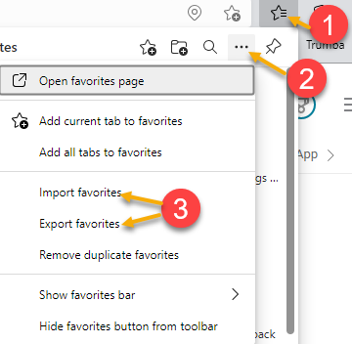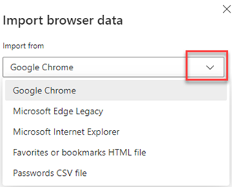

Unemployment Insurance (UI) claim and data information can be found on the UI page here https://esd.wa.gov/

CHAT
from Jackie Wetchler she/hers to everyone: 10:22 AM Make a "Safe Job Seeker" document with tips and tricks to share with clients Great idea, will do!
from Pelot, Paul (ESD) to everyone: 10:25 AM The federal resume process has changed, the SSN is no longer required on the federal resume, it is entered into USAJOBS.gov during the application process. Monique if I'm wrong, please let me know. Went to USAJOBS.gov and they do not ask for SSN on Resume.

ATTENDEES

Abigail Taft
Aparicio, Rudy
Baker, Mirayia
B Oliveri
Cori-Ann Ching
Dean Coxford
Donna Hendrickson
Dorothy Rocha
Dunning, Shellie
Ensor, Michael
Enwall, Jo Ann
Erickson, Tristan
Heather Brink
Heidi Lamers
Holmes, Carolyn
Jackie Wetchler
Jessie Cardwell
King, Kendall
Kylie Bartlett
Linda Rowling
Luci Bench
Lux Dmitri
Maricha Friedman
Mariya Kazantseva
Martin, Monique
Melissa Robinson
Mimi Reeves
Natalya Verley
Pelot, Paul
Pochi
Smith, Jasmine
Sparks, Teresa
Sutton, Terry
Tamara Toles
Teresa Anda
Tina Newcomer
Tracy Ferrell
Vey Damneun
Zafar, Elias

Zander

